Building Structured FTTO Cabling System

Request For Proposal

Prepared for

OM3 / OM4 / OS2 fibre system
using
pre-terminated assemblies / OF cables to be terminated on site
in physical Star / Ring topology

(Please keep only the technology and topology you want to use)

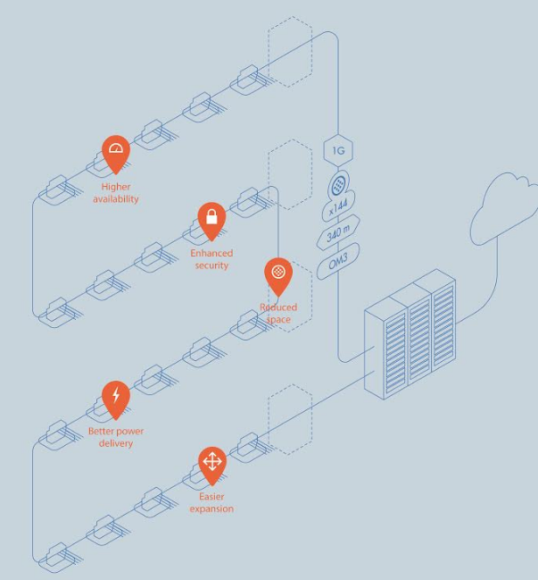
Tenderbook V3.22 updated 08/2026

Instructions for use of the NCS FTTO cabling tender document

The present modular FTTO Request For Proposal (RFP) master document shall be adapted by the user according to his project.

Every chapters to all tender types are included – The user shall review and tailor it according to his own needs.

All possible versions are contained into this document.

Using the outline mode of MS word the content of the document can be reduced to the main chapter heads or be expanded level by level (see user guide).
Deleting the head of a chapter/subchapter in the outline mode also remove the whole content of this chapter and MS Word automatically update the numbering of the remaining chapters.
The process begins at the main chapters (first) level. The complete useless chapters are removed (select and delete).
The list is than expanded to the next level and the sub-chapters of the second level that are not needed are deleted.
The process is going to continue down to the fully expanded document.

Please be aware that two other RFP document dedicated to Building and Data Centre passive cabling projects are also available.

The current page and all instruction texts highlighted in yellow
are to be deleted before publishing of the RFP doc.
Table of Contents

1. Standards & Regulations 5
2. Compliance to European Construction Product Regulation (CPR) 5
3. Fibre sub-system 8
3.1. OM3 bend insensitive (BIMMF) fibre sub-system 8
3.2. OM4 bend insensitive (BIMMF) fibre sub-system 9
3.3. OS2 bend insensitive (BI) fibre sub-system 10
4. FTTO cabling design 11
4.1. FTTO concept 11
4.2. FTTO cabling topology 12
4.3. FTTO cabling technology 27
5. Optical Fibre Cabling infrastructure 29
5.1. Fibre distribution cable 29
5.2. Fibre pre-terminated cable assembly 36
5.3. Optical Fibre characteristics 40
5.4. OF Telecommunications outlet 42
5.5. Ruggedised lockable ZD box 44
5.6. Demarcation box 47
5.7. Optical fibre CP links 48
5.8. Optical Fibre Patch Panel 49
5.9. Optical Fibre pigtails 62
5.10. Optical Fibre Patch Cords 66
5.11. Copper Patch cords 71
6. FTTO switches 75
6.1. General FTTO switch features 75
6.2. Redundancy Scenarios 76
6.3. FTTO switches for office environments 77
6.4. FTTO switch for MEDICAL environment 81
6.5. FTTO switch for ruggedized environment 81
6.6. Software Features 82
6.7. Removable HEAD modules (HEAD range) 84
6.8. Upgrade capability to PoE++ HEAD 84
6.9. Accessories 85
7. Fibre in the Digital Ceiling 89
7.1. Digital Ceiling switch 89
8. SFP and SFP+ transceivers 94
9. Click-In Power Supply Units 97
10. Management Software 101
11. Rack unit solution 103
11.1. Smart Building racks 103
11.2. Server DC racks 105
12. Testing 108
12.1. Fibre testing 108
13. Procedures 109
13.1. Installation Guide 109
13.2. Fire Protection 109
13.3. Earthing 109
14. Management of the Project 109
14.1. Design of the Project and labelling 109
14.2. Project Management 109
14.3. Integration of FTTO switches 109
14.4. Define information to collect 109
14.5. Device configuration 110
14.6. Administration platform 110
15. Warranty 111
15.1. Fibre sub-system 111
15.2. FTTO switches 113
16. Documentation 113
16.1. Response inclusions to the bid price 113
16.2. During the Presentation of the Offer 113
16.3. Kick-off of the Project 113
16.4. On completion of the installation 113

Table of content update: When the creation of your RFP document is completed, please right-click into the table of content and choose ‘update field’ and select the ‘update entire table’ option.

Standards & Regulations

This Request For Proposal (RFP) provides a description for a generic structured cabling system based on the latest edition of the applicable standards:
- ISO/IEC 11801: 2017 Ed.3 and subsequent addendums and revisions
or
- EN 50173-1 to -3:2018 and subsequent addendums and revisions
- EN50174-1:2018 / EN50174-2:2018 / EN50174-3:2013/A1:2017 and subsequent addendums and revisions

The object of this RFP is to define the structured cabling independently of the applications, which it is capable of supporting.
Furthermore, to allow for future demands, the cabling system must be easy to expand and maintain.

Furnishing and installing the workplace FTTO switches with POE (Power Over Ethernet) capability is also included in the scope of work. The requested components are also defined in this document.
Note: the central active equipment (Switches and media converters if needed) are not part of the scope of work.

FTTO switches shall be compliant to the following engineering standards:
- Electrical safety (IT equipment): EN 62368-1
- Electrical conditions (EMC): EN 55032 and EN 55024
- RoHS EN 50581

The successful vendor shall meet or exceed all requirements for the cabling system described in
this document.

The cabling system installation shall be realized in accordance with the recommendations made in
the relevant standards, manufacturer’s recommendations and/or best industry practices.

Compliance to European Construction Product Regulation (CPR)

Background information
Started as a Directive in 1989 (“CPD”) and turned into a Regulation in 2011 (“CPR”) which became applicable from 01st July 2013, the CPR was brought to life by the European Commission to enforce that construction works be designed and executed so as not to endanger the safety of persons, domestic animals or property nor damage the environment.
The goals of the CPR were:
- To define harmonised rules for marketing of construction products within the EU.
- To provide a common technical language to assess performance of construction products.
- To ensure availability of reliable information to allow comparison of construction products from different manufacturers in different countries.
EN 50575 is the harmonised European standard, issued in 2014 and published in the Official Journal of the European Union (OJEU) on 10th July 2015, which specifies requirements for cables used in permanent constructions with regard to their reaction to fire.
The fire performance of cables is classified based on a number of criteria:
- Flame spread and heat release
- Smoke production, acidity and flaming droplets
These criteria and test methods are specified in existing standards IEC/EN 60332-1, IEC/EN 61034-2, IEC/EN 60754-2 and in a new harmonised European standard EN 50399.
Cable performance classes
- 7 Euroclasses for flame spread and heat release: A_{ca}, B1_{ca}, B2_{ca}, C_{ca}, D_{ca}, E_{ca} and F_{ca} (A_{ca} being the most severe i.e. non-combustible and F_{ca} having no criteria specified)
- 3 classifications and 2 sub-classes for smoke production: s1, s1a, s1b, s2, s3 (s1a being the most severe and s3 no criteria specified or failing any of the other four classifications)
- 3 classifications for acidity: a1, a2, a3 (a1 being the most severe and a3 no criteria specified or failing any of the other two classifications)
- 3 classifications for flaming droplets: d0, d1, d2 (d0 being the most severe and d2 no criteria specified or failing any of the other two classifications)
Requirements are going to depend on various parameters such as the type of building, the level of occupation, the difficulty of evacuation, etc. As building designs and operational rules will differ,
these requirements are not harmonised and therefore may vary from country to country.
It is the legal obligation of each EU Member State government to adopt CPR in national regulation, define the cable performance class and to guarantee effective surveillance of its market.
The company who place the product on the market in the EU is responsible to comply with the CPR obligations. This is either the actual manufacturer or the importer.
The product needs to have a Declaration of Performance (DoP)
This is a document drawn up by the manufacturer (or importer) in the language(s) required by the EU country where the product is made available and containing defined information such as product identification, its intended use, its declared performance according to CPR and the identification of the Notified Body. The DoP needs to be made publicly available, either on paper or in electronic format. It does not need to accompany the product itself.
The product packaging needs to have defined labelling including CE marking
labels on cable drums and boxes need to contain the same data as on the DoP, the reference number of the DoP, the CE mark and the year in which the CE marking was first affixed. The language of the label information can be chosen by the manufacturer (or importer). The cable itself does not need to bear the CE marking nor contain any other of the CPR requirements for labelling.
The cable manufacturer is not the solely responsible for CPR compliance. Also Distributors, Specifiers and Building Owners also bear responsibilities.
- Distributors should not resell cables (which they bought after the 1st of July 2017) for which there is no DoP and which do not bear the appropriate labelling.
- Specifiers must reference appropriate Euroclasses and s/a/d criteria according to national CPR regulations.
- Building owners need to ensure that the infrastructure on their building plans is in line with national CPR regulations.
Applicability
The regulation came into force from the 1st of July 2017, date when CE marking for CPR became mandatory.
As a consequence the bidder shall only propose copper and fibre cables that are compliant to the CPR.
Example of mandatory drum labelling:
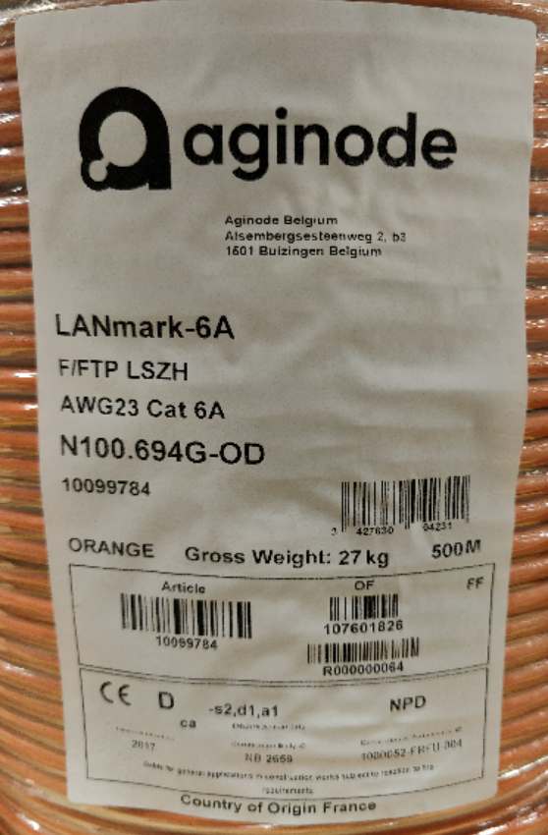
For the purpose of this tender CPR marking on the cables jacket is mandatory
Example of mandatory print legend:
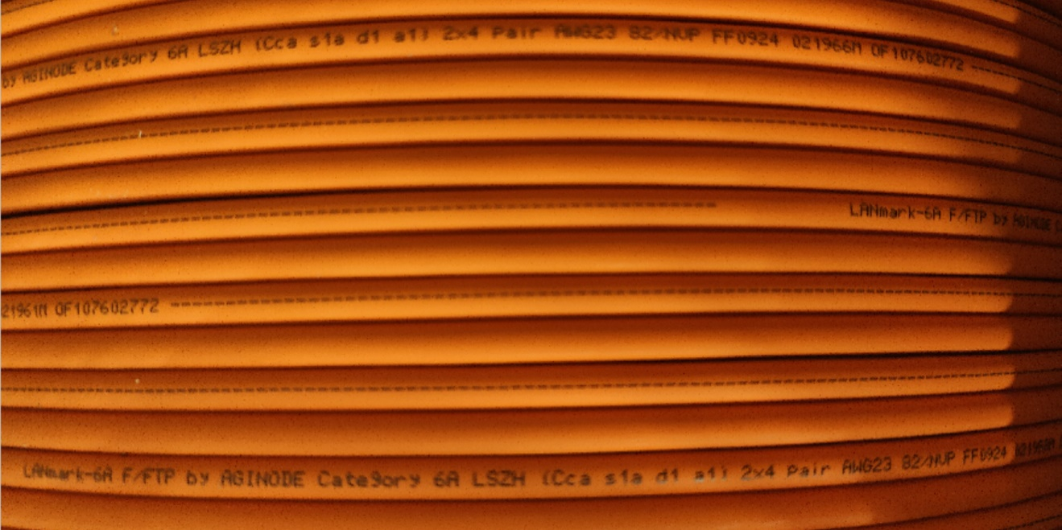

For each cable listed in this document and to be installed in the customer Data Centre and/or premises the Euroclass selected is clearly defined in the following pages according to the type of building, the level of occupation, the difficulty of evacuation, etc. as defined by the government of the country in which the cabling has to be installed (Requirements may vary from country to country).

All cables installed on this project, Copper, fibre and associated patch cords will be of Low
Smoke Zero Halogen construction complying with IEC 61034-1& 2 (smoke density test) and IEC 60754-2 (acidity and conductivity test). Plenum rated cables will not be installed.

Notes
Please select the appropriate Euroclass in every chapter when needed (Delete the wrong ones).

Fibre sub-system
The optical fibre backbone shall be capable of providing the bandwidth required by the use of a the FTTO applications.

OM3 bend insensitive (BIMMF) fibre sub-system
This Tender document covers the design, supply, installation, testing and commissioning of an OM3 BIMMF (Ben Insensitive Multimode Fibre) cabling sub-system.

The fibre systems shall be warranted to support any current or future application designed to be supported
by OM3 fibres according to IEC 60793-2-10 A1a.2b.
BIMMF fibres are designed to withstand tight bends with substantially less signal loss than traditional multimode fibre.

The cabling system is also open to new applications which require an OM3 cabling sub-system as defined in the latest editions of the standards: ISO/IEC 11801: 2017 or EN 50173:2018.

Effective modal bandwidth (EMB) of OM3 fibres shall be measured according to the templates method of IEC 60793-2-10 section D2 and the calculated effective modal bandwidth of IEC 60793-2-10 ed.4 section D3.

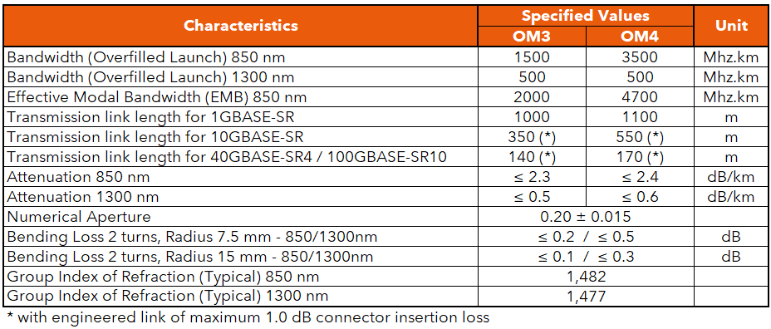

The data sheets and warranty modules showing the features and the guaranteed values compliant to the requirements of this RFP will be attached by the vendor to his tender documents.

All proposed components including the connectors, pigtails and patch cords have to be produced by the same manufacturer. This issue will ensure that the applications and the distance support Warranty as described in the Warranty chapter of this RFP can be obtained from the manufacturer.

Guaranteed distances

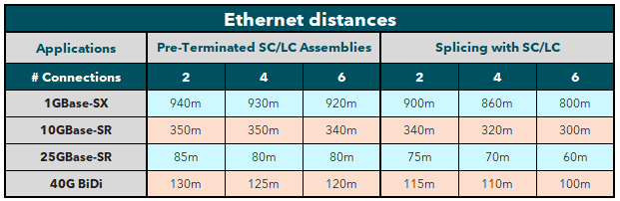
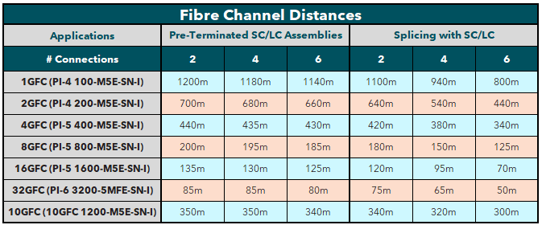

OM4 bend insensitive (BIMMF) fibre sub-system
This Tender document covers the design, supply, installation, testing and commissioning of an OM4 BIMMF (Ben Insensitive Multimode Fibre) cabling sub-system.

The fibre systems shall be warranted to support any current or future application designed to be supported
by OM4 fibres according to IEC 60793-2-10 A1a.3b.
BIMMF fibres are designed to withstand tight bends with substantially less signal loss than traditional multimode fibre.

The cabling system is also open to new applications which require an OM4 cabling sub-system as defined in the latest editions of the standards: ISO/IEC 11801: 2017 or EN 50173:2018.

Effective modal bandwidth (EMB) of OM4 fibres shall be measured according to the templates method of IEC 60793-2-10 section D4 and the calculated effective modal bandwidth of IEC 60793-2-10 de.4 section D5.

The data sheets and warranty modules showing the features and the guaranteed values compliant to the requirements of this RFP will be attached by the vendor to his tender documents.

All proposed components including the connectors, pigtails and patch cords have to be produced by the same manufacturer. This issue will ensure that the applications and the distance support Warranty as described in the Warranty chapter of this RFP can be obtained from the manufacturer.

Guaranteed distances
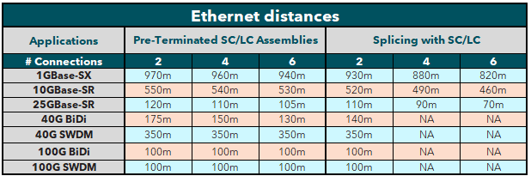
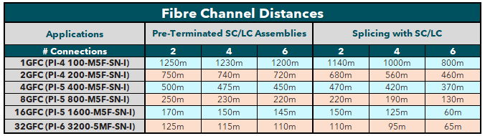

OS2 bend insensitive (BI) fibre sub-system
This Tender document covers the design, supply, installation, testing and commissioning of a BI OS2 cabling sub-system.

The fibre systems shall be warranted to support any current or future application designed to be supported
By Bend Insensitive Singlemode G657.A1 fibres.
The BI OS2 fibre shall be compliant to the IEC 60793-2-50 standard as fibre type B6.a1.
BI fibres are designed to withstand tight bends with substantially less signal loss than traditional singlemode fibre.

The cabling system is also open to new applications which require an OS2 cabling sub-system as defined in the latest editions of the standards: ISO/IEC 11801: 2017 or EN 50173:2018.

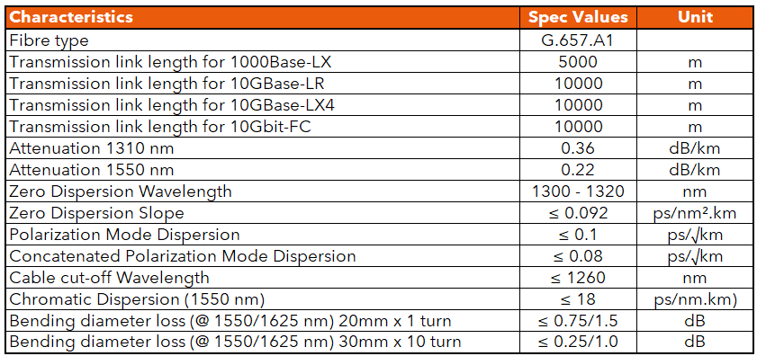

The data sheets and warranty modules showing the features and the guaranteed values compliant to the requirements of this RFP will be attached by the vendor to his tender documents.

All proposed components including the connectors, pigtails and patch cords have to be produced by the same manufacturer. This issue will ensure that the applications and the distance support Warranty as described in the Warranty chapter of this RFP can be obtained from the manufacturer.

Guaranteed distances
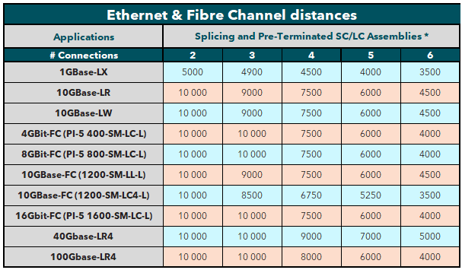

FTTO cabling design

FTTO concept

The Fibre To The Office concept combines the advantages of fibre with the requirements for flexibility, cost-efficiency and interoperability of modern enterprise networks.

The following advantages have been considered predominant and have led to the selection of a FTTO solution to build the cabling infrastructure for this project.

- Future-proof (Scalable, flexible, sustainable)
- Investment protection/life cycle
- Secure network
- Low maintenance cost/simple administration
- Low investment cost
- Quick and simple realisation
- Low energy consumption
- Simple and flexible network structure
- No need for floor distributors
- Low cable volume and fire loading
- Future-proof Fibre Optic Cabling with high bandwidth reserve
- No grounding or problematic earthing
- Simple redundancy up to the network outlet
- Low TCO (Total Cost of Ownership)

In fibre-based structured cabling, fibre is distributed to the workplace (connection point). By using fibre
optic lengths of 550 meters and more can be bridged, avoiding the need for floor distributors. At the workplace, the media conversion from copper to fibre occurs via intelligent Fibre To The Office (FTTO) FTTO switches, which are permanently installed in the trunking or in the floor box. Typically four and in special scenarios, depending on the FTTO switch, up to six terminal devices such as PCs, laptops, IP phones can be connected with full Gigabit Ethernet performance via the FTTO switch to one fibre port. The devices can also be supplied with Power over Ethernet (PoE) via the data ports of the FTTO switch.
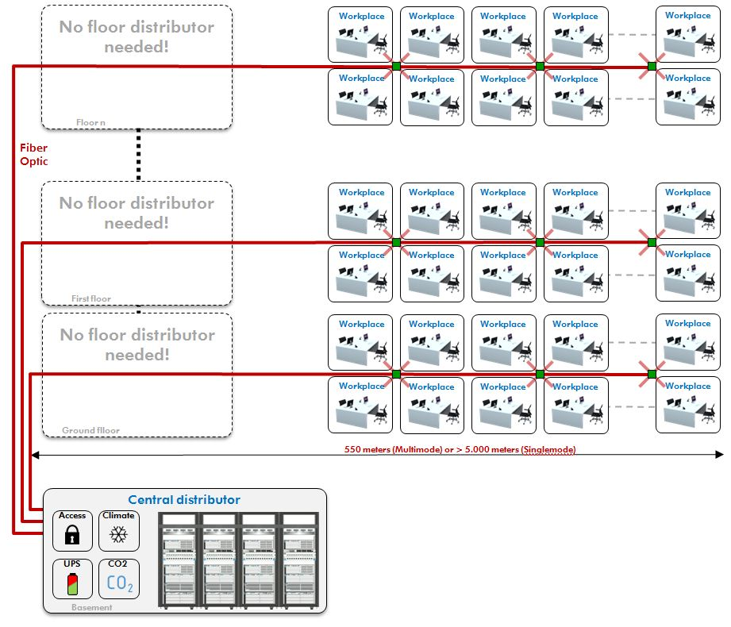

FTTO cabling topology

Star structure without redundancy

The star topology (Physical and logical star) has been selected to build the FTTO cabling system.
In star topology every node is connected to a central hub or switch with a point-to-point connection.

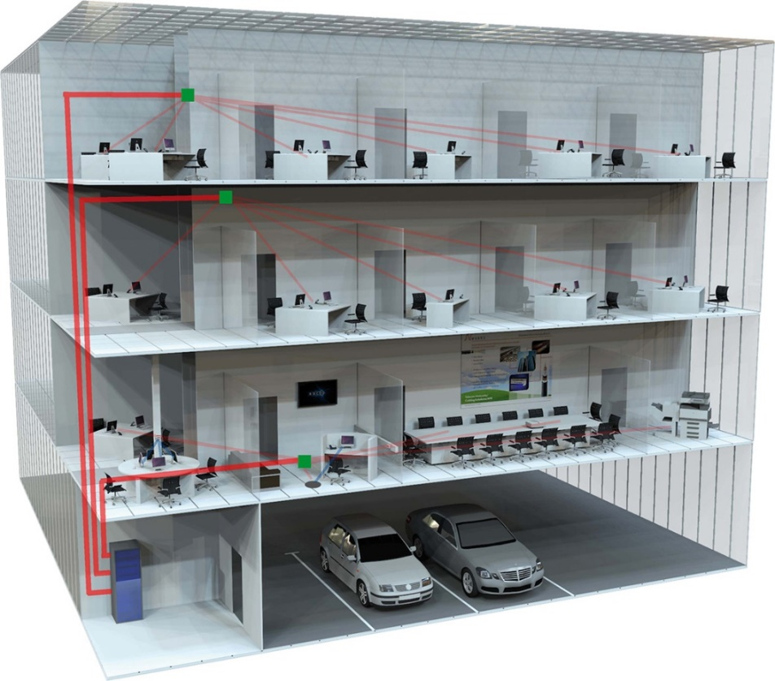

The 12 duplex LC ports of every Zone Distribution box (ZD box) will be directly connected to a patch panel installed in the Building Distributor (located in the main computer room (Data Centre) of the building) using a dedicated 24 core fibre cable.

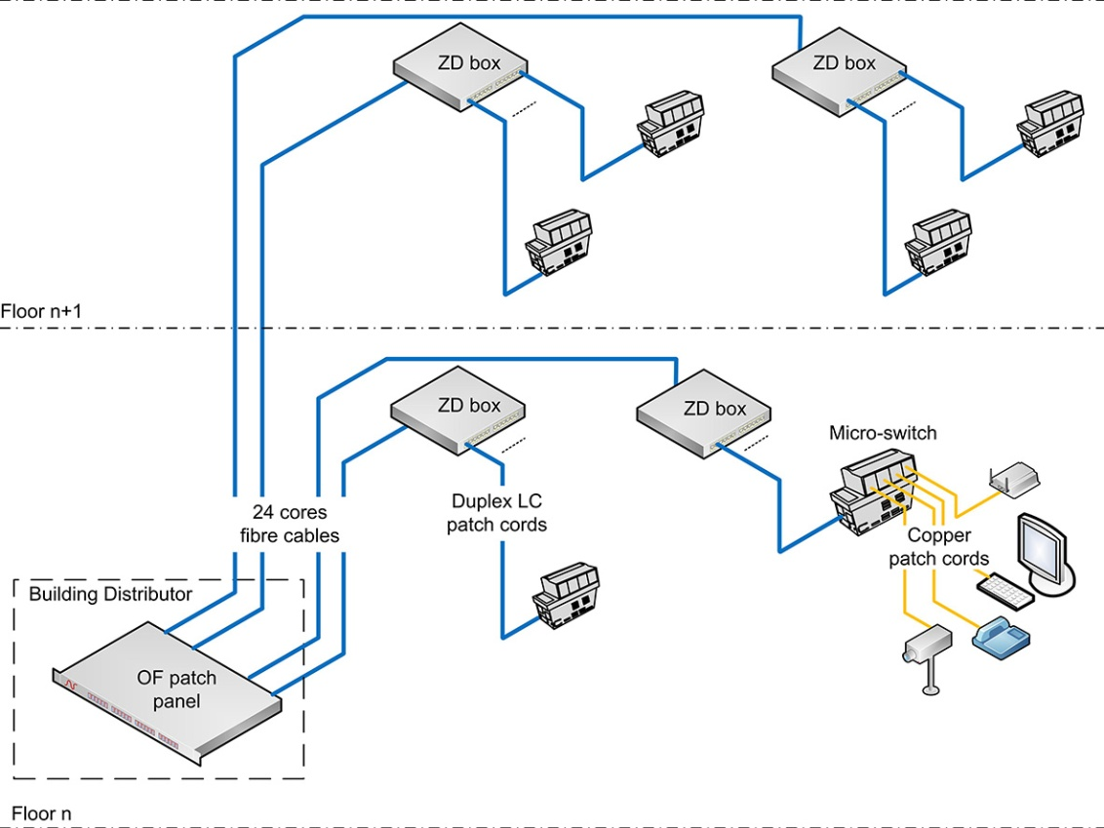

On day one a maximum of 9 FTTO switches can be connected to the ZD boxes ports using duplex LC patch cords. The three remaining duplex ports will be available for future expansions.

Four up to six RJ45 Ethernet network ports are available on every FTTO switch, each ZD box can serve up to 36 up to 54 workplaces on day one and 12 up to 18 additional workplaces can be added in the future (3 FTTO switches).

The number and the location of the ZD boxes have to be defined according to the design guidelines provided by the manufacturer of the FTTO switches.

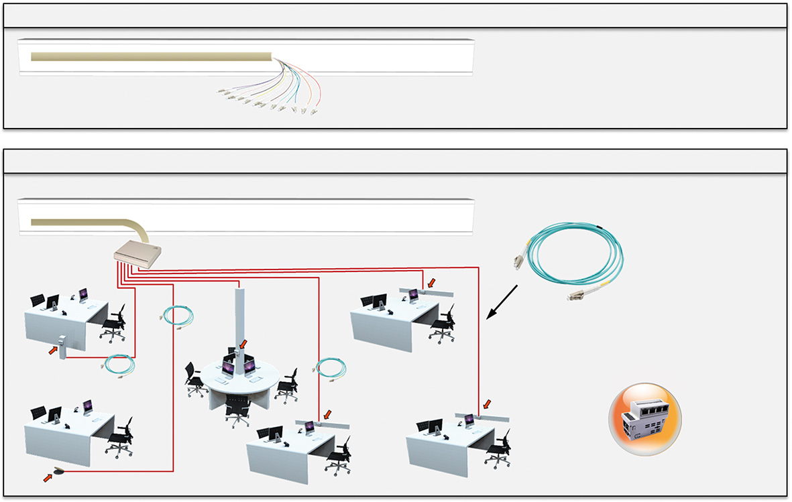

The number of ZD boxes is a function of the number of people to be served.
One or two RJ45 outlets can be needed for every workplace depending on voice and data convergence.
If two RJ45 outlets are needed for every workplace, one FTTO switch will serve two up to three workplaces and as every ZD box will be connected to 9 FTTO switches, the ZD box can serve 18 up to 27 workplaces on day one (with 3 duplex ports of the ZD box remaining free for future expansion).

Note: The workplace is the physical location where a single person works and interacts with telecommunications terminal equipment. As shown on the drawing several workplaces are usually included in an office space. Therefore we recommend to install at least one FTTO switch in every office area (Depending on the size of this office area).

Star structure with redundancy / 1 Building Distributor
The star topology (Physical and logical star) has been selected to build the FTTO cabling system.
In star topology every node is connected to a central hub or switch with a point-to-point connection.

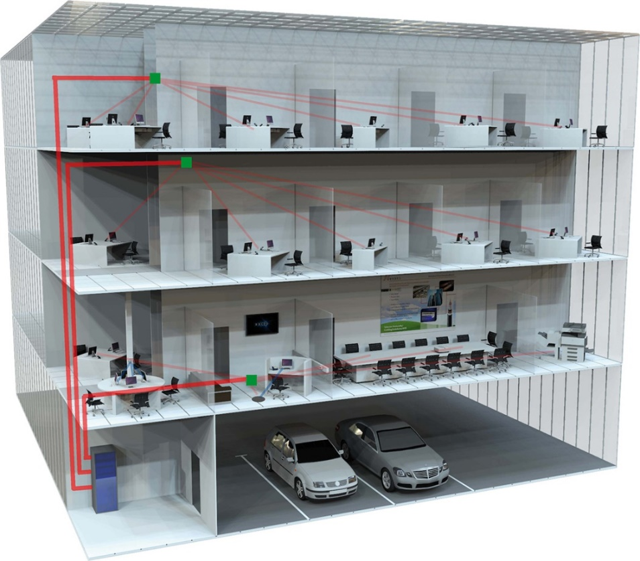

The 12 duplex LC ports of every Zone Distribution box (ZD box) will be directly connected to a patch panel installed in the Building Distributor (located in the main computer room (Data Centre) of the building) using a dedicated 24 core fibre cable.

On day one a maximum of 9 FTTO switches can be connected to the ZD boxes ports using duplex LC patch cords. The three remaining duplex ports will be available for future expansions.

Four RJ45 Ethernet network ports are available on every FTTO switch, each ZD box can serve up to 36 workplaces on day one and 12 additional workplaces can be added in the future (3 FTTO switches).

The number and the location of the ZD boxes have to be defined according to the design guidelines provided by the manufacturer of the FTTO switches.

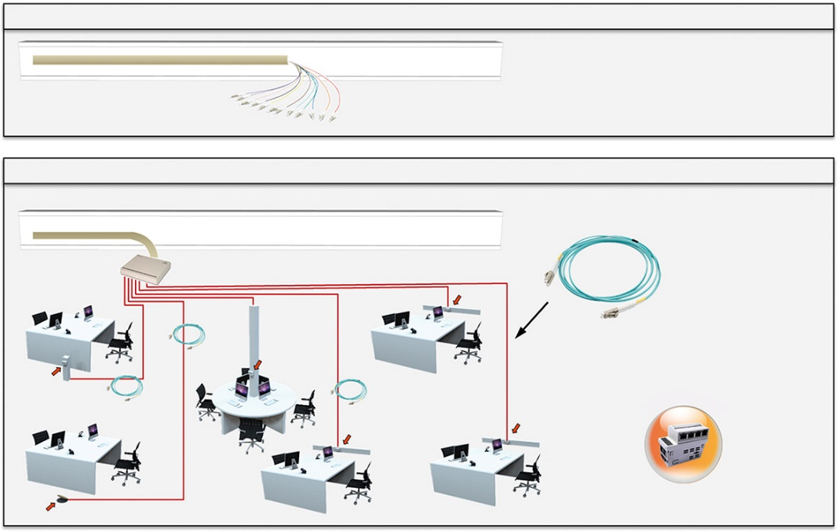

The number of ZD boxes is a function of the number of people to be served.
One or two RJ45 outlets can be needed for every workplace depending on voice and data convergence.
If two RJ45 outlets are needed for every workplace, one FTTO switch will serve two workplaces and as every ZD box will be connected to 9 FTTO switches, the ZD box can serve 18 workplaces on day one (with 3 duplex ports of the ZD box remaining free for future expansion).

Note: The workplace is the physical location where a single person works and interacts with telecommunications terminal equipment. As shown on the drawing several workplaces are usually included in an office space. Therefore we recommend to install at least one FTTO switch in every office area (Depending on the size of this office area).

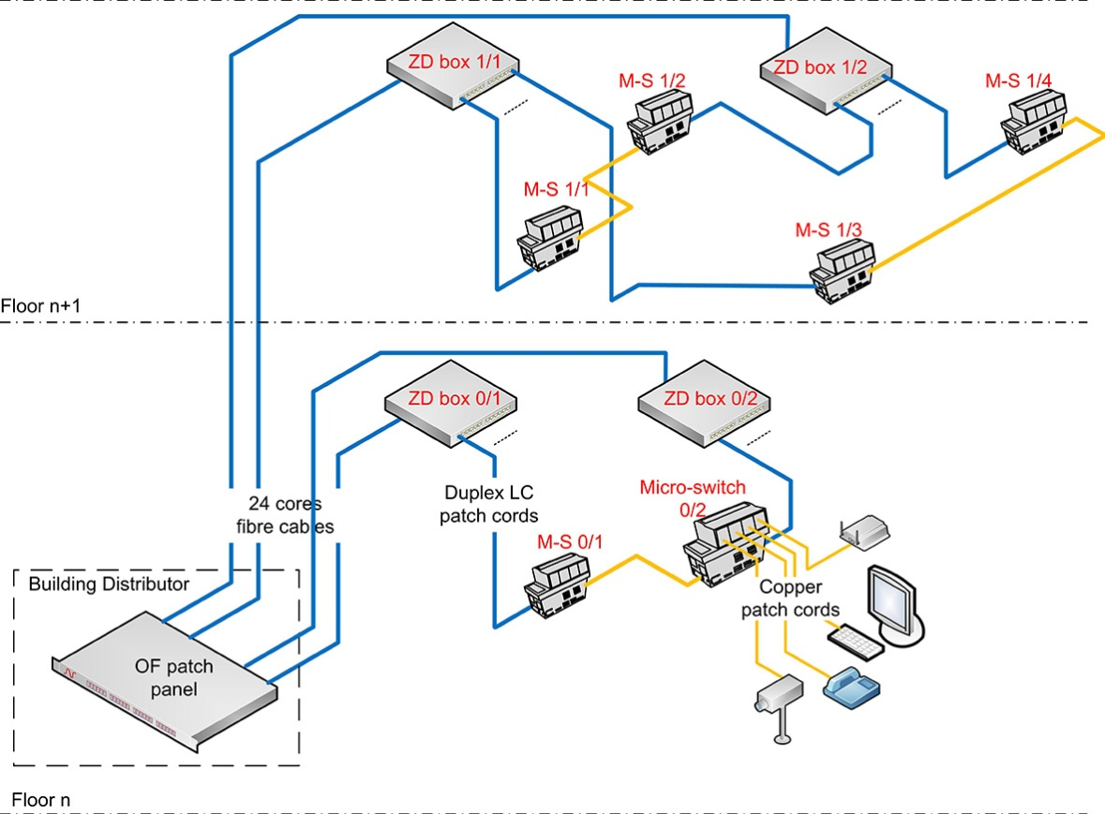

To provide redundancy the design will be created according to the following rules as shown on the drawing above:
- On every floor both the ZD boxes and the FTTO switches will be numbered from 1 to n according to their geographical location
- Every even numbered FTTO switch will be connected to an even numbered ZD box and every odd numbered FTTO switch will be connected to an odd numbered ZD box
- Every even numbered FTTO switch will be connected to the next odd numbered FTTO switch using an RJ45 patch cord

This configuration will allow every FTTO switch to be connected to the network through two different backbones OF cables: Direct fibre connection + indirect connection through the copper connection with the other FTTO switch that is connected to a different fibre cable.

Wherever possible the two OF cables serving the odd numbered and even numbered ZD boxes shall follow a different route back to the Building Distributor. If this is not possible on the backbone, the horizontal path should at least be diversely managed.

Star structure with redundancy / 2 Building Distributors
The star topology (Physical and logical star) has been selected to build the FTTO cabling system.
In star topology every node is connected to a central hub or switch with a point-to-point connection.

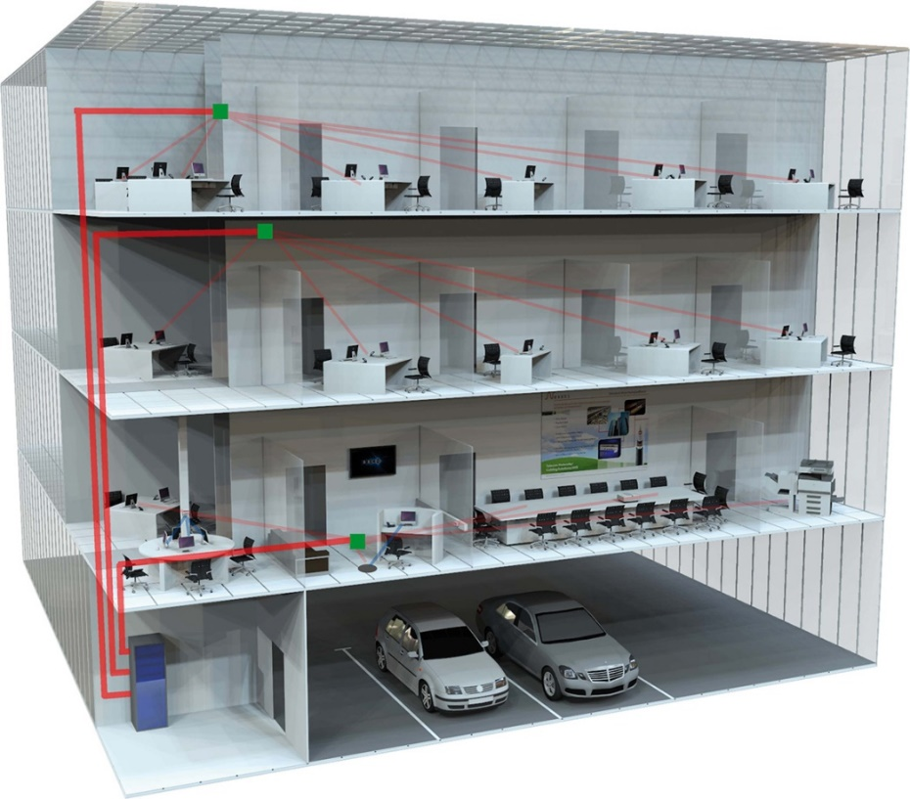

The 12 duplex LC ports of every Zone Distribution box (ZD box) will be directly connected to a patch panel installed in the Building Distributor (located in the main computer room (Data Centre) of the building) using a dedicated 24 core fibre cable.
On day one a maximum of 9 FTTO switches can be connected to the ZD boxes ports using duplex LC patch cords. The three remaining duplex ports will be available for future expansions.

Four RJ45 Ethernet network ports are available on every FTTO switch, each ZD box can serve up to 36 workplaces on day one and 12 additional workplaces can be added in the future (3 FTTO switches).

The number and the location of the ZD boxes have to be defined according to the design guidelines provided by the manufacturer of the FTTO switches.

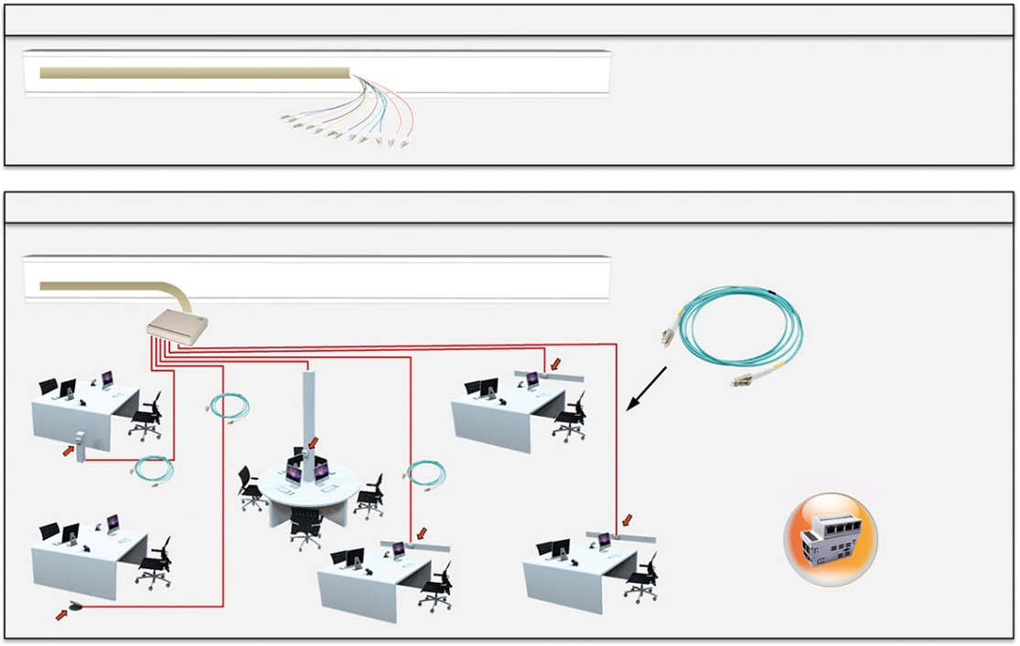

The number of ZD boxes is a function of the number of people to be served.
One or two RJ45 outlets can be needed for every workplace depending on voice and data convergence.
If two RJ45 outlets are needed for every workplace, one FTTO switch will serve two workplaces and as every ZD box will be connected to 9 FTTO switches, the ZD box can serve 18 workplaces on day one (with 3 duplex ports of the ZD box remaining free for future expansion).

Note: The workplace is the physical location where a single person works and interacts with telecommunications terminal equipment. As shown on the drawing several workplaces are usually included in an office space. Therefore we recommend to install at least one FTTO switch in every office area (Depending on the size of this office area).

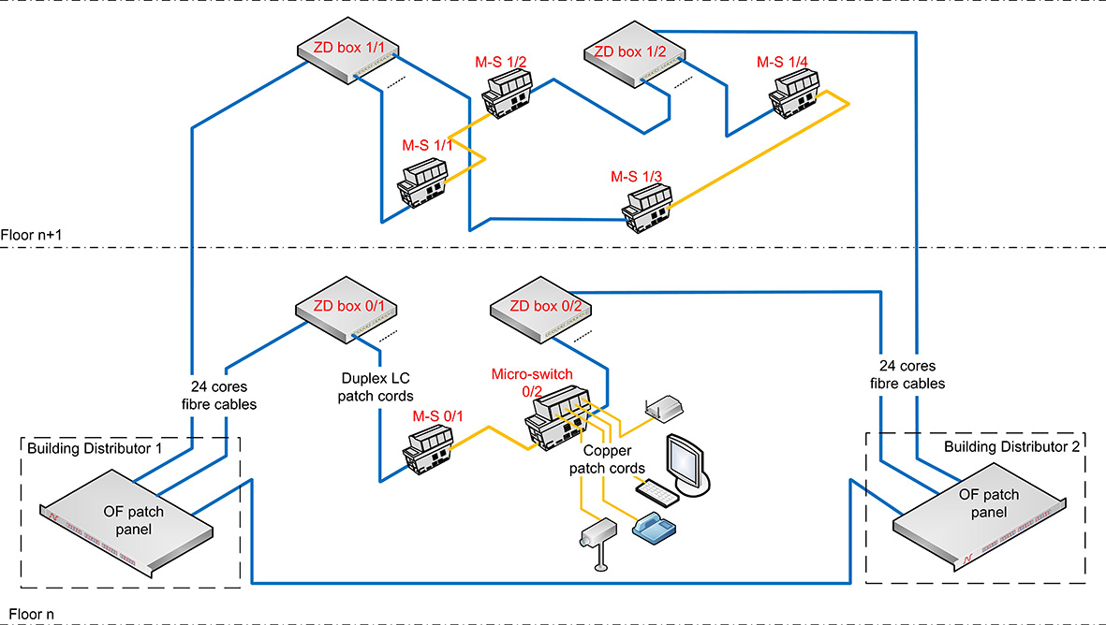

To provide redundancy the design will be created according to the following rules as shown on the drawing above:
- On every floor both the ZD boxes and the FTTO switches will be numbered from 1 to n according to their geographical location
- Every even numbered FTTO switch will be connected to an even numbered ZD box and every odd numbered FTTO switch will be connected to an odd numbered ZD box
- Every even numbered FTTO switch will be connected to the next odd numbered FTTO switch using an RJ45 patch cord
- Every even numbered ZD box will be connected to the Building Distributor 1 (BD1) and the odd numbered ones will be connected to the BD2
- The two BDs will be connected together with a 24 / 48 (Select the required number) core fibre cable

This configuration will allow every FTTO switch to be connected to both building distributors: Direct fibre connection + indirect connection through the copper connection with the other FTTO switch that is connected to the other BD.

Wherever possible the two OF cables serving the odd numbered and even numbered ZD boxes shall follow a different route back to the Building Distributor. If this is not possible on the backbone, the horizontal path should at least be diversely managed.

Physical Ring structure without redundancy
In order to reduce the cable pulling cost the physical ring topology has been selected to build the FTTO cabling system.
One or several high density fibre cables (up to 144 fibres) with extractable bundle technology will be installed in a loop trough the selected parts of the building.

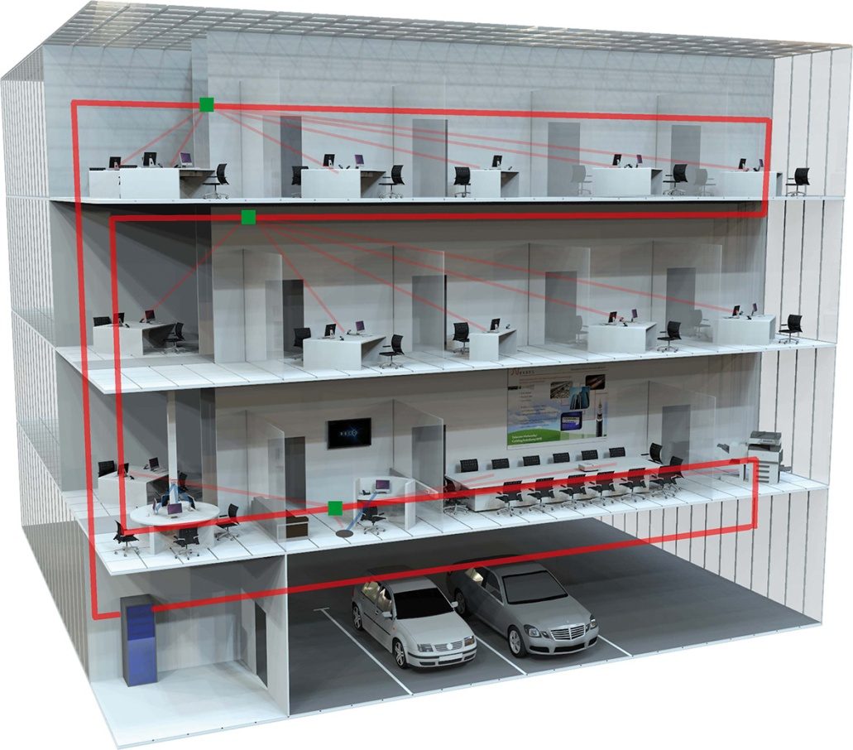

Both ends of the looped cable will be terminated in the Building Distributor located in the main computer room (Data Centre) of the building.
However, this physical ring structure will create a logical star topology.
In star topology every node is connected to a central hub or switch with a point-to-point connection.

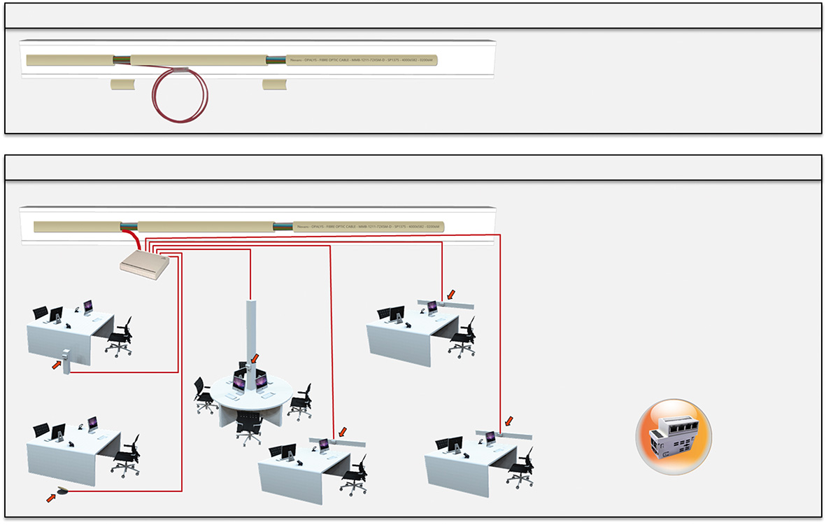

Zone Distribution boxes (ZD box) will be installed at predefined locations all along the cable. Depending on the number of users, one or two bundles of 12 fibres will be extracted from the cable and terminated in the ZD box providing a direct connection back to the Building Distributor.

The number and the location of the ZD boxes have to be defined according to the design guidelines provided by the manufacturer of the FTTO switches.

Pigtails will be spliced with the fibres of the extracted bundle and connected to 6 or 12 duplex LC ports (One or two bundle) of every zone distribution box (ZD box). Duplex LC patch cords will connect the uplink of the FTTO switches to the ports of the ZD boxes.
On day one a maximum of 80% of the LC ports should be connected to the FTTO switches. The remaining duplex ports will be available for future expansions.

There are four up to six RJ45 Ethernet network ports available on every FTTO switch. Each ZD box can serve up to 36 up to 54 workplaces on day one and 12 up to 18 additional workplaces can be added in the future (3 FTTO switches).

Up to 576 up to 864 workplaces (460 up to 690 workplaces on day one) can be connected using one loop of 144 fibre cable.
A 144 fibre cable provides a capacity of 288 fibres (144x forward loop & 144x return loop) giving a maximum of 144 switch connections (2 fibres per switch connection), which in turn provides 576 up to 864 RJ45 ports (144x4/144x6).

12 ZD Boxes equipped with 6 duplex OF ports (or 6 ZD boxes of 12 ports) on forward loop and 12 more ZD Boxes with 6 ports (or 6 ZD boxes of 12 ports) on return loop can be available throughout the building.

The number of ZD boxes is a function of the number of people to be served.
One or two RJ45 outlets can be needed for every workplace depending on voice and data convergence.
If two RJ45 outlets are needed for every workplace, one FTTO switch will serve two up to three workplaces and as every ZD box will be connected to 9 FTTO switches, the ZD box can serve 18 up to 27 workplaces on day one (with 3 duplex ports of the ZD box remaining free for future expansion).

Note: The workplace is the physical location where a single person works and interacts with telecommunications terminal equipment. As shown on the drawing several workplaces are usually included in an office space. Therefore we recommend to install at least one FTTO switch in every office area (Depending on the size of this office area).

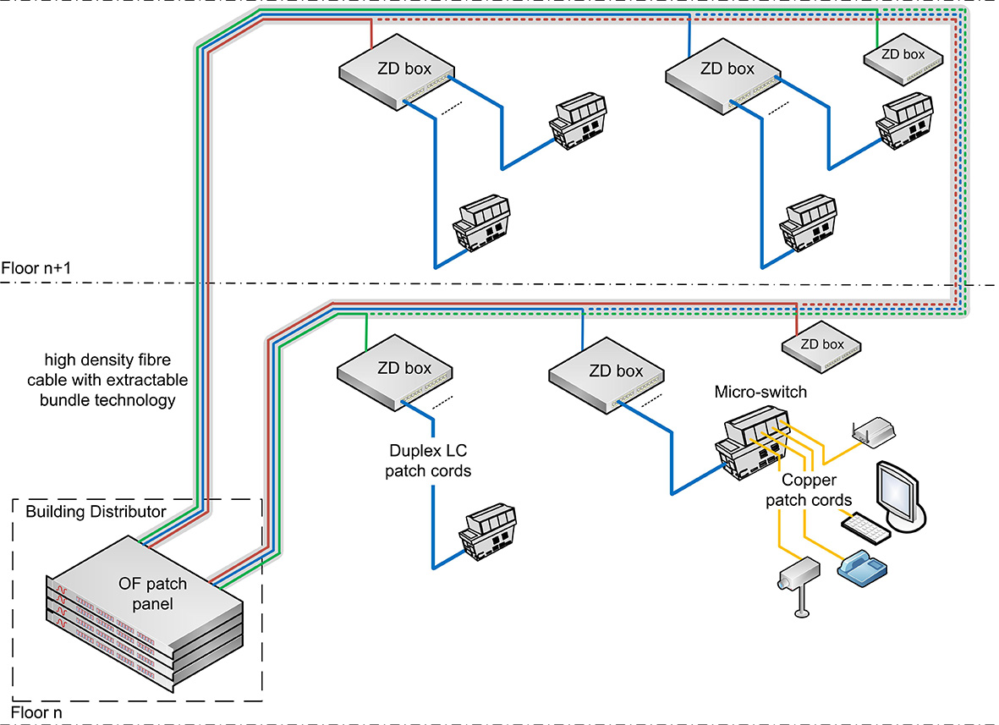

Physical Ring structure with redundancy / 1 Building Distributor
In order to reduce the cable pulling cost the physical ring topology has been selected to build the FTTO cabling system.
One or several high density fibre cables (up to 144 fibres) with extractable bundle technology will be installed in a loop trough the selected parts of the building.

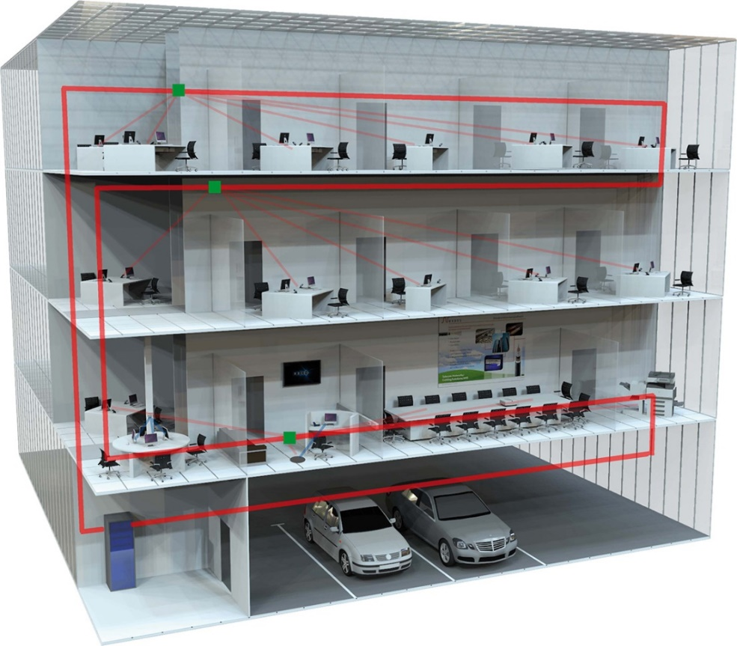

Both ends of the looped cable will be terminated in the Building Distributor located in the main computer room (Data Centre) of the building.
However, this physical ring structure will create a logical star topology.
In star topology every node is connected to a central hub or switch with a point-to-point connection.

Zone Distribution boxes (ZD box) will be installed at predefined locations all along the cable. Depending on the number of users, one or two bundles of 12 fibres will be extracted from the cable and terminated in the ZD box providing a direct connection back to the Building Distributor.

The number and the location of the ZD boxes have to be defined according to the design guidelines provided by the manufacturer of the FTTO switches.

Pigtails will be spliced with the fibres of the extracted bundle and connected to 6 or 12 duplex LC ports (One or two bundle) of every zone distribution box (ZD box). Duplex LC patch cords will connect the uplink of the FTTO switches to the ports of the ZD boxes.
On day one a maximum of 80% of the LC ports should be connected to the FTTO switches. The remaining duplex ports will be available for future expansions.

There are four RJ45 Ethernet network ports available on every FTTO switch. Each ZD box can serve up to 36 workplaces on day one and 12 additional workplaces can be added in the future (3 FTTO switches).

Up to 576 workplaces (460 workplaces on day one) can be connected using one loop of 144 fibre cable.
A 144 fibre cable provides a capacity of 288 fibres (144x forward loop & 144x return loop) giving a maximum of 144 switch connections (2 fibres per switch connection), which in turn provides 576 RJ45 ports (144x4).

12 ZD Boxes equipped with 6 duplex OF ports (or 6 ZD boxes of 12 ports) on forward loop and 12 more ZD Boxes with 6 ports (or 6 ZD boxes of 12 ports) on return loop can be available throughout the building.

The number of ZD boxes is a function of the number of people to be served.
One or two RJ45 outlets can be needed for every workplace depending on voice and data convergence.
If two RJ45 outlets are needed for every workplace, one FTTO switch will serve two workplaces and as every ZD box will be connected to 9 FTTO switches, the ZD box can serve 18 workplaces on day one (with 3 duplex ports of the ZD box remaining free for future expansion).

Note: The workplace is the physical location where a single person works and interacts with telecommunications terminal equipment. As shown on the drawing several workplaces are usually included in an office space. Therefore we recommend to install at least one FTTO switch in every office area (Depending on the size of this office area).

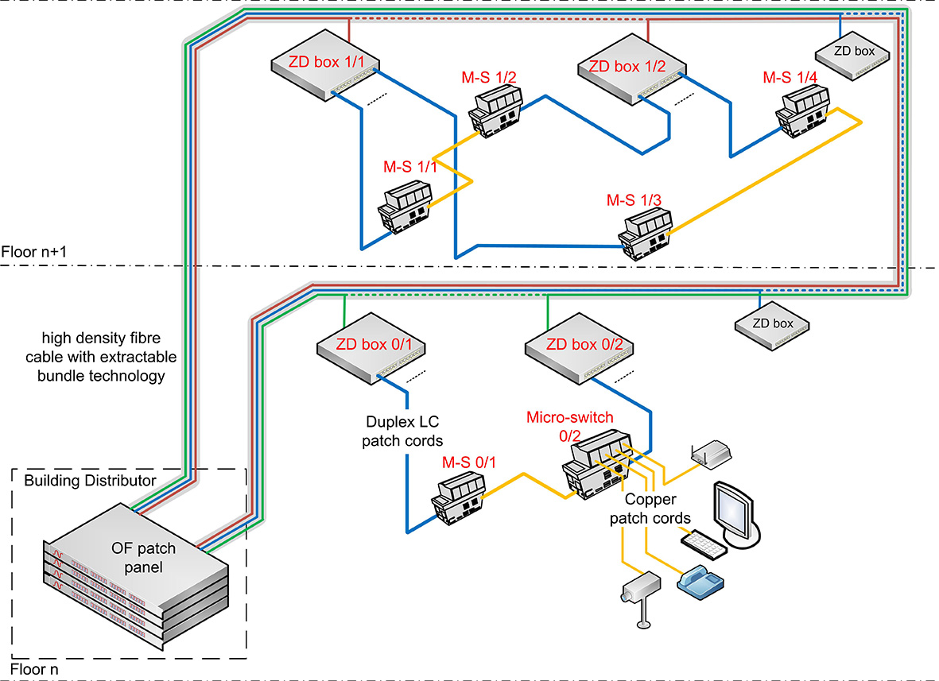

To provide redundancy the design will be created according to the following rules as shown on the drawing above:
- On every floor both the ZD boxes and the FTTO switches will be numbered from 1 to n according to their geographical location
- Every even numbered FTTO switch will be connected to an even numbered ZD box and every odd numbered FTTO switch will be connected to an odd numbered ZD box
- Every even numbered FTTO switch will be connected to the next odd numbered FTTO switch using an RJ45 patch cord
- Two consecutive ZD boxes will be connected to the same bundle. The even numbered ZD box will be connected to the forward loop and the odd numbered ZD box will be connected to the return loop.

This configuration will allow every FTTO switch to be connected to the network through both forward and return loops of the cable: Direct fibre connection + indirect connection through the copper connection with the other FTTO switch that is connected to the return loop.

Wherever possible the two ends of the OF cable loop shall follow a different route back to the Building Distributor.

Physical Ring structure with redundancy / 2 Building Distributors

In order to reduce the cable pulling cost the physical ring topology has been selected to build the FTTO cabling system.
One or several high density fibre cables (up to 144 fibres) with extractable bundle technology will be installed in a loop trough the selected parts of the building.

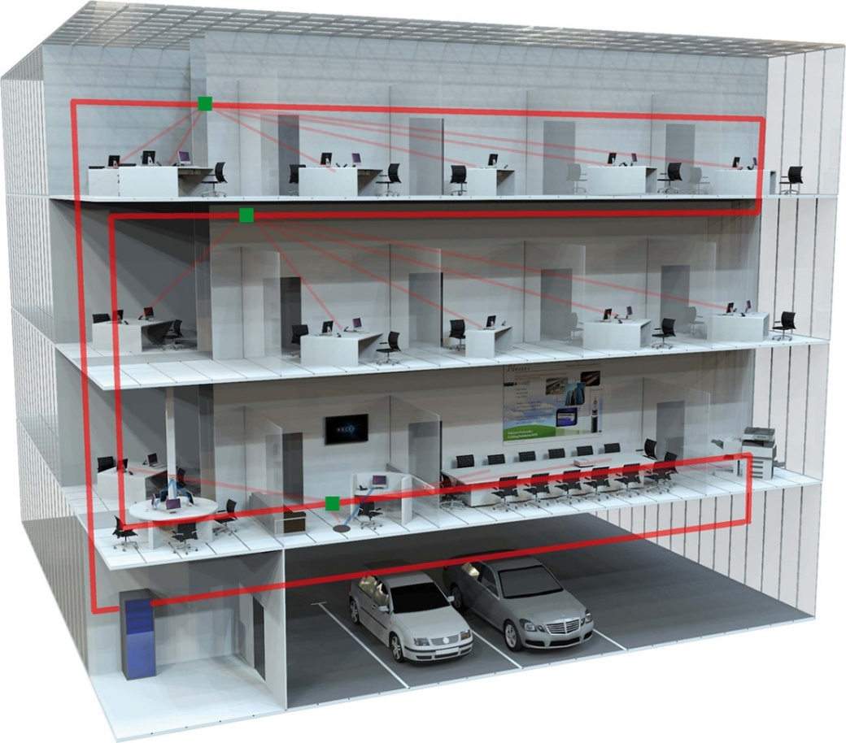

Both ends of the looped cable can be terminated in a Building Distributor (BD) located in the main computer room (Data Centre) of the building. But for this project two Building Distributors will be created to provide redundancy and each end of the cable will be terminated in a different BD (BD & or BD 2) - see 3D drawing on next page.
However, this physical ring structure will create a logical star topology.
In star topology every node is connected to a central hub or switch with a point-to-point connection.

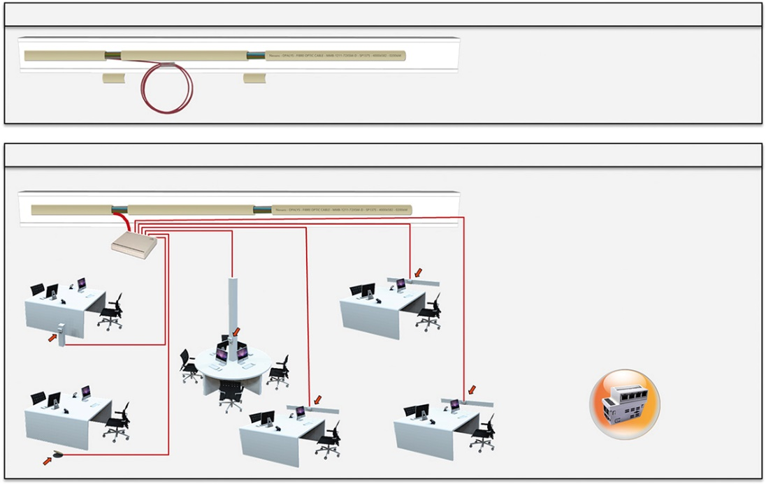

Zone Distribution boxes (ZD box) will be installed at predefined locations all along the cable. Depending on the number of users, one or two bundles of 12 fibres will be extracted from the cable and terminated in the ZD box providing a direct connection back to the Building Distributor.

The number and the location of the ZD boxes have to be defined according to the design guidelines provided by the manufacturer of the FTTO switches.

Pigtails will be spliced with the fibres of the extracted bundle and connected to 6 or 12 duplex LC ports (One or two bundle) of every zone distribution box (ZD box). Duplex LC patch cords will connect the uplink of the FTTO switches to the ports of the ZD boxes.
On day one a maximum of 80% of the LC ports should be connected to the FTTO switches. The remaining duplex ports will be available for future expansions.

There are four RJ45 Ethernet network ports available on every FTTO switch. Each ZD box can serve up to 36 workplaces on day one and 12 additional workplaces can be added in the future (3 FTTO switches).

Up to 576 workplaces (460 workplaces on day one) can be connected using one loop of 144 fibre cable.
A 144 fibre cable provides a capacity of 288 fibres (144x forward loop & 144x return loop) giving a maximum of 144 switch connections (2 fibres per switch connection), which in turn provides 576 RJ45 ports (144x4).

12 ZD Boxes equipped with 6 duplex OF ports (or 6 ZD boxes of 12 ports) on forward loop and 12 more ZD Boxes with 6 ports (or 6 ZD boxes of 12 ports) on return loop can be available throughout the building.

The number of ZD boxes is a function of the number of people to be served.
One or two RJ45 outlets can be needed for every workplace depending on voice and data convergence.
If two RJ45 outlets are needed for every workplace, one FTTO switch will serve two workplaces and as every ZD box will be connected to 9 FTTO switches, the ZD box can serve 18 workplaces on day one (with 3 duplex ports of the ZD box remaining free for future expansion).

Note: The workplace is the physical location where a single person works and interacts with telecommunications terminal equipment. As shown on the drawing several workplaces are usually included in an office space. Therefore we recommend to install at least one FTTO switch in every office area (Depending on the size of this office area).

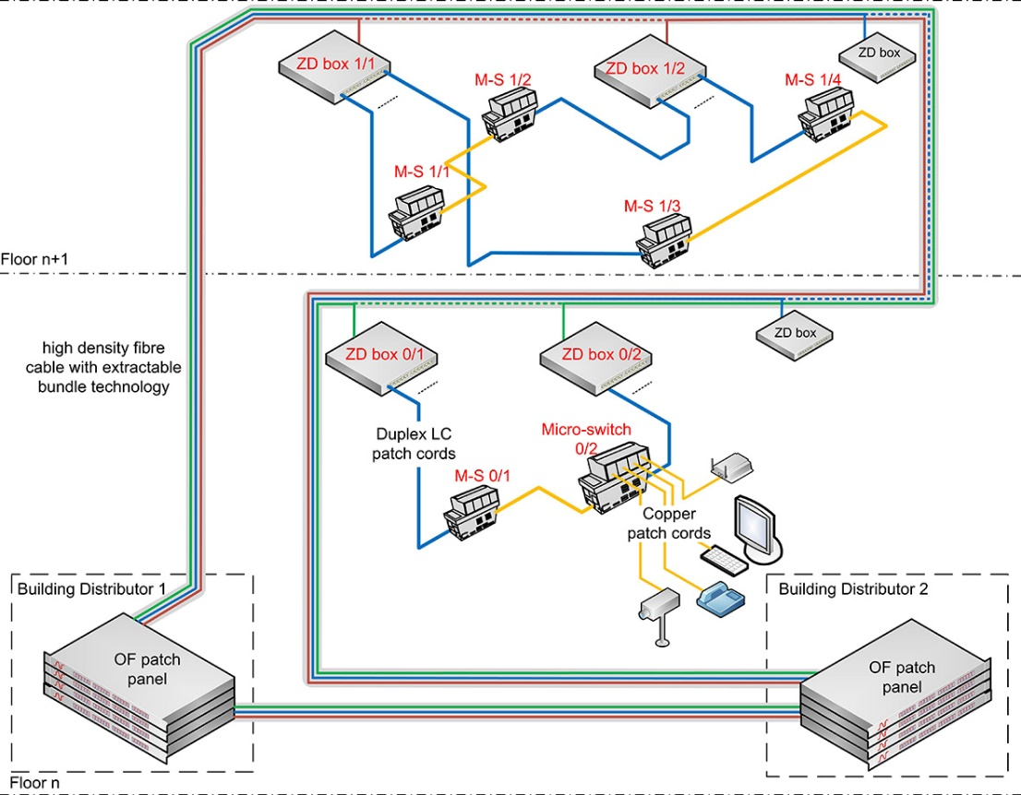

To provide redundancy the design will be created according to the following rules as shown on the drawing above:
- On every floor both the ZD boxes and the FTTO switches will be numbered from 1 to n according to their geographical location
- Every even numbered FTTO switch will be connected to an even numbered ZD box and every odd numbered FTTO switch will be connected to an odd numbered ZD box
- Every even numbered FTTO switch will be connected to the next odd numbered FTTO switch using an RJ45 cord
- Two consecutive ZD boxes will be connected to the same bundle. The even numbered ZD box will be connected to the forward loop and the odd numbered ZD box will be connected to the return loop.
- Every even numbered ZD box will be connected to the Building Distributor 1 (BD1) and the odd numbered ones will be connected to the BD2
- The two BDs will be connected together with a 24 / 48 / 96/ another 144 (Select the required number) core fibre cable

This configuration will allow every FTTO switch to be connected to the network through both forward and return loops of the cable: Direct fibre connection + indirect connection through the copper connection with the other FTTO switch that is connected to the return loop.

Wherever possible the two ends of the OF cable loop shall follow a different route back to the Building Distributor.

FTTO cabling technology

Conventional cable terminated on site (Star topology)
The conventional cable termination on site has been selected to build the cabling system.
LC Pigtails will be spliced on-site on both ends of the cables in the zone distribution boxes located all around the building and in the patch panels located in the building distributor(s)

Pre-terminated cable (Star topology)
In order to reduce the installation time it has been decided to only allow the use of pre-terminated fibre cables to build the cabling system.
LC terminated fibre assemblies will be installed between patch panels located in the building distributor(s) and the zone distribution boxes located all around the building.

Extractable bundle (Ring topology)

One or two bundles of 12 fibres have to be extracted from the cable and be terminated in a Zone Distribution (ZD) box.
First of all the jacket of the cable has to be opened and a piece of a 5 centimetres removed a few metres away from the ZD box or in between two ZD boxes if the same bundle will be terminated in two consecutive boxes.
A specific tool available from the cabling system manufacturer shall be used to perform this task to ensure that the bundles and the fibres will not be affected by this process (See picture below).
The bundle(s) to be terminated in the ZD box(es) will then be cut.

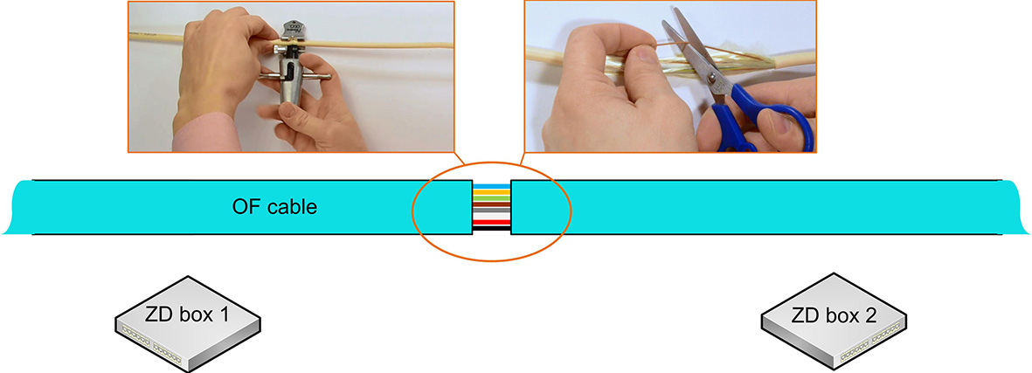

Using the same specific tool the cable jacket will also need to be opened at the location where the ZD box will be installed.
A piece of the jacket having the length needed to fully expose the bundle inside the ZD box has to be removed.
The appropriate bundle(s) will be extracted of the cable.
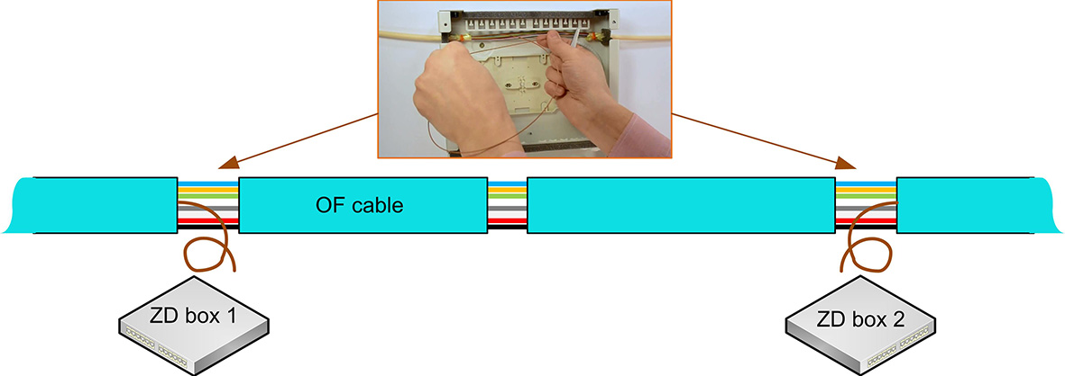

The fibres will then be spliced on LC pigtails and these will be connected to the LC couplers in the ZD box.

Patch cords will be connected between the ZD box and the FTTO switches.

The exposed bundles located between the two ZD boxes will be covered with a cable protection box available from the cabling manufacturer (See picture below).
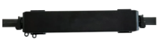
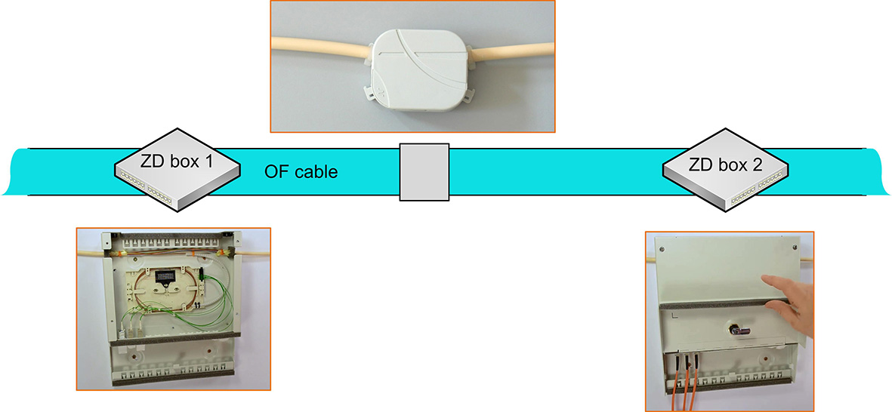

The cabling manufacturer has to provide a complete and detailed installation guide of the ZD box .

Optical Fibre Cabling infrastructure

Fibre distribution cable
This chapter has to be deleted if pre-terminated cables are selected – See next chapter

This chapter is only need needed for
- Physical Star topologies using cables terminated on site
- Physical Ring topologies

Paste here the required cable structure from the FTTO sub-system module.

Star topology only: choice between the two following structures:
- Tight Buffer
- Loose tube universal OF cables

Ring topology cable structure: the Micro-bundle Universal cable must be selected

Tight Buffered Universal OF cable
This optical fibre cable shall be used for indoor home run back to patch panel routes in risers, horizontal applications and for outdoor duct applications where ducts can be temporarily flooded. This cable shall be selected where the required fibre count is from 6 to 24.
The cable shall be suitable for connector manufacturer field termination processes (SC or LC connectors) and for OF pigtails splicing.
The cable shall be a dry construction i.e. with no gel content. The jacket material shall be waterproof and UV resistant LSZH.
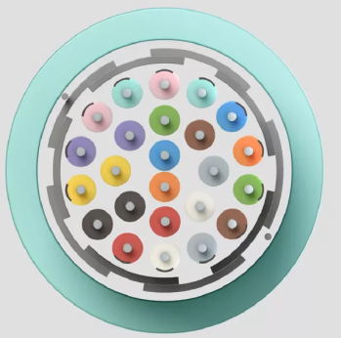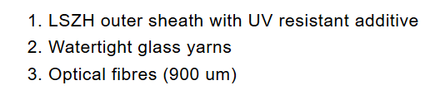

The Tight Buffer Universal cable is a fibre cable that can be used indoor and outdoor in a duct.
It complies with the indoor fire requirements and can be installed indoor both vertically and horizontally.
The Tight Buffer Universal can also be used for outdoor installation in a duct: the watertight glass yarns make the cables fully waterproof and rodent retardant.
The Tight Buffer Universal cable has 900 um buffered fibres. This second 900 um coating provides additional protection of the fibres and facilitates the handling when terminating the fibres in a patch panel. The easy strip tight buffer design allows stripping the fibre over 10 cm in one action.
The cable is most suitable for direct termination by either anaerobic or hot melt connectors. The tight buffered fibres can also be terminated with splicing of pigtails.

Construction characteristics
Fibre optic type OM3 50/125, OM4 50/125 or OS2 9/125

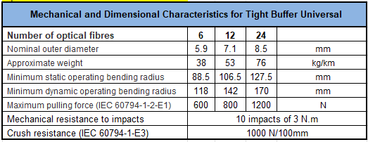
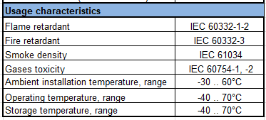

CPR grade compliance requirement (Cca s1,d1,a1)
The CPR regulations came into force in July 2016 and with effect from the 1st July 2017, cable jacket
materials must be of the appropriate Construction Product Regulations Class to meet the
requirements of EN 50399 and EN 50575 2014/A:2016 standards. In particular the cables proposed for this project must conform with EN50575 for certification and labelling.
The proposed cables must meet Class Cca s1,d1,a1 and the bidder must provide a statement from the chosen manufacturer detailing their 3rd party verification of their product and its classification.

Detailed product information (CPR grade Cca s1,d1,a1)

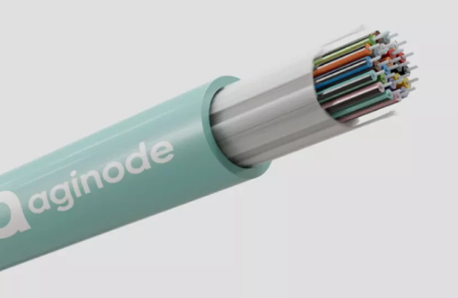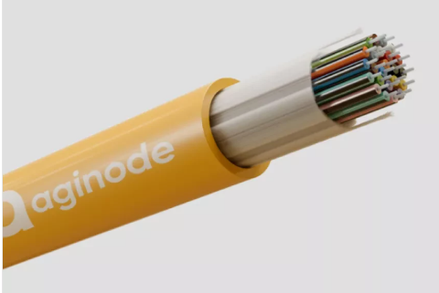
Example of product
LANmark-OF Tight Buffer Universal 12x Multimode 50/125 OM3 LSZH Cca Aqua
Aginode reference: N165.TBUN12-AC
LANmark-OF Tight Buffer Universal 24x Multimode 50/125 OM3 LSZH Cca Aqua
Aginode reference: N165.TBUN24-AC
LANmark-OF Tight Buffer Universal 12x Multimode 50/125 OM4 LSZH Cca Aqua
Aginode reference: N167.TBUN12-VC
LANmark-OF Tight Buffer Universal 24x Multimode 50/125 OM4 LSZH Cca Aqua
Aginode reference: N167.TBUN24-VC
LANmark-OF Tight Buffer Universal 12x Singlemode 9/125 OS2 LSZH Cca Yellow
Aginode reference: N164.TBUN12-YC
LANmark-OF Tight Buffer Universal 24x Singlemode 9/125 OS2 LSZH Cca Yellow
Aginode reference: N164.TBUN24-YC

Loose Tube Universal OF cable (6 – 12 – 24 FO)

The Loose Tube technology shall be specifically engineered for both indoor building and outdoor environments where high performance and fire safety are essential. Designed with a loose tube construction, it provides excellent protection for fibres against mechanical stress and environmental factors.

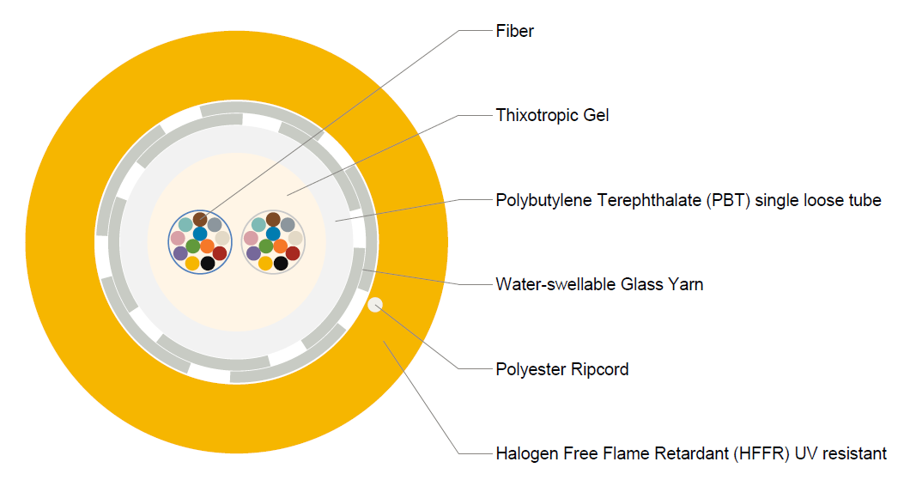

The cable shall be:
- Loose Tube Gel-Filled Design providing excellent protection against mechanical stress, water ingress, and temperature variations
- Designed for Indoor & Outdoor Application such as structured cabling in residential, commercial, and public buildings, as well as outdoor environments
- High Performance: Reliable, high-speed data transmission over long distances.
- Flexible and Robust: Easy to install in ducts, conduits, and technical spaces.
- UV-Resistant & Waterproof: Designed to withstand outdoor conditions when required.

The central tube contains up till 24 fibres with up to 2 bundles of 12 fibres well identified to make installation easy and simple.

Construction characteristics
Fibre optic type OM3 50/125, OM4 50/125 and OS2 9/125

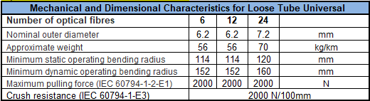

CPR grade compliance requirement (Cca s2,d1,a1)
The CPR regulations came into force in July 2016 and with effect from the 1st July 2017, cable jacket
materials must be of the appropriate Construction Product Regulations Class to meet the
requirements of EN 50399 and EN 50575 2014/A:2016 standards. In particular the cables proposed for this project must conform with EN50575 for certification and labelling.
The proposed cables must meet Class Cca s2,d1,a1 and the bidder must provide a statement from the chosen manufacturer detailing their 3rd party verification of their product and its classification.

Detailed product information (CPR grade Cca s2,d1,a1)
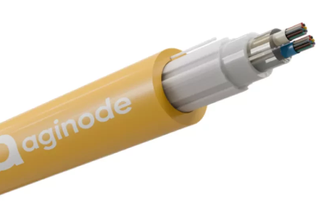

Example of product
LANmark-OF Loose Tube Universal 12xMultimode 50/125 OM3 LSZH Cca Aqua
Aginode reference: N165.LTUN12-AC
LANmark-OF Loose Tube Universal 12xMultimode 50/125 OM4 LSZH Cca Violet
Aginode reference: N167.LTUN12-VC
LANmark-OF Loose Tube Universal 12xSinglemode 9/125 OS2 LSZH Cca Yellow
Aginode reference: 164.LTUN12-YC
LANmark-OF Loose Tube Universal 24xMultimode 50/125 OM3 LSZH Cca Aqua
Aginode reference: N165.LTUN24-AC
LANmark-OF Loose Tube Universal 24xMultimode 50/125 OM4 LSZH Cca Violet
Aginode reference: N167.LTUN24-VC
LANmark-OF Loose Tube Universal 24xSinglemode 9/125 OS2 LSZH Cca Yellow
Aginode reference: N164.LTUN24-YC

Loose Tube Universal OF cable (48 - 72 - 96 - 144 F0)

The Loose Tube technology is specifically engineered for indoor buildings & outdoor where installations require both high performance and fire safety. Designed with a loose tube construction, the cable shall offer excellent protection for fibres against mechanical stresses and environmental factors.

Characteristics of the cable:

- Loose Tube Construction: Excellent fiber protection against mechanical stress and temperature variations.
- Indoor & Outdoor Versatility: Ideal for structured cabling in residential, commercial, and public buildings, with environmental resistance for exposed sections.
- High Performance: Reliable, high-speed data transmission over long distances.
- Flexible and Robust
- UV-Resistant & Waterproof: Built to withstand challenging installation conditions when necessary.
- The central tube contains up to 144 fibers organized in bundles of 12 fibers, each clearly identified to simplify installation.

Applications:
- Building backbone networks
- Data centers
- Outdoor installations


Construction characteristics
Fibre optic type OM3 50/125, OM4 50/125 or OS2 9/125

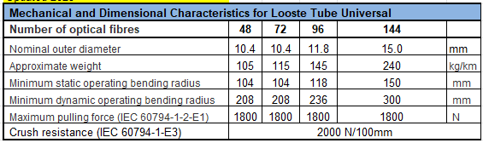
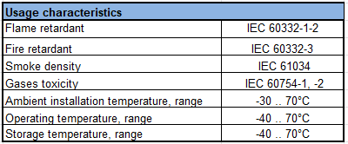

CPR grade compliance requirement (Cca s1a, d1, a1)
The CPR regulations came into force in July 2016 and with effect from the 1st July 2017, cable jacket
materials must be of the appropriate Construction Product Regulations Class to meet the
requirements of EN 50399 and EN 50575 2014/A:2016 standards. In particular the cables proposed for this project must conform with EN50575 for certification and labelling.
The proposed cables must meet Class Cca s1a, d1, a1 and the bidder must provide a statement from the chosen manufacturer detailing their 3rd party verification of their product and its classification.

Detailed product information (CPR grade Cca s2,d1,a1)

Example of product
LANmark-OF Loose Tube Universal 48xSinglemode 9/125 OS2 LSZH Cca Yellow
Aginode reference: N164.LTUN48-YC
LANmark-OF Loose Tube Universal 48xMultimode 50/125 OM4 LSZH Cca Violet
Aginode reference: N167.LTUN48-VC
LANmark-OF Loose Tube Universal 48xMultimode 50/125 OM3 LSZH Cca Aqua
Aginode reference: N165.LTUN48-AC
LANmark-OF Loose Tube Universal 96xSinglemode 9/125 OS2 LSZH Cca Yellow
Aginode reference: N164.LTUN96-YC
LANmark-OF Loose Tube Universal 96xMultimode 50/125 OM4 LSZH Cca Violet
Aginode reference: N167.LTUN96-VC
LANmark-OF Loose Tube Universal 96xMultimode 50/125 OM3 LSZH Cca Aqua
Aginode reference: N165.LTUN96-AC

Micro-bundle Universal OF cable (48 - 96 - 144 FO)
THIS CABLE IS ONLY AVAILABLE WITH OS2 FIBRES
The micro-bundle Universal cable is designed for indoor and outdoor installations, compatible with duct installation. It is optimized for both horizontal and vertical indoor applications thanks to its strict fire performance rating.

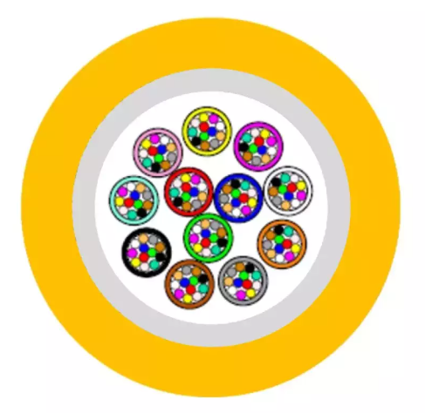

Key features:

- All-dielectric design, eliminating any conductive materials.
- The micro-bundles are extractable.
- Jelly-filled micro-modules, each containing 12 fibres, offering excellent fibre protection and easy identification.
- Waterproof structure with dry water-swellable glass yarns for optimal water blocking.
- Rodent resistance and UV resistance, ensuring high durability in outdoor environments.
- Flame retardant according to IEC 60332-1 and fire retardant according to IEC 60332-3, meeting strict indoor safety requirements.

Construction characteristics
Fibre optic type OS2 9/125

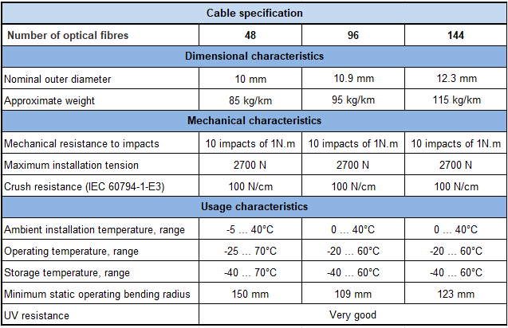

CPR grade compliance requirement (Cca s1a, d1, a1)
The CPR regulations came into force in July 2016 and with effect from the 1st July 2017, cable jacket
materials must be of the appropriate Construction Product Regulations Class to meet the
requirements of EN 50399 and EN 50575 2014/A:2016 standards. In particular the cables proposed for this project must conform with EN50575 for certification and labelling.
The proposed cables must meet Class Cca s1a, d1, a1 and the bidder must provide a statement from the chosen manufacturer detailing their 3rd party verification of their product and its classification.

Detailed product information (CPR grade s2,d1,a1)

Example of product
LANmark-OF Module Universal 48xSinglemode 9/125 OS2 LSZH Cca Yellow
Aginode reference: N164.MUN48-YC
LANmark-OF Module Universal 96xSinglemode 9/125 OS2 LSZH Cca Yellow
Aginode reference: N164.MUN96-YC
LANmark-OF Module Universal 144xSinglemode 9/125 OS2 LSZH Cca Yellow
Aginode reference: N164.MUN144-YC

Fibre pre-terminated cable assembly

UHD LC fibre pre-terminated cable assembly
The Ultra High Density (UHD) assembly consists of a Bundle construction Indoor cable terminated with connectors on each side in a factory.
Cable structure
Every fibre shall be 250µm diameter secondary coated each being a different colour or suitably identified for termination identification.
The cable shall be a Bundle construction, limited filled with gel, containing 12 fibres, with a maximum of 12 -Bundles. The jacket material shall be LSZH.
The cable shall be dielectric construction, i.e. with no metallic content.

The cable shall be flame and fire retardant according to IEC 60332-1 and IEC 60332-3.
The cable shall be compliant to the IEC 60794-2-20 standard.
The Pre-Term shall have a dual stage fan-out design.
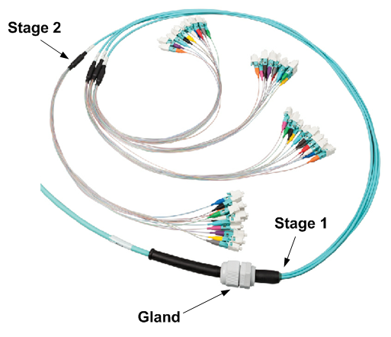
The first fan-out stage is the transition point between the cable and the legs of the fan-out. Each leg of the fan-out contains 1 Micro-Bundle with 12 fibres inside. This fan-out has been reinforced with aramid yarns.
The second fan-out stage distributes the reinforced Micro-Bundle into 12 buffered fibres. The second fan-out together with the 12 buffered fibres and connectors are optimized for installation and fixation into the UHD adaptor modules.
The connectors on the Tight Buffered fibres have coloured boots for identification in compliance with the TIA/EIA standard. In manufacturing a fibre pair flip has been implemented. When installing the connectors inside the modules of the patch panel the coloured boots need to match the colours of the integrated strip inside the module to obtain transmit-receive polarity in the channel.
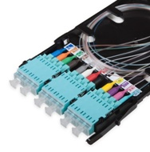
The fan-out is protected with a bubble foam for protection during transport and installation. In addition every bundle of 12 connectors has an additional individual protection to avoid mixing them up with connectors from another bundle.
The Pre-Terms are optimized for both laying and pulling. A pulling eye system is positioned at one side of the Pre-Term to facilitate the installation. This pulling eye is connected to the internal strength element of the cable. The maximum pulling force on the pulling eye is 450N.
The LC/LC Pre-Terms come with a PG-13 cable gland that fits into the patch panel slots.
In order to reduce overlengths in data centres the Pre-Terms are custom made and available with 1m increments.
The typical value for the insertion loss for the low loss LC/LC connection is 0,15 dB. The limit value is 0,25 dB measured according to standard IEC61300-3-4. The minimum return loss is measured according to standard IEC 61300-3-6. For a mutimode LC connection the RL is 30 dB, for a singlemode LC connection it is 40 dB and for a LC/APC connection it is 55 dB.
All LANmark-OF Pre-term assemblies are fully terminated and tested in a quality assured factory environment. The test results are delivered in the box with the Pre-Term.
Performances
The following performances shall be warranted by the manufacturer:

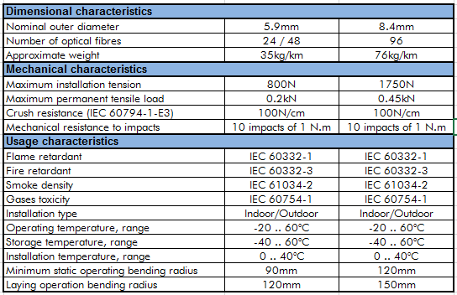

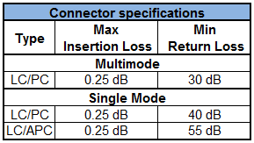

CPR grade compliance requirement (B2ca s1,d0,a1)
The CPR regulations came into force in July 2016 and with effect from the 1st July 2017, cable jacket
materials must be of the appropriate Construction Product Regulations Class to meet the
requirements of EN 50399 and EN 50575 2014/A:2016 standards. In particular the cables proposed for this project must conform with EN50575 for certification and labelling.
The proposed cables must meet Class B2ca s1,d0,a1 and the bidder must provide a statement from the chosen manufacturer detailing their 3rd party verification of their product and its classification.

Detailed product information

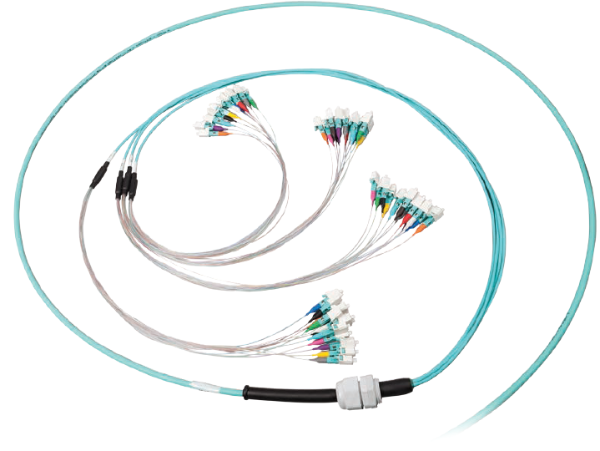

Example of product
LANmark-OF ENSPACE LC/LC Pre-Term
Aginode references

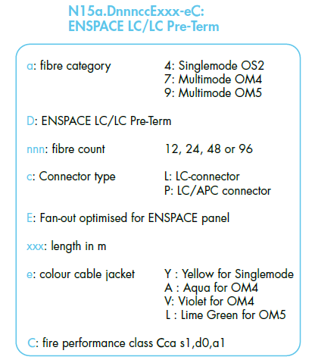

Optical Fibre characteristics

OM3 fibre characteristics
The multi-core optical fibre cable shall consist of multimode OM3 - 50/125µ fibre with fibres colour coding for identification.

The OM3 fibres shall be compliant to the following standards:
- EC 60793-1-49: differential mode delay (DMD) to measure effective modal bandwidth (EMB)
- EC 60793-1-41: overfilled mode launch bandwidth (OFL BW)
- ISO/IEC 11801: 2017 ed.3 as OM3 fibre
- IEC 60793-2-10 as fibre type A1a.2b
- Compliant to annex D2 (DMD template requirements) and annex D3 (EMBc: calculated effective modal bandwidth) of IEC 60793-2-10 ed. 4.

The OM3 fibres shall meet the following specifications:

Geometrical Characteristics of OM3 fibres

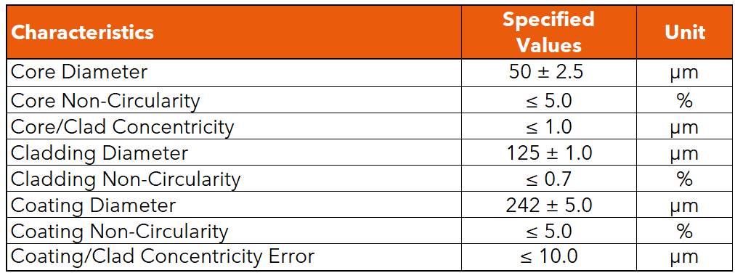

Optical parameters of OM3 fibres
Effective modal bandwidth shall be measured according to the templates method of IEC 60793-2-10 section D2 and the calculated effective modal bandwidth of IEC 60793-2-10 section D3.

OM4 fibre characteristics
The multi-core optical fibre cable shall consist of multimode OM4 - 50/125µ fibre with fibres colour coding for identification.

The OM4 fibres shall be compliant to the following standards:
- EC 60793-1-49: differential mode delay (DMD) to measure effective modal bandwidth (EMB)
- EC 60793-1-41: overfilled mode launch bandwidth (OFL BW)
- ISO/IEC 11801: 2017 ed.3 as OM4 fibre
- IEC 60793-2-10 as fibre type A1a.3b

The OM4 fibres shall meet the following specifications:

Geometrical Characteristics of OM4 fibres

Optical parameters of OM4 fibres
Effective modal bandwidth shall be measured according to the templates method of IEC 60793-2-10 section D4 and the calculated effective modal bandwidth of IEC 60793-2-10 section D5.

OS2 fibre characteristics
The multi-core optical fibre cable shall consist of singlemode OS2 - 9/125µ fibre with fibres colour coding for identification.

The OS2 fibres shall be compliant to the following standards:
- ITU-T as fibre type G.657.A1
- Singlemode OS2 cable defined in ISO/IEC 11801 - 3rd edition
- IEC 60793-1
- IEC 60793-2-50 as fibre type B6.a1

The OS2 fibres shall meet the following specifications:

Geometrical Characteristics of OS2 fibres

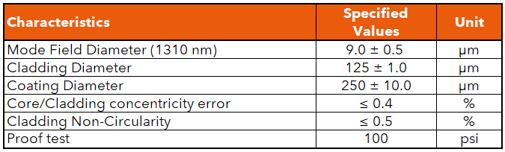

Optical parameters of OS2 fibres

OF Telecommunications outlet
This optional chapter shall only be present if OF outlets (FTTD) are required. If not, please delete this chapter

The termination of the OF horizontal links shall be performed either into standard outlet for direct termination on OF Zip cord duplex cable or into a specific FO splicing outlet.

The two OF outlet ports fitted with removable shutters shall be compatible with the Snap-In format of the manufacturer. OF couplers (SC or LC) and RJ45 connectors shall have the same Snap-In format in order to ensure compatibility and offer mixed Cu/FO outlets.

European mounting hardware
All European format (45x45) outlets are fitted with removable shutters, which can be replaced by colour-coded shutters ( 8 colours) available from the manufacturer standard product range.


The presentation of the outlet shall provide for labelling and identification. A transparent window shall protect the labelling tag.
The choice between single and dual port outlet modules shall be provided.
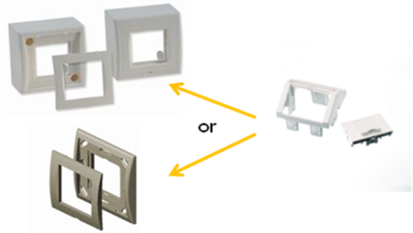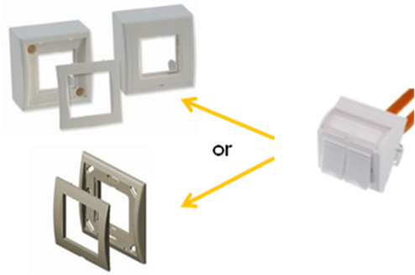
The range shall include cover plates, flat and angled modules for Snap-In connectors and surface mount boxes.

Detailed product information
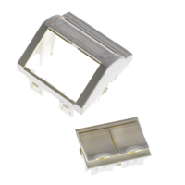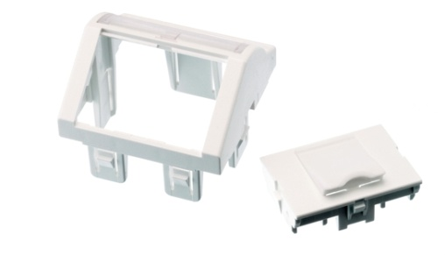
Example of product
LANmark EU style angled 45 x 45 module 1 Snap-In white
Aginode reference: N423.520
LANmark EU style angled 45 x 45 module 2 Snap-In white
Aginode reference: N423.540N
LANmark EU style 45 x 45 frame white
Aginode reference: N200.050
LANmark EU style 45 x 45 surface mount box white
Aginode reference: N200.116

FO splicing outlet

The two OF outlet ports fitted with removable shutters shall be compatible with the Snap-In format of the manufacturer. OF couplers (SC or LC) and RJ45 connectors shall have the same Snap-In format in order to ensure compatibility and offer mixed Cu/FO outlets.

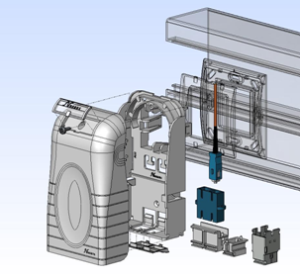

Splicing Telecom Outlet shall be designed for robust Fibre To The Desk applications. The outlet combines the benefits of the Snap-In concept with full flexibility of termination methods: direct, splicing with aluminium protections and splicing with heat shrink protections.
The fully loaded Outlet shall support up to 2 fibres when working with SC Snap-In couplers and up to 4 fibres when working with LC Snap-In couplers.
The OF Telecom Outlet shall provide management for 50 cm of fibre per link after breaking the fibres out from the cable.
In the OF Outlet, the fibres have to be wired in such a way that the dual OF channel polarity is maintained. Wiring of the fibres has to be done according to the guidelines provided by the manufacturer.
The presentation of the outlet shall provide for labelling and identification. A transparent window shall protect the labelling tag.

A fibre optic version of the Zone Distribution box (CP box) shall also be available for FTTD applications.
OF patch panels are described further in the backbone chapter.

Detailed product information

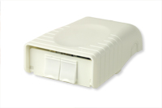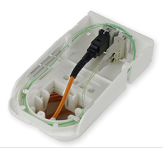
Example of product
Modular OF Splicing Outlet 45X45 for 2 Snap-in adaptors
Aginode reference: N420.035

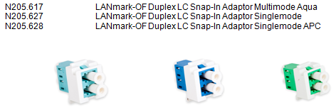

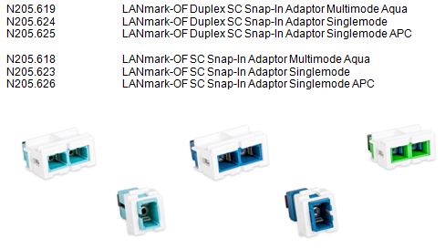

Ruggedised lockable ZD box
Designed for use as consolidation points, zone distribution boxes significantly increase the flexibility of desk locations in open office environments and provide a perfect solution for cabling to automation islands in an industrial setting.
The ZD boxes shall be easy to install on walls, under raised floors or in ceiling voids, due to their multiple mounting features.
They are compatible with all Snap-In copper connectors and fibre adaptors, which can be easily inserted with a simple "one-click" movement.
Optional coloured shutters need to be available to easily indicate different services when required.

This Ruggedised ZD Box shall have a lockable hinged lid for access to the Snap-In ports and a cover fastened with tamper-resistant screws for the "cabling" area.
All apertures are closed with foam strips to minimise the entry of dust into the box.
The cabling area contains all the necessary features to accommodate copper and fibre pre-term, direct terminated fibre, fibre splicing and on-site terminated copper.
The Ruggedised ZD box is also designed to facilitate installations using extractable fibre bundles and allows the breakout of bundles for splicing whilst allowing unobstructed side to side routes for the ongoing fibre.
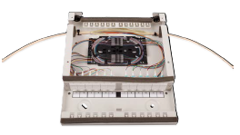
Fibre management spiders and splice cassettes optional accessories shall be available.
A specially designed steel mounting foot (N521.6121) is available as a separate order item which raises the box 50mm from the floor slab to provide protection against water ingress.
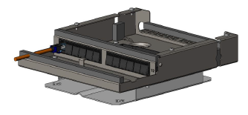

Detailed product information
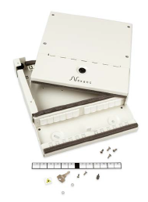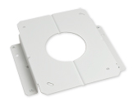
Example of product
LANmark Ruggedised Lockable ZD Box White
Aginode reference: N521.612
LANmark Ruggedised Lockable ZD Box Foot White
Aginode reference: N521.6121
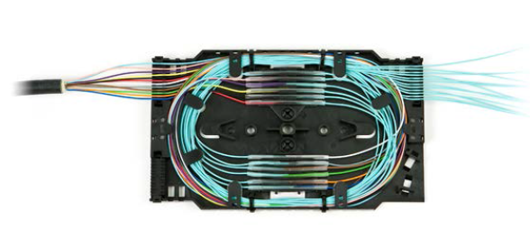
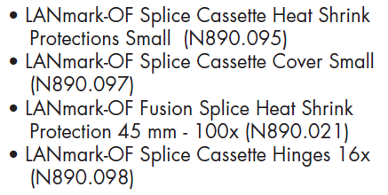

Demarcation box
The Demarcation Box shall be orientated 90˚ from the traditional ZD boxes allowing the duplex LC connections to be parallel to the extractable bundle cables.
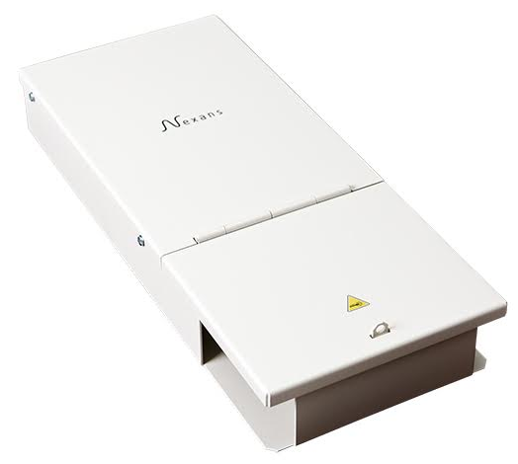
The boxes shall have the following features:
- Left or right mounting options
- 6 duplex LC adapters
- Secure accommodation of optional splice cassettes
- Lockable patching area with management ring
- Port identification
- Robust steel construction
The Demarcation Box is a robust yet lightweight solution for the break-out and termination of extractable bundle cables in FTTO implementations.
The box is symmetrical allowing mounting with the LC adaptors facing right or left and features a “hook and staple” locking feature which can be used with a padlock (not supplied), a wire tie seal or simply a plastic cable tie to prevent access to the patching area.
The Demarcation Box comes with a patch cord management ring and the screws necessary to fasten a splice cassette.

Detailed product information

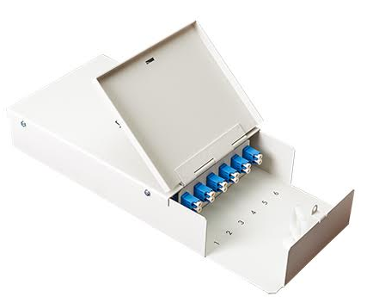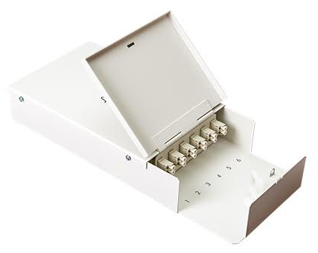
LANmark-OF Demarcation Box 12 Core Multimode White
Aginode reference: N521.621

LANmark-OF Demarcation Box 12 Core Singlemode White
Aginode reference: Aginode reference: N521.622

Optical fibre CP links
For the FTTO horizontal links OF CP links are required to connect the consolidation point (CP) to the FTTO switches.
The use of a robust patch cord is required for this application as the cord is going to be exposed to mechanical stress.
In order to ruggedise the patch cord each tight buffered fibre of the patch cord shall be protected by a coiled metal spring wire.
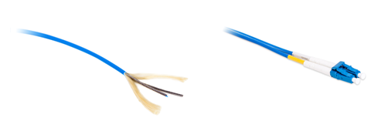
Between the spring and the LSZH jacket aramid yarns are introduced to enhance the pulling force.
Mechanical characteristics
Crush resistance (IEC 60794-1-E3) | 500N/cm
Maximum pulling force (IEC 60794-1-2-E1) | 400N
Usage characteristics
Minimum static operating bending radius | 30mm

The spring is very flexible and this results in a patch cord with a bend radius of only 30mm.
The patch cord has a duplex cable construction with a diameter of 2 X 2.8 mm.
It is terminated with LC connectors having a short boot of 19mm to facilitate the connection to the TO.
The Ruggedised LC patch cord is designed for indoor use and complies to following fire performance standards: IEC 60332-1 and IEC 60332-3.
Characteristics
- Patch cord cable is according to IEC 60794-2-50
- Maximum insertion loss according to IEC 61300-3-4: 0.25 dB
- Typical insertion loss: 0.15 dB
- Minimum return loss according to IEC 61300-3-6: 30 dB for MM and 50 dB for SM
- Colour of Jacket: Aqua for Multimode (OM3 and OM4) and Yellow for SM (OS2)

OF patch cords shall be designed according to the "Cross-Over" wiring principle to improve field installation (A1-B2, B1-A2). This conforms to the requirements of IEC 11801: Ed.3 and EN 50174-1 Ed.3.
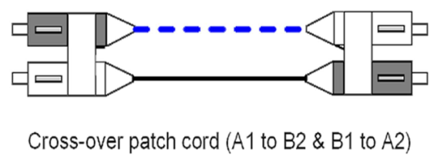

Detailed product information
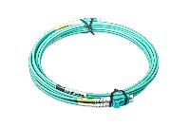
Example of product
LANmark-OF Ruggedised Patch Cord Duplex LC Duplex LC OM3 LSZH Xm Aqua
Aginode reference: N123R.5LLAX
LANmark-OF Ruggedised Patch Cord Duplex LC Duplex LC OM4 LSZH Xm Aqua
Aginode reference: N123R.7LLAX
LANmark-OF Ruggedised Patch Cord Duplex LC Duplex LC OS2 LSZH Xm Yellow
Aginode reference: N123R.4LLYX

Optical Fibre Patch Panel

Sliding modular OF Patch Panel
The 1U Optical Fibre Patch Panel must be modular having 2” empty ports that can be loaded with SC or LC Snap-In adaptors and fits in a 19” rack or cabinet.
The modular OF panel has extended cable management with multiple entries to provide maximum flexibility. It accommodates both cable glands and tie wraps for strain relief of the cables. The cable gland sizes holes are 20 mm (8x) and 25 mm (2x).
The patch panel shall be designed with an enhanced sliding mechanism enabling front side installation and maintenance work to be carried out without having to remove the entire panel.
The front adaptor plate is fixed in a recessed position in the rack using the adjustable side brackets. When set in recess position the front connector plate is deeper than the front of the 19" rails of the cabinet. This will provide sufficient bend radius for the patch cords once connected to the panel. This shall also prevent damages to the patch cords when the cabinet doors are closed.
Direct Termination of the connectors (SC & LC) on to the fibres as well as splicing of pigtails (SC & LC) shall be possible.
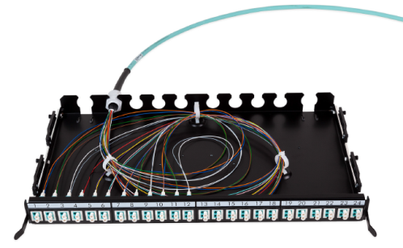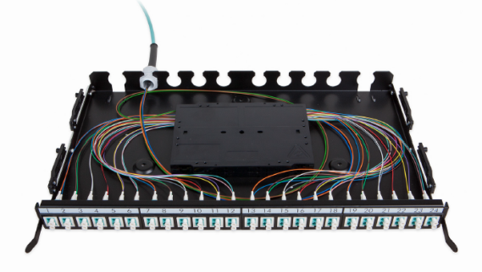
The patch panel chassis has multiple, specially designed, slots at the rear to fix the cable glands of pre-terminated cables. There shall be ample space inside the patch panel to organise the flexible fan-out of the pre-terminated cables.
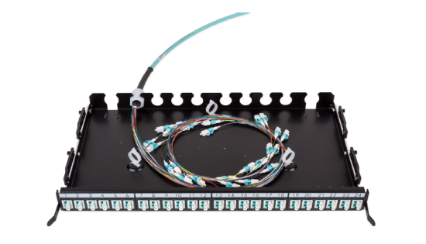
The Patch Panel shall be supplied with 3 loop rings to neatly coil the terminated fibres.
Up to four optional splice cassettes should be supported to manage up to 48 splices with heat shrink protectors and with aluminium protectors.
The splice cassettes shall feature a lifting functionality for improved ease of installation and inspection.

The front plate of the 24 port modular Patch Panel shall be compatible with the following connector types: 24 single SC, 24 duplex LC and 12 duplex DSC.
Standard LC, SC and DSC Snap-In couplers shall be available to load the modular patch panel.
The colour of the Multimode Snap-In adaptors shall be aqua.
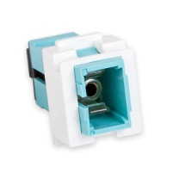
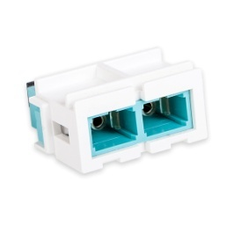
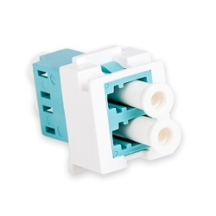

Singlemode Snap-In adaptors shall be available in Blue and Green colour. Blue colour is going to be selected to connect PC polished SC or LC connectors while green is selected for APC polished connectors.

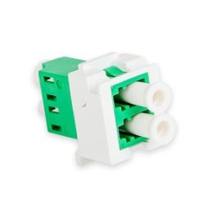
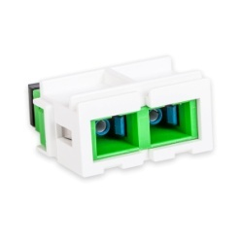
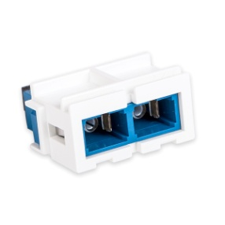
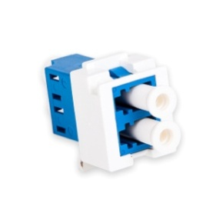

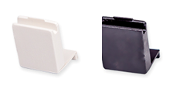
The fully loaded panel (One height unit or 1U) shall support up to 24 fibres when working with SC Snap-In couplers and up to 48 fibres when working with LC Snap-In couplers.

Unused positions can be populated with optional blank fillers.

Panels are fully painted for a professional look and feel. It t shall be available in both black and white colour.
In the panels, the fibres have to be wired in such a way that the dual OF channel polarity is maintained. Wiring of the fibres has to be done according to the guidelines provided by the manufacturer.

Detailed product information
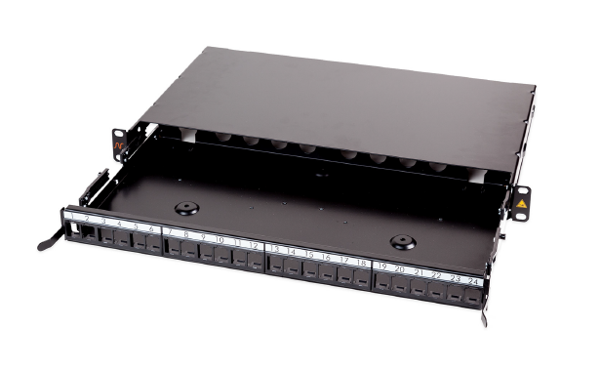
Example of product
LANmark-OF Patch Panel Snap-In Sliding Black
Aginode reference: N439.4SNB

LANmark-OF splice cassette for heat shrink protectors
Aginode reference: N890.090
LANmark-OF splice cassette cover
Aginode reference: N890.092
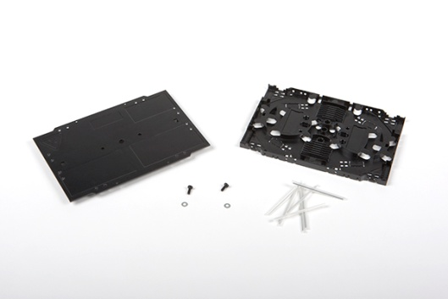

LANmark-OF splice cassette for Aluminium Protectors
Aginode reference: N890.091
LANmark-OF splice cassette cover
Aginode reference: N890.092

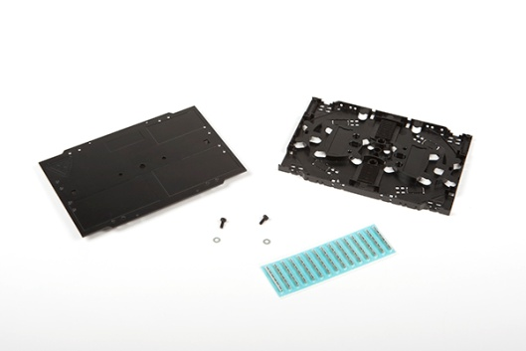

High density Plug&Play OF patch panel
The ' Plug and Play concept shall be specifically designed for installation in data centres where the high density, integrated patch cord guide and enhanced installation benefits of the patch panel meet the key requirements for implementation.

The patch panel design allows to hold up to 4 MTP/LC modules or adaptor plates in 1U of the distribution rack. Depending on the type of the module a high density of up to 96 fibre connections can be accommodated.

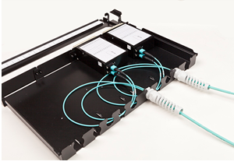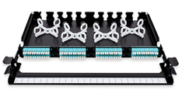

The patch cord guide sits in front of the modules and allows the patch cords to be managed within the same 1U saving expensive rack space. The patch cord guide also provides a labelling facility to identify connections. Additional labelling is provided by printed port numbers on the modules.

The tray shall slide and tilt for improved access to install new modules and adaptor plates.

The patch panel is optimised for installation of MTP/MTP or SC/LC Pre-Term assemblies. The cable glands of the Pre-Term allow a fast and solid fixing of the cable. There is ample space inside the patch panel to organise the flexible fan-out of the Pre-Term.

Optional Fibre Organiser shall be available to facilitate the installation of the SC/LC Pre-Term.

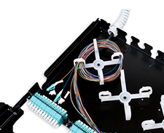

Up to 4 optional splice cassettes can be installed in the patch panel to accommodate up to 96 splices.
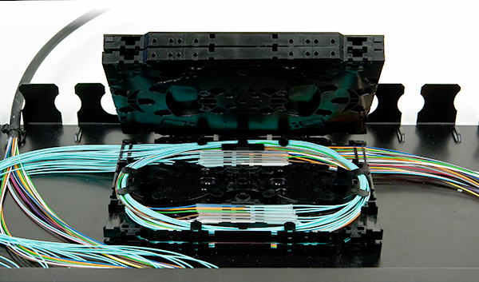
Panels are fully painted in black for a professional look and feel.
Blank fillers are available as separate accessories for unused positions to give a finished look.

The front adaptor plate can be fixed in a flush or recessed position in the rack using the adjustable side brackets. When the panel is installed recessed the distance between the rack vertical and the rear of the panel is 288 mm. The front cord management projection is 67 mm. When the panel is installed flush the distance between the rack vertical and the rear of the panel is 248 mm. The front cord management projection is 107 mm.

Detailed product information
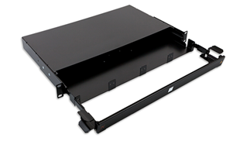
Example of product
LANmark-OF Plug&Play Patch Panel Integrated Cord Guide Sliding Black
Aginode reference: N439.3MPP

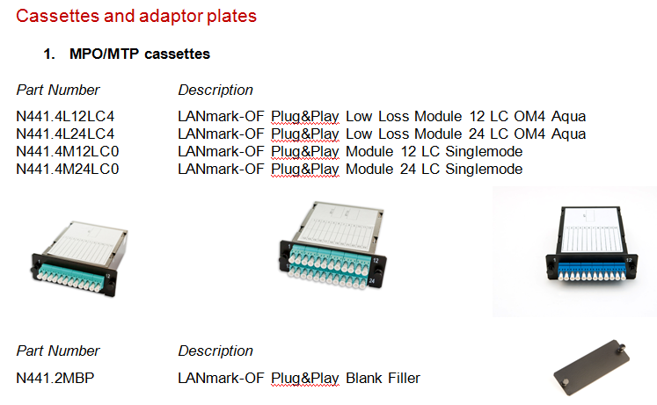

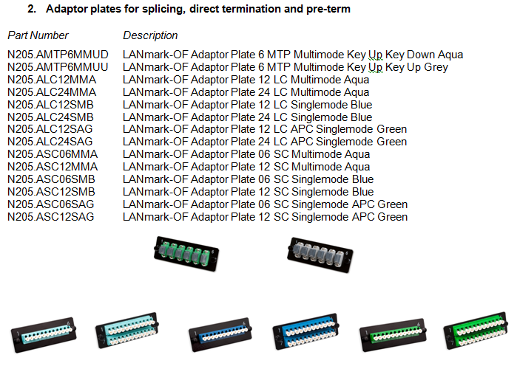

LANmark-OF fibre organiser 10x
Aginode reference: N890.070

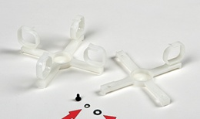

LANmark-OF splice cassette for heat shrink protectors
Aginode reference: N890.090
LANmark-OF splice cassette cover
Aginode reference: N890.092

LANmark-OF splice cassette for Aluminium Protectors
Aginode reference: N890.091
LANmark-OF splice cassette cover
Aginode reference: N890.092

UHD OF Patch Panel
The Ultra High Density (UHD) concept is designed for data centres where the very high density, integrated patch cord guides and enhanced installation benefits of the UHD patch panel meet the key requirements for implementation.
It shall allows quick changes with limited down time, easy migration to other applications and a transition path to 40G/100G.

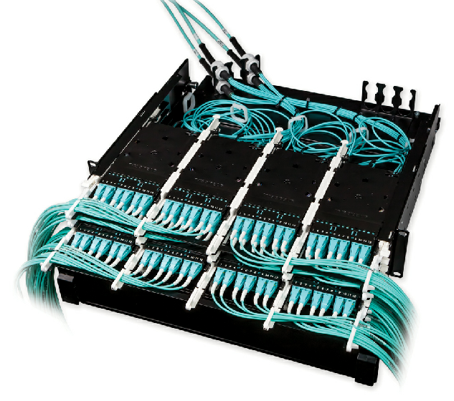

The UHD system consists of 3 sub-components: Pre-Terms, modules and patch panels.

The patch panel design shall have 3 sliding trays within 1U. Each tray can accommodate up to 4 modules. The panels can be loaded within 1U with up to 12 modules allowing 144 LC connections when modules with LC adaptors are used. With MTP adaptor modules 72 MTP connections within 1U can be installed. Modules have to be ordered separately.

The UHD Patch Panels shall be available in 1U, 2U and 4U. The panels are designed for installation inside 19 inch enclosures.

The tray slides shall have 3 locking positions.

The operational position (1) when the trays are completely in the rack.
The patching position (2) when the tray is moved forward by 75 mm. This allows easy access to the patch cords.
The final stop position (3) before removal of the tray.

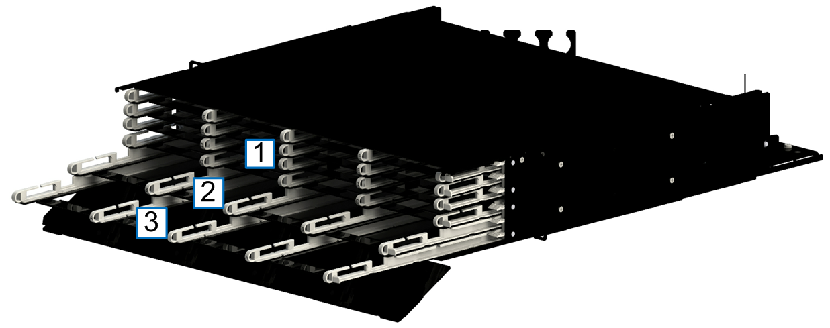

The sliding trays shall have printed letters to identify the individual trays. Additional side handles on the left and right sides enhance the pulling forward of the tray.

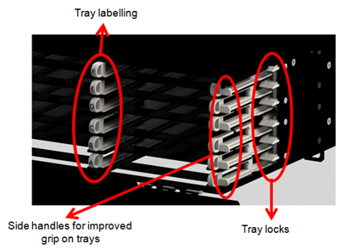

The UHD Pre-Terms shall be fixed on a separate, sliding and tilting tray located at the rear of the panel. For installation of the cables the tray can be slid out of the patch panel by about 15 cm. This allows easy access to the fixing points for the cables without being in the small space formed by the panel above and underneath when working in a high density rack.
On this rear tray 2 cable fixing kits are provided. The slots are suitable for a PG-13 cable gland. The orientation of the fixing kit can be modified to allow for side, angled or rear entry. An optional third cable fixing kit can be installed on the tray as well.

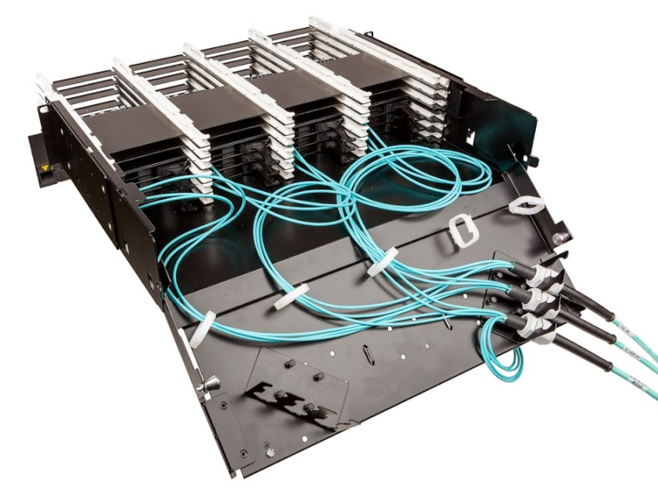

The patch panel is optimised for installation of the UHD Pre-Terms: the cable gland of the Pre-Term shall allow a fast and solid fixing of the cable. Ample space is available inside the patch panel to organise the flexible fan-out of the Pre-Terms, including the additional fan-out overlength required to allow the individual trays to slide to the patching or installation position.

A labelling hinged front cover sits in front of the modules. It can rotate almost 180° even when UHD patch panels are installed underneath. This facilitates port identification when the panel is mounted at the top of the rack.

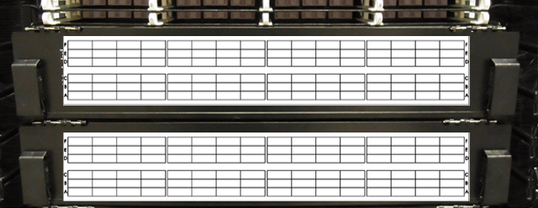

Panels are fully painted in black for a professional look and feel.

The total depth of the panel is 526mm. The panels are delivered with the labelling front projection 129mm in front of the rack vertical. The rear of the panel is 397mm recessed compared to the rack vertical. The L shaped chassis support brackets can be fitted in 5 different positions to move the position of the panel inside the rack. It can be moved backwards compared to the rack vertical by 37.5mm or forward by 37,5mm or 75mm.

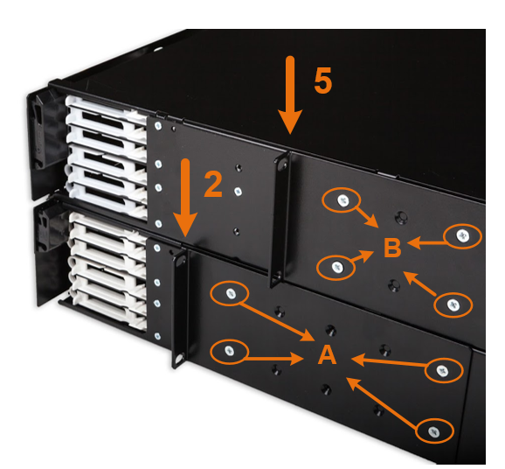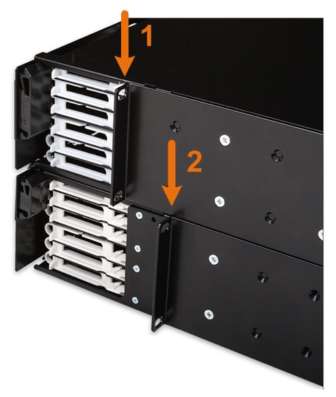

Detailed product information
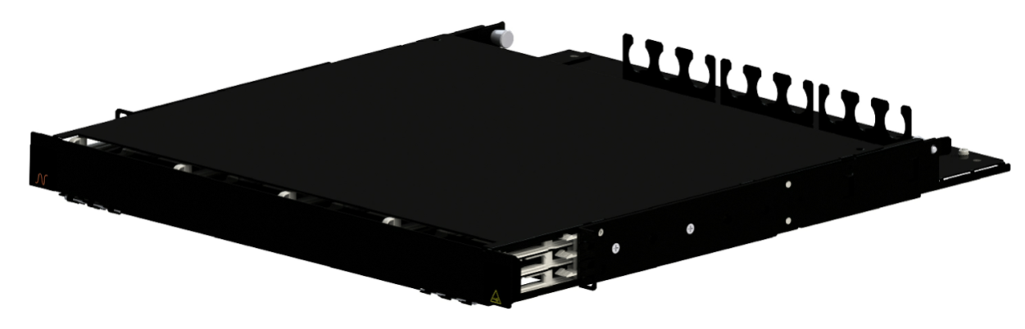
Example of product
LANmark-OF ENSPACE Patch Panel 1U 12x Modules Black
Aginode reference: NSPACE.PP1U

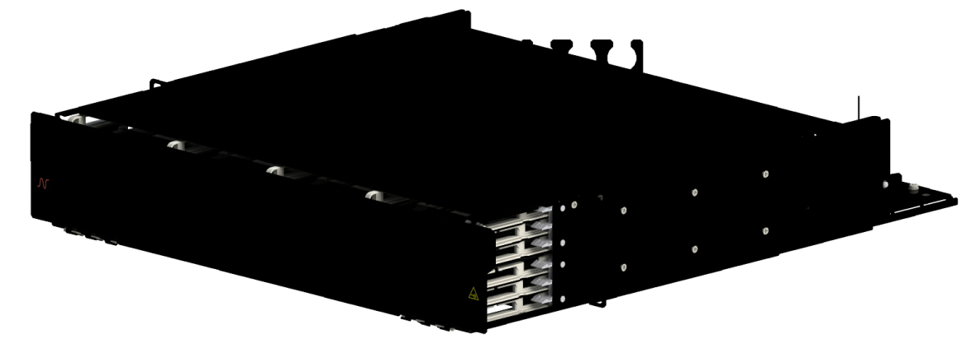
Example of product
LANmark-OF ENSPACE Patch Panel 2U 12x Modules Black
Aginode reference: NSPACE.PP2U

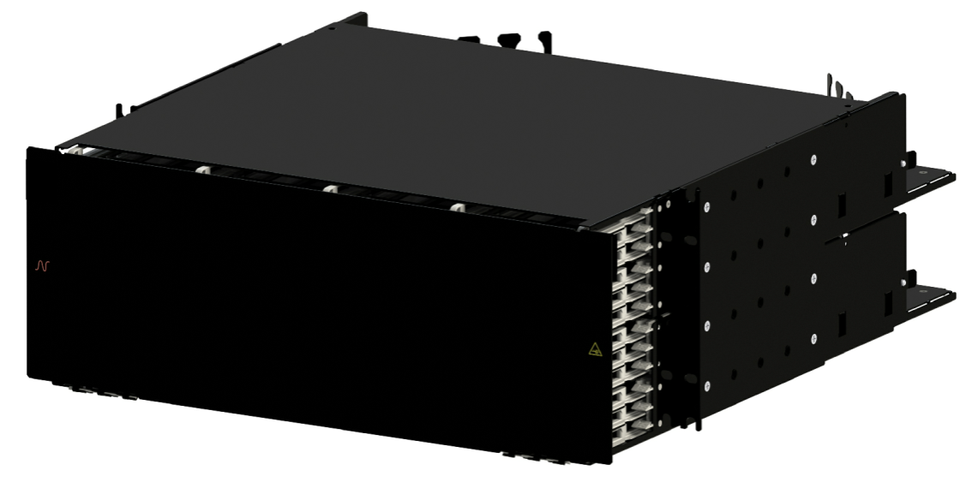

Example of product
LANmark-OF ENSPACE Patch Panel 4U 12x Modules Black
Aginode reference: NSPACE.PP4U

Optional modules ad accessories

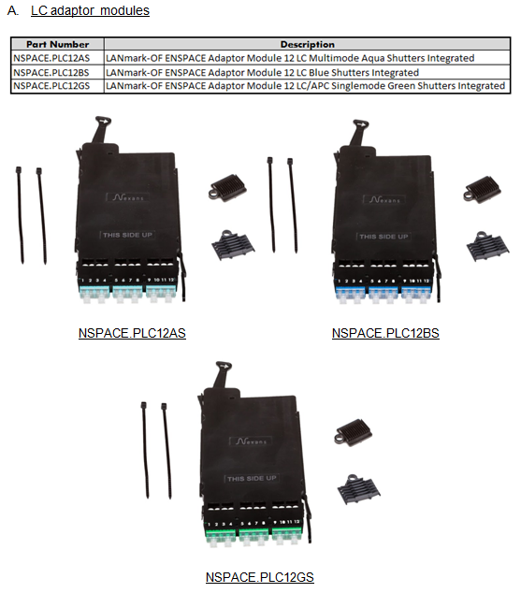

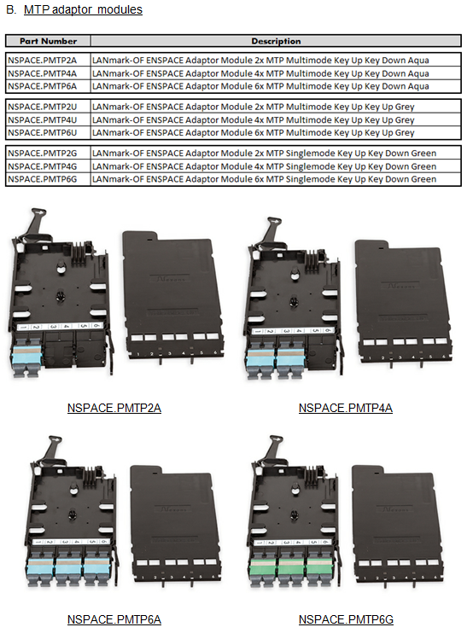

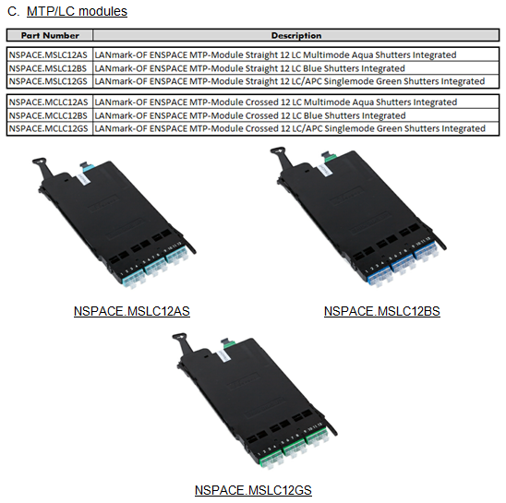

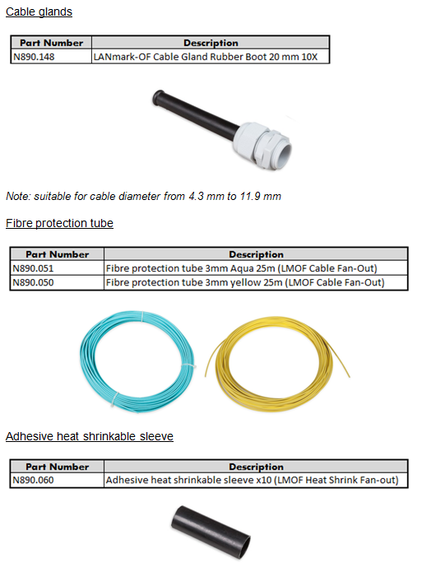

Optical Fibre pigtails
This chapter has to be deleted if pre-terminated cables are selected

Maxistrip Optical Fibre pigtails
Fusion spliced pigtails shall be used to terminate both multimode and singlemode fibres.

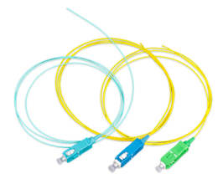

The use of Maxistrip pigtails is recommended. Maxistrip pigtail is made up of a 250µm coated fibre being loose inside a 900µm tube.

Whenever possible set of 12 coloured pigtails having colours that match the ones of the fibres of the cable shall be selected for easy identification.

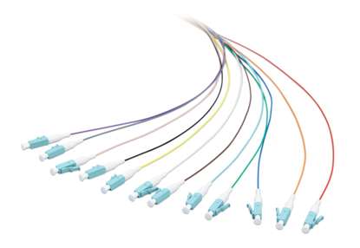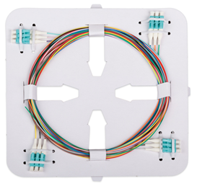

Optical performances

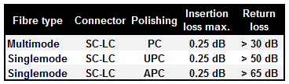

Pigtails shall be available with the following types of fibre: OM3, OM4, OM5 and OS2.

Pigtails shall be have Bend Insensitive fibre:
- OM3 compliant to IEC 60793-2-10, fibre model A1a.2b
- OM4 compliant to IEC 60793-2-10, fibre model A1a.3b
- OM5 compliant to IEC 60793-2-10, fibre model A1a.4b
- OS2 compliant to IEC 60793-2-50, fibre model B6.a1

Bend insensitive fibre performances

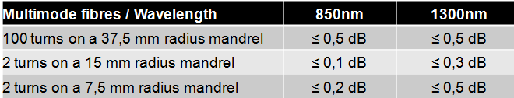

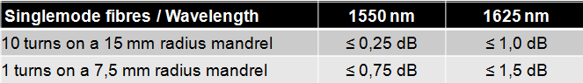

Detailed product information
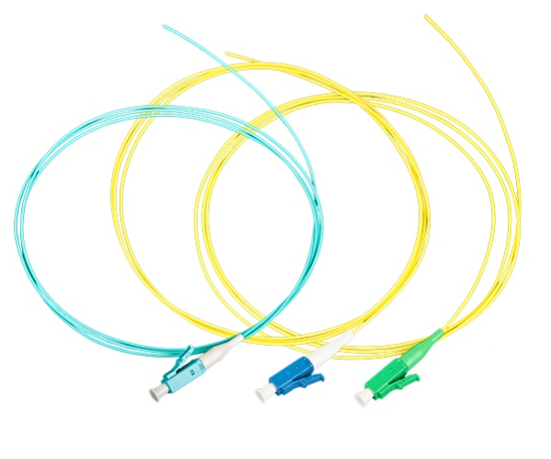
Example of product
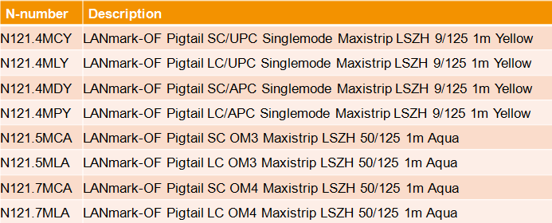

Tight Buffer Optical Fibre pigtails
Fusion spliced pigtails shall be used to terminate both multimode and singlemode fibres.

Tight buffer pigtails are recommended to be used with tight buffer cables, i.e. with 900 um fibres.
Whenever possible set of 12 coloured pigtails having colours that match the ones of the fibres of the cable shall be selected for easy identification.

Optical performances

Pigtails shall be available with the following types of fibre: OM3, OM4, OM5 and OS2.

Pigtails shall be have Bend Insensitive fibre:
- OM3 compliant to IEC 60793-2-10, fibre model A1a.2b
- OM4 compliant to IEC 60793-2-10, fibre model A1a.3b
- OM5 compliant to IEC 60793-2-10, fibre model A1a.4b
- OS2 compliant to IEC 60793-2-50, fibre model B6.a1

Bend insensitive fibre performances

Detailed product information
Example of product
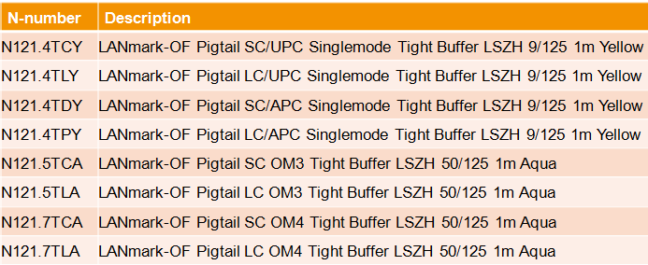

Optical Fibre Patch Cords

OM3 & OM4 BIMMF Optical Fibre Patch cords
The Fibre Snap-In adapters will be connected to the active equipment OF ports by means of “Cross-over” duplex patch cords in order to maintain the duplex OF channel polarity in accordance with the requirements of ISO/IEC 11801 and EN 50174-1.
The patch cords shall be available in lengths of 1m, 2m, 3m, 5m, 7m, 10m, 15m, 20m, 25m, 30m, 40m and 50m and have a LSHF-FR outer sheath.
The cable shall be flame and fire retardant according to IEC 60332-1 and IEC 60332-3.
When using OM3 or OM4 optical fibres, patch cords produced with the same OM3 or OM4 fibre have to be installed.
The patch cords have GIGAliteFLEX fibre inside. This bend insensitive multimode fibre (BIMMF) has a small bend radius of 10mm and is compliant to IEC 60793-2-10, fibre model A1a.3b.
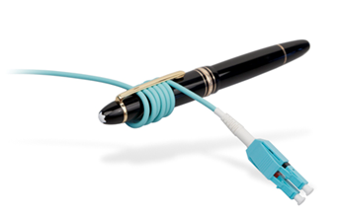
Duplex LC-LC, duplex LC-SC and duplex SC-SC patch cords have a duplex cable construction with a diameter of 2 X 2.0 mm and short connector boots of 19mm.
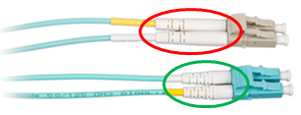
A label shall be affixed close to the duplex connector for traceability of the factory measurement results.
Insertion Loss and Return Loss test results shall be available on request.
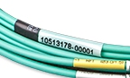
Patch cord cable is according to IEC 60794-2-50. The colour of Jacket and of the connectors shall be Aqua for both OM3 and OM4 patch cords
The "butterfly" duplex clip allows to easily change the polarity on site by simply removing the 2 connectors and put them in a reverse order back into the same clip. No tool shall be required for this polarity change.
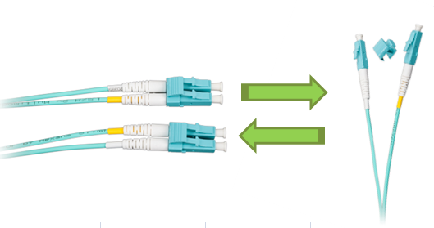
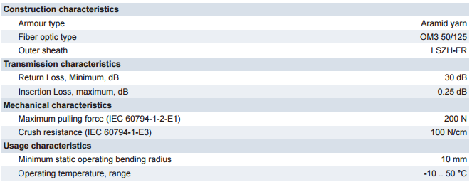

Detailed product information
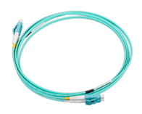
Example of products
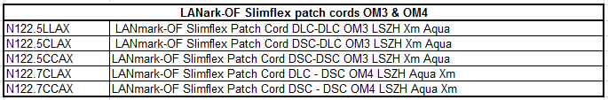

OS2 BI Optical Fibre Patch cords

The Fibre Snap-In adapters will be connected to the active equipment OF ports by means of “Cross-over” duplex patch cords in order to maintain the duplex OF channel polarity in accordance with the requirements of ISO/IEC 11801 and EN 50174-1.
The patch cords shall be available in lengths of 1m, 2m, 3m, 5m, 7m, 10m, 15m, 20m, 25m, 30m, 40m and 50m and have a LSHF-FR outer sheath.
The cable shall be flame and fire retardant according to IEC 60332-1 and IEC 60332-3.
UPC polishing performance of the connectors with RL > 50 dB is required.
APC polishing style shall be available with RL > 65 dB.
The patch cords have GIGAliteFLEX fibre inside. This bend insensitive (BI) fibre has a small bend radius of 10mm and is compliant to ITU-T G.657.A1 and to IEC 60793-2-50, fibre model B6.a1.
Duplex LC-LC, duplex LC-SC and duplex SC-SC patch cords have a duplex cable construction with a diameter of 2 X 2.0 mm and short connector boots of 19mm.
A label shall be affixed close to the duplex connector for traceability of the factory measurement results.
Insertion Loss and Return Loss test results shall be available on request.

Patch cord cable is according to IEC 60794-2-50. The colour of Jacket shall be yellow for OS2 patch cords.
OF patch cords shall be designed according to the "Cross-Over" wiring principle to improve field installation (A1-B2, B1-A2). This conforms to the requirements of IEC 11801: Ed.3 and EN 50174-1 Ed.3.
The "butterfly" duplex clip allows to easily change the polarity on site by simply removing the 2 connectors and put them in a reverse order back into the same clip. No tool shall be required for this polarity change.

Detailed product information
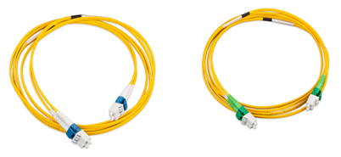
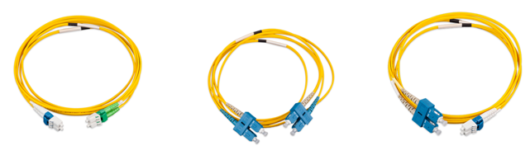

Example of products
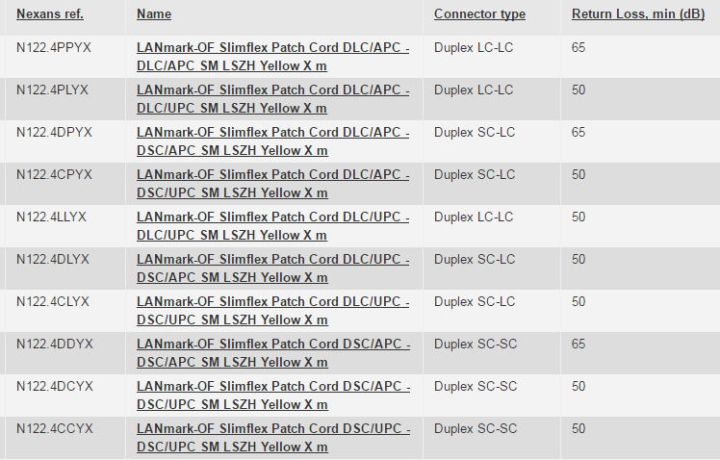

UHD bend insensitive LC OF Patch cords
The UHD (ultra High Density) patch cords shall be optimised for use in Data Centres environments.
These patch cords shall have a very small bend radius of 10 mm due to the use of bend insensitive fibre and very small diameter of 2 mm.
The round design of the UHD patch cord results in a small bend radius in any direction. Traditional patch cords based on a zipcord design have a bend radius that is dependent on the orientation and are therefore not accepted.
The patch cords shall be available in lengths of 1m, 2m, 3m, 5m, 7m and 10m and have a LSHF-FR outer sheath.
For the support of the advanced high speed Ethernet protocols with stringent power budgets the UHD patch cord features a low loss performance of 0.25 dB. This increases the headroom in the channel and reduces the risk of down time.
CHARACTERISTICS
- Patch cord cable is according to IEC 60794-2-50
- Maximum insertion loss according to IEC 61300-3-4: 0.25 dB
- Typical insertion loss: 0.125 dB
- Bend insensitive fibre
- A label is added close to the uniboot connector for traceability of the factory measurement results
DESIGN
OF patch cords shall be designed according to the "Cross-Over" wiring principle to improve field installation (A1-B2, B1-A2). This conforms to the requirements of IEC 11801: Ed.3 and EN 50174-1 Ed.3.
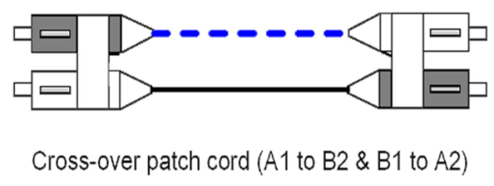
The polarity of the patch cord can be changed by opening the uniboot connector on one side and change the position of the 2 LC connectors. A black and yellow plastic square identify the fibre inside the patch cord. The patch cords are delivered with the black square on the left on side A and on the right on side B. This is required for cross-over or optical crossed patch cords. By changing the position of the black square on side A from the left to the right the patch cord becomes an optical straight patch cord.
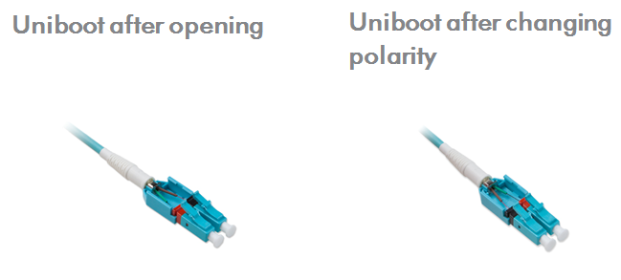

The colour of the jacket shall be Aqua for OM4 fibres and Yellow for OS2 fibres.

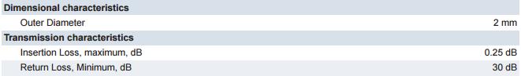
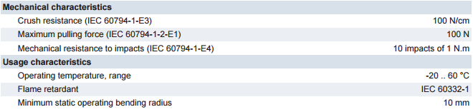

Detailed product information
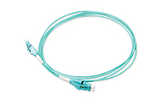
Example of products

Copper Patch cords
To achieve a Class EA Channel performance all data Patch Cords shall be Category 6A rated.
Cat.7A and/or cat.8 patch cords will only be required in the future when full Class FA or Class II channel will be needed.
The patch cord cable shall be made from LSZH material with a metric marking indicating type of cable, brand name, production code and length.
All patch cords shall be compliant to the IEC 60332-1 standard to offer flame propagation retardant properties.

Data Patch cords
All Data patch cords shall be fully screened.
The standard colours offered for the LSZH flame retardant jacket shall be orange and dark grey.
Red, Blue, Green and Yellow colours shall also be available on demand.
Special length and special cable colours shall be available in 14 days “ex warehouse”.
The default lengths available from stock shall be 1, 2, 3, 5, 10 and 20 m. in order to ensure quick delivery of the cords on site.
The patch cords feature a slim over-moulded boot which is kept inside the RJ45 boundaries to enable High Density Patching with 48 cords in 1 height unit.
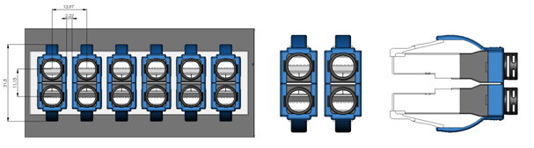
They also come with a ‘Replaceable’ black Latch Protector, which can be used for colour coding of different services.
The coloured retrofit latch protectors shall be available as accessory in 8 colours for colour coding of different services.

The cords shall be fitted with Category 6A RJ45 screened plugs, with a Self-latching, high reliable RJ45 (ISO 8877) connector. All pairs must have an impedance of 100 Ohms. The characteristic impedance of the pairs must be identical to that of the horizontal cables. The Patch Cords shall have a guaranteed performance level of greater than 750 insertions without degradation to the performance level of the solution.
The cable used for the Patch Cords shall be Category 6A LSZH U/FTP patch cable. The cable shall be a 4 twisted pair cable with individually screened stranded conductors. Traceability numbers should accompany the cables supplied from the manufacturers packaging to assist in quality validation of the installed cable.
When installed in combination with other Cat.6A components of the same manufacturer, a 25 years channel warranty can be obtained, covering full 10GBase-T support and full Cat 6A/Class EA compliance.
TheCat.6A cords fully comply and exceed the requirements of EIA/TIA-568-C.2 and ISO11801 and enable to achieve high performing Cat 6A channels. Used with other Cat.6A components of the same manufacturer, very short Cat 6A link and channel configurations with up to 3 connection points within 10 meters can be supported.
The performances shall be warranted by a certificate provided by an independent test lab.

Detailed product information

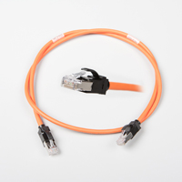

Example of products
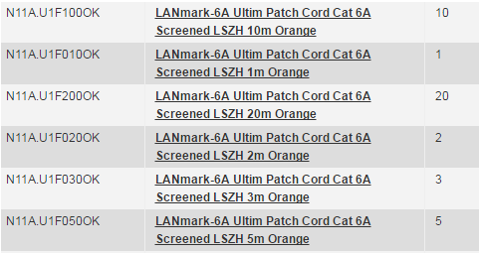

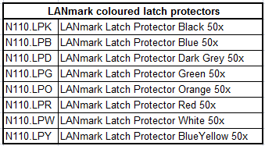

Cat.6A Secure Lock RJ45 Patch cords
Security being of paramount importance for the current project the copper sub-system shall be equipped with a system restricting the removal of the RJ45 patch cords.
The range of Secure Lock patch cords shall be designed to meet the needs of applications such as:
- PoE connector protection (damage caused by mating/unmating under load)
- Theft prevention (Hotels/Schools/Libraries)
- Critical circuit protection
- Patch Cord availability (Meeting rooms)
- Redundant Copper links
- Connection of IP security cameras
- Use in high-density switches.
There are two variants in the LANmark-6A Secure Lock Patch Cords:
- Patch Cords with locks on both the plugs
- Patch Cords with lock on only one plug
Each cord comes preassembled with a red locking boot.
The cord can be disconnected when the matching red key is used to unlock the boot.
The standard cord colour of the LSZH jacket shall be orange.
Standard cords (cat.6A S/FTP) are stocked in lengths of 1, 2, 3 and 5m - other lengths are available on demand.

Detailed product information
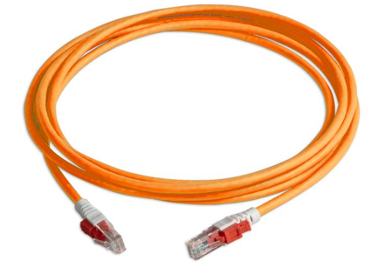
Example of products
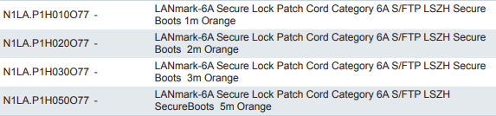

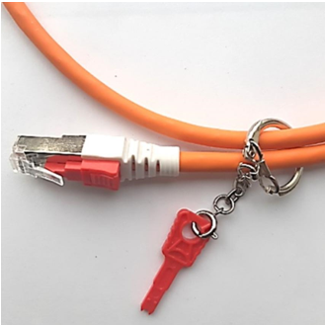

Example of products
LANmark Secure Lock Copper Patch Cord Key
Aginode reference: N1LA.KEY

Secure Lock RJ45 port blockers
Port Blockers shall secure the network infrastructure by blocking out unused or unauthorised ports.
They also protect the hardware from incoming dust and harmful foreign objects.
RJ45 Port Blockers shall fit into any standard RJ45 jack without the use of a tool.
The insertion shall be tool-free onto any standard RJ45 Jack used for outlets and Patch Panels
A dedicated black coloured key must be needed to unlock and remove Port Blockers.

Features
- Exchangeable and re-usable
- Individual packaging for Secure Lock RJ45 Port blockers should contain 100pcs
- Individual packaging for Secure Lock RJ45 Port Key should contain 5pcs
- Material: Plastic
- UL Rating: UL94V-2
- RoHS 2 compliant
- Colour of the RJ45 Port Blocker: Transparent Red, Transparent Blue and Transparent Black
- Colour of the RJ45 Port Key: Transparent Black
- Operating temperature range: -10°C~60°C
- Storage temperature range: -40°C~68°C
- Humidity: 10%~90%RH

Detailed product information
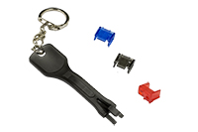
Example of products
LANmark Secure Lock RJ45 Port Blocker – Blue
Aginode reference: N110.SRJPBB
LANmark Secure Lock RJ45 Port Blocker – Red
Aginode reference: N110.SRJPBR
LANmark Secure Lock RJ45 Port Blockers – Black
Aginode reference: N110.SRJPBK
LANmark Secure Lock RJ45 Port Blocker Key
Aginode reference: N110.SRJPKK

FTTO switches

General FTTO switch features

The FTTO switches shall ensure intelligent conversion from fibre to copper and vice versa. Each FTTO switch, installed at the workplace in cable ducts or floor boxes, is equipped with four copper RJ45 user ports to feed terminal devices with data and power. Fibre speed, reliability and long distance coverage are coupled with the benefits of Ethernet. They meet current and foreseeable network requirements in terms of flexibility, cost efficiency and network interoperability.

The power supply of the systems shall be provided via an external power supply (SELV). The system will be connected to 54V DC (direct current) via the power terminal on the rear side using a 3-pin plug-in screw terminal. This 54V DC power supply can also be used to supply the connected Power over Ethernet terminal equipment simultaneously. Thanks to the implemented Power-over-Ethernet (PoE) functionalities e.g. VoIP-Phones, Wireless LAN Access Points and IP-Cameras can be supplied with power according to IEEE 802.3at, Class 0/1/2/3/4, from the switch directly. Some versions also support PoE++ with up to 60W per Port, 4-Pair 1-2/3-6/4-5/7-8.

The head module of the switch can be installed in a vertical as well as in a horizontal way, i.e. one switch system can be used for both horizontal and vertical installations. The very compact design of this switch shall allow a snap-in installation (no tools needed) in standard 45 mm cable duct systems or floor boxes without special mounting frames.
In addition to the modularity of this head module, it offers the capability to upgrade the user ports with future Power over Ethernet standards.

Hardware ECO mode support
Auto-neg. EEE Port mode: Auto-negotiation with Energy Efficient Ethernet (EEE) according to IEEE 802.3az
Support for energy saving modes:
    - ECO 10/100 Port mode: Autonegotiation, but no 1 Gbps links will be allowed
    - ECO 10/100 Powersave mode: time-controlled enable/disable of Gigabit Ports with 10/100 Mbps
    - ECO 10/100 Over Temperature mode: temperature-controlled enable ECO Mode for Gigabit Ports, because the temperature of the switch has exceeded the set upper limit
    - Time-controlled enable/disable of Power over Ethernet Ports

Memory Card supports the automatic storage of complete and most current configuration of the switch. The memory Card with own MAC address allows an easy system replacement. Memory card is an optional item and shall not be mandatory to operate the switch. Also the use of memory card can be disabled by software, if necessary. Device supports the non-volatile storage of SYSLOG messages in flash memory, SNMPv3/SCP/SSHv2/Telnet/HTTP/HTTPS management and wide range of Security features incl. Radius/IEEE 802.1X.

Technical Data
    - Operation with 54V DC: 46-57V DC via 3-pin plug-in screw terminal (+) (-) (PE)
suitable for wires up to 2.5 mm², supply of switch and PoE

    - Power consumption (without PoE): GigaSwitch series
typ. 4.4 Watts (with EEE)
/ max. 6.2 Watts (without EEE)

XGigaSwitch series
6W (typ.) 7,7W (max.)

    - Ambient temperature (operating): 0 °C up to +45 °C

    - Storage temperature (storage): -20 °C up to +85 °C

    - Mounting : toolless snap-in installation (no tools needed) in standard 45 mm
    - Installation depth: max. 35 mm
    - Dimensions (Faceplate/Housing): 90mm x 45mm / 85mm x 40mm
The very compact design of this switch allows a snap-in installation in standard 45 mm cable duct systems or floor boxes without special mounting frames

    - Management design: fail-safe update and configuration design, updates in a separate flash areas, dual-configuration and dual-firmware management, corruption impossible

    - Switching architecture: non-blocking switching
    - Switching capacity: 20 Gbps / 68Gbps
    - Switching throughput: 14 Gbps / 68Gbps
    - Packet Forwarding rate: 2x 1.488Mpps per port
    - Configuration Interface: V.24 console connector with easy access on the front side of switch without need to dismount the switch of its installation environment

- Further features:
  - Support of Jumbo-Frames (up to 9600 / 10240 Bytes)
  - MAC-Address Table for up to 8192 / 16k MAC addresses
  - Cable Diagnostic with TDR function for Twisted Pair ports
  - Optical components with industrial characteristic (-20°C up to +85°C)
  - Closed housing design for a better ESD protection of used components

Redundancy Scenarios
FTTO makes it easy to set up redundant topologies wherever there is a need for redundancy at the user level. The physical infrastructure for redundant topology is shown in chapter 4.2. Redundancy can be provided by using ring topologies or link aggregation. Both are based on standard Ethernet protocols like Spanning Tree or LACP. Using LACP for redundancy offers not only a redundant uplink to the core network, it offers also the possibility to double the bandwidth to up to 2 Gbps and shares the load on both uplinks. The used protocol is the Link Aggregation Control Protocol.

Redundancy by using Spanning Tree Protocol
Up to four FTTO switches are connected in a ring by using a copper patch cord. The first FTTO switch is connected to Core switch A and the last FTTO switch in the ring is connected to Core switch B.

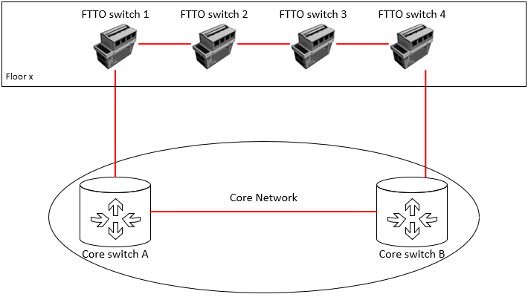

Redundancy by using Ling Aggregation
Each FTTO switch is connected to two Core switches via fibre. Both uplink ports are configured as Link Aggregation ports using LACP. This scenario requires the Multi Chassis Link Aggregation (MLAG) feature supported and configured at the core switches.
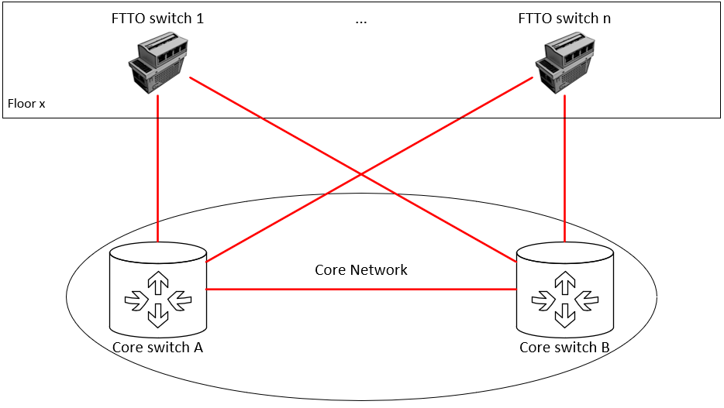
Optionally, to optimise the costs a cascading approach is used. For this a second FTTO switch (FTTO switch 1.2 and 2.2) is connected to the FTTO switch (FTTO switch 1.1 and 2.1) by using a copper patch cord.
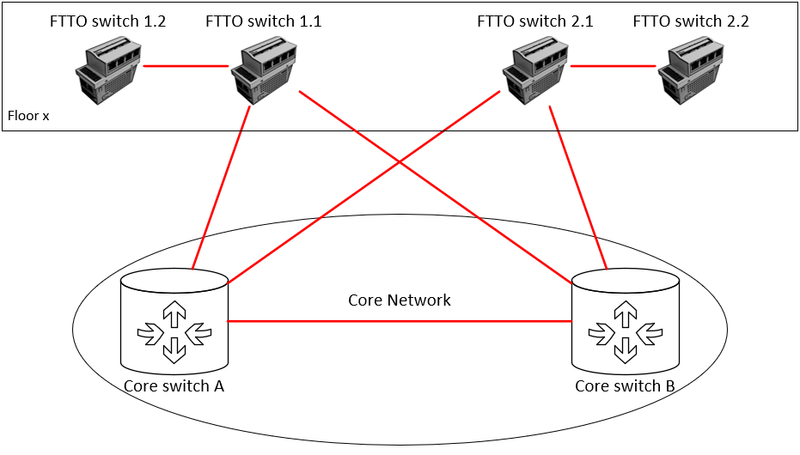

FTTO switches for office environments

FTTO switch with 2x100/1000 SFP uplinks and 1x10/100/1000 RJ45 uplink

The FTTO switch shall be a 7 Port managed Gigabit Ethernet Switch with four RJ45 user ports (1000Base-T) according to IEEE 802.3az (Energy Efficient Ethernet) on the front side, 2 Vario SFP Fast/Gigabit Ethernet uplink interfaces and an additional RJ45 uplink interface (1000Base-T) according to IEEE 802.3az (Energy Efficient Ethernet).

    - User Interfaces:
  - 4x RJ45 offering 1000BASE-T acc.to IEEE 802.3az
  - Auto-Crossover, Auto-Negotiation and Auto-Polarity (selectable)

- Uplink Interfaces:
  - 2x Vario SFP Fast Ethernet/Gigabit Ethernet Interface, SFP related monitoring functions with programmable threshold values (Syslog, SNMP-Traps etc.)
  - 1x RJ45 offering 1000Base-T acc. to IEEE 802.3az optional with PoE+ capability

- Power over Ethernet:
  - Up to 5x Power over Ethernet acc. to IEEE 802.3at (Class 0-4), remote supply of
connected devices via twisted pair cable with Mode A (1-2, 3-6) / max. 25.5 W
  - Full galvanic isolation between PoE voltage and switch electronics
  - Full PoE Plus, IEEE 802.3at, support on all ports with up to 150 Watts total power
  - Power over Ethernet Setup by Time Client

Detailed product information
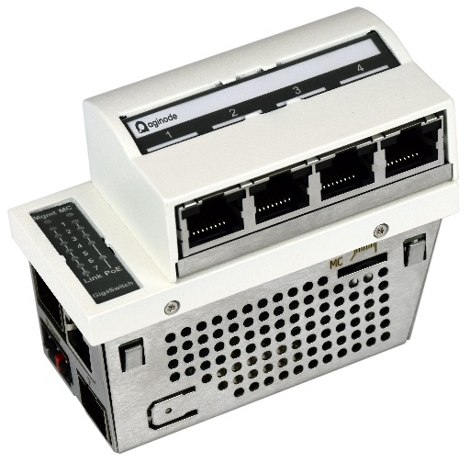
Example of products
GigaSwitch V5 TP(PSE+) SFP-2VI 54VDC, Aginode reference: 88303910
GigaSwitch V5 TP SFP-2VI 54VDC, Aginode reference: 88303920

FTTO switch with 1x100/1000 SFP uplink and 2x10/100/1000 RJ45 uplinks

The FTTO switch shall be a 7 Port managed Gigabit Ethernet Switch with four RJ45 user ports (1000Base-T) according to IEEE 802.3az (Energy Efficient Ethernet) on the front side, 1 Vario SFP Fast/Gigabit Ethernet uplink interface and two additional RJ45 uplink interface (1000Base-T) according to IEEE 802.3az (Energy Efficient Ethernet).

    - User Interfaces:
  - 4x RJ45 offering 1000BASE-T acc.to IEEE 802.3az
  - Auto-Crossover, Auto-Negotiation and Auto-Polarity (selectable)

- Uplink Interfaces:
  - 1x Vario SFP Fast Ethernet/Gigabit Ethernet Interface, SFP related monitoring functions with programmable threshold values (Syslog, SNMP-Traps etc.)
  - 2x RJ45 offering 1000Base-T acc. to IEEE 802.3az optional with PoE+ capability

- Power over Ethernet:
  - Up to 6x Power over Ethernet acc. to IEEE 802.3at (Class 0-4), remote supply of
connected devices via twisted pair cable with Mode A (1-2, 3-6) / max. 25.5 W
  - Up to 1x Power over Ethernet acc. to IEEE 802.3at (Class 0-4), as powered device with remote powering twisted pair cable with Mode A (1-2, 3-6) / max. 25.5 W
  - Full galvanic isolation between PoE voltage and switch electronics
  - Full PoE Plus, IEEE 802.3at, support on all ports with up to 150 Watts total power
  - Power over Ethernet Setup by Time Client

Detailed product information
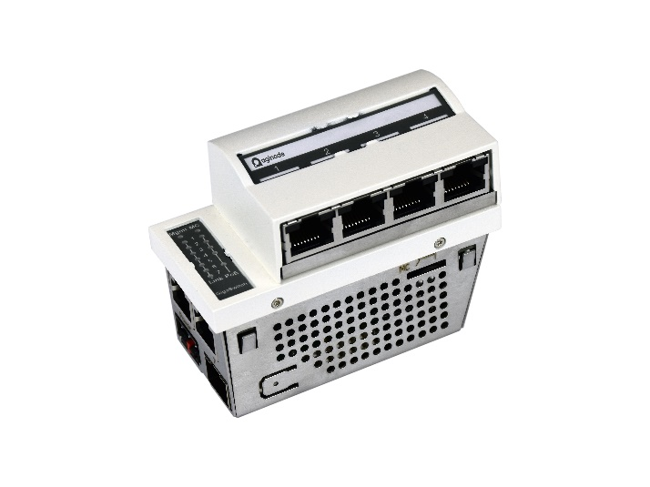
Example of products
GigaSwitch V5 2TP(PSE+) SFP-VI 54VDC, Aginode reference: 88303990
GigaSwitch V5 2TP(PD-F+) SFP-VI 54VDC, Aginode reference: 88303991
GigaSwitch V5 2TP SFP-VI 54VDC, Aginode reference: 88303992

FTTO switch with 2x/1000/10000 SFP+ uplinks and 1x10/100/1000/10000 RJ45 uplink

The FTTO switch shall be a 7 Port managed 10 Gigabit Ethernet Switch with four RJ45 user ports (1000Base-T) according to IEEE 802.3az (Energy Efficient Ethernet) on the front side, 2 Vario SFP+ Fast/Gigabit/10 Gigabit Ethernet uplink interface and one additional RJ45 uplink interface (10GBase-T) according to IEEE 802.3az (Energy Efficient Ethernet).

    - User Interfaces:
  - 4x RJ45 offering 1000BASE-T acc.to IEEE 802.3az
  - Auto-Crossover, Auto-Negotiation and Auto-Polarity (selectable)

- Uplink Interfaces:
  - 2x Vario SFP+ Fast Ethernet/Gigabit/ 10 Gigabit Ethernet Interface, SFP related monitoring functions with programmable threshold values (Syslog, SNMP-Traps etc.)
  - 1x RJ45 offering 10GBase-T acc. to IEEE 802.3az with PoE++ capability

- Power over Ethernet:
  - 4x Power over Ethernet acc. to IEEE 802.3at (Class 0-4) on the front side, remote supply of connected devices via twisted pair cable with Mode A (1-2, 3-6) / max. 25.5 W
  - 1x Power over Ethernet acc. to IEEE 802.3bt Type 3, remote supply of connected device via twisted pair cable with up to 60W output power
  - Full galvanic isolation between PoE voltage and switch electronics
  - High PoE power budget with up to 150W
  - Optional 4x Power over Ethernet acc. to IEEE 802.3bt Type 3 on the front side, remote supply of connected devices via twisted pair cable with up to 60W output power, total power budget up to 120W

Detailed product information

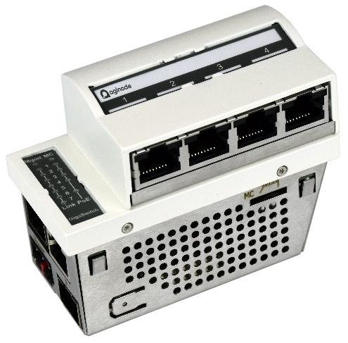
Example of products
XGigaSwitch V6 TP(PSE++) 2SFP+ 54V DC, Aginode reference: 88316722

FTTO switch with 3x1000/10000 SFP uplinks

The FTTO switch shall be a 7 Port managed 10 Gigabit Ethernet Switch with four RJ45 user ports (1000Base-T) according to IEEE 802.3az (Energy Efficient Ethernet) on the front side, 3 Vario SFP+ Gigabit/10 Gigabit Ethernet uplink interface.

    - User Interfaces:
  - 4x RJ45 offering 1000BASE-T acc.to IEEE 802.3az
  - Auto-Crossover, Auto-Negotiation and Auto-Polarity (selectable)

- Uplink Interfaces:
  - 3x Vario SFP+ Fast Ethernet/Gigabit/ 10 Gigabit Ethernet Interface, SFP related monitoring functions with programmable threshold values (Syslog, SNMP-Traps etc.)

- Power over Ethernet:
  - 4x Power over Ethernet acc. to IEEE 802.3at (Class 0-4) on the front side, remote supply of connected devices via twisted pair cable with Mode A (1-2, 3-6) / max. 25.5 W
  - Full galvanic isolation between PoE voltage and switch electronics
  - High PoE power budget with up to 150W
  - Optional 4x Power over Ethernet acc. to IEEE 802.3bt Type 3 on the front side, remote supply of connected devices via twisted pair cable with up to 60W output power, total power budget up to 120W

Detailed product information
Example of products
XGigaSwitch V6 3SFP+ 54V DC, Aginode reference: 88316723

FTTO switch for MEDICAL environment

To meet the requirements of hospitals and medical facilities, the FTTO switch shall be available in a “MEDICAL” version, i.e. in accordance with IEC 60601-1.

Specific Technical Data:
    - 4 integrated passive isolators for the user ports
    - Patient protection of 2 MOPP with overvoltage protection of up to 4 kV
    - Excellent electromagnetic compatibility (for use in laboratories, X-ray stations, in operating theatres)

Detailed product information
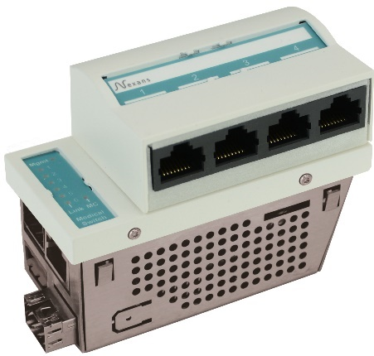
Example of products
GigaSwitch V5 TP(PSE+) SFP-2VI 54VDC MED, Aginode reference: 88303611
GigaSwitch V5 TP SFP-2VI 54VDC MED, Aginode reference: 88303612

FTTO switch for ruggedized environment
For applications in harsher environments, a ruggedized version of the FTTO switch shall be available for operation in environments with higher temperature ranges from -25°C to +60 °C.

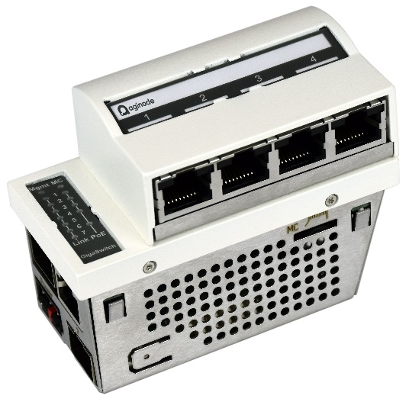
Example of products
GigaSwitch V5 TP(PSE+) SFP-2VI 54VDC IND, Aginode reference: 88303960
GigaSwitch V5 TP SFP-2VI 54VDC IND, Aginode reference: 88303965

Software Features

- Redundancy protocols
  - STP - Spanning Tree Protocol
  - RSTP - Rapid Spanning Tree Protocol
  - MSTP - Multiple Spanning Tree Protocol
  - LACP - Link Aggregation Control Protocol
  - MRP - Media Redundancy Protocol

- Discovery protocols
  - LLDP (Link Layer Discovery Protocol) acc. to IEEE 802.1ab
  - CDP (Cisco Discovery Protocol)

- Interoperability
  - Support of LLDP and CDP
    - Transfer of Voice-VLAN information to IP Phones via LLDP-Med and CDP
  - Compatibility to AAA Server like Cisco ISE, HP IMC…
    - Dynamic ACL and VLAN ID assignment Radius Server
  - Support of Fabric-Attach

- Security
  - Management hardening against external “hacker attacks”
  - AES-256 encryption for configurations on memory card
  - Security function is selectable for each port individually
  - Limitation of authorized MAC addresses (one, two or three per port)
  - Manual definition of up to three MAC addresses per port
  - Manual definition of up to three Vendor MAC addresses per port
  - Automatic learning of up to three MAC addresses per port
  - Authentication of the authorized MAC addresses via RADIUS server
  - Authentication according to IEEE 802.1x via RADIUS server
  - IEEE 802.1x authentication of IP-phone and interconnected PC
  - IEEE 802.1x Multiuser-Authentication of up to three users per port
  - IEEE 802.1x Radius MAC Bypass is selectable for user without IEEE 802.1x support
  - Unauthorized ports will be shifted to free-selectable Unsecure-, Guest- or IEEE 802.1x-Failure-VLAN
  - Optional disabling of ports in case of exceeding of maximum allowed MAC addresses number
  - IEEE 802.1x Supplicant function for uplink is selectable
  - Radius Accounting for MAC-based and IEEE 802.1x authentication is selectable
  - Change of Authorization (CoA)

- Further Management functions
  - Zero-Touch Configuration
  - Management authentication via Radius-Server (the local saved passwords can be disabled)
  - TACACS+
  - All configuration parameters and status requests are available via SSHv2/ Telnet Command Line Interface (CLI)
  - Storage of complete switch configuration as CLI-batch file
  - Loading and retrieving the switch configuration via SCP
  - Web interfaces do not need proxy server
  - Securely encrypted transfer of configuration und firmware via SCP- Secure Copy Protocol
  - System state / Configuration
  - Firmware and configuration management via software tool
  - MAC address tables
    - Separate MAC address tables per VLAN
    - The same MAC address may be placed in different VLAN's twice
    - Administration of up to 8192 MAC addresses
    - Show MAC addresses per port
    - Filtered display of MAC addresses only for selected user port
    - Address-Aging time range of 1 up to 68 minutes
  - Support of VLAN / Trunking / Hybrid
  - Up to 256 VLAN’s
  - Prioritisation acc. to IPv4, IPv6 and IEEE 802.1p is selectable
  - SNMP and SYSLOG
    - SNMPv1 and SNMPv2
    - SNMPv3 with MD5-/SHA-authentication and AES 128 Encryption
    - MIB-II, Interface -MIB, Etherlike-MIB, BRIDGE-MIB, RMON-MIB,
    - Private-MIB
    - Eight IP-Addresses for destinations of SNMP traps and SYSLOG messages
    - 26 several alarm types per destination point are selectable
    - Management Access Control/Authentication
    - 16 IP ranges can be indicated and each entry can be assigned read/write or read/only rights.
    - Access through LANactive Manager or for all interfaces can be restricted via the access list
    - SNMP access control via Read- and Write-Community
    - SCP/SSHv2/Telnet and LANactive Manager authentication via RADIUS server
    - Web, SSHv2 and Telnet console interfaces can be disabled
    - Periodic Transmission of Life Packets (can be disabled)
    - Gratuitous-ARP function guarantees accessibility of the switches after change of the IP address
  - Port counter: 30 counters for packets, bytes, unicasts, broadcasts, etc. per port
  - Environment monitoring: Temperature, internal power supply, PoE power supply

Removable HEAD modules (HEAD range)
Replacement and evolution kits for the RJ45 modules of the FTTO switches must be available for maximum flexibility:
- during the installation of the network (no need to define in advance the amount of vertical and horizontal versions)
- in case of Move-Add-Change (on-site modification, by the IT staff in a few minutes, of the orientation of the RJ-45 ports of the switched off device)

The FTTO switch must recognize the new HEAD hardware as soon as it reboots. The configuration must remain unchanged.

A LANactive MED kit version must be available to quickly prepare a standard FTTO switch for use in the patient's direct environment, i.e. its RJ45 ports must be insulated in accordance with IEC 60601-1.

Detailed product information

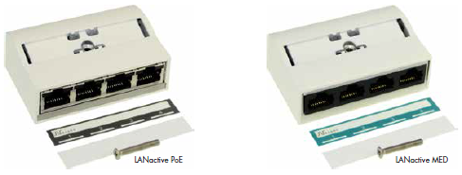

Example of products
LANactive PoE HEAD GigaSwitch V5 Kit, Aginode reference: 88303952
LANactive MED HEAD GigaSwitch V5 Kit, Aginode reference: 88303951

Upgrade capability to PoE++ HEAD
Replacement and evolution kits for the RJ45 modules of the FTTO switches must be available for maximum flexibility:
- during the installation of the network (no need to define in advance the amount of vertical and horizontal versions)
- in case of Move-Add-Change (on-site modification, by the IT staff in a few minutes, of the orientation of the RJ-45 ports of the switched off device)

The FTTO switch must recognize the new HEAD hardware as soon as it reboots. The configuration must remain unchanged.

A LANactive POE++ head version must be available to quickly prepare a standard FTTO switch for the support of PoE++.

Detailed product information

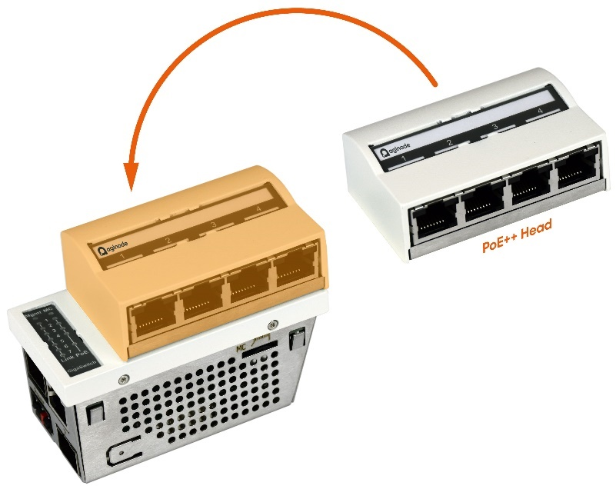

Example of products
LANactive PoE++ Head GigaSwitch Kit, Aginode reference: 88303649
LANactive PoE++ Head, pre-installed, Aginode reference: 88303648

Accessories

Memory cards
Features
      - Compact microSD Card format
      - Storage of switch configuration and firmware
      - Each Memory Card with unique MAC address
      - Easy configuration and replacement of switch systems
      - Wide temperature range

Usable for:
      - FTTO switches
      - FTTO Desk switches

Detailed product information

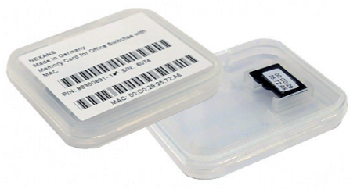

Example of products
Memory Card for Office Switches with MAC-Address
Aginode reference: 88300691

Memory Card for Office Switches with MAC-Address, integrated
Aginode reference: 88300693

Installation sets

Universal Cover set

Features
      - cover set for Snap-In systems with 45mm format
      - suitable for installation systems with dimensions 45x90 mm
      - universal support for easy installation
      - plastic cover 80x148 mm, pure white (RAL 9010)
      - additional locking against removing of Snap-In systems
      - suitable for international cable ducts systems
Scope of delivery:
- support of stainless steel
- plastic cover, pure white

Example of products
Cover set 45x90 incl. MF, PW/9010 80x150, Aginode reference: 88646030

Mounting Kits
The mounting kits can be used for installation of FTTO switches in typical construction environment. These professional boxes allow easy mounting and integration of network equipment into and on walls. The mounting sets are equipped with holder and faceplate, 88646267 and 88646266, according to 45x45 mm Form Factor. The mounting kits allow the tool-free installation of the Switches and Click-In Power Supply series. More technical information and support on request.


Example of products
Cover 82x224/45x135 Legrand, white, horizontal, Aginode reference: 88646266

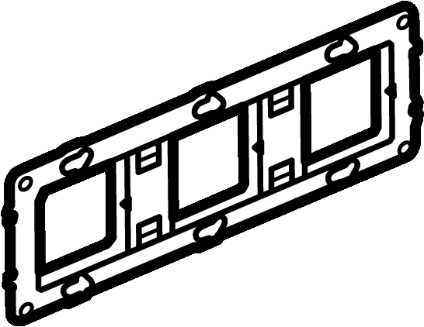
Example of products
Universal support for Legrand cover 82x224, Aginode reference: 88646267

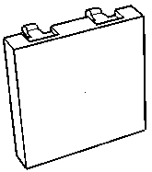
Example of products
Blind cover 45x45, white, Aginode reference: 88646037



In-wall installation box 3 gang, 55 mm installation depth, Aginode reference: 88646268

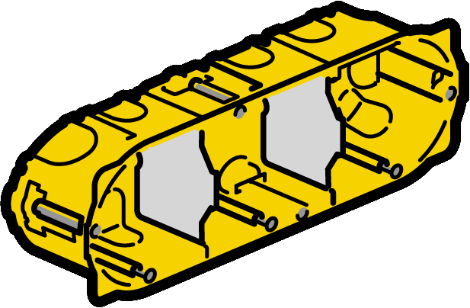
Drywall installation box 3 gang, 55 mm installation depth, Aginode reference: 88646274
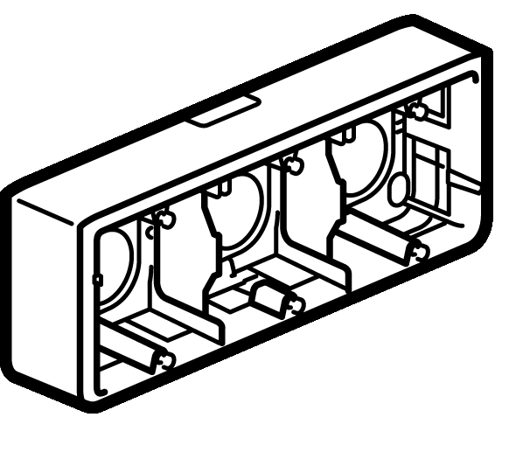
On-wall installation box 3 gang,Aginode reference: 88646276

Installation Profile
Aginode installation profile for GigaSwitch series provides a best integration of a switch in combination with a Click-In power supply unit. The range of use cases is supported through variety of connection options for pre-terminated fibre optic cable, twisted pair and power cables. The profile can be mounted on the wall and the table. Optionally available is the corresponding blind cover in 45 x 45 mm.

Features
- Suitable for GigaSwitch and Click-In 70W or 130W power supplies
- Easy mounting
- 4x M25 holes for cable glands
- Hole for Kensington lock
- Optional desk mounting kit
- Compact design
Scope of delivery:
Profile incl. wall mounting kit and screws in pure white
Example of products
Installation profile 4x6 RAL9010 4xPG, Aginode reference: 88646310

DIN-Rail Mounting kit

Features
      - Dimensions for 45x90mm footprint: 43x89x40 mm (without DIN-rail clip), 43x89x47 mm (with DIN-rail clip)
      - Dimensions for 45x135mm footprint: 43x144x38 mm (without DIN-rail clip), 43x144x46 mm (with DIN-rail clip)
      - Material: zinc coated sheet

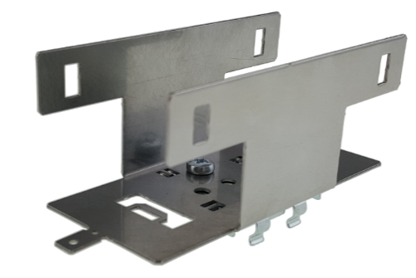
Example of products
Mounting kit 45x90 GSW metal DIN-rail, Aginode reference: 88646199
Mounting Kit 45x135 DIN-Rail, Aginode reference: 88646197

Fibre in the Digital Ceiling
Based on the latest technology standards and the increasing number of IoT and BIoT devices, a future proof IT infrastructure must be able to serve all the connected applications. Such a future-proof infrastructure is based on fibre optic cabling and active Ethernet switches located in different places in the building. Especially, serving application that are located in the ceiling like Wireless LAN access points, IP cameras or Smart Building Systems, makes it necessary to think about new cabling concepts.
The installation of fanless, active Ethernet switches above or next to the ceiling connecting these applications is one approach.
The active switches ensure intelligent conversion from fibre to copper and vice versa. Each switch, is equipped with RJ45 user ports to feed terminal devices with data and power. Fibre speed, reliability and long distance coverage are coupled with the benefits of Ethernet.

Bandwidth
The user ports must support the latest generation of WiFi 6 access points coming with Multigigabit interfaces. The uplink bandwidth must be 10 Gigabit based on SFP+ transceiver.

Redundancy
Redundancy, via dual optical uplink interfaces, must be available by using ring topology or link aggregation.

Installation
To offer an easy and fast installation in a ceiling environment, the concept contains a set of installation possibilities. Additional installation equipment offering a toolless installation of the active switch must be available, combined with the option to terminate the passive network like copper or fibre cables.

Memory Card
A memory card supports the automatic storage of complete and most current configuration and firmware of the switch. The Memory Card with own MAC address allows an easy system replacement. Memory card is an optional item and shall not be mandatory to operate the switch. Also the use of Memory card can be disabled by software, if necessary.

Security
The switch supports the non-volatile storage of SYSLOG messages in flash memory, SNMPv3/SCP/SSHv2/Telnet/HTTP/HTTPS management and wide range of Security features incl. TACACS+/Radius/IEEE 802.1x/Network Access Control Lists (NACLs).

Digital Ceiling switch

The Digital Ceiling switch shall be a 10 Port managed Ethernet Switch with 8 user ports on the front side and 2 SFP+ uplink interfaces.

    - User Interfaces:
  - 4x 1000BASE-T acc. to IEEE 802.3az
  - 4x 2.5GBase-T acc. to IEEE 802.3bz
  - Auto-Crossover, Auto-Negotiation and Auto-Polarity (selectable)
  - IEEE802.3az Energy Efficient Ethernet
  - Twisted Pair Cable Diagnostic
    - Uplink Interfaces:
  - 2x SFP+ supporting 10Gigabit or Gigabit Ethernet
  - Digital Diagnostic Monitoring Interface.
    - Power over Ethernet (optionally, refer to chapter 11.1.2):
  - Up to 8x Power over Ethernet acc. to IEEE 802.3bt (Class 0-8) up to 90W per port with a total power budget of
500W with external PSU or
240W with internal PSU

- Memory Card: SD Memory Card
- LEDs: Management, Memory Card, Port status, PoE status
- Switching capacity: 68 Gbps
- Packet buffer: 8 Mbytes
- MAC-Address-Table size: 16k MAC-addresses
- Dimensions (WxHxD): 345 x 53 x 170 mm
- Operating voltage range: 100…240V AC, 50/60Hz with internal PSU
- 46…57V DC with external PSU
- Power Consumption without PoE: Max. 16.5W
- Operating temperature range: 0…+45°C
- Storage temperature range: -40…+85°C
- Relative humidity: 20% - 90% non condensing
- Cooling concept: Fanless, passive cooling concept

Scope of delivery:
88306800: XGigaSwitch DICE incl. power cable
88306801: XGigaSwitch DICE

Detailed product information

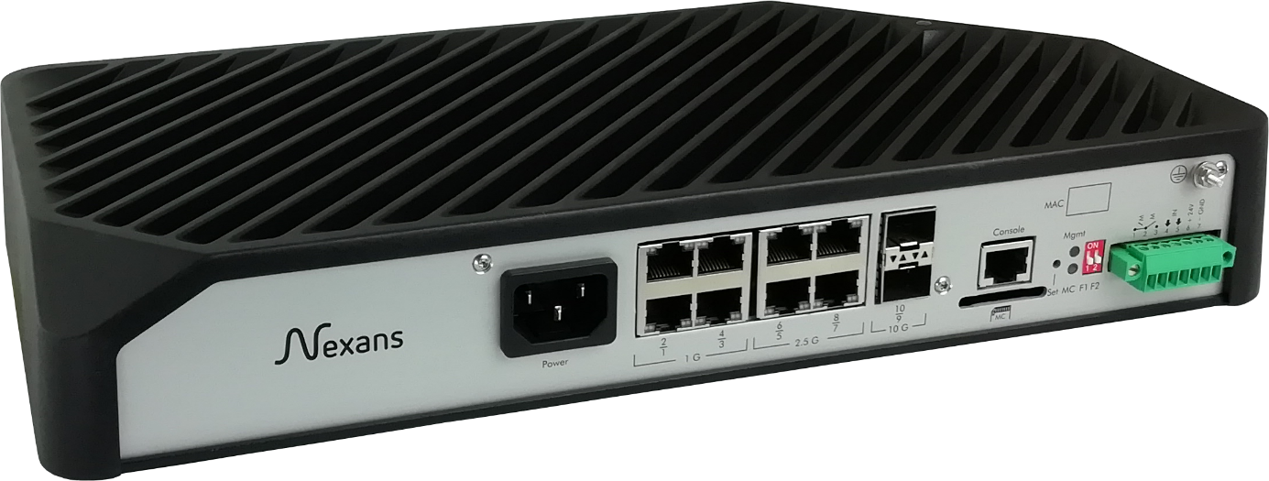

Example of products
XGigaSwitch DICE 8TP 2SFP+ AC, Aginode reference: 88306800
XGigaSwitch DICE 8TP 2SFP+ DC, Aginode reference: 88306801

Software Features
The software contains the same features like the FTTO switches. Refer to chapter 10.6.

Power over Ethernet options
To offer the full flexibility and a product based on customer demands and projects, the Power over Ethernet functionality should be optional. The Digital Ceiling switch should be equipped without a PoE module, with a PoE+ module or with a PoE++ module. This module is fixed in the switch and not movable. It cannot be equipped by customer, it must be installed during production.

The following options should be available:
- 8x PoE+ according to IEEE802.3at with up to 30W per port
- 8x PoE++ according to IEEE802.3bt with up to 90W per port

iOption PoE+ 6/8-30W, Aginode references: 88301604
iOption PoE++ 6/8-90W, Aginode references: 88301666

Accessories
Digital Ceiling switches shall offer the maximum mounting capabilities in combination with several passive components.

19“ Mounting Kit
The 19“ Mounting Kit allows an easy installation of the Digital Ceiling switch in 19” racks. The brackets are mounted sidewise.
Example of products
XGigaSwitch DICE 19“ Mounting Kit, Aginode reference: 88646402

DIN-Rail Mounting Kit
The DIN-Rail Mounting Kit allows an easy installation of the Digital Ceiling switch on standard DIN-Rails. The clip is fixed on the backside of the switch.

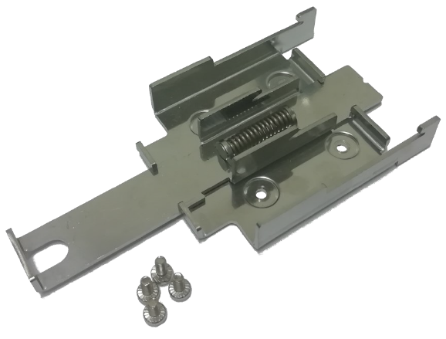
Example of products
XGigaSwitch DIN-Rail Mounting Kit, Aginode reference: 88306811

Mounting Plate
The mounting plate allows an easy and smart installation of the Digital Ceiling switch. It can be mounted on walls or below the ceiling and has an integrated fixing mechanism for the active switch. After installation of the mounting plate the Digital Ceiling switch can be mounted toolless. The integrated strain-relief allows a safe and protected installation of cop-per or fibre optic cables.
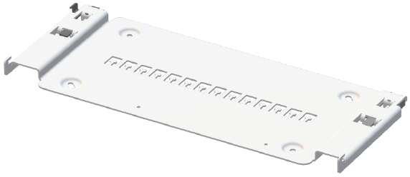
Example of products
XGigaSwitch DICE Mounting Plate, Aginode reference: 88646400

Strain-relief
In case the integrated strain-relief is not sufficient at the mounting plate, an external additional strain-relief can be added to fix the cables in front of the Digital Ceiling switch.
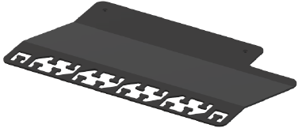
Example of products
XGigaSwitch DICE Strain-Relief, Aginode reference: 88646401

Mounting Frame
The mounting frame allows the installation and termination of the needed network and power cabling. It offers the installation of up to 12 Aginode snap-in connectors terminating copper and/or fibre cabling. It is also possible to connect the power cabling via WAGO or Wieland connector.
After installation of the mounting frame the Digital Ceiling switch can be mounted toolless.
Example of products
XGigaSwithc DICE Mounting Frame, Aginode reference: 88646470

Mounting Frame Cable Protection
To protect the cabling for unauthorized access the cable protection can be used.
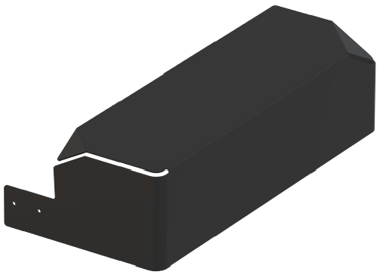
Example of products
DICE Mounting Frame Cable Protection, Aginode reference: 88646472

SFP and SFP+ transceivers

SFP/SFP+ transceiver are plug-in modules. “SFP” stands for Small Form Factor Pluggable. The devices with SFP capability are economical and offer flexibility when the users need to change or upgrade the network interface of the FTTO switch.
The SFP shall be compliant with SFP MSA (Multi-Source Agreement) and SFF-8472. All modules shall satisfy Class I Laser Safety requirements in accordance with the international standard IEC-825.

Features
      - Fast Ethernet, Gigabit Ethernet and 10 Gigabit Ethernet Versions
      - LC Duplex or LC simplex connector
      - Hot-swap pluggable
      - Compliant with SFP MSA specification and SFF-8472
      - Wide industrial operating temperature range, -40°C up to +85°C
      - Long reach with single-mode fibre, up to 120km
      - Digital Diagnostic Monitoring (DDM)
      - Threshold values capability
      - Diagnostic information in EEPROM
      - Detailed product specific information in EEPROM
      - Predefined warning capability
      - Class 1 Laser Safety Compliance

DDM Function
The SFPs shall also support the “Digital Diagnostic Monitoring” function according to the standard SFF-8472 and multisource agreement. This feature gives the users the ability to monitor real-time parameters of the SFP module.

Moreover, by using SFP modules with Digital Diagnostic Monitoring function in FTTO switches or Digital Ceiling switches users are able to monitor via the management software the optical parameters such as optical input power, optical output power, transceiver’s supply voltage and laser bias current, and to recognize upcoming problems with the fibre optic link at an early stage!

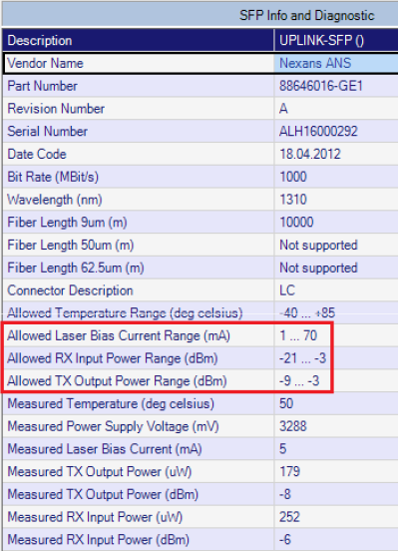

Alarm Function
The switch management software (see chapter 12) shall allow to define “Threshold Values” for Laser Bias Current, Output Power and Input Power for each individual SFP interface! Using this function as an early warning system allows to increase network availability drastically. The FTTO switches with SFP slots can use the monitoring and diagnostic capability to calculate attenuation of the fibre link.

Technical Data

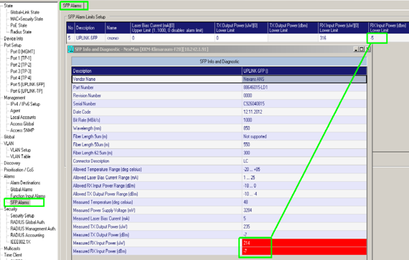

Parameter | 88646015 | 88646016 | 88646073 | 88646075
Data rate | GbE | GbE | GbE | GbE
Fibre Type | multi mode | single mode | single mode | single mode
Link Type | dual fiber | dual fiber | single fiber | single fiber
TX Centre Wavelength, nm | 850 | 1310 | 1310 | 1550
RX Centre Wavelength, nm | 850 | 1310 | 1550 | 1310
Specified Link Length, m | 550 | 10,000 | 10,000 | 10,000
DDM* Support | Yes | Yes | Yes | Yes
Output Optical Power, dBm | -9…-4 | -9…-3 | -9…-3 | -9…-3
Optical Input Sensitivity, dBm | -18…0 | -21…-3 | -21…-3 | -21…-3
Optical Budget, dB | 9 | 12 | 12 | 12
Case Operating Temperature, °C | -40…+85 | -40…+85 | -40…+85 | -40…+85

Parameter | 88646390 | 88646391 | 88646392 | 88646393
Data rate | 10GbE | 10GbE | 10GbE | 10GbE
Fibre Type | multi mode | single mode | single mode | single mode
Link Type | dual fiber | dual fiber | single fiber | single fiber
TX Centre Wavelength, nm | 850 | 1310 | 1270 | 1310
RX Centre Wavelength, nm | 850 | 1310 | 1310 | 1270
Specified Link Length, m | 550 | 10,000 | 10,000 | 10,000
DDM* Support | Yes | Yes | Yes | Yes
Output Optical Power, dBm | -6…-1 | -6…-0.5 | -6…-1 | -6…-1
Optical Input Sensitivity, dBm | -10…0.5 | -15…-0.5 | -14.4…-0.5 | -14.4…-0.5
Optical Budget, dB | 4 | 9 | 8.4 | 8.4
Case Operating Temperature, °C | -40…+85 | -40…+85 | -40…+85 | -40…+85

Detailed product information

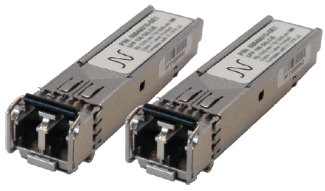
Example of products
Aginode SFP 1000 Transceiver GI(LC)E – dual fibre, Aginode reference: 88646015
Aginode SFP 1000 Transceiver SM(LC)E L10 – dual fibre, Aginode reference: 88646016
Aginode SFP 1000 Transceiver SM(LC)E L40 – dual fibre, Aginode reference: 88646017
Aginode SFP 1000 Transceiver SM(LC)E L80 – dual fibre, Aginode reference: 88646018
Aginode SFP 1000 Transceiver SF3(LC)E L10 – single fibre, Aginode reference: 88646073
Aginode SFP 1000 Transceiver SF5(LC)E L10 – single fibre, Aginode reference: 88646075

Aginode SFP+, 10G Base-SR, 850nm MM, Aginode reference: 88646390
Aginode SFP+, 10G Base-LR, 1310nm SM, Aginode reference: 88646391
Aginode SFP+, 10G Base-BX-U, 1270nm SM Bi, Aginode reference: 88646392
Aginode SFP+, 10G Base-BX-D, 1330nm SM Bi, Aginode reference: 88646393

Click-In Power Supply Units

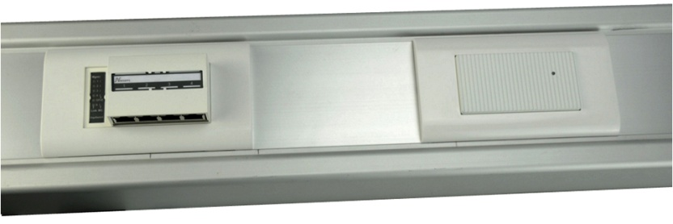
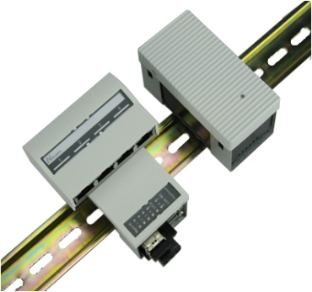
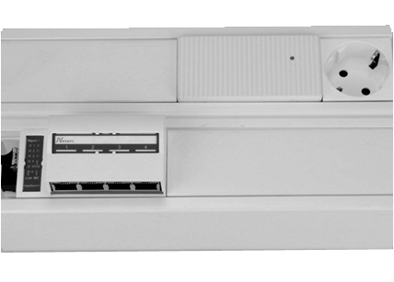
Regarding the FTTO switches with Power over Ethernet function, for the PoE defined by the IEEE 802.3at standard, 54V DC is the voltage to be supplied. This is to be carried through a 230V AC / 54V DC power supply unit (PSU) perfectly integrated in the cable trunk (see picture below) and able to deliver up to 70 Watts or 130 Watts (depending on the version).
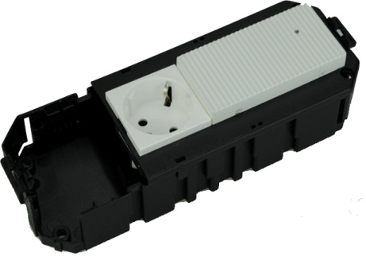

In case of 70 Watts version, the possibility of eventually migrating to a more powerful PSU will be considered from the beginning. For that, an additional 45x45 space must be planed.

Concept schemes
The first rule is that power (W) should always be transmitted with the highest possible voltage (V). The distributed power supply concept is the best approach when it comes to flexibility and energy efficiency.
Due to the comparatively short distances between the powered end user devices and the power source, significant losses can be avoided and important power savings can be achieved.
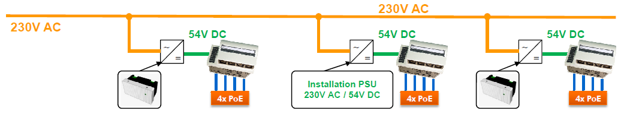
When a higher power budget is required, e.g. over 70W or 130W per FTTO switch, power supplies with a higher power output can be used.

It is possible to consider the installation of a UPS to manage the micro cuts and so prevent electrical interruptions...

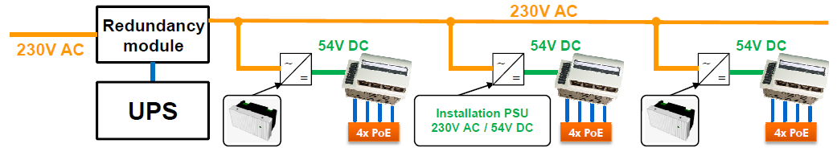

Features
The PSU shall be ultra-compact, of a small depth and optimized for better caloric dissipation (metal front). The Click-In power supply has a front LED for a quick indication of its condition.

- Power Supply for FTTO switches with 54V DC Input and PoE capability
- Full PoE+, IEEE 802.3at, compatibility
- Easy and toolless installation
- Support of 45mm installation format
- Fanless System with aluminum faceplate for best thermal performance
- Control-LED
- Output Power: 70 Watts or 130 Watts depending on the version
- Primary Connection (100-240V AC): - Removable 3-pin connector
- Secondary connection (54V DC): - Removable 3-pin connector
- Mutual connection of function earth
- Low Voltage Directive "Protection Class I"
- Redundancy with to DC coupled power supply possible
- Different cable connection sets depending on project demands

Dimensions (mm):
70W version: 90 x 45 x 46 (aluminum faceplate: 90 x 45 x 13; plastic housing: 85 x 40 x 33)
130W version: 135 x 45 x 53 (aluminum faceplate: 135 x 45 x 20; plastic housing: 130 x 40 x 33)

Detailed product information
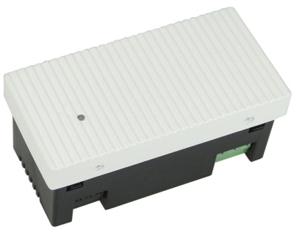
Example of product
Click-In Power Supply 54VDC/70W 90x45, Aginode reference: 88646210

Click-In Power Supply 54VDC/70W 90x45
Rated input range 100-240V AC – 50/60Hz
Rated output range 54V DC
Output current, max. 1.24A
Output power, max. 70W
Electrical protection short circuit, over voltage and over current protection
Efficiency min. 86% / typ. 90%
Weight 200g
Dimensions 90 x 45 x 46
(aluminum faceplate: 90 x 45 x 13; plastic housing: 85 x 40 x 33)
Ambient operating temperature range 0…+45°C
Storage temperature range -10…+55°C
Relative humidity 5% - 90%
Safety EN 62368-1
EMC EN 55032, EN 55035 , EN 61000-3-2, EN 61000-3-3
RoHS EN 50581
Protection Class I

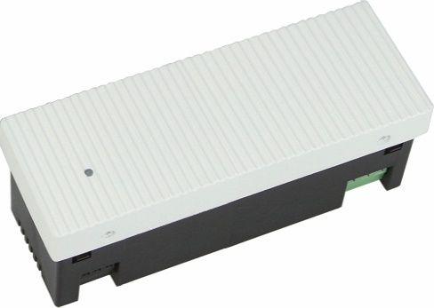
Example of product
Click-In Power Supply 54VDC/130W 135x45, Aginode reference: 88646241

Click-In Power Supply 54VDC/130W 135x45
Rated input range 100-240V AC – 50/60Hz
Rated output range 54V DC
Output current, max. 2.4A
Output power, max. 130W
Electrical protection short circuit, over voltage and over current protection
Efficiency min. 90% / typ. 92%
Weight 330g
Dimensions 135 x 45 x 53
(aluminum faceplate: 135 x 45 x 20; plastic housing: 130 x 40 x 33)
Ambient operating temperature range 0…+45°C
Storage temperature range -10…+70°C
Relative humidity 5% - 90%
Safety EN 62368-1
EMC EN 55032, EN 55035 , EN 61000-3-2, EN 61000-3-3
RoHS EN 50581
Protection Class I

Accessories
The power cables for the power supplies can be equipped with plug-in electrical connectors like Wago, Wieland or other types. This option helps for a fast installation and is particularly appreciated for a simplified maintenance.
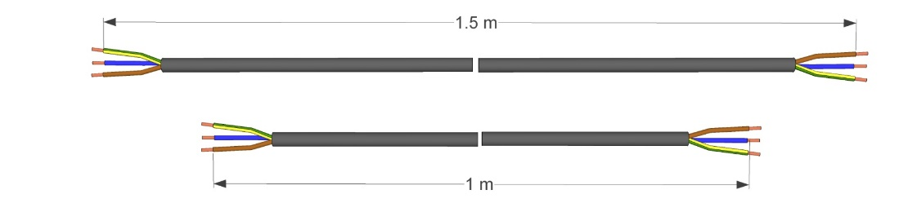
Cable set pre-term 1m 1.5m open wires
Aginode reference: 88646280

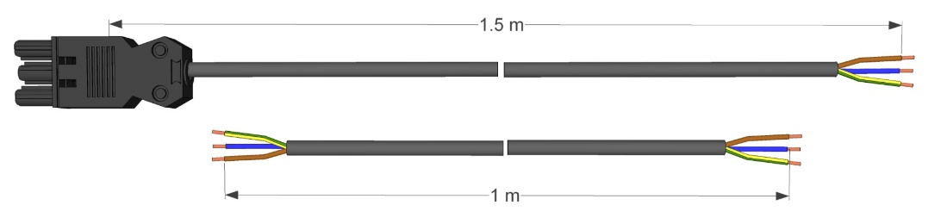
Cable set pre-term 1m 1.5m-Wieland GST18
Aginode reference: 88646281

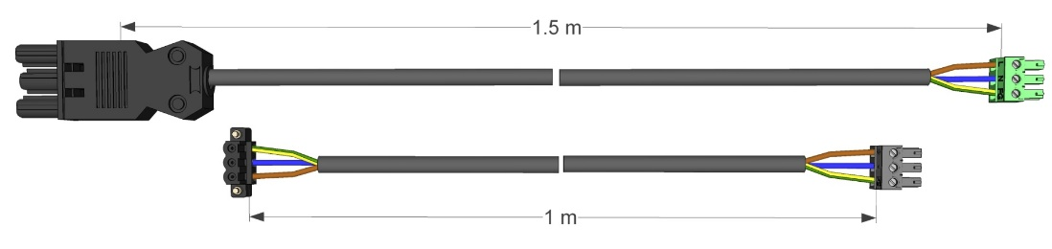
Cable set 54VDC 1m 230VAC 1.5m WLND
Aginode reference: 88646264

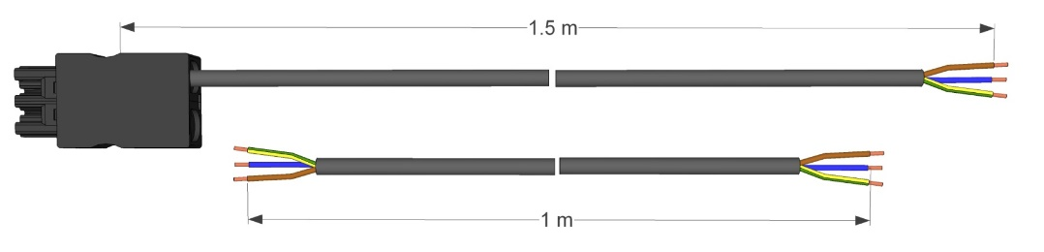
Cable set pre-term 1m 1.5m-Wago Winsta
Aginode reference: 88646282

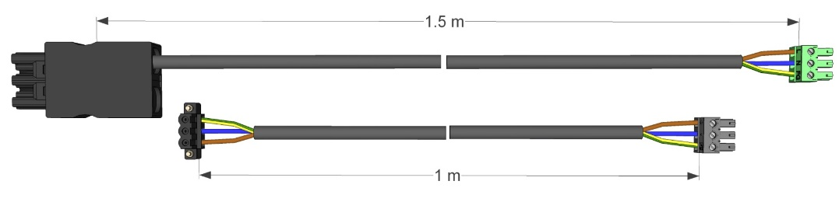

Cable Set 54VDC 1m 230VAC 1.5m Winsta
Aginode reference: 88646278

Management Software
The centralized management software provides an easy and comfortable solution for configuration, management and supervision of FTTO and Digital Ceiling switches being part of a network.

Integration into Higher Level Management system
Thanks to activation of optional parameters during set-up of the management software, it can be easily integrated into a central management system.

Zero-Touch Configuration
Zero-Touch Configuration is a contemporary way of designing, building and operating networks with minimum efforts. The management software ensures that networks are flexible and scalable.
After connecting a switch to a network segment, the switch will automatically link to its controller to receive provisioned firmware and configuration.

Auto discovery feature
Through the automatic discovery feature at layer 2, all switches part of the same network segment, or VLAN as the management PC will be found. Alternatively, a layer 3 automatic discovery via a router can be performed.

Master Configuration
Through a master configuration single or multiple switches of a device list can be configured at once. The administrator can select which parameter shall be transmitted. Hence, Master Configurations can be set up, in which for instance only SNMP settings or password for switches will be changed. Moreover master configuration can be saved for each department, in case they require different settings.

- Fast Layer-2 Autodiscovery and simple basic configuration for devices within the local segment
- Layer-3 Autodiscovery through configurable IP ranges for devices behind IP routers
- The devices are permanently polled and marked in the device list in corresponding colors
- The device list is automatically updated through polling and changes are highlighted in color
- Devices with alarm messages are automatically shifted to the top of the list
- Firmware update for one or more devices
- Time-scheduled firmware update in the night or at the weekend
- Reading and writing of device configurations via SCP
- Username/password protected reading and writing of device configurations
- Automatic download of device configurations for one or more devices
- Storage of device configurations in a database on the PC or on a central server
- Storage of old device configurations via history function in the database
- Five state tabs with online indication of all state information of the device
- Reset of Error and Statistics counters for one or more devices
- Individual selection of storage locations for device lists, database, master configurations and firmware
- Creation of any number of device lists, e.g. to arrange devices into groups etc.
- Creation of any number of master configurations for distribution to one or more devices
- Each master configuration may specify different parameters for distribution
- Comprehensive information on update and progress in a log window
- Information from the log windows available for later analysis
- Sorting of device list by IP address, MAC addresses, device name and software version
- Import of device lists as CSV (comma/semicolon separated) files, e.g. from NSCM or Excel
- Layer 2 Autoconfiguration of basic switch parameters like IP address, gateway etc...
- Direct calling of SSH or WEB from the device list of device editor
- Easy restoration of the delivery condition
- Online diagnostic and monitoring information of SFP-modules
- Freely definable categories in tree structure
- Assignment of the devices via Drag & Drop
- Recursive counting of devices within the category
- Labeling of category by incoming alarms in basic or in the sub-category
- Device manager access via SCP (Secure Copy Protocol)
- Freely definable view of device list (Displayed columns)
- Creation of Excel or XML inventory lists
- Client-Controller Functionality
- Database Mirroring (SQL Server) increases availability of database and data protection
- Improved availability of the production database during upgrades
- Access-Levels and Device-List assignment
  - Easily add/edit/manage user credentials
  - Assign different roles and Switch Lists per user

Positioning on Maps or Floor Plans
It is possible to place the switches on a map or on customized building floor plans. A simple click on the map automatically defines the longitude and latitude.
For positioning inside the building, you only need to upload the floor plans and place the switches at the locations where they are installed.

Web Interface
Web access allows technicians and administrators to connect to LANactive Manager through a standard browser on a device such as a tablet or smartphone.
For this purpose, LANactive Manager must be installed as a “Controller” instance, including a Controller license.
Access to LANactive Manager can be secured via HTTPS. You can either use the default certificate or provide your own.

Detailed product information
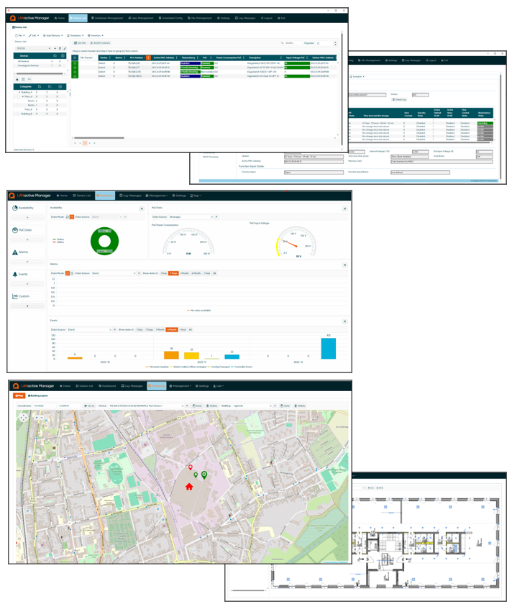

Example of products
LANactive Manager V8 Controller 500 – Initial license for up to 500 switches + 1 year of operation
Aginode Reference: 88643008
Possibility to extend the total number of Aginode switches on the network in increments of 500, 1000, or 2000.

LANactive Manager V8 Controller 500 – Additional 1‑year operation license
Aginode Reference: 88643012

LANactive Manager V8 Stand-alone 100 – Initial license for up to 100 switches + 1 year of operation
Aginode Reference: 88643015
Possibility to extend the total number of Aginode switches on the network in increments of 100 or 200.

LANactive Manager V8 Stand-alone 100 – Additional 1‑year operation license
Aginode Reference: 88643018

Rack unit solution

Smart Building racks
The proposed 19’’ rack shall be a high-performance cabling rack engineered for structured network configurations in corporate environments.
The rack is designed to perfectly answer to the enterprise cabling configuration, with smart cable management and to support current and future IT densities with efficiency and precision.
Offering loading capacity of 1500kg, the rack is equipped with double front glass door and double rear full metal door.
The specific metal frame sh all be developed to support high loading capacity up to 1500kg, and so
supporting 19-inch switches and all LAN equipment to secure and organized the network installation.
The rack is optimized for efficient cable routing and maintenance in enterprise networks.
The rack is equipped with a digital thermometer for a view on the internal temperature in order to allow a quick intervention in case of high temperature.
The rack shall be equipped with side panels divided into upper and lower sections. For safety and ergonomic reasons, the upper section shall be opened first to allow access to the lower section. This two-part design reduces the lifting effort compared to a single large panel and facilitates easier handling during installation. The upper section shall be equipped with a lock.

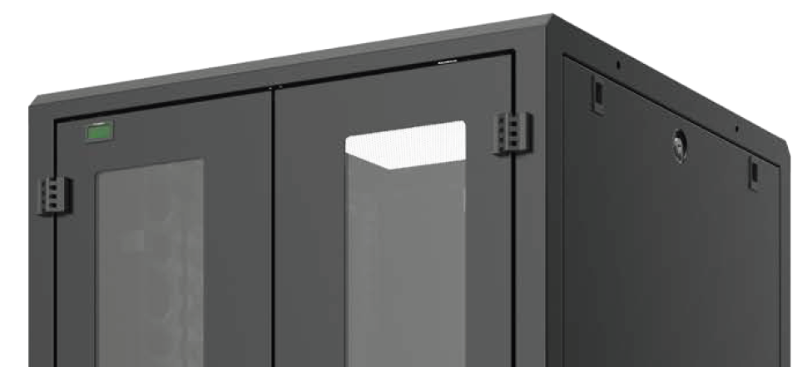

Equipped with double glass door, with a full opening at 180°, to allow a quick check on the correct operation of the IT network.
The rack shall be available in both standard and extension executions. Extension executions shall be supplied without side panels for use in row configurations, as only the first and last racks in the line require side panels.
A width of 800 mm shall provide adequate lateral space for enhanced cable management through dedicated lateral cable managers. An optional internal cable tray may be added to support internal cable routing.
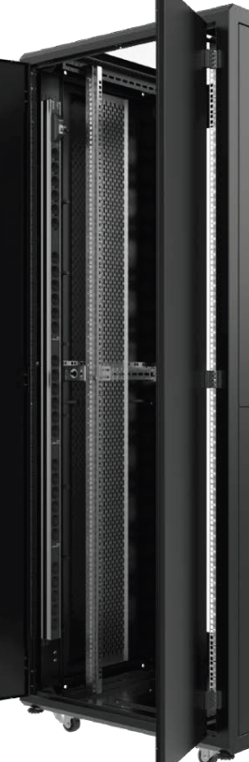
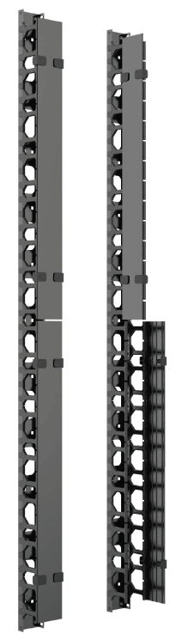

The rack shall be available in 800mm and 1000mm depth
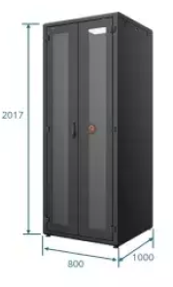

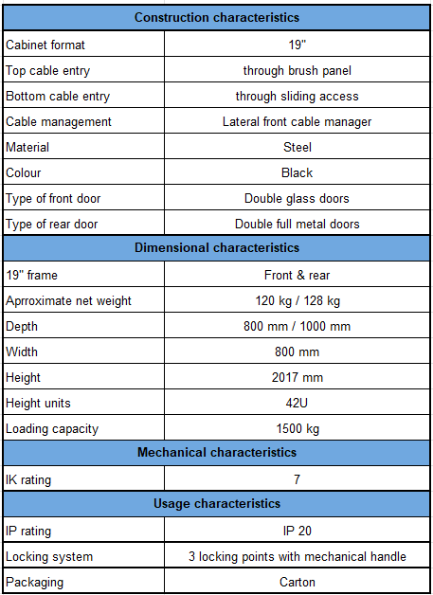

Detailed product information
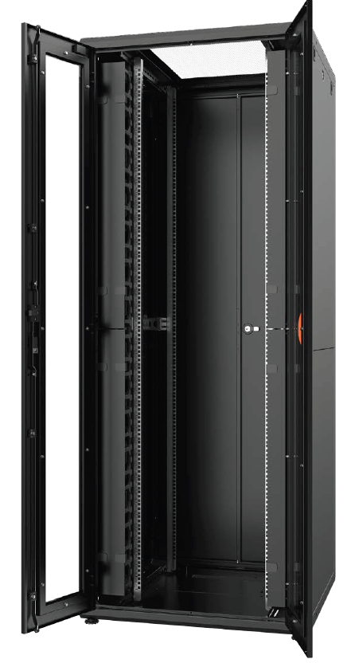
Example of products
LANMARK RACK UNIT SOLUTION CSB 42U 800X800 GLASS FRONT DOOR
Aginode reference: NRCK.420808.261-B

LANMARK RACK UNIT SOLUTION CSB 42U 800X1000 GLASS FRONT DOOR
Aginode reference: NRCK.420810.261-B

Server DC racks
The proposed 19’’ rack shall be a high-performance cabling rack engineered for Data Centre environments. It shall ensure optimal airflow through an 80% perforation ratio. With the growing use of AI configurations and heavier GPU servers, the rack’s metallic frame shall be designed to support a high load capacity of up to 1500 kg.
The integrated smart cable management system shall ensure proper bending radius for all cables and patch cords, maintaining optimal performance. A double front door shall provide full access to the cabling area, facilitating technical interventions inside the rack. The doors shall be equipped with a three-point locking system to guarantee a high security level.
A smart handle with RFID card access may be offered as an option to eliminate the need for key management.
The rack shall be offered with the following dimensions
- Heights: 42U and 47U
- Depths: 800, 1000 and 1200 mm
- Width: 800 mm
The rack shall be equipped with side panels divided into upper and lower sections. For safety and ergonomic reasons, the upper section shall be opened first to allow access to the lower section. This two-part design reduces the lifting effort compared to a single large panel and facilitates easier handling during installation. The upper section shall be equipped with a lock.
The rack shall be available in both standard and extension executions. Extension executions shall be supplied without side panels for use in row configurations, as only the first and last racks in the line require side panels.
A width of 800 mm shall provide adequate lateral space for enhanced cable management through dedicated lateral cable managers. An optional internal cable tray may be added to support internal cable routing.

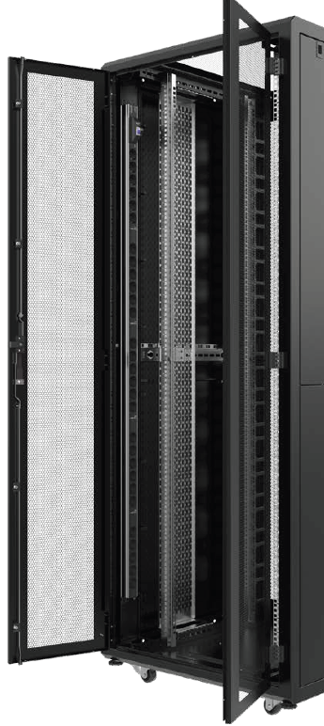

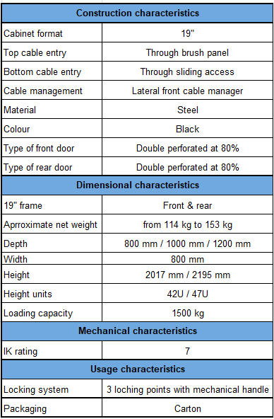

Detailed product information
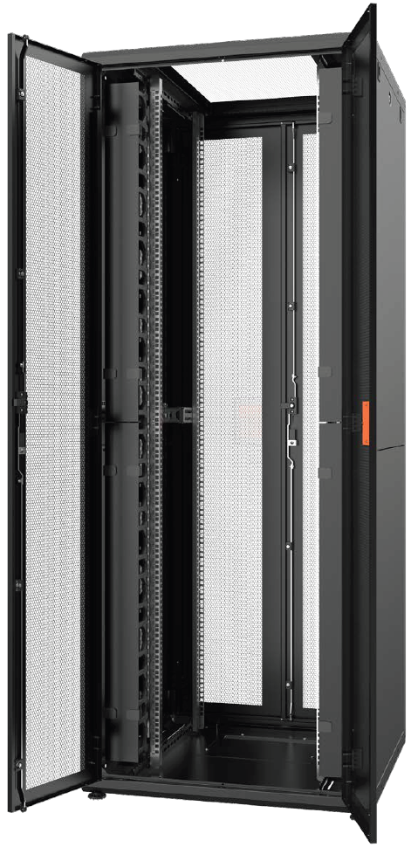
Example of products
DCMARK RACK UNIT SOLUTION SERVER DC 42U 800X800
Aginode reference: NRCK.420808.441-B

DCMARK RACK UNIT SOLUTION SERVER DC 47U 800X1000
Aginode reference: NRCK.470810.441-B

Testing
The manufacturer of the cabling system shall provide copper (Data) and optical fibre testing procedures that
clearly describes the tools and settings to be used to ensure correct measurements of the system.

Fibre testing
In order to avoid contamination and potential damage of optical fibre end-faces and/or connecting hardware
due to the build-up of static charge during transport, manufacturers recommended cleaning procedures (compliant to the ISO 62627 standard – Fibre optic connector cleaning methods) shall be applied before any connection is made to any fibre connector.
Although pre-terminated assemblies (LC or MTP) are supplied with test certificates, it is a requirement under the manufacturer warranty procedure to supply test results for the installed system and applies for both Multimode and Singlemode installations.
The testing procedure shall comply with the ISO/IEC 14763-3:2006/A1 2009 and IEC 61280-4-1/Ed.3 and IEC 61280-4-2/Ed.2 standards and be in accordance with the latest issue of the ‘Field testing procedure’ document to be provided by the cabling manufacturer.
The ISO/IEC 14763 standard specifies the implementation and operation of customer premises cabling.
The part 3 of this ISO document (14763-3) details test procedures for optical fibre cabling designed in accordance with ISO/IEC 11801: 2017 ed.3 and installed according to the recommendations of ISO/IEC 14763-2 (Planning and installation of customer premises cabling).
For Multimode fibres, the test procedure is based on the use of the “one-jumper method” specified by Method 2 of IEC 61280-4-1. This procedure is used for testing links for which the connector loss is a significant portion of the total link attenuation. This is the case for LAN premises links.
For singlemode fibres, the test procedure to be applied is the same and is based on the use of the “one-jumper method” specified by Method 1a of IEC 61280-4-2.
Fibre-optic Tests applied to links and exclude equipment and work area cord.
All 100 % of the installed OF links have to be tested and must pass the acceptance criteria.
Test cords shall be equipped with reference connectors and ISO 14763-3:2006 limits shall be selected on the tester.
The attenuation of the link is measured using the insertion loss method. This method uses an optical source and an optical power meter to compare the difference between two optical power levels.
When testing multimode optical fibre links with a Light Source and a Power Meter, this measurement equipment has to be capable of operating at
- 850nm and 1300nm for multimode fibres (OM3, OM4 & OM5)
- 1310nm and 1550nm for singlemode fibres (OS2)
Encircled Flux compliance shall be provided through the use of a Modal Controller Device that is either integrated into the test equipment (light source), or an external device.
The test scenario with an OTDR shall be one of the following for each link:
- Dual direction @ 850nm and @ 1300nm for multimode fibres
- Dual direction @ 1310nm and @ 1550nm for singlemode fibres
The use of launch and receiving reels is required. (Refer to manufacturer testing procedure)
The use of certification tool is recommended. Those tools are capable of producing a report logging the time of the test the link identification under test, the link length, the attenuation at the window tested and the acceptable link attenuation. The report shall also identify in which direction the testing was implemented.
when testing with basic optical source and power meter, the operator will fill up a report logging
- the time of the test,
- the link identification under test,
- the link length and attenuation at the window tested.
- The report shall also identify in which direction the testing was implemented.
- Acceptable link attenuation (To be calculated)

The measured attenuation of the links shall have a lower value than the acceptable link attenuation calculated.
The testing equipment must be yearly calibrated by the manufacturer and the copy of the calibration certificate must be included in the warranty request.

Procedures

Installation Guide
All the components have to be installed according to the procedures prescribed by the supplier. During the whole period of installation, the installer has to put an Installation Guide at the disposal of the client, so that he can verify the compliance of the installation to the guidelines of the supplier.

Fire Protection
The installer has to closely follow the local regulations concerning fire protection.
The integrity of the fire barrier has to be maintained or restored.
Where fire-stopping compounds are used to restore integrity around data cables , they must be to an approved material so as not to damage the cable.(Cable manufacturer can advise approved compounds).

Earthing
For the earthing of all the proposed products, the installer has to closely follow the related recommendations of the supplier, in accordance with local regulations. The earthing procedure that has to be followed shall be put at the disposal by the supplier under an official document.

Management of the Project

Design of the Project and labelling
The vendor will first make a site survey. This will allow him to propose a complete turnkey solution without any additional costs for unforeseen labour. If possible, the installer will try to use the existing infrastructure as much as possible. If cable supports or cable trays are lacking, then the vendor will have to evaluate the necessary quantities and price and take up a detailed description in his offer.
To ensure the transparency of the installation and the maintenance of the structured cabling, the vendor has to develop a numbering and labelling scheme in agreement with the owner or his representative in order to identify all the components without ambiguity. After the temporary reception of the project, all the cabinets’ layouts and the drawings of the building will be completed referring to this numbering scheme.

Project Management
For the complete duration of the project the vendor will appoint a Project Manager, who will work on his behalf. He will be the single point of contact to ensure a smooth co-ordination.

For project with an estimated duration over 2 weeks, the vendor will appoint a Site Manager, who will be permanently present on site on behalf of the vendor. The Site Manager will report to the Project Manager, in order to ensure that the correct information is communicated from the commencement of the project until the hand-over of the network to the client

Integration of FTTO switches

The integration of FTTO switches in the customer IT Network, especially with the central/aggregation switches is under the responsibility of the tenderer who needs to have the right required IT competencies (ie : certified partner from Cisco, HP etc…) and especially certified by Aginode ANS.

In order to guarantee an optimal and efficient integration of FTTO switches (delivered with factory default settings and without any specific or customised configuration on board, only activated for connection to DHCP server), the tenderer can choose to get active assistance (remote session) from the manufacturer (service contracts « Getting Started » or « Engage » from Aginode ANS). It is highly recommended to have performed a training session on the FTTO switch management software, (« Enhanced Network Management Training » from Aginode ANS). A certificate can be issued at any time.

Define information to collect
Based on expectations in terms FTTO switch identification ( ie per location, per office, per room, per fibre cable, per patch panel or central switch port number, etc…) it must be agreed with the installer about the type of information to collect step by step during the installation (ie create a relation between a MAC address and an office or a fibre cable). Manufacturer provides Excel sheet with device relevant information, MAC addresses and serial number, for delivered items on request.
FTTO switches support DHCP/BootP function. It is possible to load device specific and customised configuration via these protocols from a server automatically.

Device configuration
Regardless of the device quantity, thanks to the Master-Configuration tool inside the management software, we have the possibility to:

- Assign individual device description parameters
To each FTTO switch individual parameters like „Name“, „Location“, „Contact“ et „Domain“ can be automatically assigned.

- Assign configurations parameters
Within a few mouse clicks, configurations parameters like: VLAN, security, redundancy protocols, etc can be changed on all, or a group of FTTO switches.

Administration platform

As factory default, the FTTO switch is delivered with factory default settings and without any specific or customised parameters on board. It is only DHCP enabled. The Aginode management software offers a secure way to put configurations parameters on FTTO switches. This software runs on standard PC or virtual machine with Windows XP, Vista, 7, 8 and 10.

Warranty

The following copper and fibre sub-system warranties apply to both standard AND AIM products.
Telecommunications contractor must register the project and submit test data for approval, per the requirements of the cabling manufacturer certification program guidelines.
Once approved, the manufacturer will extend a 25-year Warranty to the end user.
Copper and fibre patch cords are considered as replaceable items and are specifically excluded from the 25 year product guarantee due to the normal wear and tear that can occur.

Fibre sub-system

OM3 sub-system
The manufacturer must guarantee to the End User that the products referenced within the specific Warranty Modules (OM3 pre-terminated fibre System) when correctly installed in accordance with installation guidelines:
- Will be free from product defects in materials and workmanship
- support any current or future application designed to be supported by fibres according to IEC 60793-2-10 A1a.2b

Fibre systems are warranted for 25 years.

Guaranteed distances vary depending on the number of connections and shall comply to the following table:

All components including the patch cords and pigtails have to be produced by the same cabling system manufacturer to ensure warranted performances and applications distances against the standards.

OM4 sub-system
The manufacturer must guarantee to the End User that the products referenced within the specific Warranty Modules (OM4 pre-terminated fibre System) when correctly installed in accordance with installation guidelines:
- Will be free from product defects in materials and workmanship
- support any current or future application designed to be supported by fibres according to IEC 60793-2-10 A1a.3b

Fibre systems are warranted for 25 years.

Guaranteed distances vary depending on the number of connections and shall comply to the following table:

All components including the patch cords and pigtails have to be produced by the same cabling system manufacturer to ensure warranted performances and applications distances against the standards.

OS2 sub-system
The manufacturer must guarantee to the End User that the products referenced within the specific Warranty Modules (OS2 pre-terminated fibre System) when correctly installed in accordance with installation guidelines:
- Will be free from product defects in materials and workmanship
- support any current or future application designed to be supported by Singlemode G657.A1 fibres

Fibre systems are warranted for 25 years.

Guaranteed distances vary depending on the number of connections and shall comply to the following table:

All components including the patch cords and pigtails have to be produced by the same cabling system manufacturer to ensure warranted performances and applications distances against the standards.

FTTO switches
The Aginode ANS products have a 2 years warranty.
The warranty on the FTTO switches increases from 2 to 4 years as soon as both Aginode passive and active products constitute the global and complete solution in one same project.

Documentation

Response inclusions to the bid price
- Datasheets of the proposed components
- Table with the guaranteed values for the proposed twisted pair cables
- Detailed warranty conditions
- Certificate of Approved/Certified Installer granted by the supplier
- Schedule of execution with the expected start and end dates
- Summarised plan of the backbone philosophy + cabinets layouts that have to be submitted to the customer for approval.

During the Presentation of the Offer
- Presentation of the proposed products
- Technical justification of the backbone concept

Kick-off of the Project
- Installation guide of the supplier
- Schedule of execution in agreement with the customer

On completion of the installation
- Certification file
- 25-year “Link & Channel Warranty” delivered by the supplier
- Plans “as built”
- electronic file of the relation table "MAC address <--> Switch location"

Disclaimer
This document is intended to be used as technical guidelines to develop specific requirements for FTTO cabling Systems.
Aginode reserves the right to change the technical specifications at any time without notice.
The user should review the information to ensure conformity to the current applicable standards and to the project requirements.
Aginode assumes no liability due to the use of these specifications and is not responsible for any error or omission.

