Data Centre Structured Cabling System

Request For Proposal

Modular master document to be tailored according to the requirements for the considered project

Prepared for
Cat.n / Class m – x/xTP copper sub-systems
&
Oyn fibre sub-system

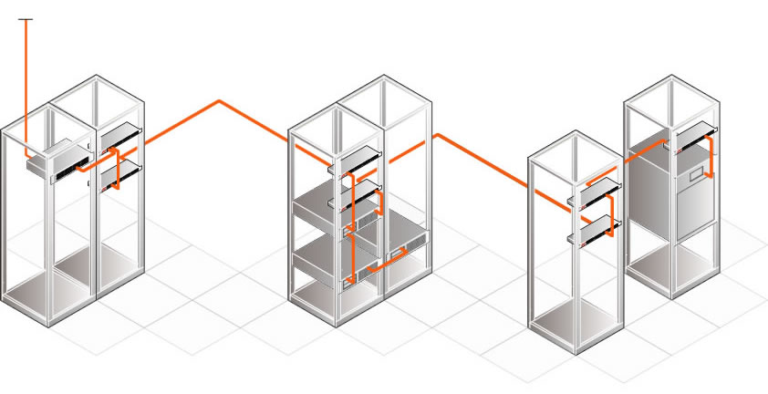
Tenderbook V3.2 updated 02/2026

Instructions for use of the NCS modular Data Centre tender document

The present modular Data Centre Request For Proposal (RFP) master document shall be adapted by the user according to his project.

Every chapters to all tender types are included – The user shall review and tailor it according to his own needs.

All possible versions are contained into this document.

Using the outline mode of MS word the content of the document can be reduced to the main chapter heads or be expanded level by level (see user guide).
Deleting the head of a chapter/subchapter in the outline mode also remove the whole content of this chapter and MS Word automatically update the numbering of the remaining chapters.
The process begins at the main chapters (first) level. The full useless chapters are removed (select and delete).
The list is than expanded to the next level and the sub-chapters of the second level that are not needed are deleted.
The process is going to continue down to the fully expanded document.

Pre-terminated assemblies are mainly intended to be used to complete the present Data Centre tender master document.

According to the ISO/IEC 11801: 2017 edition 3 cabling standard, Aginode recommend to only build Data Centre cabling systems using copper cat.6A, ou Cat.7A links and Fibre OM3, OM4, OM5 or OS2 links.

By default, all links are created using pre-terminated assemblies but you can also use Cu and/or OF cables to be terminated on site. If so, please replace the pre-terminated chapters by Cable and connectors chapters to be pasted from the Building tenderbook document.

Please be aware that a second modular RFP master document dedicated to Building project is also available. This document is mainly dedicated to building projects.

The current page and all instruction texts highlighted in yellow
are to be deleted before publishing of the RFP doc.
Table of Contents

1. Standards & Regulations 4
2. Compliance to European Construction Product Regulation (CPR) 6
3. Copper sub-system 8
3.1. Cat.6A copper sub-system 8
3.2. Cat.7A copper sub-system 9
4. Fibre sub-system 10
4.1. OM4 bend insensitive (BIMMF) fibre sub-system 10
4.2. OM5 bend insensitive (BIMMF) fibre sub-system 11
4.3. OS2 bend insensitive (BI) fibre sub-system 13
5. Data Centre design 13
6. Zone Distribution (ZD) Cabling 16
6.1. ZD copper links (Termination onsite) 16
6.2. ZD copper pre-terminated cable assembly 35
6.3. 24 port modular copper Patch Panels 41
6.4. ZD Fibre pre-terminated assembly 47
6.5. Optical Fibre Patch Panel 61
6.6. Local Distribution point (LDP) 84
6.7. Copper Patch cords 85
6.8. Optical Fibre Patch Cords 92
6.9. Link and Channel performance 102
7. Main Distribution cabling 104
7.1. MD copper links (Termination onsite) 104
7.2. ZD copper pre-terminated cable assembly 122
7.3. 24 port modular copper Patch Panels 128
7.4. ZD Fibre pre-terminated assembly 133
7.5. Optical Fibre Patch Panel 145
7.6. Local Distribution point (LDP) 168
7.7. Copper Patch cords 169
7.8. Optical Fibre Patch Cords 177
7.9. Link and Channel performance 186
8. Network Access Cabling – ENI 187
9. Rack unit solution 188
9.1. Server DC racks 188
9.2. Collocation racks 190
10. Earthing requirements 193
11. Testing 194
11.1. Data Copper Testing 194
11.2. Fibre testing 194
12. Procedures 196
12.1. Installation Guide 196
12.2. Fire Protection 196
12.3. Earthing 196
13. Management of the Project 196
13.1. Design of the Project and Labelling 196
13.2. Project Management 196
14. Warranty 197
14.1. Copper sub-system 197
14.2. Fibre sub-system 198
15. Documentation 202
15.1. Response inclusions to the bid price 202
15.2. During the Presentation of the Offer 202
15.3. Kick-off of the Project 203
15.4. On completion of the installation 203

Table of content update: When the creation of your RFP document is completed, please right-click into the table of content and choose ‘update field’ and select the ‘update entire table’ option.

Standards & Regulations

The cabling system being installed in a Data Centre, it shall comply to the requirements of the latest edition of the applicable standards (and subsequent addendums and revisions):
- ISO/IEC 11801-5: 2017 - Information technology -- Generic cabling for customer premises -- Part 5: Data centres
or
- EN50173-5:2018: Information technology - Generic cabling systems - Part 5: Data centres
- EN50600 series: Information technology — Data centre facilities and infrastructures

This Request For Proposal (RFP) provides a description for a generic structured cabling system based on:
- ISO/IEC 11801:2017 and subsequent addendums and revisions
- EN 50173-1 to -3:2018 and subsequent addendums and revisions
- EN50174-1:2018 / EN50174-2:2018 / EN50174-3:2013/A1:2017 and subsequent addendums and revisions

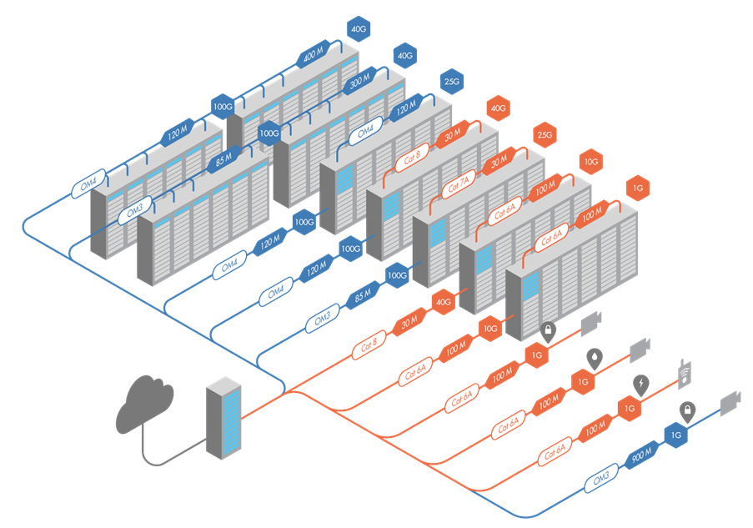

The object of this RFP is to define the structured cabling independently of the applications, which it is capable of supporting.
Furthermore, to allow for future demands, the cabling system must be easy to expand and maintain.

The Cabling system installation shall be realised in accordance with the recommendations made in
the relevant standards, manufacturer’s recommendations and/or best industry practices.

The successful vendor shall meet or exceed all requirements for the cabling system described in
this document.

The technical specifications which follow have to be respected for the construction of the cabling owed in conformance with the present RFP.
If within this tender book a product brand or reference is provided, it is to specify the item required to fulfil the requirements.

The bidder may propose directly equivalent alternative materials / products. However, the level of quality, performance, functionality and ease of installation etc of the proposed alternative product must match that of the originally detailed product within the tender book.
Therefore, the bidder has to establish his offer, fully respecting the requirements of all the materials.

The bidder can therefore propose products produced by alternative manufacturers to those quoted in this tender book, provided that:
- the proposed products are equivalent to the ones as originally detailed – as mentioned above and detailed below.
- the corresponding data sheets and technical documents, together with the reasons for proposing the alternative product are included with the offer.

The acceptance or refusal by the owner, or its representative, of “equivalent” products proposed by the bidder will be decided during a product evaluation process. The proposed products that are not be found to be "equivalent", will have to be replaced by products as originally detailed in the tender book, at the bidder’s expense. Therefore, the bidder should carefully verify that any proposed alternative products are completely suitable, as they will bear the full responsibility for the financial consequences regarding their substitution if deemed not to be appropriate.

Alternative materials will be considered as “equivalent” provided that they comply to all of the following:
- are produced by the same manufacturer and be part of a full manufacturer’s warranted system that is equivalent, both in specification and duration, to that provided by use of the originally detailed product within the tender book.
- are of the same technology and comply to the same Standards to that of the originally detailed products within the tender book.
- have specifications (temperature range, mechanical properties, fire resistance, electrical performance etc) that are at least equivalent to that of the originally detailed products within the tender book (which may exceed Standard’s requirements).
- have functionality that is equivalent to that of the originally detailed products within the tender book.
- can be equipped at a later stage with the same optional components and accessories as the ones originally detailed within the tender book (even if those options are not originally requested).
- have at least the same level of quality as the product originally detailed within the tender book.
- have at least the same level of ease of installation as the product originally detailed within the tender book.

Compliance to European Construction Product Regulation (CPR)

Background information
Started as a Directive in 1989 (“CPD”) and turned into a Regulation in 2011 (“CPR”) which became applicable from 01st July 2013, the CPR was brought to life by the European Commission to enforce that construction works be designed and executed so as not to endanger the safety of persons, domestic animals or property nor damage the environment.
The goals of the CPR were:
- To define harmonised rules for marketing of construction products within the EU.
- To provide a common technical language to assess performance of construction products.
- To ensure availability of reliable information to allow comparison of construction products from different manufacturers in different countries.
EN 50575 is the harmonised European standard, issued in 2014 and published in the Official Journal of the European Union (OJEU) on 10th July 2015, which specifies requirements for cables used in permanent constructions with regard to their reaction to fire.
The fire performance of cables is classified based on a number of criteria:
- Flame spread and heat release
- Smoke production, acidity and flaming droplets
These criteria and test methods are specified in existing standards IEC/EN 60332-1, IEC/EN 61034-2, IEC/EN 60754-2 and in a new harmonised European standard EN 50399.
Cable performance classes
- 7 Euroclasses for flame spread and heat release: A_{ca}, B1_{ca}, B2_{ca}, C_{ca}, D_{ca}, E_{ca} and F_{ca} (A_{ca} being the most severe i.e. non-combustible and F_{ca} having no criteria specified)
- 3 classifications and 2 sub-classes for smoke production: s1, s1a, s1b, s2, s3 (s1a being the most severe and s3 no criteria specified or failing any of the other four classifications)
- 3 classifications for acidity: a1, a2, a3 (a1 being the most severe and a3 no criteria specified or failing any of the other two classifications)
- 3 classifications for flaming droplets: d0, d1, d2 (d0 being the most severe and d2 no criteria specified or failing any of the other two classifications)
Requirements are going to depend on various parameters such as the type of building, the level of occupation, the difficulty of evacuation, etc. As building designs and operational rules will differ,
these requirements are not harmonised and therefore may vary from country to country.
It is the legal obligation of each EU Member State government to adopt CPR in national regulation, define the cable performance class and to guarantee effective surveillance of its market.
The company who places the product on the market in the EU is responsible to comply with the CPR obligations. This is either the actual manufacturer or the importer.
The product needs to have a Declaration of Performance (DoP)
This is a document drawn up by the manufacturer (or importer) in the language(s) required by the EU country where the product is made available and containing defined information such as product identification, its intended use, its declared performance according to CPR and the identification of the Notified Body. The DoP needs to be made publicly available, either on paper or in electronic format. It does not need to accompany the product itself.
The product packaging needs to have defined labelling including CE marking
labels on cable drums and boxes need to contain the same data as on the DoP, the reference number of the DoP, the CE mark and the year in which the CE marking was first affixed. The language of the label information can be chosen by the manufacturer (or importer). The cable itself does not need to bear the CE marking nor contain any other of the CPR requirements for labelling.
The cable manufacturer is not the solely responsible for CPR compliance. Also Distributors, Specifiers and Building Owners also bear responsibilities.
- Distributors should not resell cables (which they bought after the 1st of July 2017) for which there is no DoP and which do not bear the appropriate labelling.
- Specifiers must reference appropriate Euroclasses and s/a/d criteria according to national CPR regulations.
- Building owners need to ensure that the infrastructure on their building plans is in line with national CPR regulations.

Applicability
The regulation came into force from the 1st of July 2017, date when CE marking for CPR became mandatory.
As a consequence the bidder shall only propose copper and fibre cables that are compliant to the CPR.
Example of mandatory drum labelling:
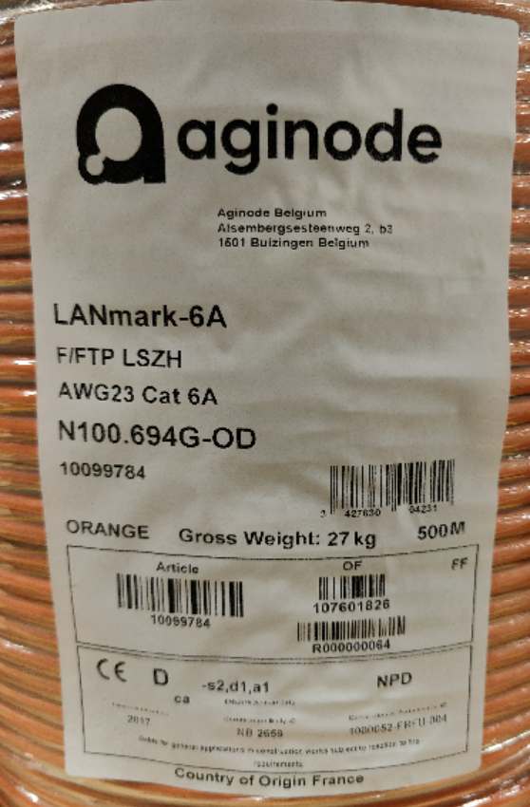

For the purpose of this tender CPR marking on the cables jacket is mandatory
Example of mandatory print legend:
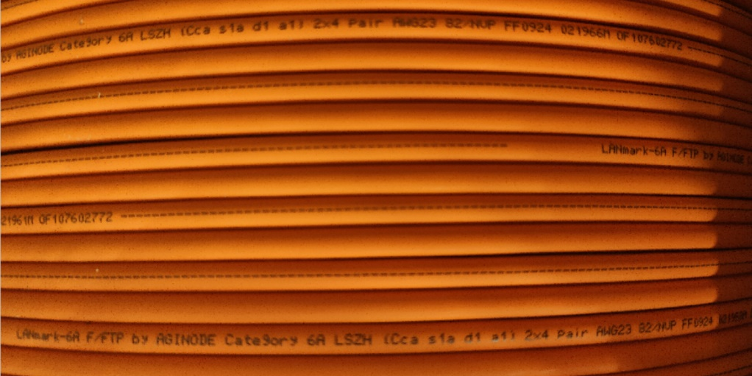

For each cable listed in this document and to be installed in the customer Data Centre and/or premises the Euroclass selected is clearly defined in the following pages according to the type of building, the level of occupation, the difficulty of evacuation, etc. as defined by the government of the country in which the cabling has to be installed (Requirements may vary from country to country).

All cables installed on this project, Copper, fibre and associated patch cords will be of Low
Smoke Zero Halogen construction complying with IEC 61034-1& 2 (smoke density test) and IEC 60754-2 (acidity and conductivity test). Plenum rated cables will not be installed.

Notes
Please select the appropriate Euroclass in every chapter when needed (Delete the wrong ones).

Copper sub-system

Cat.6A copper sub-system
This Tender document covers the design, supply, installation, testing and commissioning of a Category 6A cabling system.

Tenderers shall propose and submit a Category 6A universal cabling system which will function for voice, data and LAN communications, for video applications etc.
The cabling system is also open to new applications which require a Class EA / Cat 6A cabling system as defined in the latest editions of the standards: ISO/IEC 11801:2017 or EN 50173:2018.
The terminology and references in this document as well as the Link/Channel Performance figures for Class EA are based on ISO/IEC 11801:2017 or EN 50173:2018.

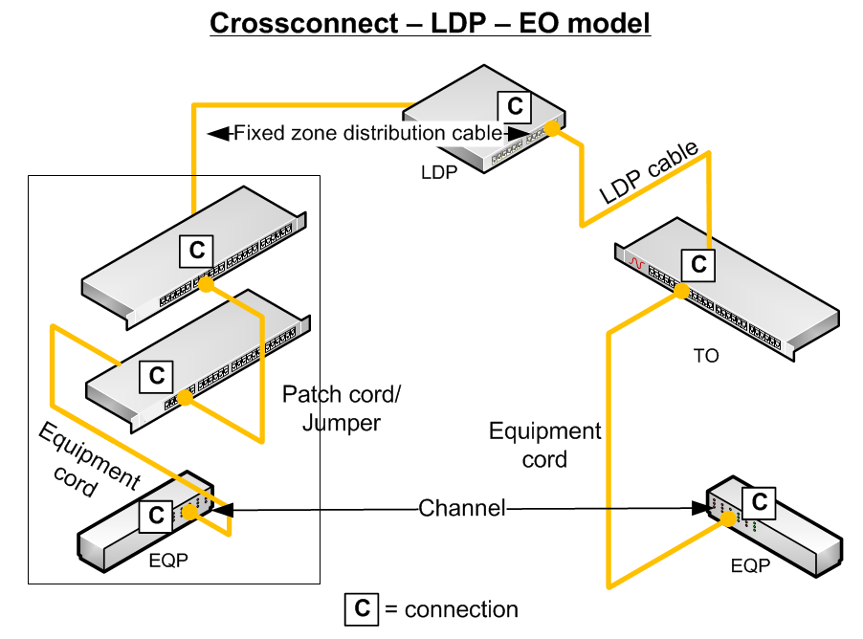

The data sheets and warranty modules showing the features and the guaranteed values compliant to the requirements of this RFP will be attached by the vendor to his tender documents.

All proposed components including the patch cords have to be produced by the same manufacturer. This issue will ensure that a « Class EA Channel Warranty » can be obtained from the manufacturer.

Cat.7A copper sub-system
This Tender document covers the design, supply, installation, testing and commissioning of a Category 7A cabling system.

Tenderers shall propose and submit a Category 7A universal cabling system which will function for voice, data and LAN communications, for video applications etc.
The cabling system is also open to new applications which require a Class FA / Cat 7A cabling system as defined in the latest editions of the standards ISO/IEC 11801:2017 or EN 50173:2018.

The terminology and references in this document as well as the Link/Channel Performance figures for Class EA are based on ISO/IEC 11801:2017 or EN 50173:2018.

The data sheets and warranty modules showing the features and the guaranteed values compliant to the requirements of this RFP will be attached by the vendor to his tender documents.

All proposed components including the patch cords have to be produced by the same manufacturer. This issue will ensure that a « Class FA Channel Warranty » can be obtained from the manufacturer.

Fibre sub-system
The optical fibre backbone shall be capable of providing the bandwidth required by the use of the horizontal cabling solution defined in the former chapter 3.

OM4 bend insensitive (BIMMF) fibre sub-system
This Tender document covers the design, supply, installation, testing and commissioning of an OM4 BIMMF (Ben Insensitive Multimode Fibre) cabling sub-system.

The fibre systems shall be warranted to support any current or future application designed to be supported
by OM4 fibres according to IEC 60793-2-10 A1a.3b.
BIMMF fibres are designed to withstand tight bends with substantially less signal loss than traditional multimode fibre.

The cabling system is also open to new applications which require an OM4 cabling sub-system as defined in the latest editions of the standards: ISO/IEC DIS 11801:2017 or EN 50173:2018.

Effective modal bandwidth (EMB) of OM4 fibres shall be measured according to the templates method of IEC 60793-2-10 section D4 and the calculated effective modal bandwidth of IEC 60793-2-10 de.4 section D5.
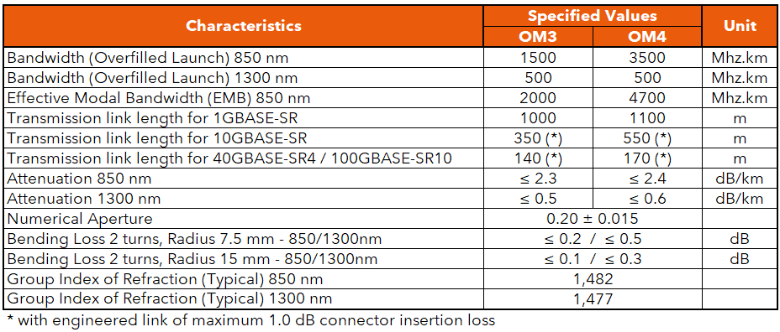

The data sheets and warranty modules showing the features and the guaranteed values compliant to the requirements of this RFP will be attached by the vendor to his tender documents.

All proposed components including the connectors, pigtails and patch cords have to be produced by the same manufacturer. This issue will ensure that the applications and the distance support Warranty as described in the Warranty chapter of this RFP can be obtained from the manufacturer.

Guaranteed distances
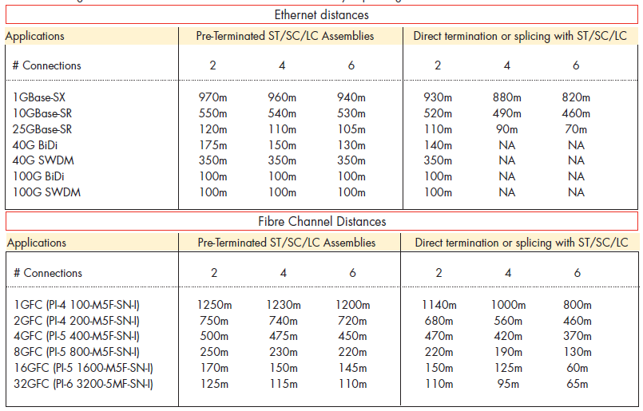

OM5 bend insensitive (BIMMF) fibre sub-system
This Tender document covers the design, supply, installation, testing and commissioning of an OM4 cabling sub-system.

The fibre systems shall be warranted to support any current or future application designed to be supported
by OM5 fibres according to IEC 60793-2-10 A1a.4b.

The cabling system is also open to new applications which require an OM5 cabling sub-system as defined in the latest editions of the standards: ISO/IEC 11801:2017 or EN 50173:2018.
BI fibres are designed to withstand tight bends with substantially less signal loss than traditional multimode fibre.

Effective modal bandwidth (EMB) of OM5 fibres shall be measured according to the templates method of IEC 60793-2-10 section D4 and the calculated effective modal bandwidth of IEC 60793-2-10 section D5.

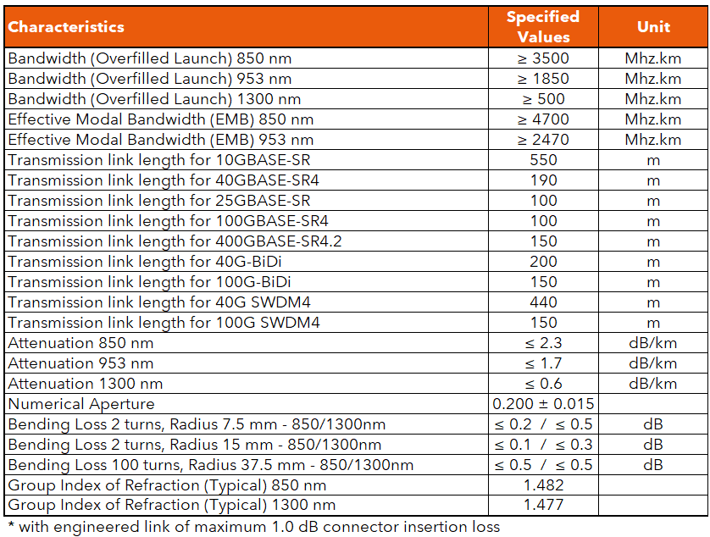

The data sheets and warranty modules showing the features and the guaranteed values compliant to the requirements of this RFP will be attached by the vendor to his tender documents.

All proposed components including the connectors, pigtails and patch cords have to be produced by the same manufacturer. This issue will ensure that the applications and the distance support Warranty as described in the Warranty chapter of this RFP can be obtained from the manufacturer.

Guaranteed distances
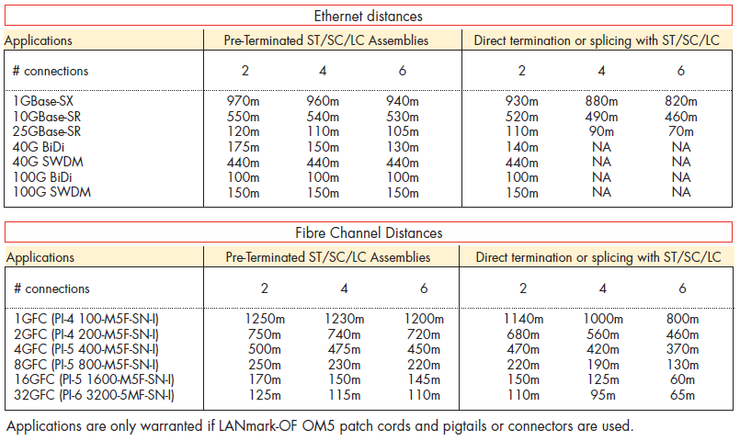

OS2 bend insensitive (BI) fibre sub-system
This Tender document covers the design, supply, installation, testing and commissioning of a BI OS2 cabling sub-system.

The fibre systems shall be warranted to support any current or future application designed to be supported
By Bend Insensitive Singlemode G657.A1 fibres.
The BI OS2 fibre shall be compliant to the IEC 60793-2-50 standard as fibre type B6.a1.
BI fibres are designed to withstand tight bends with substantially less signal loss than traditional singlemode fibre.

The cabling system is also open to new applications which require an OS2 cabling sub-system as defined in the latest editions of the standards: ISO/IEC DIS 11801:2017 or EN 50173:2018.

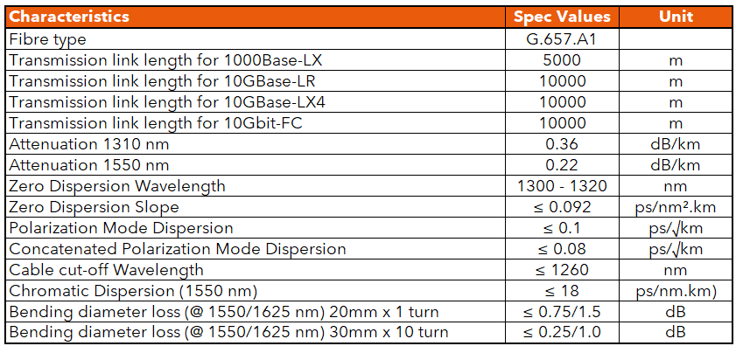

The data sheets and warranty modules showing the features and the guaranteed values compliant to the requirements of this RFP will be attached by the vendor to his tender documents.

All proposed components including the connectors, pigtails and patch cords have to be produced by the same manufacturer. This issue will ensure that the applications and the distance support Warranty as described in the Warranty chapter of this RFP can be obtained from the manufacturer.

Guaranteed distances
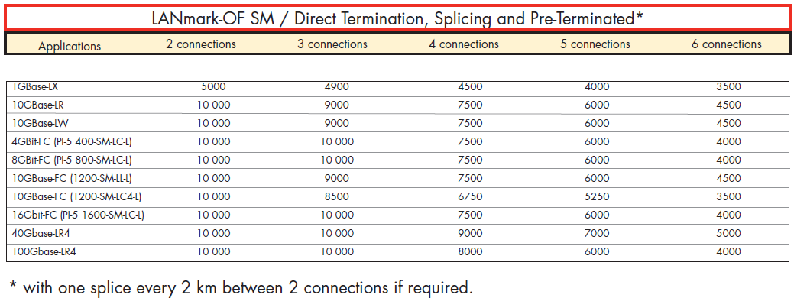

Data Centre design
When planning and designing mission-critical data centre facilities, the infrastructure of the network on which the entire enterprise will rely is concerned. The physical infrastructure is the foundation of the owner business and its strength and reliability is crucial.

The following considerations will apply for Data Centre design:
- High bandwidth and high performance taking into account future growth and convergence support
- High quality, reliability and scalability
- Redundancy (highly recommended to minimise costly network downtime)
- Flexibility and expandability with easy access for Moves, Additions and Changes (MACs)
- Incorporation of Automated Infrastructure Management (AIM) System for monitoring (Recommended by EN50174-1 standard for large cabling)

The cabling architecture in a Data Centre is divided in different subsystems as it is for the cabling architecture of a building but the names of those sub-parts (as defined in the DC standards) are different.

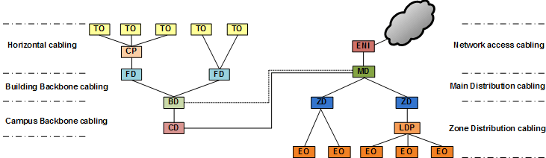

Fig.1: Building and Data Centre cabling architectures

DC generic cabling systems contain up to three subsystems:

Network Access cabling
The Main Distributor (MD) is connected to the External Network Interface (ENI) distributor and to the BD or CD of the campus/building cabling system. The main DC cabling cross-connect use to be part of the MD.

Main Distribution cabling
The MD is connected to the every Zone Distributors (Equivalent of the FDs and Floor backbone links).

Zone Distribution cabling
Every Zone Distributor (ZD) is connected to the equipment outlets it serves (Equivalent to the horizontal distribution – FD to user outlets).
In a DC, the end user interface is not a single or dual wall-mounted RJ45 or FO outlet but one or several RJ45 and/or FO patch panels in a Server or SAN Rack.
As for horizontal distribution in building cabling, an additional intermediate connexion can be implemented: the Local Distribution Point (LDP - Equivalent to the Consolidation Point). The LDP will provide more flexibility when a reconfiguration (MAC) is required.

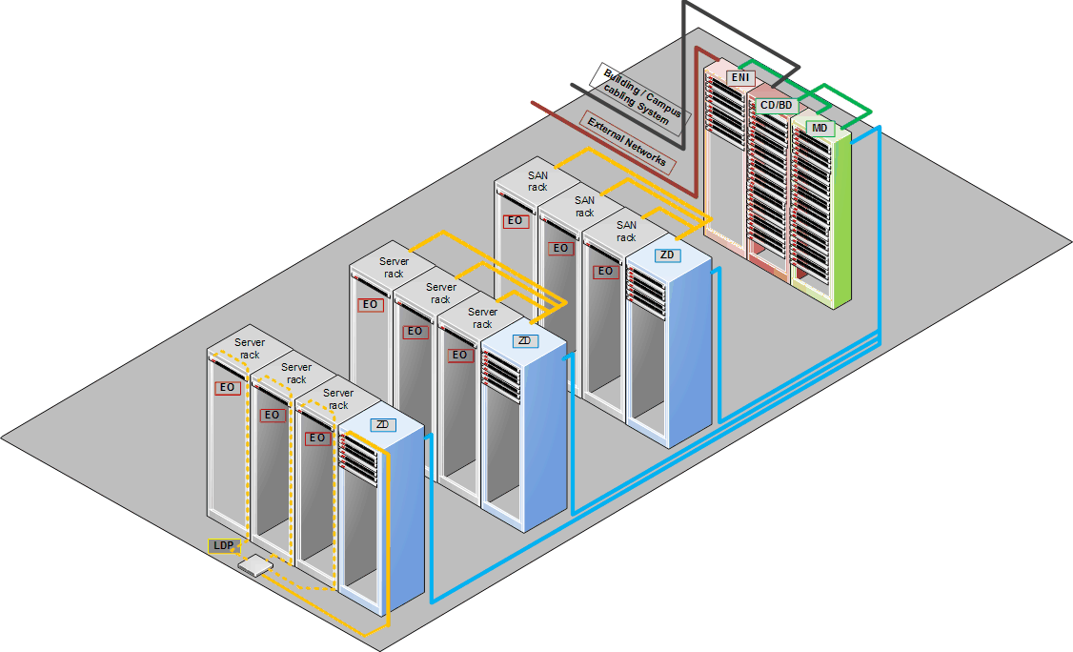

Fig.2: Standard Compliant Data Centre cabling architecture

Zone Distribution (ZD) Cabling

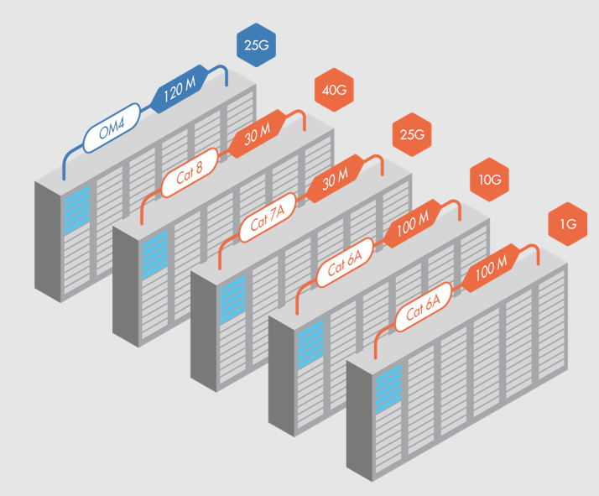

ZD to server and ZD to SAN rack connections are to be created using copper links, fibre links or both. The choice is to be made according to the specific requirements of the customer.
By default, both Cu and OF links are described in the following chapters. The user shall adapt the content to his project requirements.

The number of CU/OF links is to be defined according to the specific requirement of the project.

In order to ensure flexibility and expandability, every server/SAN cabinets will be linked back to the Zone Distributor (ZD) of the cabinet row it belongs to using both copper and FO pre-terminated cable assemblies.
A Local Distribution Point (LDP) can also be created in between to ease re-configuration and/or serve Equipment Outlets (EO) located in different cabinets.

ZD copper links (Termination onsite)

Extended Channel Application Warranty

The cabling system manufacturer shall provide an application-specific warranty covering channel lengths exceeding the standard 100 m limit. This warranty shall guarantee support for the Ethernet applications listed below over the extended channel distances specified in the following table.

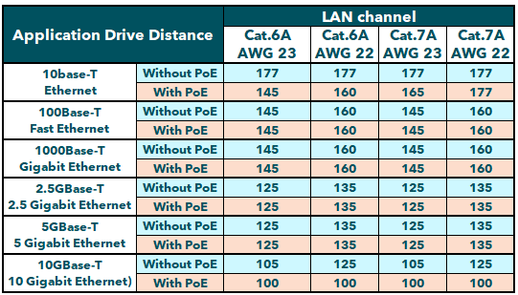

The warranty shall meet the following minimum requirements:

Scope of Coverage
The warranty shall guarantee the correct operation of the supported Ethernet applications (10BASE-T, 100BASE-TX, 1000BASE-T, 2.5GBASE-T, 5GBASE-T, and/or 10GBASE-T with or without PoE as applicable) over the extended channel distances defined, up to and including the maximum distances published by the manufacturer.
The Distances shall be valid for 2-connector channel configurations and for PoE Type 4 (IEEE 802.3bt)
The indicated channel lengths include 5m total cordage (e.g. 2m + 3m patch cord)

Cabling Types
The warranty shall be applicable to the cable categories and constructions offered (Category 6A and 7A with specified conductor gauges).

Compliance with this clause is mandatory for the acceptance of the proposed cabling solution.

Copper Zone Distribution cable

Cat.6A F¹/UTP cable
The horizontal 4 pair cable shall be Category 6A F¹/UTP to meet the quality and performance criteria necessary to ensure correct operation of the installation for frequencies up to 500 MHz and to ensure the compliance with the warranty.
The installation design and routing of all cables shall take account of the manufacturer limits for the continued performance of the cables and the compliance with the warranty.
The cable shall be a 4 twisted pair cable with AWG 23 plain copper conductors and shall have an external sheathing in a material that does not give off toxic fumes (Zero Halogen) in case of fire and offer flame propagation retardant properties. The cable shall be compliant to the IEC 60332-1 standard.
Traceability numbers should accompany the cable supplied from the manufacturers packaging to assist in quality validation of the installed cable.
In order to provide alien cross-talk (AXT) immunity for 10 GBASE-T Ethernet transmission, the use of screened cable is mandatory.
In the construction of the cable NEXT performance shall be maintained using a C³ (Central dielectric Cross-talk Cancellation) member set between the 4 pairs.
All pairs must have a fitted impedance of 100 Ohms, with a tolerance of +/- 5 Ohms.
Conductor pairs shall be identified by insulation utilising standardised colour code (Blue/White, Orange/White, Green/White, Brown/White).
The cable shall contain 1 foil screen. The foil shall have the metallic side facing outwards, allowing the cable to be automatically grounded during the termination process without having to fold back the foil. This will provide instant 360° grounding contact to ensure immunity from Alien Crosstalk and other external interference.

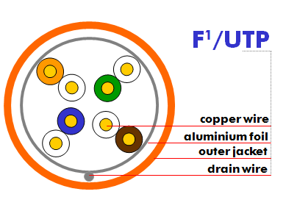

A tinned copper drain wire, shall be provided between the aluminium screen and the external sheathing.

The Cat.6A cable shall comply to the following electrical performances.
Max. And Min. Values shall be warranted by the manufacturer.

CPR grade compliance requirement (Dca s2,d2,a1)
The CPR regulations came into force in July 2016 and with effect from the 1st July 2017, cable jacket
materials must be of the appropriate Construction Product Regulations Class to meet the
requirements of EN 50399 and EN 50575 2014/A:2016 standards. In particular the cables proposed for this project must conform with EN50575 for certification and labelling.
The proposed cables must meet Class Dca s2,d2,a1 and the bidder must provide a statement from the chosen manufacturer detailing their 3rd party verification of their product and its classification.

Detailed product information (CPR grade Dca s2,d2,a1)

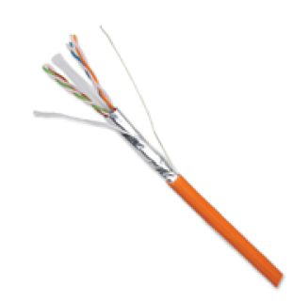
Example of product
LANmark-6A F1/UTP AWG23 Cat 6A LSZH Dca s2 d2 a1 Orange 1000m reel
Aginode reference: N100.622G-OD

CPR grade compliance requirement (Cca s1a,d1,a1)
The CPR regulations came into force in July 2016 and with effect from the 1st of July 2017, cable jacket
materials must be of the appropriate Construction Product Regulations Class to meet the
requirements of EN 50399 and EN 50575 2014/A:2016 standards. In particular the cables proposed for this project must conform with EN50575 for certification and labelling.
The proposed cables must meet Class Cca s1a,d2,a1 and the bidder must provide a statement from the chosen manufacturer detailing their 3rd party verification of their product and its classification.

Detailed product information (CPR grade Cca s1a,d1,a1)

Example of product
LANmark-6A F1/UTP AWG23 Cat 6A LSZH Cca s1a d1 a1 Orange 1000m reel
Aginode reference: N100.622G-OC

Cat.6A F/FTP cable
The horizontal 4 pair cable shall be Category 6A F/FTP to meet the quality and performance criteria necessary to ensure correct operation of the installation for frequencies up to 500 MHz and to ensure the compliance with the warranty.
The installation design and routing of all cables shall take account of the manufacturer limits for the continued performance of the cables and the compliance with the warranty.
The cable shall be a 4 twisted pair cable with AWG 23 plain copper conductors and shall have an external sheathing in a material that does not give off toxic fumes (Zero Halogen) in case of fire and offer flame propagation retardant properties. The cable shall be compliant to the IEC 60332-1 standard.
Traceability numbers should accompany the cable supplied from the manufacturers packaging to assist in quality validation of the installed cable.
In order to provide alien cross-talk (AXT) immunity for 10 GBASE-T Ethernet transmission, the use of screened cable is mandatory.
This high performance cable shall have an individual and a common screen construction to ensure immunity from Alien Crosstalk and other external interference up to 500 MHz.
All four pairs shall be individually screened with an aluminium foil.
The overall cable shall be screened with a complementary aluminium foil.
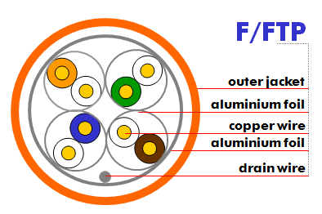
All pairs must have a fitted impedance of 100 Ohms, with a tolerance of +/- 5 Ohms.
Conductor pairs shall be identified by insulation utilising standardised colour code (Blue/White, Orange/White, Green/White, Brown/White).
The Cat.6A cable shall comply to the following electrical performances.
Maximum and Minimum values shall be warranted by the manufacturer.

CPR grade compliance requirement (Dca s2,d2,a1)
The CPR regulations came into force in July 2016 and with effect from the 1st July 2017, cable jacket
materials must be of the appropriate Construction Product Regulations Class to meet the
requirements of EN 50399 and EN 50575 2014/A:2016 standards. In particular the cables proposed for this project must conform with EN50575 for certification and labelling.
The proposed cables must meet Class Dca s2,d2,a1 and the bidder must provide a statement from the chosen manufacturer detailing their 3rd party verification of their product and its classification.

Detailed product information (CPR grade Dca s2,d2,a1)
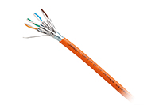
Example of product
LANmark-6A F/FTP AWG23 Cat 6A LSZH Dca s2 d2 a1 Orange 1000m reel
Aginode reference: N100.692G-OD

CPR grade compliance requirement (Cca s1a,d2,a1)
The CPR regulations came into force in July 2016 and with effect from the 1st July 2017, cable jacket
materials must be of the appropriate Construction Product Regulations Class to meet the
requirements of EN 50399 and EN 50575 2014/A:2016 standards. In particular the cables proposed for this project must conform with EN50575 for certification and labelling.
The proposed cables must meet Class Cca s1a,d2,a1 and the bidder must provide a statement from the chosen manufacturer detailing their 3rd party verification of their product and its classification.

Detailed product information (CPR grade Cca s1a,d2,a1)
Example of product
LANmark-6A F/FTP AWG23 Cat 6A LSZH Cca s1 d2 a1 Orange 1000m reel
Aginode reference: N100.692G-OC

Cat.6A FXTP cable
This cable is not available in France and in Scandinavian countries
The horizontal 4 pair cable shall be Category 6A FXTP to meet the quality and performance criteria necessary to ensure correct operation of the installation for frequencies up to 500 MHz and to ensure the compliance with the warranty.
The installation design and routing of all cables shall take account of the manufacturer limits for the continued performance of the cables and the compliance with the warranty.
The cable shall be a 4 twisted pair cable with AWG 23 plain copper conductors and shall have an external sheathing in a material that does not give off toxic fumes (Zero Halogen) in case of fire and offer flame propagation retardant properties. The cable shall be compliant to the IEC 60332-1 standard.
Traceability numbers should accompany the cable supplied from the manufacturers packaging to assist in quality validation of the installed cable.
In order to provide alien cross-talk (AXT) immunity for 10 GBASE-T Ethernet transmission, the use of screened cable is mandatory.
This high performance cable shall have metal foil construction forming a central cross and shaped around each pair, acting as global screen and individual pair shielding at the same time. Compared to traditional F/FTP and S/FTP cables, this clever design facilitates fast and easy cable preparing whilst offering outstanding electrical performance.to ensure immunity from Alien Crosstalk and other external interference up to 500 MHz.
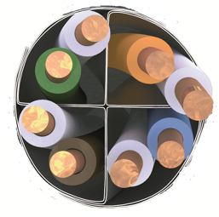
All pairs must have a fitted impedance of 100 Ohms, with a tolerance of +/- 5 Ohms.
Conductor pairs shall be identified by insulation utilising standardised colour code (Blue/White, Orange/White, Green/White, Brown/White).
The Cat.6A cable shall comply to the following electrical performances.
Maximum and Minimum values shall be warranted by the manufacturer.
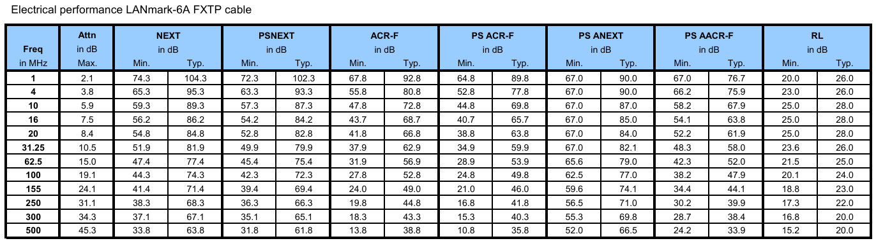

CPR grade compliance requirement (Dca s2,d2,a1)
The CPR regulations came into force in July 2016 and with effect from the 1st July 2017, cable jacket
materials must be of the appropriate Construction Product Regulations Class to meet the
requirements of EN 50399 and EN 50575 2014/A:2016 standards. In particular the cables proposed for this project must conform with EN50575 for certification and labelling.
The proposed cables must meet Class Dca s2,d2,a1 and the bidder must provide a statement from the chosen manufacturer detailing their 3rd party verification of their product and its classification.

Detailed product information (CPR grade Dca s2,d2,a1)
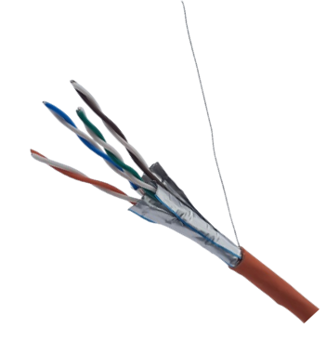
Example of product
LANmark-6A FXTP AWG23 Cat 6A LSZH Dca s2 d2 a1 Orange 500m reel
Aginode reference: N100.654G-OD

CPR grade compliance requirement (Cca s1a,d1,a1)
The CPR regulations came into force in July 2016 and with effect from the 1st July 2017, cable jacket
materials must be of the appropriate Construction Product Regulations Class to meet the
requirements of EN 50399 and EN 50575 2014/A:2016 standards. In particular the cables proposed for this project must conform with EN50575 for certification and labelling.
The proposed cables must meet Class Cca s1a,d1,a1 and the bidder must provide a statement from the chosen manufacturer detailing their 3rd party verification of their product and its classification.

Detailed product information (CPR grade Cca s1a,d1,a1)
Example of product
LANmark-6A FXTP AWG23 Cat 6A LSZH Cca s1a d1 a1 Orange 500m reel
Aginode reference: N100.654G-OC

Cat.6A EXTP cable
The horizontal 4 pair cable shall be Category 6A EXTP to meet the quality and performance criteria necessary to ensure correct operation of the installation for frequencies up to 500 MHz and to ensure the compliance with the warranty.
The installation design and routing of all cables shall take account of the manufacturer limits for the continued performance of the cables and the compliance with the warranty.
The cable shall be a 4 twisted pair cable with AWG 22 plain copper conductors and shall have an external sheathing in a material that does not give off toxic fumes (Zero Halogen) in case of fire and offer flame propagation retardant properties. The cable shall be compliant to the IEC 60332-1 standard.
Traceability numbers should accompany the cable supplied from the manufacturers packaging to assist in quality validation of the installed cable.
In order to provide alien cross-talk (AXT) immunity for 10 GBASE-T Ethernet transmission, the use of screened cable is mandatory.
This high performance cable shall have metal foil construction forming a central cross and shaped around each pair, acting as global screen and individual pair shielding at the same time. Compared to traditional F/FTP and S/FTP cables, this clever design facilitates fast and easy cable preparing whilst offering outstanding electrical performance.to ensure immunity from Alien Crosstalk and other external interference up to 500 MHz.
All pairs must have a fitted impedance of 100 Ohms, with a tolerance of +/- 5 Ohms.
Conductor pairs shall be identified by insulation utilising standardised colour code (Blue/White, Orange/White, Green/White, Brown/White).
The Cat.6A cable shall comply to the following electrical performances.
Maximum and Minimum values shall be warranted by the manufacturer.
Tested to 650MHz with guaranteed performance to 500MHz the EXTP cables exceed the requirements of the International, European and American cable standards.

CPR grade compliance requirement (Dca s2,d2,a1)
The CPR regulations came into force in July 2016 and with effect from the 1st July 2017, cable jacket
materials must be of the appropriate Construction Product Regulations Class to meet the
requirements of EN 50399 and EN 50575 2014/A:2016 standards. In particular the cables proposed for this project must conform with EN50575 for certification and labelling.
The proposed cables must meet Class Dca s2,d2,a1 and the bidder must provide a statement from the chosen manufacturer detailing their 3rd party verification of their product and its classification.

Detailed product information (CPR grade Dca s2,d2,a1)
Example of product
LANMARK-6A ULTIM EXTP AWG22 CAT 6A 650MHZ LSZH DCA S2 D2 A1 ORANGE 500M REEL
Aginode reference: N100.964G-OD

CPR grade compliance requirement (Cca s1a,d1,a1)
The CPR regulations came into force in July 2016 and with effect from the 1st July 2017, cable jacket
materials must be of the appropriate Construction Product Regulations Class to meet the
requirements of EN 50399 and EN 50575 2014/A:2016 standards. In particular the cables proposed for this project must conform with EN50575 for certification and labelling.
The proposed cables must meet Class Cca s1a,d1,a1 and the bidder must provide a statement from the chosen manufacturer detailing their 3rd party verification of their product and its classification.

Detailed product information (CPR grade Cca s1a,d1,a1)
Example of product
LANMARK-6A ULTIM EXTP AWG22 CAT 6A 650MHZ LSZH CCA S1A D1 A1 ORANGE 500M REEL
Aginode reference: N100.964G-OC

Cat.6A S/FTP cable
The horizontal 4 pair cable shall be Category 6A S/FTP to meet the quality and performance criteria necessary to ensure correct operation of the installation for frequencies up to 500 MHz and compliance with the warranty.
The installation design and routing of all cables shall take account of the manufacturer limits for the continued performance of the cables and the compliance with the warranty.
The cable shall be a 4 twisted pair cable with AWG 23 plain copper conductors and shall have an external sheathing in a material that does not give off toxic fumes (Zero Halogen) in case of fire and offer flame propagation retardant properties. The cable shall be compliant to the IEC 60332-1 standard.
Traceability numbers should accompany the cable supplied from the manufacturers packaging to assist in quality validation of the installed cable.
This very high performance cable shall have an individual and a common screen construction to ensure immunity from Alien Crosstalk and other external interference up to 500 MHz.
All four pairs shall be individually screened with an aluminium foil.
The cable shall be shielded with a tinned copper braid.
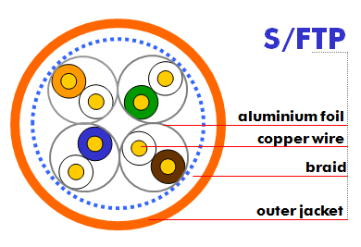
All pairs must have a fitted impedance of 100 Ohms, with a tolerance of +/- 5 Ohms.
Conductor pairs shall be identified by insulation utilising standardised colour code (Blue/White, Orange/White, Green/White, Brown/White).
The Cat.6A cable shall comply to the following electrical performances up to 500 MHz.
Maximum and Minimum values shall be warranted by the manufacturer.

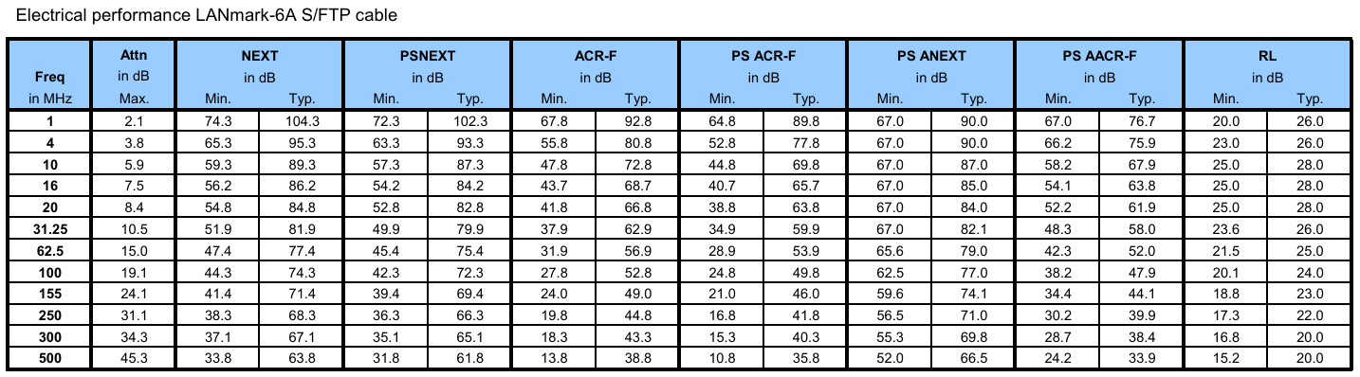

CPR grade compliance requirement (Dca s2,d2,a1)
The CPR regulations came into force in July 2016 and with effect from the 1st July 2017, cable jacket
materials must be of the appropriate Construction Product Regulations Class to meet the
requirements of EN 50399 and EN 50575 2014/A:2016 standards. In particular the cables proposed for this project must conform with EN50575 for certification and labelling.
The proposed cables must meet Class Dca s2,d2,a1 and the bidder must provide a statement from the chosen manufacturer detailing their 3rd party verification of their product and its classification.

Detailed product information (CPR grade Dca s2,d2,a1)
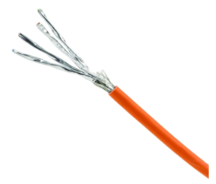
Example of product
LANmark-6A S/FTP AWG23 Cat 6A LSZH Dca s2 d2 a1 Orange 500m reel
Aginode reference: N100.684G-OD

CPR grade compliance requirement (Cca s1a,d1,a1)
The CPR regulations came into force in July 2016 and with effect from the 1st July 2017, cable jacket
materials must be of the appropriate Construction Product Regulations Class to meet the
requirements of EN 50399 and EN 50575 2014/A:2016 standards. In particular the cables proposed for this project must conform with EN50575 for certification and labelling.
The proposed cables must meet Class Cca s1a,d1,a1 and the bidder must provide a statement from the chosen manufacturer detailing their 3rd party verification of their product and its classification.

Detailed product information (CPR grade Cca s1a,d1,a1)
Example of product
LANmark-6A S/FTP AWG23 Cat 6A LSZH Cca s1a d1 a1 Orange 500m reel
Aginode reference: N100.684G-OC

Cat.7 S/FTP cable
The horizontal 4 pair cable shall be Category 7 S/FTP to meet the quality and performance criteria necessary to ensure correct operation of the installation for frequencies up to 600 MHz and compliance with the warranty.
The installation design and routing of all cables shall take account of the manufacturer limits for the continued performance of the cables and the compliance with the warranty.
The cable shall be a 4 twisted pair cable with AWG 23 plain copper conductors and shall have an external sheathing in a material that does not give off toxic fumes (Zero Halogen) in case of fire and offer flame propagation retardant properties. The cable shall be compliant to the IEC 60332-1 standard.
Traceability numbers should accompany the cable supplied from the manufacturers packaging to assist in quality validation of the installed cable.
This very high performance cable shall have an individual and a common screen construction to ensure immunity from Alien Crosstalk and other external interference up to 600 MHz.
All four pairs shall be individually screened with an aluminium foil.
The cable shall be shielded with a tinned copper braid.
All pairs must have a fitted impedance of 100 Ohms, with a tolerance of +/- 5 Ohms.
Conductor pairs shall be identified by insulation utilising standardised colour code (Blue/White, Orange/White, Green/White, Brown/White).
The Cat.7 cable shall comply to the following electrical performances up to 600 MHz.
Maximum and Minimum values shall be warranted by the manufacturer.

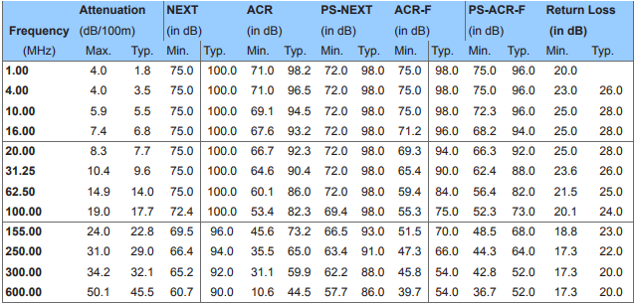

CPR grade compliance requirement (Cca s1a,d1,a1)
The CPR regulations came into force in July 2016 and with effect from the 1st July 2017, cable jacket
materials must be of the appropriate Construction Product Regulations Class to meet the
requirements of EN 50399 and EN 50575 2014/A:2016 standards. In particular the cables proposed for this project must conform with EN50575 for certification and labelling.
The proposed cables must meet Class Cca s1a,d1,a1 and the bidder must provide a statement from the chosen manufacturer detailing their 3rd party verification of their product and its classification.

Detailed product information (CPR grade Cca s1a,d1,a1)
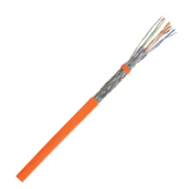
Example of product
LANmark-7 S/FTP 23AWG LSZH C s1a d1 a1 Orange 1000m Reel
Aginode reference: N100.365-OC

CPR grade compliance requirement (B2ca s1a,d1,a1)
The CPR regulations came into force in July 2016 and with effect from the 1st July 2017, cable jacket
materials must be of the appropriate Construction Product Regulations Class to meet the
requirements of EN 50399 and EN 50575 2014/A:2016 standards. In particular the cables proposed for this project must conform with EN50575 for certification and labelling.
The proposed cables must meet Class B2ca s1a,d1,a1 and the bidder must provide a statement from the chosen manufacturer detailing their 3rd party verification of their product and its classification.

Detailed product information (CPR grade B2ca s1a,d1,a1)
Example of product
LANmark-7 S/FTP 23AWG LSZH B2 s1a d1 a1 Orange 1000m Reel
Aginode reference: N100.365-OB

Cat.7A S/FTP cable
The horizontal 4 pair cable shall be Category 7A S/FTP to meet the quality and performance criteria necessary to ensure correct operation of the installation for frequencies up to 1250 MHz and compliance with the warranty.
It offers large headroom above the Cat 7A requirement. Due to this excellent electrical performance and positive ACR up to at least 1250MHz the cable supports the applications like 10GBASE-T as well as 25GBASE-T
The installation design and routing of all cables shall take account of the manufacturer limits for the continued performance of the cables and the compliance with the warranty.
The cable shall be a 4 twisted pair cable with AWG 23 plain copper conductors and shall have an external sheathing in a material that does not give off toxic fumes (Zero Halogen) in case of fire and offer flame propagation retardant properties. The cable shall be compliant to the IEC 60332-1 standard.
Traceability numbers should accompany the cable supplied from the manufacturers packaging to assist in quality validation of the installed cable.
This very high performance cable shall have an individual and a common screen construction to ensure immunity from Alien Crosstalk and other external interference up to 1250 MHz.
All four pairs shall be individually screened with an aluminium foil.
The cable shall be shielded with a tinned copper braid.
All pairs must have a fitted impedance of 100 Ohms, with a tolerance of +/- 5 Ohms.
Conductor pairs shall be identified by insulation utilising standardised colour code (Blue/White, Orange/White, Green/White, Brown/White).
The Cat.7A cable shall comply to the following electrical performances.
Maximum and Minimum values shall be warranted by the manufacturer.
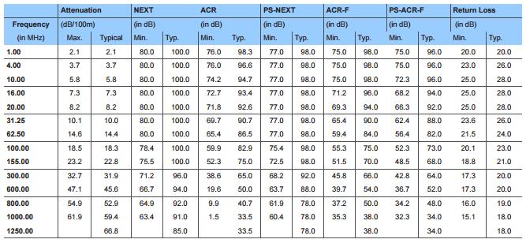

CPR grade compliance requirement (Dca s2,d2,a1)
The CPR regulations came into force in July 2016 and with effect from the 1st July 2017, cable jacket
materials must be of the appropriate Construction Product Regulations Class to meet the
requirements of EN 50399 and EN 50575 2014/A:2016 standards. In particular the cables proposed for this project must conform with EN50575 for certification and labelling.
The proposed cables must meet Class Dca s2,d2,a1 and the bidder must provide a statement from the chosen manufacturer detailing their 3rd party verification of their product and its classification.

Detailed product information (CPR grade Dca s2,d2,a1)
Example of product
LANmark-7A S/FTP Cat 7A 1250MHz 23AWG LSZH Dca s2 d2 a1 Orange 1000m Reel
Aginode reference: N100.371-OD

CPR grade compliance requirement (Cca s1a,d1,a1)
The CPR regulations came into force in July 2016 and with effect from the 1st July 2017, cable jacket
materials must be of the appropriate Construction Product Regulations Class to meet the
requirements of EN 50399 and EN 50575 2014/A:2016 standards. In particular the cables proposed for this project must conform with EN50575 for certification and labelling.
The proposed cables must meet Class Cca s1a,d1,a1 and the bidder must provide a statement from the chosen manufacturer detailing their 3rd party verification of their product and its classification.

Detailed product information (CPR grade Cca s1a,d1,a1)
Example of product
LANmark-7A S/FTP Cat 7A 1250MHz 23AWG LSZH C s1a d1 a1 Orange 1000m Reel
Aginode reference: N100.371-OC

CPR grade compliance requirement (B2ca s1a,d1,a1)
The CPR regulations came into force in July 2016 and with effect from the 1st July 2017, cable jacket
materials must be of the appropriate Construction Product Regulations Class to meet the
requirements of EN 50399 and EN 50575 2014/A:2016 standards. In particular the cables proposed for this project must conform with EN50575 for certification and labelling.
The proposed cables must meet Class B2ca s1a,d1,a1 and the bidder must provide a statement from the chosen manufacturer detailing their 3rd party verification of their product and its classification.

Detailed product information (CPR grade B2ca s1a,d1,a1)
Example of product
LANmark-7A S/FTP Cat 7A 1250MHz 23AWG LSZH B2 s1a d1 a1 Orange 1000m Reel
Aginode reference: N100.371-OB

Modular RJ45 jack

Cat.6A screened connector
The RJ45 connector shall be fully shielded with a die-cast metal housing to provide excellent immunity against Alien Crosstalk and Electromagnetic Interference. The connector shall also provide termination facilities for the drain wire of some screened cables.
1.27 micron (50 microinch) gold plated front contacts shall offer superior mechanical durability, ensuring at least 2500 plug insertion cycles and supporting Power over Ethernet transmission up to 90 W (IEEE 802.3bt) without degrading effect.
The connector shall be fully compliant to the IEC 60603-7-51 standard that defines the Cat.6A connector to be used to form a Class EA channel as specified in the ISO/IEC 11801:2017 standard. It is certified by an independent lab for connecting hardware, PoE++ compliance and various Link and Channel configurations.
Each connector shall provide both T568A and T568B colour code identification for the IDC contacts at the rear of the connector. Termination is to be in accordance with the T568B colour code. Reassignment of pairs is forbidden.
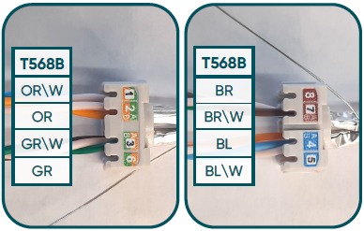
All conductors from the 4 pair cable are to be terminated on the respective contacts.
To avoid installation errors, pair assignment in the wire organiser of the Snap-In jack must be identified using colours which match the cable pairs.
The Snap-In format of the connector shall make it compatible with the whole range of modular structural hardware including patch panels, outlets and CP boxes.
Optional clips shall be available to turn Snap-In into keystone format.
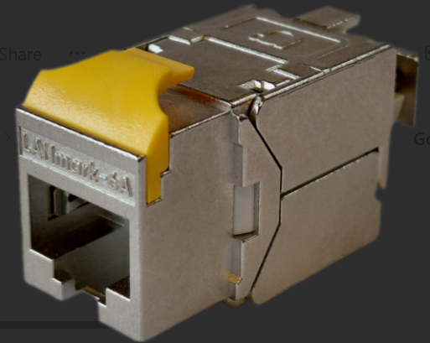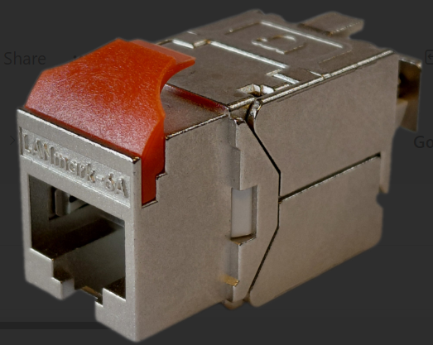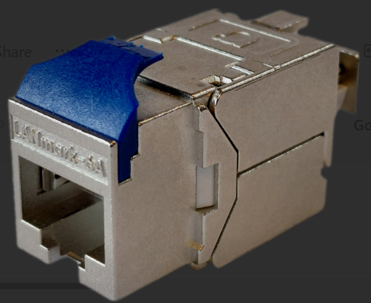
A table of compatibility indicating which clip shall be used to ensure compatibility with a large range of third-party structural hardware shall be available from the manufacturer.
The 100% toolless design features a wire organiser that enables straight forward management of the wires, ensuring that the cable pair twists are maintained. All RJ45 connectors shall be easily re-installable. The connector is a one-piece design, with a wire organiser as sole accessory, guaranteeing infallible management of the twisted pairs.
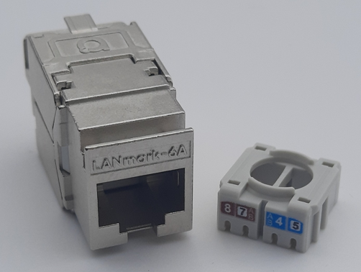
The connector is compatible with a wide range of cables, from AWG26 to AWG22, for both solid & stranded conductors. This flexibility allows using just one connector for all types of configurations, whether in permanent links or in flexible consolidation points.
Sustainability: To reduce environmental impact, the manufacturer shall implement measures to eliminate plastic from packaging. The RJ45 connector is supplied in 100% recyclable, plastic-free materials.

Detailed product information
Example of product
LANMARK-6A ULTIM SNAP-IN CONNECTOR CATEGORY 6A SCREENED CE
Aginode reference: N420.960

Cat.7A screened connector
The GG45 connector shall be fully screened to ensure protection against EMI and for Alien cross-talk compliance. Connectors shall also provide termination facilities for the drain wire of some screened cable.
The connector shall support PoE (IEEE 802.3af), PoE + (IEEE 802.3at) and PoE ++ (IEEE 802.3bt) applications and shall pass all the tests for PoE ++ requirements according to IEC 60512-99-002 Ed.1).
The connector shall be fully compliant to the IEC 60603-7-71 and IEC 60603-7-82 standard that defines the Cat.8.2 connector to be used to form a Class I/II channel as specified in the ISO/IEC 11801:2017 standard.
In particular, the connector shall contain a full Cat.6 (RJ45) interface as well as a full Cat.7A/Cat.8 interface using four additional contacts for 2000MHZ transmission.
It shall offer full backward compatibility with RJ45 plugs.
Each connector shall provide both T568A and T568B colour code identification for the IDC contacts at the rear of the connector. Termination is to be in accordance with the T568B colour code. Reassignment of pairs is forbidden.
All conductors from the 4 pair cable are to be terminated on the respective contacts.
To avoid installation errors, pair assignment in the wire organiser of the Snap-In jack must be identified using colours which match the cable pairs.
The Snap-In format of the connector shall make it compatible with the whole range of modular structural hardware including patch panels, outlets and CP boxes.
In the case of a 3 or 4 connector Channel (up to Class FA) with Consolidation Point (CP), a specific version of connector having IDC contacts suitable for the termination of stranded cable shall be used at the TO and/or at the presentation panel.
Electrical performances of the GG45 connector
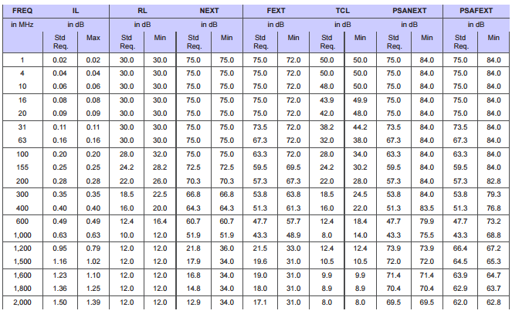

Detailed product information
LANmark GG45 is a screened RJ45-compatible cable jack specified up to 2000MHz. It is designed specifically to support the high frequencies required for applications beyond 10 Gigabit Ethernet.
- Combined with LANmark-7A Cable and Patch Cords, GG45 offers support for 25GBase-T.
- Combined with a LANmark-8 2GHz cable, GG45 offers support for 40GBase-T.
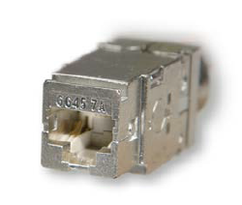
Example of product
LANmark GG45 12C Snap-In Connector Cat.7A/8 2000MHz Screened
Aginode reference: N420.735

ZD copper pre-terminated cable assembly

Cat.6A copper pre-terminated cable assembly

Cat.6A Pre-Term Bundles shall be assemblies of 6, 8 or 12 pre-terminated units. These can be Jack-Jack, Jack-Plug or Plug-Plug units.
Single units shall be cabled to form laid up bundles. This makes sure that connectors’ alignment is maintained. This also makes the bundle more flexible and easier to install.

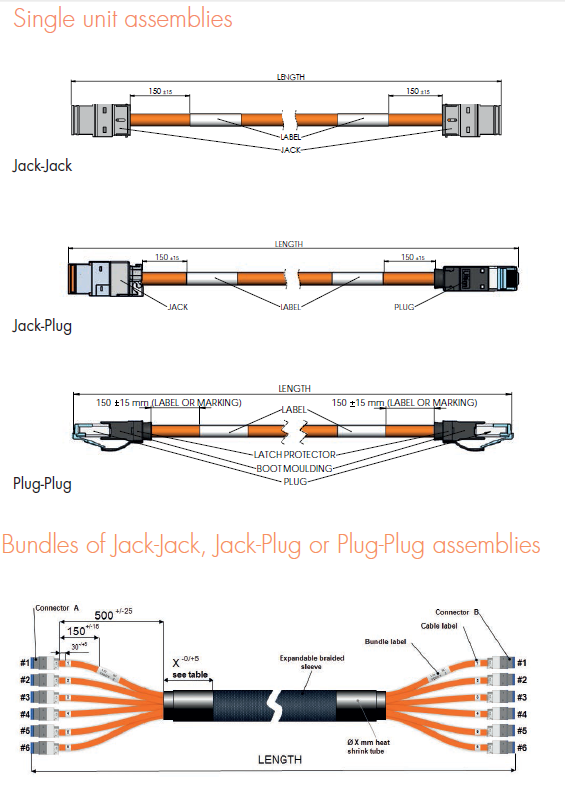
They provide a significant installation advantage as connectors termination is simply eliminated.
A numbering shall be present on each leg (on both sides).
All bundles shall be factory tested and the results shall be available from the manufacturer on request.
The preterm bundles shall be available on order in any length from 5m up to 90m.
Regarding short links, the standard channel performance shall be warranted for a 10 meters / 3 connectors link with 5 meters of cable length for both Patch Panel to Consolidation Point (CP or LDP) and Consolidation Point to Equipment Outlet segments.

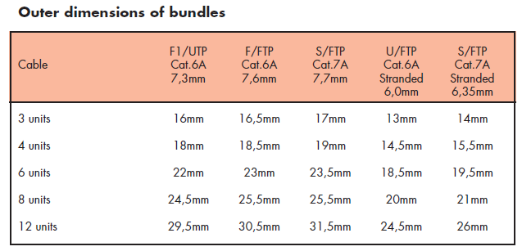

The 4 pair cables of the pre-terminated assemblies shall be Category 6A F/FTP to meet the quality and performance criteria necessary to ensure correct operation of the installation for frequencies up to 500 MHz and to ensure the compliance with the warranty.
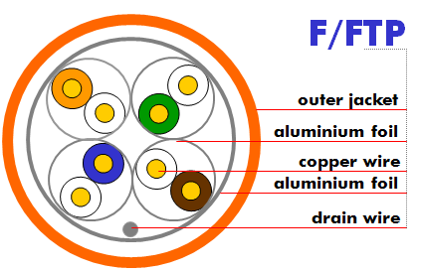
The installation design and routing of all cables shall take account of the manufacturer limits for the continued performance of the cables and the compliance with the warranty.
The cable shall be a 4 twisted pair cable with AWG 23 plain copper conductors and shall have an external sheathing in a material that does not give off toxic fumes (Zero Halogen) in case of fire and offer flame propagation retardant properties the cable shall be compliant to the IEC 60332-1 standard.
This high performance cable shall have an individual and a common screen construction to ensure immunity from Alien Crosstalk and other external interference up to 500 MHz.
All four pairs shall be individually screened with an aluminium foil.
The overall cable shall be screened with a complementary aluminium foil.
In order to provide alien cross-talk (AXT) immunity for 10 GBASE-T Ethernet transmission, the use of screened cable is mandatory.
The Cat.6A cable shall comply to the following electrical performances.
Maximum and Minimum values shall be warranted by the manufacturer.

The RJ45 connectors of the units shall be fully screened to ensure protection against EMI and for Alien cross-talk compliance.
The connector shall be fully compliant to the IEC 60603-7-51 standard that defines the Cat.6A connector to be used to form a Class EA channel as specified in the ISO/IEC 11801:2017 standard.
The Snap-In format of the connector shall make it compatible with the whole range of modular structural hardware including patch panels, outlets and CP boxes.

CPR grade compliance requirement (Dca s2,d2,a1) – Only valid for Jack-Jack assemblies
The CPR regulations came into force in July 2016 and with effect from the 1st July 2017, cable jacket
materials must be of the appropriate Construction Product Regulations Class to meet the
requirements of EN 50399 and EN 50575 2014/A:2016 standards. In particular the cables proposed for this project must conform with EN50575 for certification and labelling.
The proposed cables must meet Class Dca s2,d2,a1 and the bidder must provide a statement from the chosen manufacturer detailing their 3rd party verification of their product and its classification.

Detailed product information
The range of Aginode pre-terminated copper assemblies includes single units in Category 6A or 7A:
- Jack-Jack assemblies: 4 pair cable terminated with LANmark Snap-In jacks at both ends
- Jack-Plug assemblies: 4 pair cable terminated with a LANmark Snap-In jack at one end and a LANmark plug at the other end
- Plug-Plug assemblies: 4 pair cable terminated with LANmark plugs at both ends
These units can then be further assembled to form bundles of 3, 4, 6, 8, 12 or 2x12 units

Example of product
LANmark-6A Pre-Term Bundle of 12 Cat 6A F/FTP Solid LSZH Orange Screened Jack Cat 6A
Aginode reference: N63A.4G21A6XA6Xxxx (xxx = length in decimetres)

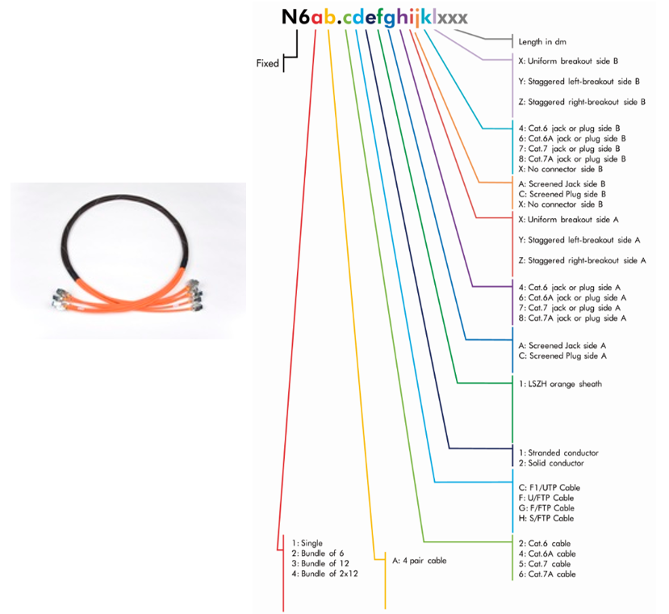

Cat.7A copper pre-terminated cable assembly
Cat.7A Pre-Term Bundles shall be assemblies of 6, 8 or 12 pre-terminated units. These can be Jack-Jack, Jack-Plug or Plug-Plug units.
Single units shall be cabled to form laid up bundles. This makes sure that connectors’ alignment is maintained. This also makes the bundle more flexible and easier to install.
They provide a significant installation advantage as connectors termination is simply eliminated.
A numbering shall be present on each leg (on both sides).
All bundles shall be factory tested and the results shall be available from the manufacturer on request.
The preterm bundles shall be available on order in any length from 15m to 90m.
The 4 pair cables of the units shall be Category 7A S/FTP to meet the quality and performance criteria necessary to ensure correct operation of the installation for frequencies up to 1000 MHz and compliance with the warranty.
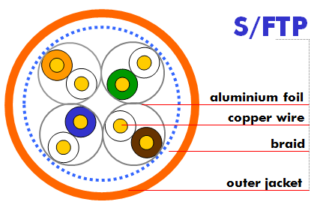
The installation design and routing of all cables shall take account of the manufacturer limits for the continued performance of the cables and the compliance with the warranty.
The cable shall be a 4 twisted pair cable with AWG 23 plain copper conductors and shall have an external sheathing in a material that does not give off toxic fumes (Zero Halogen) in case of fire and offer flame propagation retardant properties the cable shall be compliant to the IEC 60332-1 standard.
This very high performance cable shall have an individual and a common screen construction to ensure immunity from Alien Crosstalk and other external interference up to 1250 MHz.
All four pairs shall be individually screened with an aluminium foil.
The cable shall be shielded with a tinned copper braid.
The GG45 connector shall be fully screened to ensure protection against EMI and for Alien cross-talk compliance. The connector shall be fully compliant to the IEC 60603-7-71 standard that defines the Cat.7A connector to be used to form a Class FA channel as specified in the ISO/IEC 11801:2017 standard.
In particular, the connector shall contain a full Cat.6 (RJ45) interface as well as a full Cat.7A interface using four additional contacts for 1000MHZ transmission.
It shall offer full backward compatibility with RJ45 plugs.
The Snap-In format of the connector shall make it compatible with the whole range of modular structural hardware including patch panels, outlets and CP boxes.

CPR grade compliance requirement (D_{CA} s2,d2,a1) – Only valid for Jack-Jack assemblies
The CPR regulations came into force in July 2016 and with effect from the 1st July 2017, cable jacket
materials must be of the appropriate Construction Product Regulations Class to meet the
requirements of EN 50399 and EN 50575 2014/A:2016 standards. In particular the cables proposed for this project must conform with EN50575 for certification and labelling.
The proposed cables must meet Class D_{CA} s2,d2,a1 and the bidder must provide a statement from the chosen manufacturer detailing their 3rd party verification of their product and its classification.

Detailed product information
The range of Aginode pre-terminated copper assemblies includes single units in Category 6A, 7A and Cat 8:
- Jack-Jack assemblies: 4 pair cable terminated with LANmark Snap-In jacks at both ends
- Jack-Plug assemblies: 4 pair cable terminated with a LANmark Snap-In jack at one end and a LANmark plug at the other end
- Plug-Plug assemblies: 4 pair cable terminated with LANmark plugs at both ends
These units can then be further assembled to form bundles of 3, 4, 6, 8, 12 or 2x12 units

Example of product
LANmark-7A Pre-Term Bundle of 2x12 Cat 7A S/FTP Solid LSZH Orange Screened Jack GG45
Aginode reference: N64A.6H21A8XA8Xxxx (xxx = length in decimetres)

24 port modular copper Patch Panels

Flat and fixed (non sliding) patch panel
Patch panels must have 19" equipment practice dimensions to permit mounting in standard cabinets, racks or bays.
The vendor shall make their proposals for this tender using unloaded black or white 24 port Snap-In format (Modular) patch panels fitted with black or white shutters to protect the RJ45 Ports.
Optional coloured shutters need to be available to easily indicate different services when required.
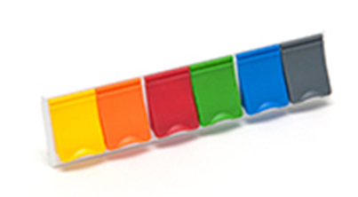
The fixed Panels features a screen printed numbering systems for labelling.
If baluns, circuit cross over or impedance matchers are used, these shall be external to the Patch Panel.
The Snap-In panels feature an exclusive Clip-On system to secure the connector in the panel and to provide a simple means of bonding shielded connectors to facilitate installation. Connection of the panel to earth is achieved with a unique Auto-Connect feature removing the need for individual bonding conductors.
The installer must avoid any risk of cable pinching or compression during the installation or termination of the cables. Therefore the use of Velcro cable ties is preferred.
In the rack, the Patch Panels shall be separated by metallic patch-guides that have a closed front to protect the patch cords. The height of these guides will be 1U or 2U depending on the layout of the rack.
The Patch Panel shall also provide an automatic contact with the metal frame of the cabinet in order to ensure correct protective and functional bonding of the cabling system.
The dimensions of the patch panel shall be 19" 1 U high, depth 75 mm.

Detailed product information
This panel features vertical "T" clips for rapid cable retention which allows loading of the panel in around 25% of the time needed to fasten tie wraps which leads to time saving during installation.

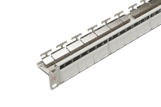
Example of product
Patch Panel 24 Snap-In Fixed White
Aginode reference: N521.661

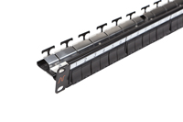
Example of product
Patch Panel 24 Snap-In Fixed Black
Aginode reference: N521.661BK

Flat and sliding patch panel
Patch panels must have 19" equipment practice dimensions to permit mounting in standard cabinets, racks or bays.
The vendor shall make their proposals for this tender using unloaded black or white sliding 24 port Snap-In format (Modular) patch panels fitted with black or white shutters to protect the RJ45 Ports.
Optional coloured shutters need to be available to easily indicate different services when required.
The presentation of the Patch Panel with sliding mechanism shall provide for labelling using a printed numbering system.
If baluns, circuit cross over or impedance matchers are used, these shall be external to the Patch Panel.
The Snap-In panels feature an exclusive Clip-On system to secure the connector in the panel and to provide a simple means of bonding shielded connectors to facilitate installation. Connection of the panel to earth is achieved with a unique Auto-Connect feature removing the need for individual bonding conductors.
The installer must avoid any risk of cable pinching or compression during the installation or termination of the cables. Therefore the use of Velcro cable ties is preferred.
In the rack, the Patch Panels shall be separated by metallic patch-guides that have a closed front to protect the patch cords. The height of these guides will be 1U or 2U depending on the layout of the rack.
The Patch Panel shall also provide an automatic contact with the metal frame of the cabinet in order to ensure correct protective and functional bonding of the cabling system.
The Patch Panel with sliding mechanism has to be mounted in the cabinet before termination of the cables.
The installer shall locate the cables in the cabinet with enough slack to enable the termination of the connectors to be completed from the front of the cabinet.
The dimensions of the patch panel shall be 19" 1 U high, depth 125mm.

Detailed product information
This panel features vertical "T" clips for rapid cable retention which allows loading of the panel in around 25% of the time needed to fasten tie wraps which leads to time saving during installation.
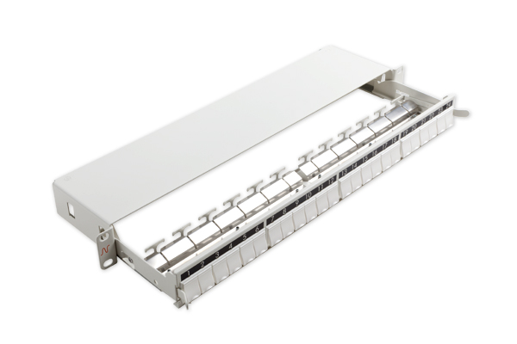
Example of product
Patch Panel 24 Snap-In Sliding White
Aginode reference: N521.663

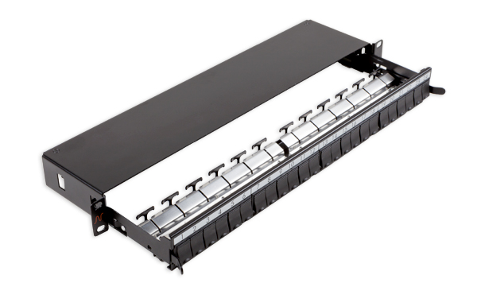
Example of product
Patch Panel 24 Snap-In sliding Black
Aginode reference: N521.663BK

Angled copper patch panels
Patch panels must have 19" equipment practice dimensions to permit mounting in standard cabinets, racks or bays.
The vendor shall make their proposals for this tender using unloaded black or white 24 port angled Snap-In format (Modular) patch panels.
Optional coloured shutters need to be available to easily indicate different services when required.
Manufactured from steel, the panel provides a robust, high density mounting mechanism for Snap-In modular connectors and incorporates an integral cable management tray for the secure strain relief of terminated cables.
The angled panel is designed for use in high density applications such as in Data Centres where the specially shaped panel encourages enhanced patch cord management with a reduced requirement for horizontal management bars.
The Angled Panel is recommended for use in patching frames which incorporate enhanced vertical (side) management features.
The panel features a screen printed numbering systems for labelling.
The dimensions of the patch panel shall be 19" 1 U high, depth 185 mm.

Detailed product information

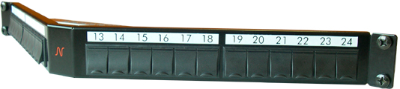

Example of product
LANsense Panel 24 Snap-In black
Aginode reference: N521.671

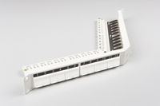

LANsense Panel 24 Snap-In white
Aginode reference: N521.675

Flat copper patch panel with Angled connectors
Patch panels must have 19" equipment practice dimensions to permit mounting in standard cabinets, racks or bays.
The Panel with angled connectors shall be a shielded 19”/1U patch panel with a fixed tray for up to 24 regular Snap-In connectors, which are mounted in an angled position inside the panel.

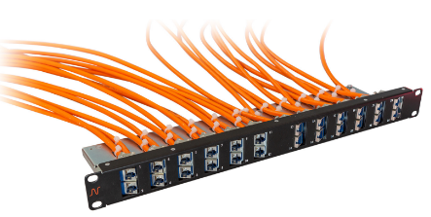
Six Dual Port Packs are mounted on each side, so that 12 connectors pointing to the left side and 12 connectors pointing to the right side.
Due to the angled design of the Dual Port Packs, it is possible to patch without any cable management panel above or below the panel.
Snap-In connectors can be easily fitted into the patch panel by using blue Keystone Clips, which are delivered with the panel. The packaging of the panel does not contain connectors but is including 24 Keystone Clips for Snap-In connectors.
The panel shall be available with and without cable support tray.
The patch panels are designed for standard 19" enclosures, are 1U high, and support the following common features:
- Front colour black, similar to RAL 9005
- Designed for screened and unscreened Snap-In connectors
- Compatible with all performance categories of connector
- 24 Ports available; port numbering from left to right
- Robust steel construction
- UL94V-0

Detailed product information

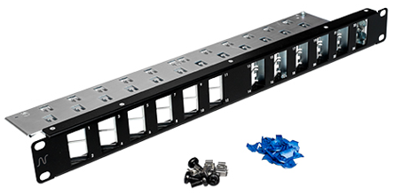
Example of product
LANmark Patch Panel 24 Angled Snap-In Black Cable Support
Aginode reference: N521.681BK

High density 48-port copper patch panel

Patch panels must have 19" equipment practice dimensions to permit mounting in standard cabinets, racks or bays.

The High-Density Copper Patch Panel shall support 48 Connection Points on only 1 Rack Height Unit and allows to connect full 48 port switches. It helps to reduce the space required for cabling and to free up this space to other services.
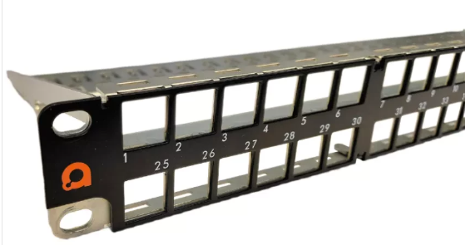

The Panel is designed to accommodate 48 Category 6A RJ45 Connectors.
It is a robust, fully metal Patch Panel, which supports the weight load of 48 cables and offers a rear cable management with 48 T-connection points for Tie-Wraps.

Connectors are mounted Latch Up / Latch Down to enable easy patching of RJ45 Cords. Port Numbering is on the opposite side of the latch to keep it visible. Numbering is horizontal from left to right.

To install the connectors in the panel, they must be fitted with a keystone clip. Two bags of 24 clips shall be provided with the panel, for that purpose.

Connection of the panel to earth is achieved with a unique Auto-Connect feature removing the need for individual bonding conductors or earthing screws at the rear of the panel.

Detailed product information

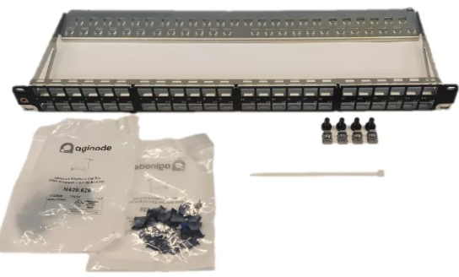

Example of product
LANmark Patch Panel 48-port for ULTIM 1U Black
Aginode reference: N521.960BK

Intelligent flat and fixed copper patch panels
Patch panels must have 19" equipment practice dimensions to permit mounting in standard cabinets, racks or bays.
The vendor shall make their proposals for this tender using unloaded black 24 port Snap-In format (Modular) patch panels carry on-board intelligence which remains dormant until enabled by Automated Infrastructure Management (AIM) analysers and software.
The panels have in-built sensors to detect the connection status of each port and an I/O connector to link to the analysers.
The fixed panel features a screen printed numbering systems for labelling.
In the rack, the Patch Panels shall be separated by metallic patch-guides that have a closed front to protect the patch cords. The height of these guides will be 1U or 2U depending on the layout of the rack.
The Patch Panel shall also provide an automatic contact with the metal frame of the cabinet in order to ensure correct protective and functional bonding of the cabling system.
The dimensions of the patch panel shall be 19" 1 U high, depth 75 mm.
Every port of the panel must be equipped with integrated copper sensors to support ‘outband’ detection of a patch cable via its 9th wire.
The communication between the AIM panel and the scanning hardware (analyser) must utilise a close circuit (DC electrical loop) to constantly (real time) detect connectivity changes.
Switch presentation (Mirror) panels for all active equipment port representation shall be installed in every AIM (Automated Infrastructure Management) controlled distributors.

Detailed product information
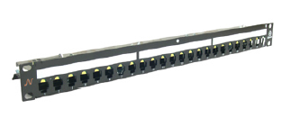
Example of product
LANsense Panel 24 Snap-In black
Aginode reference: N881.311

ZD Fibre pre-terminated assembly

Fibre pre-terminated cable assembly

UHD LC fibre pre-terminated cable assembly
The Ultra High Density (UHD) assembly consists of a Bundle construction Indoor cable terminated with connectors on each side in a factory.
Cable structure
Every fibre shall be 250µm diameter secondary coated each being a different colour or suitably identified for termination identification.
The cable shall be a Bundle construction, limited filled with gel, containing 12 fibres, with a maximum of 12 -Bundles. The jacket material shall be LSZH.
The cable shall be dielectric construction, i.e. with no metallic content.

The cable shall be flame and fire retardant according to IEC 60332-1 and IEC 60332-3.
The cable shall be compliant to the IEC 60794-2-20 standard.
The Pre-Term shall have a dual stage fan-out design.
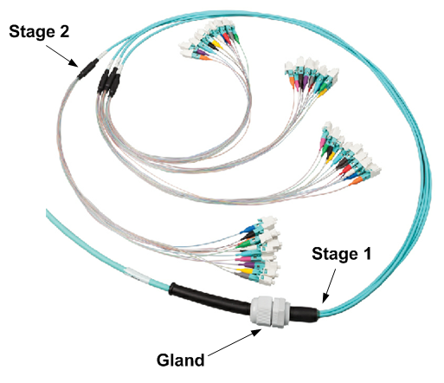
The first fan-out stage is the transition point between the cable and the legs of the fan-out. Each leg of the fan-out contains 1 Bundle with 12 fibres inside. This fan-out has been reinforced with aramid yarns.
The second fan-out stage distributes the reinforced Bundle into 12 buffered fibres. The second fan-out together with the 12 buffered fibres and connectors are optimized for installation and fixation into the UHD adaptor modules.
The connectors on the Tight Buffered fibres have coloured boots for identification in compliance with the TIA/EIA standard. In manufacturing a fibre pair flip has been implemented. When installing the connectors inside the modules of the patch panel the coloured boots need to match the colours of the integrated strip inside the module to obtain transmit-receive polarity in the channel.
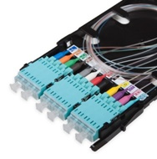
The fan-out is protected with a bubble foam for protection during transport and installation. In addition every bundle of 12 connectors has an additional individual protection to avoid mixing them up with connectors from another bundle.
The Pre-Terms are optimized for both laying and pulling. A pulling eye system is positioned at one side of the Pre-Term to facilitate the installation. This pulling eye is connected to the internal strength element of the cable. The maximum pulling force on the pulling eye is 450N.
The LC/LC Pre-Terms come with a PG-13 cable gland that fits into the patch panel slots.
In order to reduce overlengths in data centres the Pre-Terms are custom made and available with 1m increments.
The typical value for the insertion loss for the low loss LC/LC connection is 0,15 dB. The limit value is 0,25 dB measured according to standard IEC61300-3-4. The minimum return loss is measured according to standard IEC 61300-3-6. For a multimode LC connection the RL is 30 dB, for a singlemode LC connection it is 40 dB and for a LC/APC connection it is 55 dB.
All LANmark-OF Pre-term assemblies are fully terminated and tested in a quality assured factory environment. The test results are delivered in the box with the Pre-Term.
Performances
The following performances shall be warranted by the manufacturer:
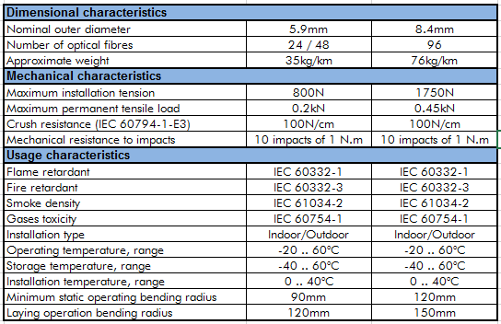

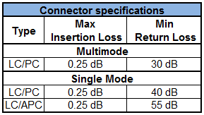

CPR grade compliance requirement (Cca s1,d0,a1)
The CPR regulations came into force in July 2016 and with effect from the 1st July 2017, cable jacket
materials must be of the appropriate Construction Product Regulations Class to meet the
requirements of EN 50399 and EN 50575 2014/A:2016 standards. In particular the cables proposed for this project must conform with EN50575 for certification and labelling.
The proposed cables must meet Class Cca s1,d0,a1 and the bidder must provide a statement from the chosen manufacturer detailing their 3rd party verification of their product and its classification.

Detailed product information

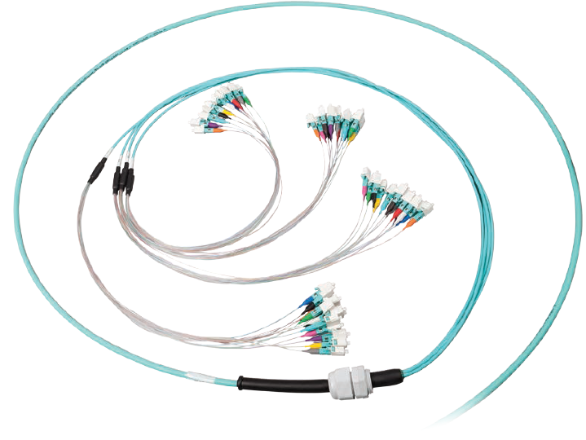

Example of product
LANmark-OF ENSPACE LC/LC Pre-Term
Aginode references
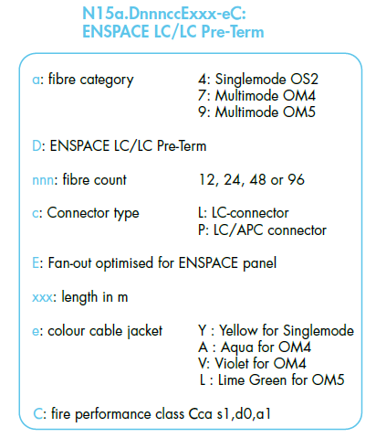

UHD MTP-MTP fibre pre-terminated cable assembly

The Ultra High Density (UHD) Pre-Term cable shall be based on an advanced Micro-Bundle design. The mechanically strong Micro-Bundle cable shall feature a central strength element and aramid yarns.
Cable must feature a round small diameter of 5.9 mm for cables up to 48 fibres and of 8.4 mm for the cable with 96 fibres to facilitate use in Data Centre environment where space and airflow restrictions restrict the use of conventional design.
The cable shall have a round shape (No ribbon cable allowed) in order to avoid preferential bend radius of the cable and of the fan-outs.

The MTP-MTP Pre-Term has standard pinned (male) connectors. This matches with the un-pinned (female) connectors in the MTP/LC modules.

In order to reduce overlengths in data centres the Pre-Terms are custom made and available with 1m increments. The "xxx" in the N-number is the length in metre between the cable glands, i.e. the Pre-Term length between the back side of the patch panels.

After the cable gland the Pre-Term has a fan-out. The fan-out splits the cable into legs. The legs are reinforced with aramid yarns. Each leg contains 12 fibres. At the end of each leg a MTP-connectors is mounted. The colour of the jacket of the legs is the same as the cable jacket. Close to the MTP-connector a label is installed to identify the number of the leg.

The Pre-Terms are optimized for both pulling and laying in data centres. On both sides the MTP connectors are protected by a bubble foam. On one side there is also a protecting net around the fan-out with MTP connectors and a pulling eye. The maximum pulling force on the pulling eye is 450N.

The MTP-MTP Pre-Terms come with a PG-13 cable gland that fits into the patch panel slots.

On the cable at a distance of 10-20 cm of the cable gland a label that provides the following information is affixed:
- Serial number
- Traceability code
- P/N-number

The Pre-Term cable shall be LSZH jacketed and shall meet the requirements for flame non propagation (IEC 60332-1) and fire non-propagation (IEC 60332-3).

Performances

Insertion loss for individual MTP connection
Fibre type | Multimode  (OM4 or OM5) | Singlemode  OS2 with G657
Typical loss | 0.15 dB | 0.30 dB
Max loss | 0.30 dB | 0.50 dB
Factory tested according to IEC 61300-3-45 standard

Factory Testing and warranty
Test report providing detailed information on each MTP cable (insertion loss and return loss) shall be included.
Every delivered item must be labelled to ensure traceability and reference to the associated test report.
The pre-terminated assemblies shall be fully terminated and tested in a quality assured factory environment, with 25-year product guarantee on the application and performance.

Method C polarity (To be selected for termination on MTP/LC modules – 10G)
The design shall incorporate in built polarity mechanisms (pair-wise fibre flip inside the MPO-MPO Pre-Term) to ensure correct link configuration with standard crossed patch cords on both sides (TIA 568-B-1-7-2006 method C - key up / key down design with a fibre pair-flip) whether installed initially or reconfigured after installation. Reconfiguration of patch cords shall not be required when moving or replacing cables.
Due to the adoption of the above mentioned method C for fibre polarity management, the same type of modules and of patch cords shall be used on both sides of the link.

Method B polarity (To be selected for direct termination on MTP adaptors – 40G/100G)
The method B Pre-Term has a straight key up / key up design in agreement with standard TIA 568-B-1-7-2006 method B.

For a duplex transmission like for 10GBase-SR (10G) polarity in the channel is maintained with this method B design and the use of a straight cassette on side A and a crossed cassette on side B. In addition the same patch cords can be used on both sides.

For parallel optics like for 40GBase-SR4 (40G) these method B Pre-Terms can be used with key up/key down adaptors on both sides of the channel. The same straight female-female patch cords can be used on both sides.

CPR grade compliance requirement (Cca s1,d0,a1)
The CPR regulations came into force in July 2016 and with effect from the 1st July 2017, cable jacket
materials must be of the appropriate Construction Product Regulations Class to meet the
requirements of EN 50399 and EN 50575 2014/A:2016 standards. In particular the cables proposed for this project must conform with EN50575 for certification and labelling.
The proposed cables must meet Class Cca s1,d0,a1 and the bidder must provide a statement from the chosen manufacturer detailing their 3rd party verification of their product and its classification.

Detailed product information

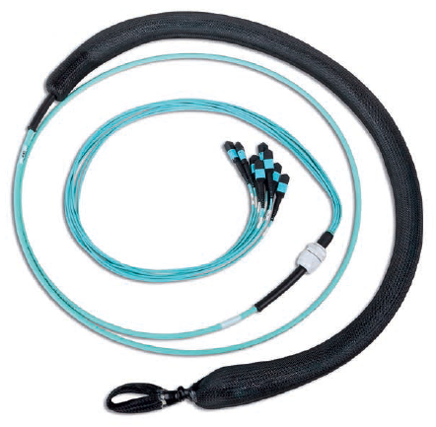
Example of product
LANmark-OF ENSPACE MTP Pre-Term
Aginode references
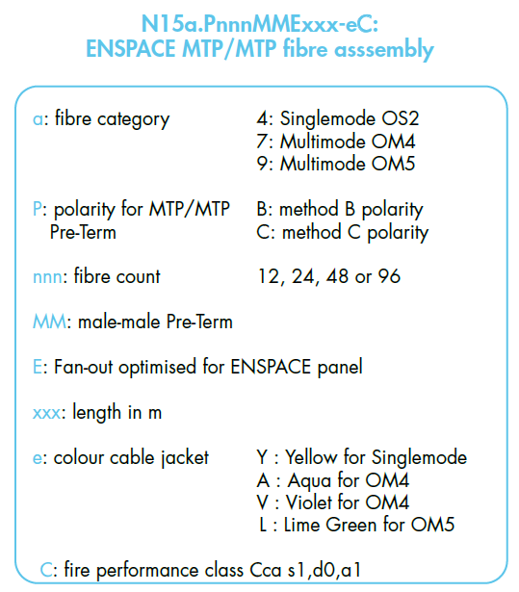

UHD LC patching assembly
Ultra High Density (UHD) patching assemblies allow the rapid deployment of high density patching in SAN and LAN environments in data centres. Patching assemblies allow to represent switches with patch panels. On one end the patch cord fan-out is designed to be directly connected to switches (or any active equipment) ports. On the other end the assembly is optimized for installation inside the patch panel.

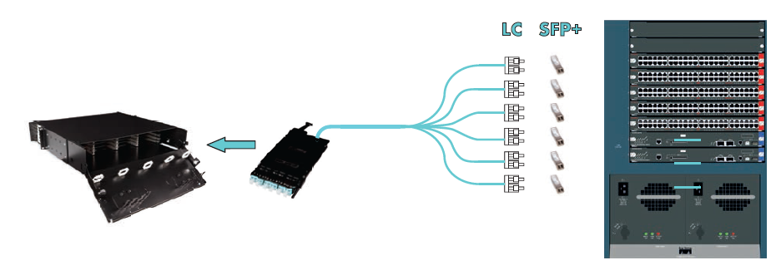
On the active equipment end the fibres are grouped by 2. These couples of fibres are located inside a round 2mm patch cord and are terminated with an uniboot connector. The length from the fan-out point to the uniboot connectors is typical 1m for all uniboot connectors, but can be customized to 1,5m or 2m length.

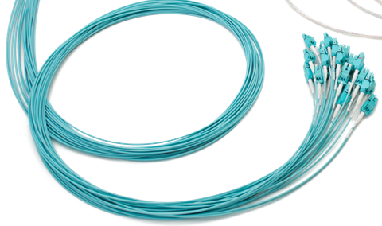
The 900 µm side is optimised for installation inside the LANmark-OF ENSPACE patch panel. This side has a dual fan-out design.
The first fan-out stage is the transition point between the cable and the legs of the fan-out. Each leg of the fan-out contains 1 Micro-Bundle with 12 fibres inside. This fan-out has been reinforced with aramid yarns. To identify each leg a label is affixed close to the second fan-out. The jacket of the leg is the same as the jacket of the cable.
The second fan-out stage distributes the reinforced Micro-Bundle into 12 buffered fibres. The 900 µm tubes are transparent and the fibres are identified with coloured boots in compliance with the TIA/EIA-standard.
The second fan-out together with the 12 buffered fibres and connectors are optimized for installation and fixing into the UHD adaptor modules.
The fan-out is protected with a bubble foam and a black net for protection during transport and installation. In addition every bundle of 12 connectors has an additional individual protection to avoid mixing them up with connectors from another bundle.
The 900 µm side of the Pre-Term is equipped with a PG13 cable gland that can be fixed on the patch panels.
On the 900µ side a pulling eye and a black protecting net are installed. The maximum pulling force on the pulling eye is 450N.
Insertion loss for the connectors is less than 0,25 dB measured according to standard IEC 61300-3-4. The minimum return loss is measured according to standard IEC 61300-3-6. For a multimode LC connection the return loss is 30 dB, for a singlemode connection it is 40 dB and for a LC/APC connection it is 55 dB.

CPR grade compliance requirement (Cca s1,d0,a1)
The CPR regulations came into force in July 2016 and with effect from the 1st July 2017, cable jacket
materials must be of the appropriate Construction Product Regulations Class to meet the
requirements of EN 50399 and EN 50575 2014/A:2016 standards. In particular the cables proposed for this project must conform with EN50575 for certification and labelling.
The proposed cables must meet Class Cca s1,d0,a1 and the bidder must provide a statement from the chosen manufacturer detailing their 3rd party verification of their product and its classification.

Detailed product information

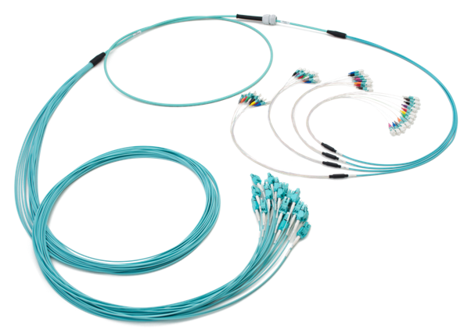
Example of product
LANmark-OF ENSPACE patching assemblies
Aginode references
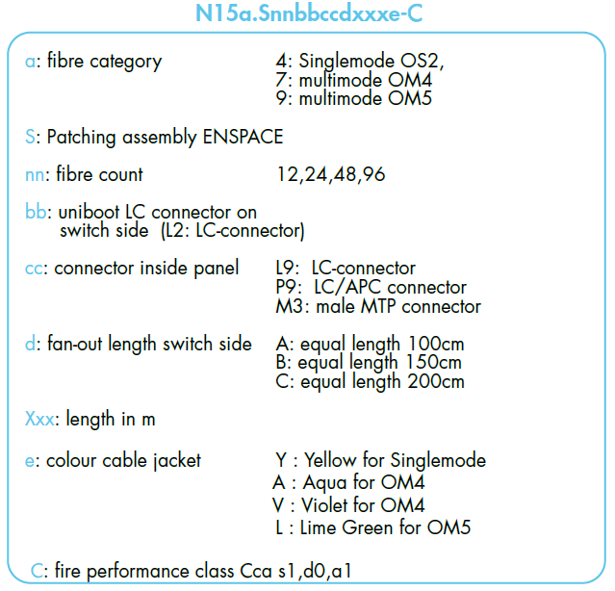

Fibre characteristics

OM4 fibre characteristics
The multi-core optical fibre cable shall consist of multimode OM4 - 50/125µ fibre with fibres colour coding for identification.

The OM4 fibres shall be compliant to the following standards:
- EC 60793-1-49: differential mode delay (DMD) to measure effective modal bandwidth (EMB)
- EC 60793-1-41: overfilled mode launch bandwidth (OFL BW)
- ISO/IEC 11801:2017 as OM4 fibre
- IEC 60793-2-10 as fibre type A1a.3b
- Compliant to annex D4 (DMD template requirements) and annex D5 (EMBc: calculated effective modal bandwidth) of IEC 60793-2-10 ed. 4

The OM4 fibres shall meet the following specifications:

Geometrical Characteristics of OM4 fibres

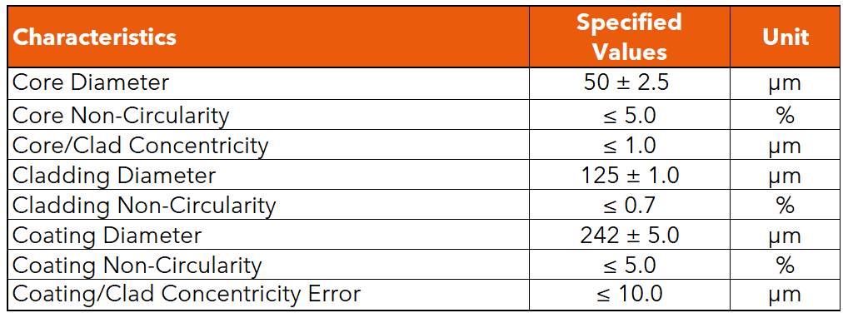

Optical parameters of OM4 fibres
Effective modal bandwidth shall be measured according to the templates method of IEC 60793-2-10 section D4 and the calculated effective modal bandwidth of IEC 60793-2-10 section D5.

OM5 fibre characteristics

The multi-core optical fibre cable shall consist of multimode OM5 - 50/125µ fibre with fibres colour coding for identification.

The OM5 fibres shall be compliant to the following standards:
- EC 60793-1-49: differential mode delay (DMD) to measure effective modal bandwidth (EMB)
- EC 60793-1-41: overfilled mode launch bandwidth (OFL BW)
- ISO/IEC 11801:2017 as OM5 fibre
- IEC 60793-2-10 as fibre type A1a.4b
- Compliant to annex D4 (DMD template requirements) and annex D5 and D6 (EMBc: calculated effective modal bandwidth) of IEC 60793-2-10 ed. 6

The OM5 fibres shall meet the following specifications:

Geometrical Characteristics of OM5 fibres

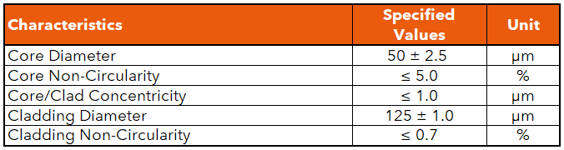

Optical parameters of OM5 fibres
Effective modal bandwidth shall be measured according to the templates method of IEC 60793-2-10 section D4 and the calculated effective modal bandwidth of IEC 60793-2-10 section D5.

OS2 fibre characteristics
The multi-core optical fibre cable shall consist of singlemode OS2 - 9/125µ fibre with fibres colour coding for identification.

The OS2 fibres shall be compliant to the following standards:
- ITU-T as fibre type G.652.D and G657A1
- Singlemode OS2 cable defined in ISO/IEC 11801:2017
- IEC 60793-1 Measurement Methods and Test procedures
- IEC 60793-2-50 as fibre type B1.3 and B6_a1

The OS2 fibres shall meet the following specifications:

Geometrical Characteristics of OS2 fibres

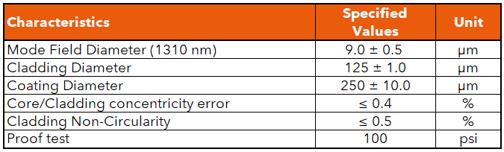

Optical parameters of OS2 fibres

Optical Fibre Patch Panel

Sliding modular OF Patch Panel
The 1U Optical Fibre Patch Panel must be modular having 24 empty ports that can be loaded with SC or LC Snap-In adaptors and fits in a 19” rack or cabinet.
The modular OF panel has extended cable management with multiple entries to provide maximum flexibility. It accommodates both cable glands and tie wraps for strain relief of the cables. The cable gland sizes holes are 20 mm (8x) and 25 mm (2x).
The patch panel shall be designed with an enhanced sliding mechanism enabling front side installation and maintenance work to be carried out without having to remove the entire panel.
The front adaptor plate is fixed in a recessed position. When set in recess position the front connector plate is deeper than the front of the 19" rails of the cabinet. This will provide sufficient bend radius for the patch cords once connected to the panel. This shall also prevent damages to the patch cords when the cabinet doors are closed.
Direct Termination of the connectors (SC & LC) on to the fibres as well as splicing of pigtails (SC & LC) shall be possible.
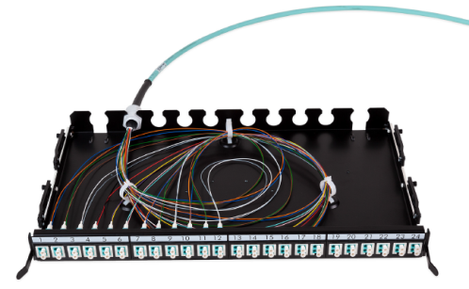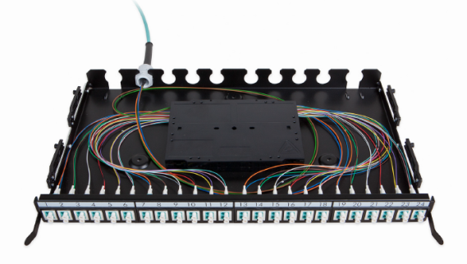
The patch panel chassis has multiple, specially designed, slots at the rear to fix the cable glands of pre-terminated cables. There shall be ample space inside the patch panel to organise the flexible fan-out of the pre-terminated cables.
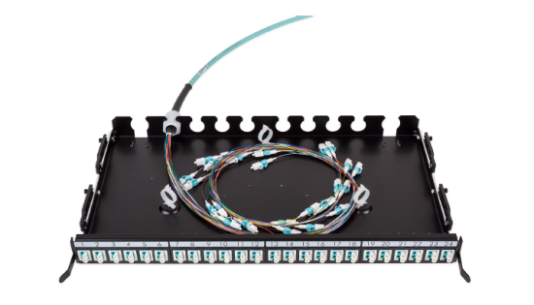
The Patch Panel shall be supplied with 3 loop rings to neatly coil the terminated fibres.
Up to four optional splice cassettes should be supported to manage up to 48 splices with heat shrink protectors and with aluminium protectors.
The splice cassettes shall feature a lifting functionality for improved ease of installation and inspection.

The front plate of the 24 port modular Patch Panel shall be compatible with the following connector types: 24 single SC, 24 duplex LC and 12 duplex DSC.
Standard LC, SC and DSC Snap-In couplers shall be available to load the modular patch panel.
The colour of the Multimode Snap-In adaptors shall be aqua.
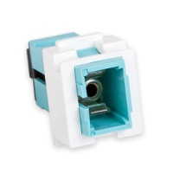
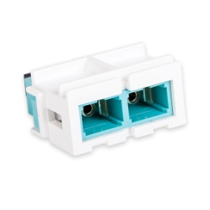
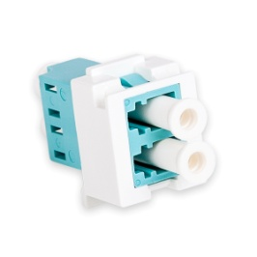
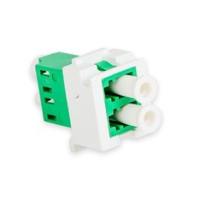
Singlemode Snap-In adaptors shall be available in Blue and Green colour. Blue colour is going to be selected to connect PC polished SC or LC connectors while green is selected for APC polished connectors.
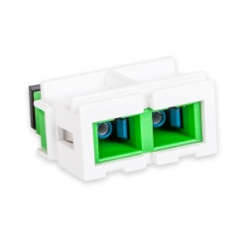
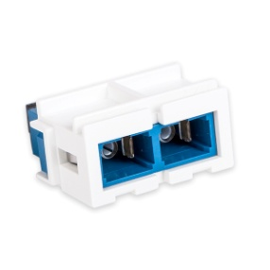
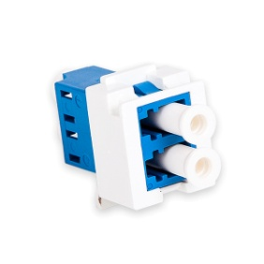
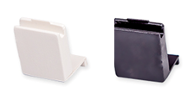
The fully loaded panel (One height unit or 1U) shall support up to 24 fibres when working with SC Snap-In couplers and up to 48 fibres when working with LC Snap-In couplers.

Unused positions can be populated with optional blank fillers.

Panels are fully painted for a professional look and feel. It t shall be available in both black and white colour.
In the panels, the fibres have to be wired in such a way that the dual OF channel polarity is maintained. Wiring of the fibres has to be done according to the guidelines provided by the manufacturer.

Detailed product information
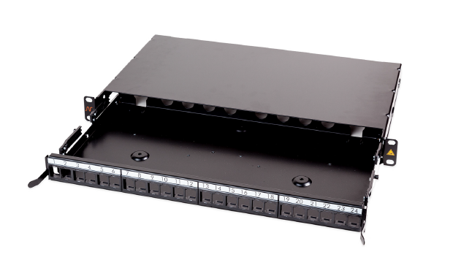
Example of product
LANmark-OF Patch Panel Snap-In Sliding Black
Aginode reference: N439.4SNB

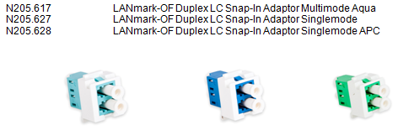

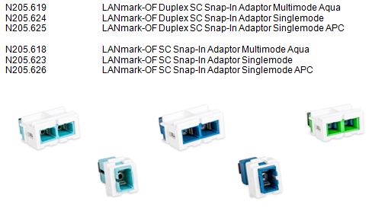

High density Plug&Play OF patch panel
The ' Plug and Play concept shall be specifically designed for installation in data centres where the high density, integrated patch cord guide and enhanced installation benefits of the patch panel meet the key requirements for implementation.

The patch panel design allows to hold up to 4 MTP/LC modules or adaptor plates in 1U of the distribution rack. Depending on the type of the module a high density of up to 96 fibre connections can be accommodated.

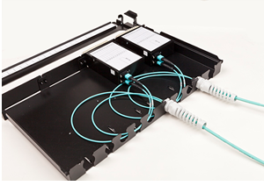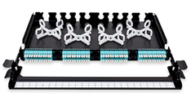

The patch cord guide sits in front of the modules and allows the patch cords to be managed within the same 1U saving expensive rack space. The patch cord guide also provides a labelling facility to identify connections. Additional labelling is provided by printed port numbers on the modules.

The tray shall slide and tilt for improved access to install new modules and adaptor plates.

The patch panel is optimised for installation of MTP/MTP or SC/LC Pre-Term assemblies. The cable glands of the Pre-Term allow a fast and solid fixing of the cable. There is ample space inside the patch panel to organise the flexible fan-out of the Pre-Term.

Optional Fibre Organiser shall be available to facilitate the installation of the SC/LC Pre-Term.
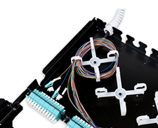

Up to 4 optional splice cassettes can be installed in the patch panel to accommodate up to 96 splices.
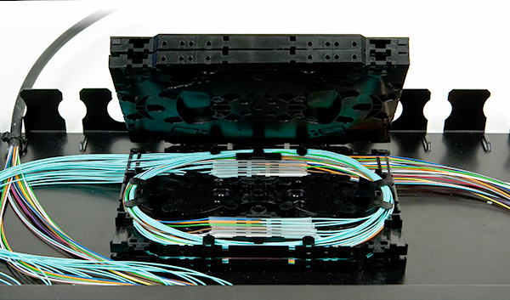
Panels are fully painted in black for a professional look and feel.
Blank fillers are available as separate accessories for unused positions to give a finished look.

The front adaptor plate can be fixed in a flush or recessed position in the rack using the adjustable side brackets. When the panel is installed recessed the distance between the rack vertical and the rear of the panel is 288 mm. The front cord management projection is 67 mm. When the panel is installed flush the distance between the rack vertical and the rear of the panel is 248 mm. The front cord management projection is 107 mm.

Detailed product information
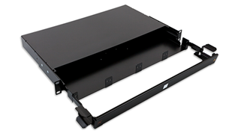
Example of product
LANmark-OF Plug&Play Patch Panel Integrated Cord Guide Sliding Black
Aginode reference: N439.3MPP

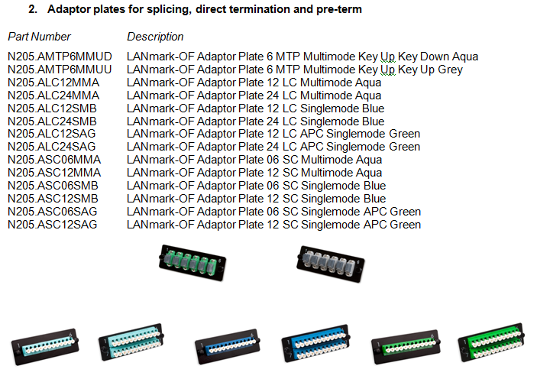

LANmark-OF fibre organiser 10x
Aginode reference: N890.070

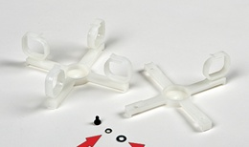

LANmark-OF splice cassette for heat shrink protectors
Aginode reference: N890.090
LANmark-OF splice cassette cover
Aginode reference: N890.092
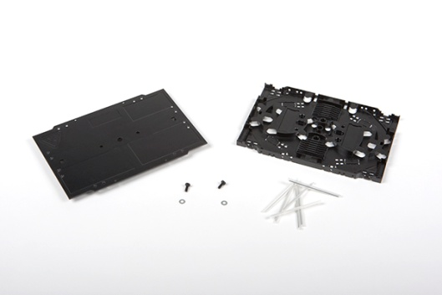

LANmark-OF splice cassette for Aluminium Protectors
Aginode reference: N890.091
LANmark-OF splice cassette cover
Aginode reference: N890.092

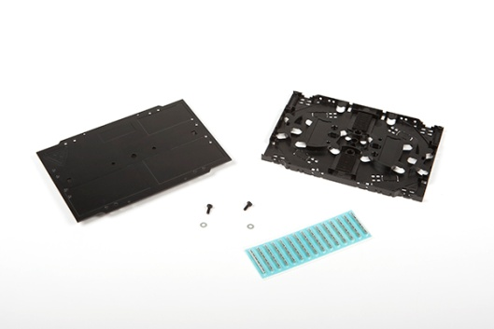

HD OF Patch Panel
The High Density (HD) concept is designed for data centres where the high density, integrated patch cord guides and enhanced installation benefits of the HD patch panel meet the key requirements for implementation.
It shall allow quick changes with limited down time, easy migration to other applications and a transition path to parallel optics.

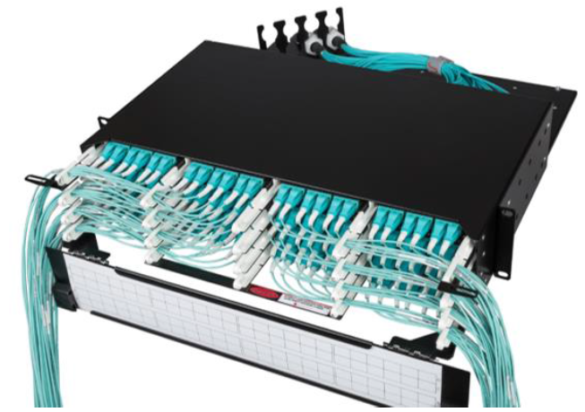

The Aginode’ unique ENSPACE HD 1U panel design has 2 fixed trays. Each tray can have up to 4 ENSPACE modules. The panel can accommodate up to 8 modules allowing 96 LC connections when modules with LC adaptors are used. With LANmark-OF ENSPACE MTP adaptor modules 48 MTP connections within 1U can be installed. ENSPACE modules need to be ordered separately.

The HD Patch Panels shall be available in 1U and 2U. The panels are designed for installation inside 19 inch enclosures.

The trays are staggered to facilitate patching and have easier access to the latch of the patch cord. The trays have printed letters for identification.
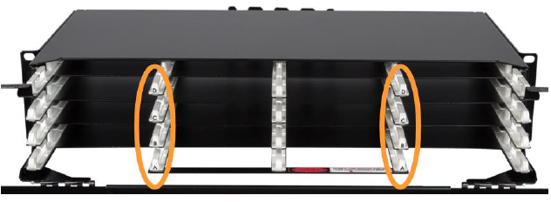

On the rear tray 1 cable fixing kit is provided. The slots are suitable for a PG-13 cable gland. The orientation of the fixing kit can be modified to allow for side, angled or rear entry. An optional third cable fixing kit can be installed on the tray as well.

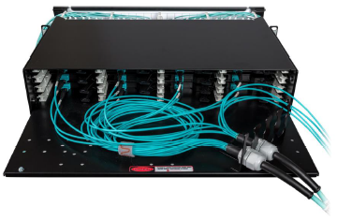

The patch panel is optimised for installation of the LANmark-OF ENSPACE Pre-Terms: the cable gland of the Pre-Term allows a fast and solid fixing of the cable. There is ample space inside the patch panel to organise the flexible fan-out of the Pre-Terms.

A labelling hinged front cover sits in front of the modules. It can rotate almost 180° even when UHD patch panels are installed underneath. This facilitates port identification when the panel is mounted at the top of the rack.

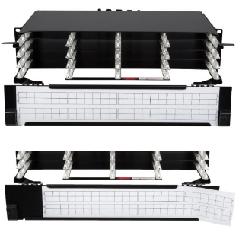

Panels are fully painted in black for a professional look and feel.

The total depth of the panel is 493mm. The panels are delivered with the labeling front projection 129mm in front of the rack vertical. The rear of the panel is 364mm recessed compared to the rack vertical. The position of the panel inside the rack can be changed with adjustable side brackets. It can be moved backwards compared to the rack vertical by 37.5mm or forward by 37,5mm or 75mm.

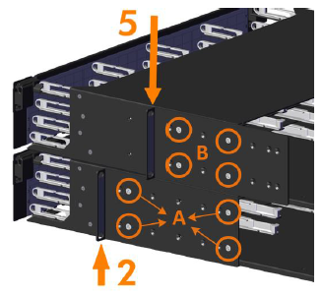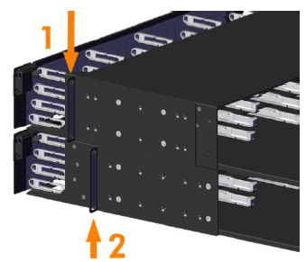

Detailed product information
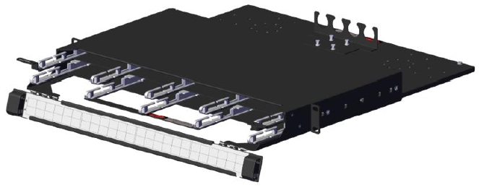
Example of product
LANmark-OF ENSPACE HD Patch Panel 1U 8x Modules Black
Aginode reference: NSPACE.PPHD1U

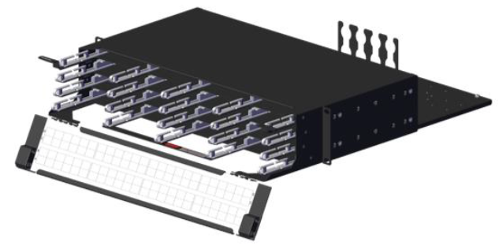
Example of product
LANmark-OF ENSPACE HD Patch Panel 2U 16x Modules Black
Aginode reference: NSPACE.PPHD2U

Optional modules and accessories

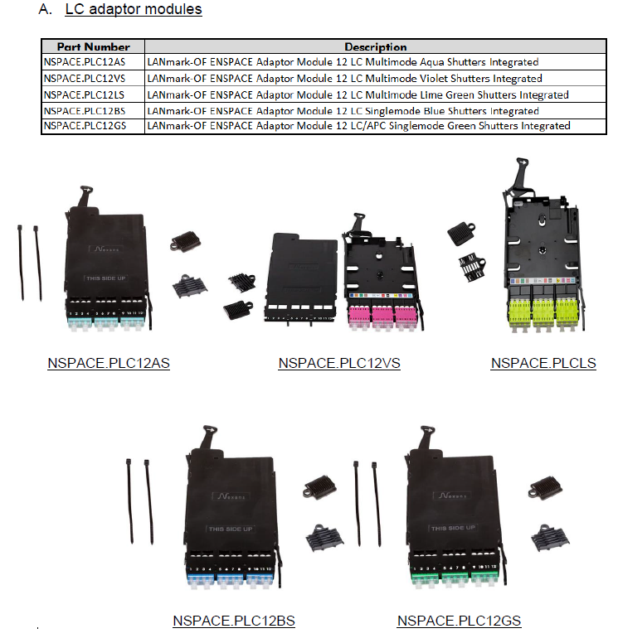

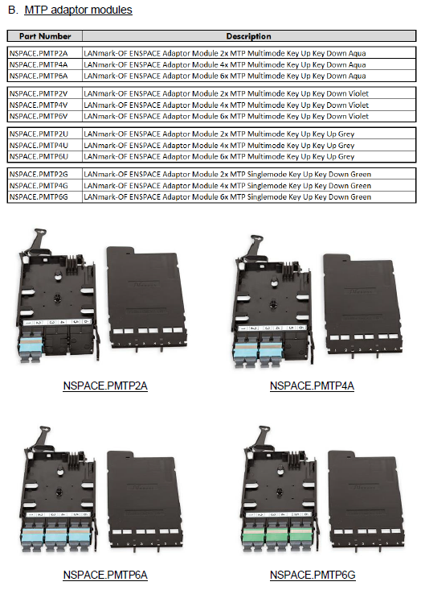

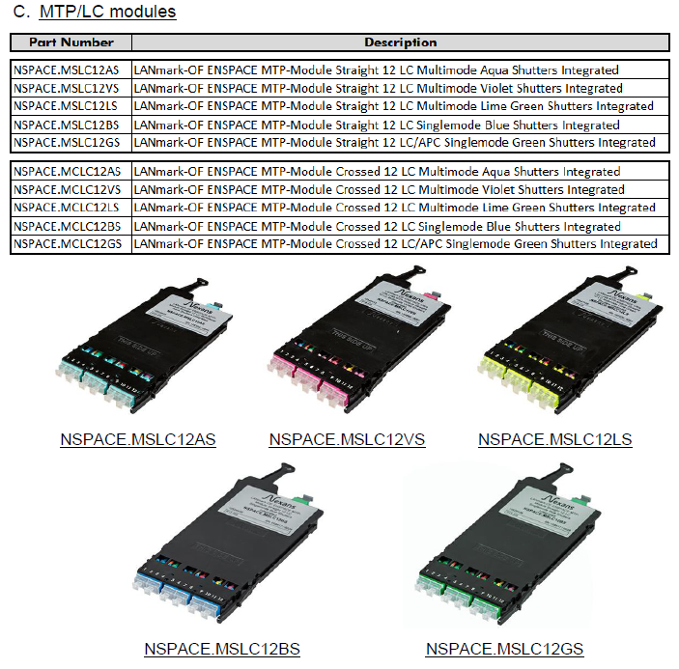

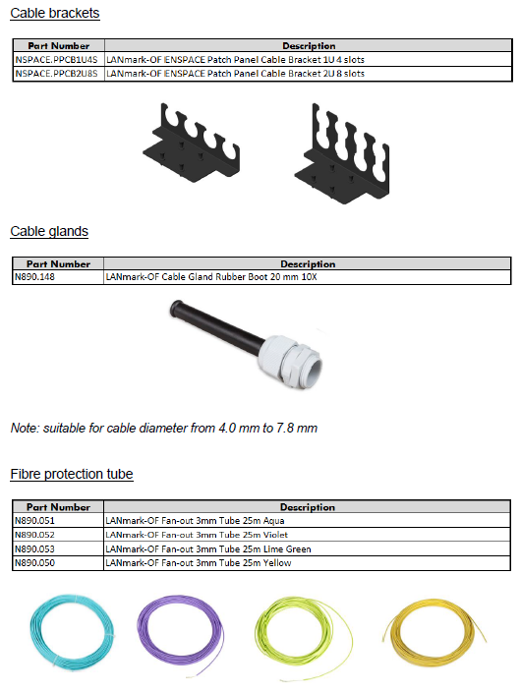
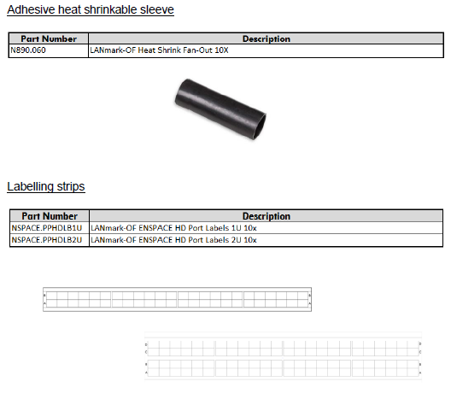

UHD OF Patch Panel
The Ultra High Density (UHD) concept is designed for data centres where the very high density, integrated patch cord guides and enhanced installation benefits of the UHD patch panel meet the key requirements for implementation.
It shall allow quick changes with limited down time, easy migration to other applications and a transition path to 40G/100G.

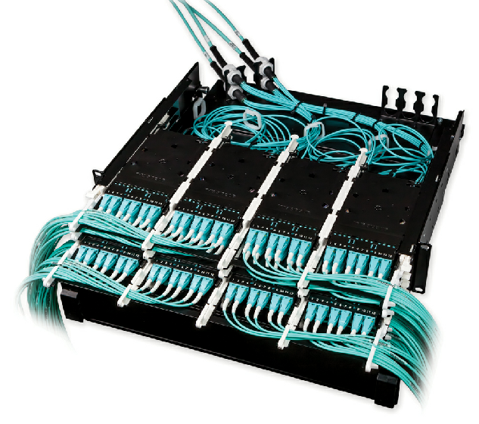

The UHD system consists of 3 sub-components: Pre-Terms, modules and patch panels.

The patch panel design shall have 3 sliding trays within 1U. Each tray can accommodate up to 4 modules. The panels can be loaded within 1U with up to 12 modules allowing 144 LC connections when modules with LC adaptors are used. With MTP adaptor modules 72 MTP connections within 1U can be installed. Modules have to be ordered separately.

The UHD Patch Panels shall be available in 1U, 2U and 4U. The panels are designed for installation inside 19 inch enclosures.

The tray slides shall have 3 locking positions.

The operational position (1) when the trays are completely in the rack.
The patching position (2) when the tray is moved forward by 75 mm. This allows easy access to the patch cords.
The final stop position (3) before removal of the tray.

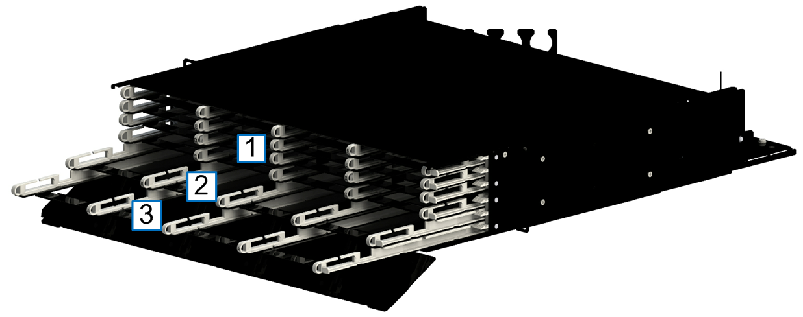

The sliding trays shall have printed letters to identify the individual trays. Additional side handles on the left and right sides enhance the pulling forward of the tray.

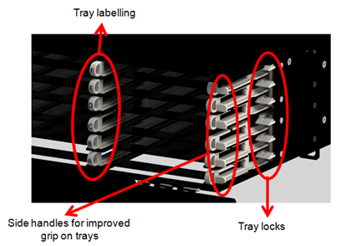

The UHD Pre-Terms shall be fixed on a separate, sliding and tilting tray located at the rear of the panel. For installation of the cables the tray can be slid out of the patch panel by about 15 cm. This allows easy access to the fixing points for the cables without being in the small space formed by the panel above and underneath when working in a high density rack.
On this rear tray 2 cable fixing kits are provided. The slots are suitable for a PG-13 cable gland. The orientation of the fixing kit can be modified to allow for side, angled or rear entry. An optional third cable fixing kit can be installed on the tray as well.

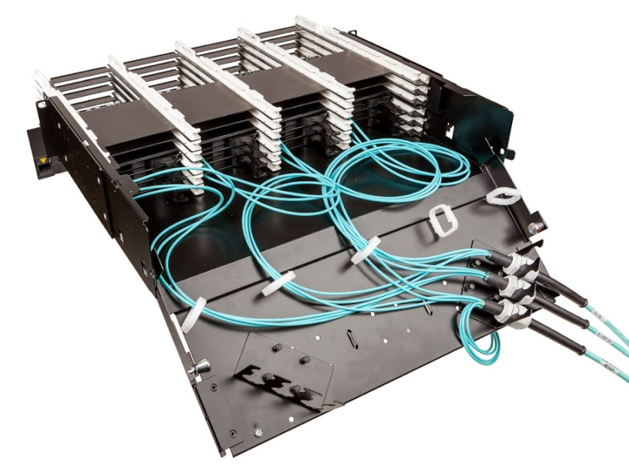

The patch panel is optimised for installation of the UHD Pre-Terms: the cable gland of the Pre-Term shall allow a fast and solid fixing of the cable. Ample space is available inside the patch panel to organise the flexible fan-out of the Pre-Terms, including the additional fan-out overlength required to allow the individual trays to slide to the patching or installation position.

A labelling hinged front cover sits in front of the modules. It can rotate almost 180° even when UHD patch panels are installed underneath. This facilitates port identification when the panel is mounted at the top of the rack.

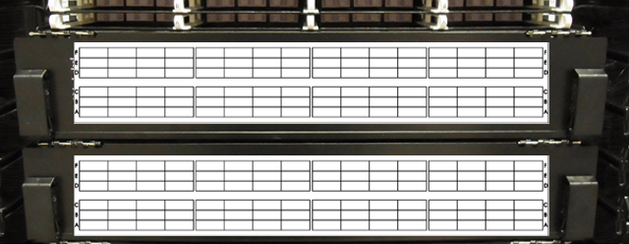

Panels are fully painted in black for a professional look and feel.

The total depth of the panel is 526mm. The panels are delivered with the labelling front projection 129mm in front of the rack vertical. The rear of the panel is 397mm recessed compared to the rack vertical. The L shaped chassis support brackets can be fitted in 5 different positions to move the position of the panel inside the rack. It can be moved backwards compared to the rack vertical by 37.5mm or forward by 37,5mm or 75mm.

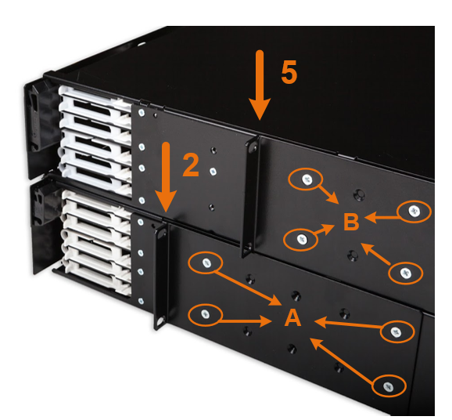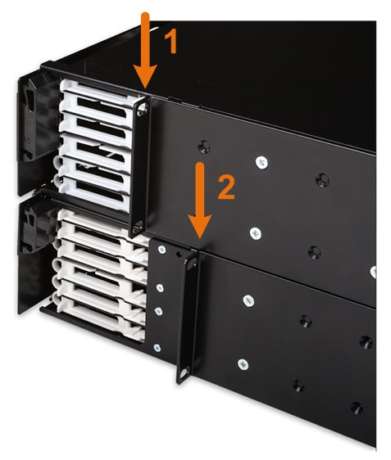

Detailed product information
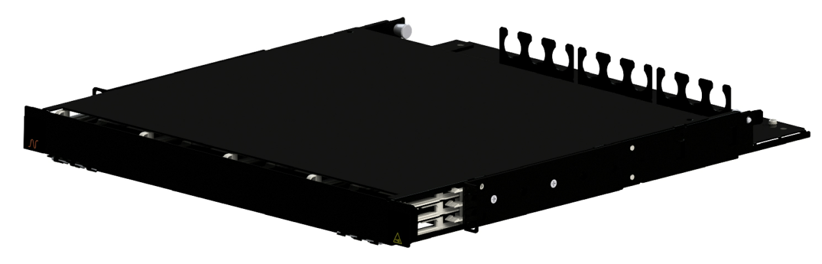
Example of product
LANmark-OF ENSPACE UHD Patch Panel 1U 12x Modules Black
Aginode reference: NSPACE.PP1U

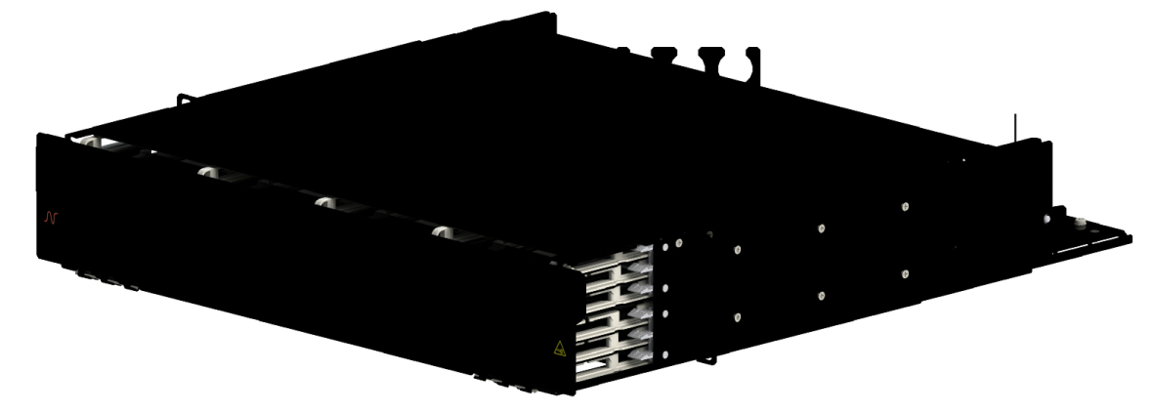
Example of product
LANmark-OF ENSPACE UHD Patch Panel 2U 12x Modules Black
Aginode reference: NSPACE.PP2U

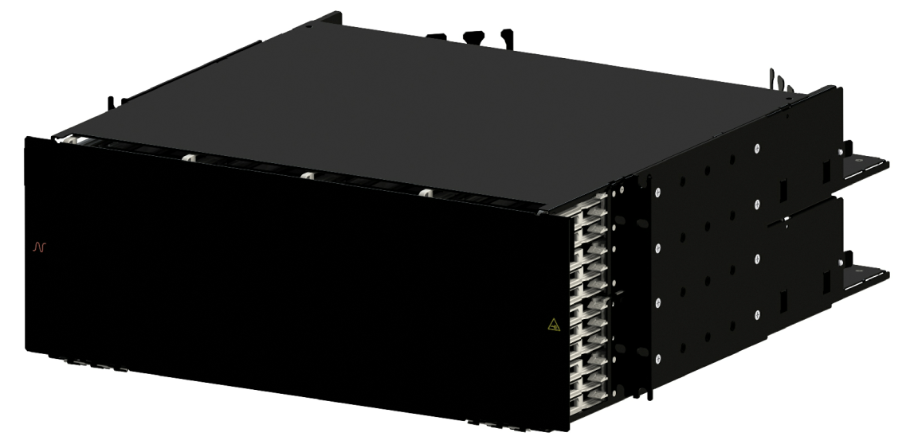

Example of product
LANmark-OF ENSPACE UHD Patch Panel 4U 12x Modules Black
Aginode reference: NSPACE.PP4U

Optional modules ad accessories

Local Distribution point (LDP)
Local Distribution Points significantly improve the flexibility of connexion to server/SAN racks in the DC. It is particularly useful when reconfiguration is required between those active equipment racks.
Moreover, expensive rack space can be saved in active equipment racks by installing passive patch panels outside the racks.
The overhead position shall be preferred. This contribute to increase cabling density per square metre.
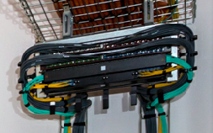
The overhead open frame shall be designed to host copper and fibre patch panels. Both 4U and 6U versions shall be available.
It can be fitted with up to 3 optional patch cords management hooks on both sides. An extra 1U cable guide can be added horizontally under the frame. These accessories hold and guide the patch cords dropping into the racks located below the frame.
The frame and brackets shall be made of galvanised steel, grey natural colour.
Overhead Patching frame shall be fitted with brackets enabling vertical installation under, along and over cable trays. The frame can be angled to 20° by using the angled side of these brackets in order to ease readability of patch panel labels.
The weight of the empty frame and its mounting brackets shall not be over 2,5kg. The total weight (frame and equipment) shall be compliant to the maximum load of the tray to which the frame will be fixed to.

Detailed product information

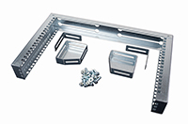
Example of product
LANmark Overhead Patching Frame 4U
Aginode reference: N345.400

LANmark Overhead Patching Frame 6U
Aginode reference: N345.600

Copper Patch cords
To achieve a Class EA Channel performance all data Patch Cords shall be Category 6A rated.
Cat.7A patch cords will only be required in the future when full Class FA or Class II channel will be needed.
The patch cord cable shall be made from LSZH material with a metric marking indicating type of cable, brand name, production code and length.
All patch cords shall be compliant to the IEC 60332-1 standard to offer flame propagation retardant properties.

Cat.6A Data Patch cords
All Data patch cords shall be fully screened.
The standard colours offered for the LSZH flame retardant jacket shall be orange and dark grey.
Red, Blue, Green and Yellow colours shall also be available on demand.
Special length and special cable colours shall be available in 14 days “ex warehouse”.
The default lengths available from stock shall be 1, 2, 3, 5, 10 and 20 m. in order to ensure quick delivery of the cords on site.
The patch cords feature a slim over-moulded boot which is kept inside the RJ45 boundaries to enable High Density Patching with 48 cords in 1 height unit.
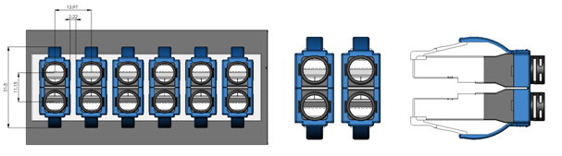
They also come with a ‘Replaceable’ black Latch Protector, which can be used for colour coding of different services.
The coloured retrofit latch protectors shall be available as accessory in 8 colours for colour coding of different services.

The cords shall be fitted with Category 6A RJ45 screened plugs, with a Self-latching connector. All pairs must have an impedance of 100 Ohms. The characteristic impedance of the pairs must be identical to that of the horizontal cables. The Patch Cords shall have a guaranteed performance level of greater than 750 insertions without degradation to the performance level of the solution.
The cable used for the Patch Cords shall be Category 6A LSZH U/FTP patch cable. The cable shall be a 4 twisted pair cable with individually screened stranded conductors. Traceability numbers should accompany the cables supplied from the manufacturers packaging to assist in quality validation of the installed cable.
When installed in combination with other Cat.6A components of the same manufacturer, a 25 years channel warranty can be obtained, covering full 10GBase-T support and full Cat 6A/Class EA compliance.
TheCat.6A cords fully comply and exceed the requirements of EIA/TIA-568-C.2 and ISO11801 and enable to achieve high performing Cat 6A channels. Used with other Cat.6A components of the same manufacturer, very short Cat 6A link and channel configurations with up to 3 connection points within 10 meters can be supported.

Detailed product information

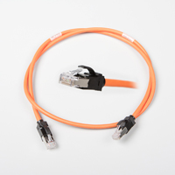

Example of products
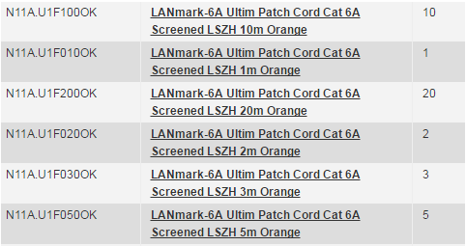

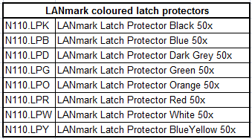

Cat.6A screened small diameter patch cords
Cat. 6A Slimflex cords are developed to support 10 Gigabit Ethernet (IEEE 802.3an) and any other Cat.6A application and require 44 % less space than regular Cat6A patch cords.
They use thin AWG30 wires inside a cable with an outer diameter of only 4.5mm. When formed into bundles, this results into significant space savings.

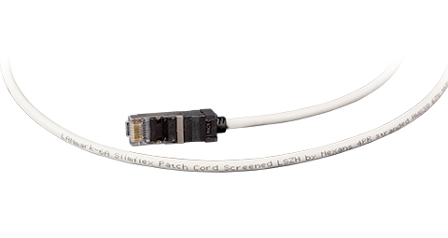
LANmark-6A Slimflex Cords offer a frequency range up to 500MHz and are matched with other LANmark-6A components to provide improved data throughput in complex channel configurations. They use stranded cable to provide maximum flexibility.

The patch cords feature a slim over-moulded boot which is kept inside the RJ45 boundaries to enable High Density Patching with 48 cords in 1 height unit.
They also come with a ‘Replaceable’ black Latch Protector, which can be used for colour coding of different services.
The coloured retrofit latch protectors shall be available as accessory in 8 colours for colour coding of different services.

The cords shall be fitted with Category 6A RJ45 screened plugs, with a Self-latching connector. All pairs must have an impedance of 100 Ohms. The characteristic impedance of the pairs must be identical to that of the horizontal cables. The Patch Cords shall have a guaranteed performance level of greater than 750 insertions without degradation to the performance level of the solution.
The cable used for the Patch Cords shall be Category 6A LSZH screened S/FTP patch cable. The cable shall be a 4 twisted pair cable with stranded conductors. Traceability numbers should accompany the cables supplied from the manufacturers packaging to assist in quality validation of the installed cable.

The LANmark-6A Slimflex cords fully comply and exceed the requirements of ISO11801:2017, except the maximum length requirements. The maximum length of channels is reduced to 96m. The cord derating factor is 2.6.
Used with other Cat. 6A components of the same manufacturer, very short Cat 6A link and channel configurations with up to 3 connection points within 10 meters can be supported.

Detailed product information

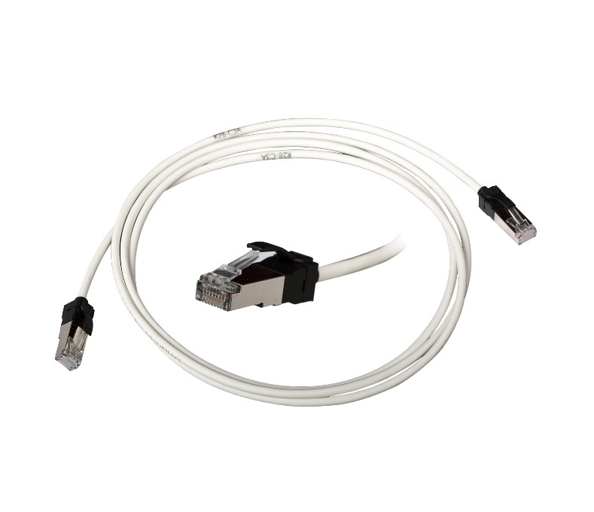

Example of products
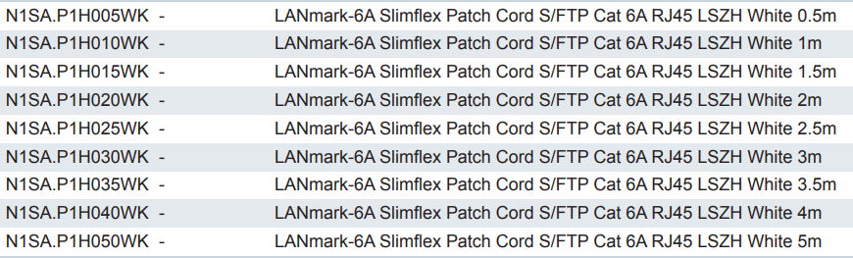

Cat.7A Data Patch cords
All Cat.7A Data patch cords shall be full screened. The standard colour offered for the LSZH flame retardant jacket shall be orange.
The cords shall be fitted with Category 7A GG45 plugs, booted at each connector.
The Cat.7 plugs shall be compliant to the IEC 61076-3-110 standard.
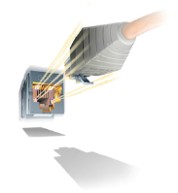
The characteristic impedance of the pairs must be identical to that of the horizontal cables. The Patch Cords shall have a guaranteed performance level of greater than 750 insertions without degradation to the performance level of the solution.
The cable used for the Patch Cords shall be Category 7A S/FTP patch cable. The cable shall be a 4 twisted pair cable with stranded conductors. Traceability numbers should accompany the cables supplied from the manufacturers packaging to assist in quality validation of the installed cable.
All pairs must have an impedance of 100 Ohms.
When used with the LANmark-7A system, Cat 7A/Class FA channel performance complies with the channel limits of ISO/IEC 11801:2017 and it exceeds the requirements of the ISO/IEC 4-connector model.

Detailed product information

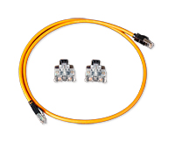

Example of products
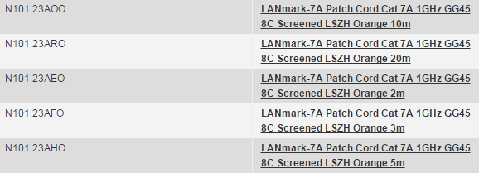

Cat.6A Secure Lock RJ45 Patch cords
Security being of paramount importance for the current project the copper sub-system shall be equipped with a system restricting the removal of the RJ45 patch cords.
The range of Secure Lock patch cords shall be designed to meet the needs of applications such as:
- PoE connector protection (damage caused by mating/unmating under load)
- Theft prevention (Hotels/Schools/Libraries)
- Critical circuit protection
- Patch Cord availability (Meeting rooms)
- Redundant Copper links
- Connection of IP security cameras
- Use in high-density switches.
There are two variants in the LANmark-6A Secure Lock Patch Cords:
- Patch Cords with locks on both the plugs
- Patch Cords with lock on only one plug
Each cord comes preassembled with a red locking boot.
The cord can be disconnected when the matching red key is used to unlock the boot.
The standard cord colour of the LSZH jacket shall be orange.
Standard cords (cat.6A S/FTP) are stocked in lengths of 1, 2, 3 and 5m - other lengths are available on demand.

Detailed product information
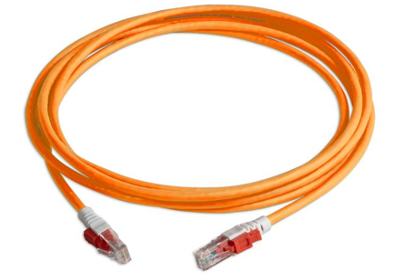
Example of products
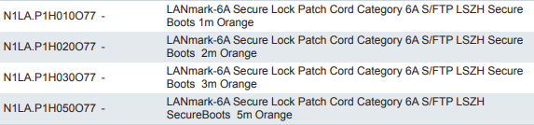

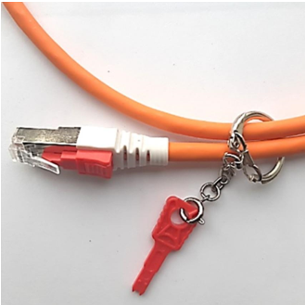

Example of products
LANmark Secure Lock Copper Patch Cord Key
Aginode reference: N1LA.KEY

Secure Lock RJ45 port blockers
Port Blockers shall secure the network infrastructure by blocking out unused or unauthorised ports.
They also protect the hardware from incoming dust and harmful foreign objects.
RJ45 Port Blockers shall fit into any standard RJ45 jack without the use of a tool.
The insertion shall be tool-free onto any standard RJ45 Jack used for outlets and Patch Panels
A dedicated black coloured key must be needed to unlock and remove Port Blockers.

Features
- Exchangeable and re-usable
- Individual packaging for Secure Lock RJ45 Port blockers should contain 100pcs
- Individual packaging for Secure Lock RJ45 Port Key should contain 5pcs
- Material: Plastic
- UL Rating: UL94V-2
- RoHS 2 compliant
- Colour of the RJ45 Port Blocker: Red, Blue and Black
- Colour of the RJ45 Port Key: Black
- Operating temperature range: -10°C~60°C
- Storage temperature range: -40°C~60°C
- Humidity: 10%~90%RH

Detailed product information
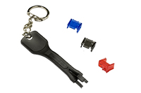
Example of products
LANmark Secure Lock RJ45 Port Blocker – Blue
Aginode reference: N110.SRJPBB
LANmark Secure Lock RJ45 Port Blocker – Red
Aginode reference: N110.SRJPBR
LANmark Secure Lock RJ45 Port Blockers – Black
Aginode reference: N110.SRJPBK
LANmark Secure Lock RJ45 Port Blocker Key
Aginode reference: N110.SRJPKK

Optical Fibre Patch Cords

OM3 & OM4 BIMMF Optical Fibre Patch cords
The patch cords shall be available in lengths of 1m, 2m, 3m, 5m, 7m, 10m, 15m, 20m, 25m, 30m, 40m and 50m and have a LSHF-FR outer sheath.
The cable shall be flame and fire retardant according to IEC 60332-1.
When using OM3 or OM4 optical fibres, patch cords produced with the same OM3 or OM4 fibre have to be installed.
The patch cords have a small bend radius of 10mm.
They are produced with GIGAliteFLEX fibre. This bend insensitive multimode fibre (BIMMF) has a small bend radius of 7.5mm and is compliant to IEC 60793-2-10, fibre model A1a.3b.
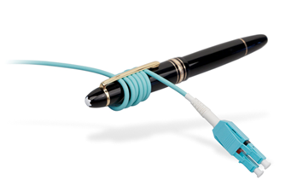
Duplex LC-LC, duplex LC-SC and duplex SC-SC patch cords have a duplex cable construction with a diameter of 2 X 2.0 mm and short connector boots of 19mm.
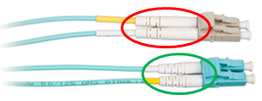
A label shall be affixed close to the duplex connector for traceability of the factory measurement results.
Insertion Loss and Return Loss test results shall be available on request.
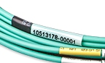
Patch cord cable is according to IEC 60794-2-50. The colour of Jacket and of the connectors shall be Aqua for both OM3 and OM4 patch cords.
The Fibre Snap-In adapters will be connected to the active equipment OF ports by means of “Cross-over” duplex patch cords in order to maintain the duplex OF channel polarity in accordance with the requirements of ISO/IEC 11801:2017 and EN 50174-1 Ed.3.
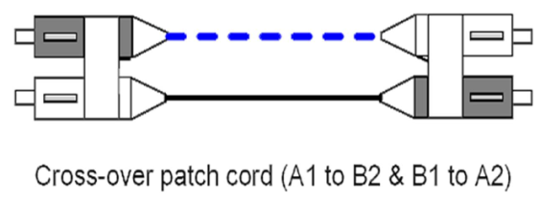

The "butterfly" duplex clip allows to easily change the polarity on site by simply removing the 2 connectors and put them in a reverse order back into the same clip. No tool shall be required for this polarity change.
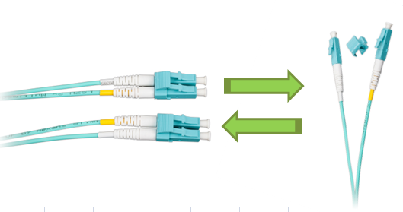
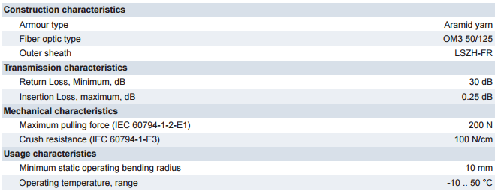

Detailed product information
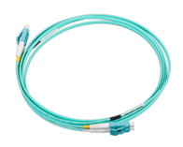
Example of products
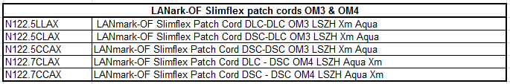

OS2 BI Optical Fibre Patch cords

The patch cords shall be available in lengths of 1m, 2m, 3m, 5m, 7m, 10m, 15m, 20m, 25m, 30m, 40m and 50m and have a LSHF-FR outer sheath.
The cable shall be flame and fire retardant according to IEC 60332-1.
UPC polishing performance of the connectors with RL > 50 dB is required.
APC polishing style shall be available with RL > 65 dB.
The patch cords have GIGAliteFLEX fibre inside. This bend insensitive (BI) fibre has a small bend radius of 7.5 mm and is compliant to ITU-T G.657.A1 and to IEC 60793-2-50, fibre model B6.a1.
Duplex LC-LC, duplex LC-SC and duplex SC-SC patch cords have a duplex cable construction with a diameter of 2 X 2.0 mm and short connector boots of 19mm.
A label shall be affixed close to the duplex connector for traceability of the factory measurement results.
Insertion Loss and Return Loss test results shall be available on request.

Patch cord cable is according to IEC 60794-2-50. The colour of Jacket shall be yellow for OS2 patch cords.
The Fibre Snap-In adapters will be connected to the active equipment OF ports by means of “Cross-over” duplex patch cords in order to maintain the duplex OF channel polarity in accordance with the requirements of ISO/IEC 11801:2017 and EN 50174-1 Ed.3.
The "butterfly" duplex clip allows to easily change the polarity on site by simply removing the 2 connectors and put them in a reverse order back into the same clip. No tool shall be required for this polarity change.
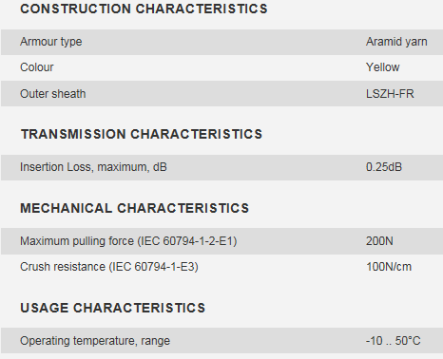

Detailed product information
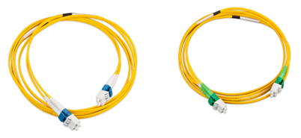
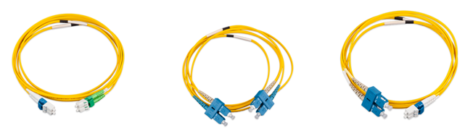

Example of products
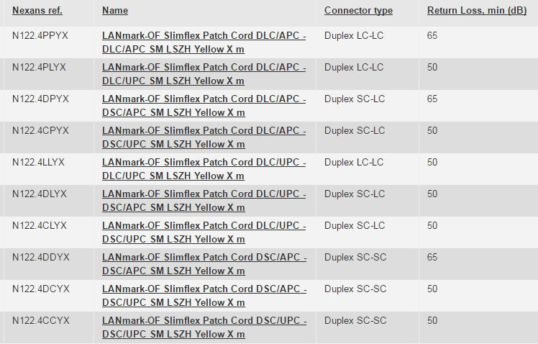

UHD bend insensitive LC OF Patch cords
The UHD (ultra High Density) patch cords shall be optimised for use in Data Centres environments.
These patch cords shall have a very small bend radius of 10 mm due to the use of bend insensitive fibre and very small diameter of 2 mm.
The round design of the UHD patch cord results in a small bend radius in any direction. Traditional patch cords based on a zipcord design have a bend radius that is dependent on the orientation and are therefore not accepted.
The patch cords shall be available in lengths of 1m, 2m, 3m, 5m, 7m and 10m and have a LSHF-FR outer sheath.
For the support of the advanced high speed Ethernet protocols with stringent power budgets the UHD patch cord features a low loss performance of 0.25 dB. This increases the headroom in the channel and reduces the risk of down time.
CHARACTERISTICS
- Patch cord cable is according to IEC 60794-2-50
- Maximum insertion loss according to IEC 61300-3-4: 0.25 dB
- Typical insertion loss: 0.125 dB
- Bend insensitive fibre
- A label is added close to the uniboot connector for traceability of the factory measurement results
DESIGN
The Fibre Snap-In adapters will be connected to the active equipment OF ports by means of “Cross-over” duplex patch cords in order to maintain the duplex OF channel polarity in accordance with the requirements of ISO/IEC 11801:2017 and EN 50174-1 Ed.3.
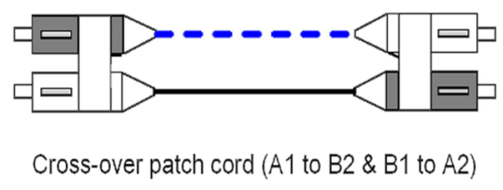
The polarity of the patch cord can be changed by opening the uniboot connector on one side and change the position of the 2 LC connectors. A black and yellow plastic square identify the fibre inside the patch cord. The patch cords are delivered with the black square on the left on side A and on the right on side B. This is required for cross-over or optical crossed patch cords. By changing the position of the black square on side A from the left to the right the patch cord becomes an optical straight patch cord.
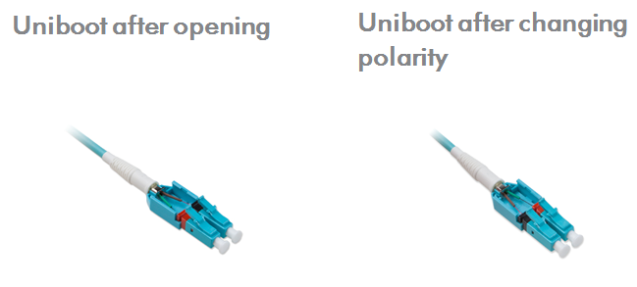

The colour of the jacket shall be Aqua for OM4 fibres and Yellow for OS2 fibres.

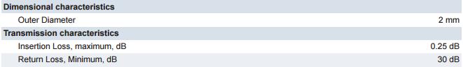
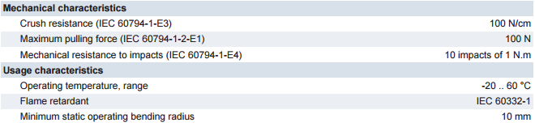

Detailed product information
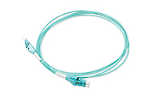
Example of products

UHD bend insensitive MTP PRO OF Patch cords
UHD OF MTP-MTP patch cords have been designed for indoor applications in support of parallel optics, i.e. 40GBase-SR4 and 100GBase-SR 4.
OF MTP patch cords are delivered as straight patch cords with a key up - key up design. The patch cords are delivered with female MTP* PRO connectors.
* MTP is a trade name of US Conec. MPO patch cords shall be terminated with MTP connectors to ensure superior mechanical and optical performances.
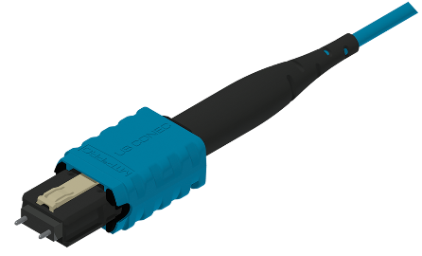
For ease of patching the MTP PRO connector has a short boot length of 17mm.
With a specific tool available from the manufacturer the gender and polarity of the patch cords can be changed. Gender can be changed to male with the pins exchangers. The polarity can be changed to a key up – key down design.
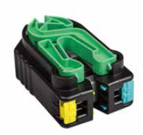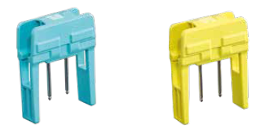
The patch cords are available with OM4 or OS2 fibres.
The typical value for the insertion loss for a multimode MTP connection is 0,125 dB. The limit value for a multimode MTP connection is 0,25 dB measured according to standard IEC 61300-3-45. The minimum return loss for a multimode MTP connection is 20 dB measured according to IEC 61300-3-6.
Mechanical characteristics of the Pre-Term are conform to the IEC 60794-20 standard for indoor cables. The small diameter of 2.5 mm and the small bend radius of 30mm the cable facilitates the patching in densely populated areas in the data centre..
The length between the 2 MTP-connectors is variable and can be increased in steps of 1m.
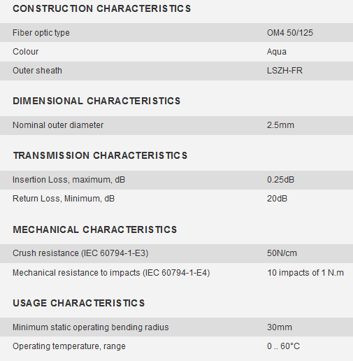

Detailed product information
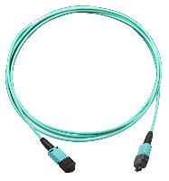
Example of products

Secure Lock LC port blockers
Port Blockers shall secure the network infrastructure by blocking out unused or unauthorised Duplex LC Adaptors. They also protect the hardware from incoming dust and harmful foreign objects.
LC Port Blockers shall fit into any standard Duplex LC Adaptors without the use of a tool and shall not interfere or lead to the degradation of network performance.
The insertion shall be tool-free onto any standard Duplex LC Adaptors used for outlets and Patch Panels
A dedicated black coloured key must be needed to unlock and remove Port Blockers.

Features
- Exchangeable and re-usable
- Individual packaging for a LANmark-OF Secure Lock - LC Port blockers should contain 100pcs
- Individual packaging for a LANmark-OF Secure Lock LC Port Key should contain 5pcs
- Material: Plastic
- UL Rating: UL94V-2
- RoHS 2 compliant
- Colour of the LC Port Blocker: Transparent Red and Transparent Blue
- Colour of the LC Port Key: Transparent Black
- Operating temperature range: -10°C~60°C
- Storage temperature range: -40°C~68°C
- Humidity: 10%~90%RH

Detailed product information
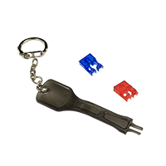
Example of products
LANmark Secure Lock LC Port Blockers - Blue
Aginode reference: N124.SLCPBB
LANmark Secure Lock LC Port Blockers - Red
Aginode reference: N124.SLCPBR
LANmark-OF Secure Lock key for LC Port Block key (5pcs)
Aginode reference: N124.SLCPKK

Link and Channel performance

Cat.6A performance
Manufacturer shall demonstrate guaranteed minimum worst-case (4-connector Link) performance to be compliant with class EA link and channel performance according to the ISO/IEC 11801:2017 standard.
The system supplier must be able to demonstrate in house design and manufacturing expertise for all components used (e.g. cables, outlets, panels and cords) in order to ensure compatibility of system elements.
Regarding short links, the standard channel performance shall be warranted for a 10 meters / 3 connectors link with 5 meters of cable length for both Patch Panel to Consolidation Point and Consolidation Point to Terminal Outlet segments.
The Cat.6A channel shall comply to the following electrical performances.
Maximum and Minimum values shall be warranted by the manufacturer.

All values are based on Worst Case 4 Connector Channel configurations according to ISO11801:2017.
Standard (Std) values are based on ISO11801: 2017 Class EA.
Minimal and maximum values represent guaranteed channel performance.

Cat.7A performance
Manufacturer should demonstrate guaranteed minimum worst case (4-connector channel) performance to be compliant with class EA and class FA channel performance according to the ISO/IEC 11801:2017 standard.

Components used must be compliant with both the Category 6A and Category 7A standards mentioned above.
The performance of both the components and the link should show stable performance up to 1,000MHz in order to allow for possible future applications.
The performance of the channel should show stable performance
- Up to 500MHz when using Cat.6A patch cords
- Up to 1,250MHz when using Cat.7A patch cords
The system supplier must be able to demonstrate in house design and manufacturing expertise for all components used (e.g. cables, outlets, panels and cords) in order to ensure compatibility of system elements.
All components shall be produced by the same system manufacturer.
Electrical Performance Class FA 4 Connectors Channels:
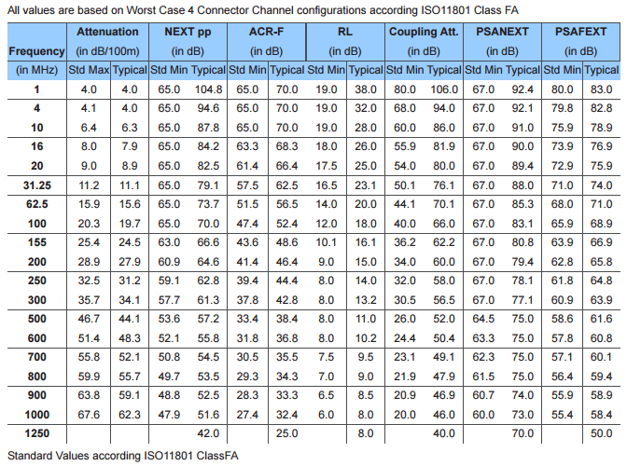

Main Distribution cabling

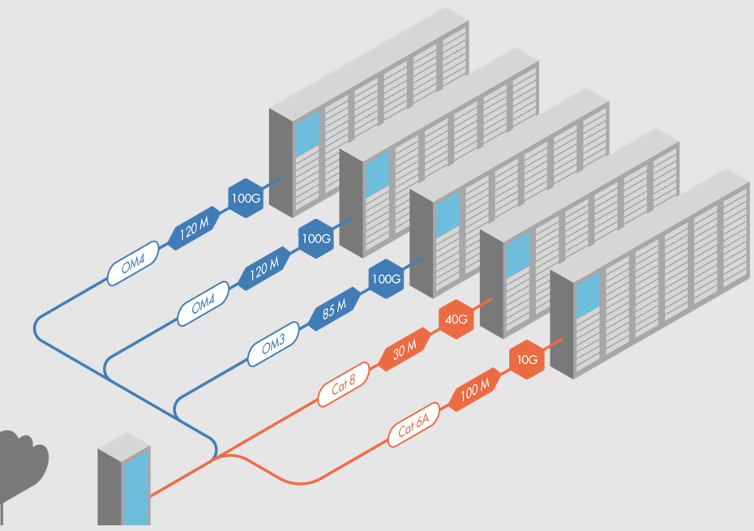

ZDs to MD rack connections are to be created using copper links, fibre links or both. The choice is to be made according to the specific requirements of the customer.
By default, both Cu and OF links are described in the following chapters. The user shall adapt the content to his project requirements.
The number of CU/OF links is to be defined according to the specific requirement of the project.
If redundancy is requested, 2 MDs can also be needed – To be define according to project requirements.

In order to ensure flexibility and expandability, every ZD cabinets will be linked back to the Main Distributor (MD) of the DC room it belong to using both copper and FO pre-terminated cable assemblies.

MD copper links (Termination onsite)
The passive copper components to be used to create the MD cabling shall be the same than the ones described in the former Zone Distribution chapter.
Should the choice of component be different than the ones selected for the ZD part, delete the former sentence and use a selection of the next paragraphs according to the requirements.
If not needed just delete the following paragraphs

Extended Channel Application Warranty

The cabling system manufacturer shall provide an application-specific warranty covering channel lengths exceeding the standard 100 m limit. This warranty shall guarantee support for the Ethernet applications listed below over the extended channel distances specified in the following table.

The warranty shall meet the following minimum requirements:

Scope of Coverage
The warranty shall guarantee the correct operation of the supported Ethernet applications (10BASE-T, 100BASE-TX, 1000BASE-T, 2.5GBASE-T, 5GBASE-T, and/or 10GBASE-T with or without PoE as applicable) over the extended channel distances defined, up to and including the maximum distances published by the manufacturer.
The Distances shall be valid for 2-connector channel configurations and for PoE Type 4 (IEEE 802.3bt)
The indicated channel lengths include 5m total cordage (e.g. 2m + 3m patch cord)

Cabling Types
The warranty shall be applicable to the cable categories and constructions offered (Category 6A and 7A with specified conductor gauges).

Compliance with this clause is mandatory for the acceptance of the proposed cabling solution.

Copper Zone Distribution cable

Cat.6A F¹/UTP cable
The horizontal 4 pair cable shall be Category 6A F¹/UTP to meet the quality and performance criteria necessary to ensure correct operation of the installation for frequencies up to 500 MHz and to ensure the compliance with the warranty.
The installation design and routing of all cables shall take account of the manufacturer limits for the continued performance of the cables and the compliance with the warranty.
The cable shall be a 4 twisted pair cable with AWG 23 plain copper conductors and shall have an external sheathing in a material that does not give off toxic fumes (Zero Halogen) in case of fire and offer flame propagation retardant properties. The cable shall be compliant to the IEC 60332-1 standard.
Traceability numbers should accompany the cable supplied from the manufacturers packaging to assist in quality validation of the installed cable.
In order to provide alien cross-talk (AXT) immunity for 10 GBASE-T Ethernet transmission, the use of screened cable is mandatory.
In the construction of the cable NEXT performance shall be maintained using a C³ (Central dielectric Cross-talk Cancellation) member set between the 4 pairs.
All pairs must have a fitted impedance of 100 Ohms, with a tolerance of +/- 5 Ohms.
Conductor pairs shall be identified by insulation utilising standardised colour code (Blue/White, Orange/White, Green/White, Brown/White).
The cable shall contain 1 foil screen. The foil shall have the metallic side facing outwards, allowing the cable to be automatically grounded during the termination process without having to fold back the foil. This will provide instant 360° grounding contact to ensure immunity from Alien Crosstalk and other external interference.

A tinned copper drain wire, shall be provided between the aluminium screen and the external sheathing.

The Cat.6A cable shall comply to the following electrical performances.
Max. And Min. Values shall be warranted by the manufacturer.

CPR grade compliance requirement (Dca s2,d2,a1)
The CPR regulations came into force in July 2016 and with effect from the 1st July 2017, cable jacket
materials must be of the appropriate Construction Product Regulations Class to meet the
requirements of EN 50399 and EN 50575 2014/A:2016 standards. In particular the cables proposed for this project must conform with EN50575 for certification and labelling.
The proposed cables must meet Class Dca s2,d2,a1 and the bidder must provide a statement from the chosen manufacturer detailing their 3rd party verification of their product and its classification.

Detailed product information (CPR grade Dca s2,d2,a1)

Example of product
LANmark-6A F1/UTP AWG23 Cat 6A LSZH Dca s2 d2 a1 Orange 1000m reel
Aginode reference: N100.622G-OD

CPR grade compliance requirement (Cca s1a,d1,a1)
The CPR regulations came into force in July 2016 and with effect from the 1st July 2017, cable jacket
materials must be of the appropriate Construction Product Regulations Class to meet the
requirements of EN 50399 and EN 50575 2014/A:2016 standards. In particular the cables proposed for this project must conform with EN50575 for certification and labelling.
The proposed cables must meet Class Cca s1a,d1,a1 and the bidder must provide a statement from the chosen manufacturer detailing their 3rd party verification of their product and its classification.

Detailed product information (CPR grade Cca s1a,d1,a1)

Example of product
LANmark-6A F1/UTP AWG23 Cat 6A LSZH Cca s1a d1 a1 Orange 1000m reel
Aginode reference: N100.622G-OC

Cat.6A F/FTP cable
The horizontal 4 pair cable shall be Category 6A F/FTP to meet the quality and performance criteria necessary to ensure correct operation of the installation for frequencies up to 500 MHz and to ensure the compliance with the warranty.
The installation design and routing of all cables shall take account of the manufacturer limits for the continued performance of the cables and the compliance with the warranty.
The cable shall be a 4 twisted pair cable with AWG 23 plain copper conductors and shall have an external sheathing in a material that does not give off toxic fumes (Zero Halogen) in case of fire and offer flame propagation retardant properties. The cable shall be compliant to the IEC 60332-1 standard.
Traceability numbers should accompany the cable supplied from the manufacturers packaging to assist in quality validation of the installed cable.
In order to provide alien cross-talk (AXT) immunity for 10 GBASE-T Ethernet transmission, the use of screened cable is mandatory.
This high performance cable shall have an individual and a common screen construction to ensure immunity from Alien Crosstalk and other external interference up to 500 MHz.
All four pairs shall be individually screened with an aluminium foil.
The overall cable shall be screened with a complementary aluminium foil.
All pairs must have a fitted impedance of 100 Ohms, with a tolerance of +/- 5 Ohms.
Conductor pairs shall be identified by insulation utilising standardised colour code (Blue/White, Orange/White, Green/White, Brown/White).
The Cat.6A cable shall comply to the following electrical performances.
Maximum and Minimum values shall be warranted by the manufacturer.

CPR grade compliance requirement (Dca s2,d2,a1)
The CPR regulations came into force in July 2016 and with effect from the 1st July 2017, cable jacket
materials must be of the appropriate Construction Product Regulations Class to meet the
requirements of EN 50399 and EN 50575 2014/A:2016 standards. In particular the cables proposed for this project must conform with EN50575 for certification and labelling.
The proposed cables must meet Class Dca s2,d2,a1 and the bidder must provide a statement from the chosen manufacturer detailing their 3rd party verification of their product and its classification.

Detailed product information (CPR grade Dca s2,d2,a1)
Example of product
LANmark-6A F/FTP AWG23 Cat 6A LSZH Dca s2 d2 a1 Orange 1000m reel
Aginode reference: N100.692G-OD

CPR grade compliance requirement (Cca s1a,d1,a1)
The CPR regulations came into force in July 2016 and with effect from the 1st July 2017, cable jacket
materials must be of the appropriate Construction Product Regulations Class to meet the
requirements of EN 50399 and EN 50575 2014/A:2016 standards. In particular the cables proposed for this project must conform with EN50575 for certification and labelling.
The proposed cables must meet Class Cca s1a,d1,a1 and the bidder must provide a statement from the chosen manufacturer detailing their 3rd party verification of their product and its classification.

Detailed product information (CPR grade Cca s1a,d1,a1)
Example of product
LANmark-6A F/FTP AWG23 Cat 6A LSZH Cca s2 d1 a1 Orange 1000m reel
Aginode reference: N100.692G-OC

Cat.6A FXTP cable
This cable is not available in France and in Scandinavian countries
The horizontal 4 pair cable shall be Category 6A FXTP to meet the quality and performance criteria necessary to ensure correct operation of the installation for frequencies up to 500 MHz and to ensure the compliance with the warranty.
The installation design and routing of all cables shall take account of the manufacturer limits for the continued performance of the cables and the compliance with the warranty.
The cable shall be a 4 twisted pair cable with AWG 23 plain copper conductors and shall have an external sheathing in a material that does not give off toxic fumes (Zero Halogen) in case of fire and offer flame propagation retardant properties. The cable shall be compliant to the IEC 60332-1 standard.
Traceability numbers should accompany the cable supplied from the manufacturers packaging to assist in quality validation of the installed cable.
In order to provide alien cross-talk (AXT) immunity for 10 GBASE-T Ethernet transmission, the use of screened cable is mandatory.
This high performance cable shall have metal foil construction forming a central cross and shaped around each pair, acting as global screen and individual pair shielding at the same time. Compared to traditional F/FTP and S/FTP cables, this clever design facilitates fast and easy cable preparing whilst offering outstanding electrical performance.to ensure immunity from Alien Crosstalk and other external interference up to 500 MHz.
All pairs must have a fitted impedance of 100 Ohms, with a tolerance of +/- 5 Ohms.
Conductor pairs shall be identified by insulation utilising standardised colour code (Blue/White, Orange/White, Green/White, Brown/White).
The Cat.6A cable shall comply to the following electrical performances.
Maximum and Minimum values shall be warranted by the manufacturer.

CPR grade compliance requirement (Dca s2,d2,a1)
The CPR regulations came into force in July 2016 and with effect from the 1st July 2017, cable jacket
materials must be of the appropriate Construction Product Regulations Class to meet the
requirements of EN 50399 and EN 50575 2014/A:2016 standards. In particular the cables proposed for this project must conform with EN50575 for certification and labelling.
The proposed cables must meet Class Dca s2,d2,a1 and the bidder must provide a statement from the chosen manufacturer detailing their 3rd party verification of their product and its classification.

Detailed product information (CPR grade Dca s2,d2,a1)
Example of product
LANmark-6A FXTP AWG23 Cat 6A LSZH Dca s2 d2 a1 Orange 500m reel
Aginode reference: N100.654G-OD

CPR grade compliance requirement (Cca s1a,d1,a1)
The CPR regulations came into force in July 2016 and with effect from the 1st July 2017, cable jacket
materials must be of the appropriate Construction Product Regulations Class to meet the
requirements of EN 50399 and EN 50575 2014/A:2016 standards. In particular the cables proposed for this project must conform with EN50575 for certification and labelling.
The proposed cables must meet Class Cca s1a,d1,a1 and the bidder must provide a statement from the chosen manufacturer detailing their 3rd party verification of their product and its classification.

Detailed product information (CPR grade Cca s1a,d1,a1)
Example of product
LANmark-6A FXTP AWG23 Cat 6A LSZH Cca s1a d1 a1 Orange 500m reel
Aginode reference: N100.654G-OC

Cat.6A EXTP cable
The horizontal 4 pair cable shall be Category 6A EXTP to meet the quality and performance criteria necessary to ensure correct operation of the installation for frequencies up to 500 MHz and to ensure the compliance with the warranty.
The installation design and routing of all cables shall take account of the manufacturer limits for the continued performance of the cables and the compliance with the warranty.
The cable shall be a 4 twisted pair cable with AWG 22 plain copper conductors and shall have an external sheathing in a material that does not give off toxic fumes (Zero Halogen) in case of fire and offer flame propagation retardant properties. The cable shall be compliant to the IEC 60332-1 standard.
Traceability numbers should accompany the cable supplied from the manufacturers packaging to assist in quality validation of the installed cable.
In order to provide alien cross-talk (AXT) immunity for 10 GBASE-T Ethernet transmission, the use of screened cable is mandatory.
This high performance cable shall have metal foil construction forming a central cross and shaped around each pair, acting as global screen and individual pair shielding at the same time. Compared to traditional F/FTP and S/FTP cables, this clever design facilitates fast and easy cable preparing whilst offering outstanding electrical performance.to ensure immunity from Alien Crosstalk and other external interference up to 500 MHz.
All pairs must have a fitted impedance of 100 Ohms, with a tolerance of +/- 5 Ohms.
Conductor pairs shall be identified by insulation utilising standardised colour code (Blue/White, Orange/White, Green/White, Brown/White).
The Cat.6A cable shall comply to the following electrical performances.
Maximum and Minimum values shall be warranted by the manufacturer.
Tested to 650MHz with guaranteed performance to 500MHz the EXTP cables exceed the requirements of the International, European and American cable standards.

CPR grade compliance requirement (Dca s2,d2,a1)
The CPR regulations came into force in July 2016 and with effect from the 1st July 2017, cable jacket
materials must be of the appropriate Construction Product Regulations Class to meet the
requirements of EN 50399 and EN 50575 2014/A:2016 standards. In particular the cables proposed for this project must conform with EN50575 for certification and labelling.
The proposed cables must meet Class Dca s2,d2,a1 and the bidder must provide a statement from the chosen manufacturer detailing their 3rd party verification of their product and its classification.

Detailed product information (CPR grade Dca s2,d2,a1)
Example of product
LANMARK-6A ULTIM EXTP AWG22 CAT 6A 650MHZ LSZH DCA S2 D2 A1 ORANGE 500M REEL
Aginode reference: N100.964G-OD

CPR grade compliance requirement (Cca s1a,d1,a1)
The CPR regulations came into force in July 2016 and with effect from the 1st July 2017, cable jacket
materials must be of the appropriate Construction Product Regulations Class to meet the
requirements of EN 50399 and EN 50575 2014/A:2016 standards. In particular the cables proposed for this project must conform with EN50575 for certification and labelling.
The proposed cables must meet Class Cca s1a,d1,a1 and the bidder must provide a statement from the chosen manufacturer detailing their 3rd party verification of their product and its classification.

Detailed product information (CPR grade Cca s1a,d1,a1)
Example of product
LANMARK-6A ULTIM EXTP AWG22 CAT 6A 650MHZ LSZH CCA S1A D1 A1 ORANGE 500M REEL
Aginode reference: N100.964G-OC

Cat.6A S/FTP cable
The horizontal 4 pair cable shall be Category 6A S/FTP to meet the quality and performance criteria necessary to ensure correct operation of the installation for frequencies up to 500 MHz and compliance with the warranty.
The installation design and routing of all cables shall take account of the manufacturer limits for the continued performance of the cables and the compliance with the warranty.
The cable shall be a 4 twisted pair cable with AWG 23 plain copper conductors and shall have an external sheathing in a material that does not give off toxic fumes (Zero Halogen) in case of fire and offer flame propagation retardant properties. The cable shall be compliant to the IEC 60332-1 standard.
Traceability numbers should accompany the cable supplied from the manufacturers packaging to assist in quality validation of the installed cable.
This very high performance cable shall have an individual and a common screen construction to ensure immunity from Alien Crosstalk and other external interference up to 500 MHz.
All four pairs shall be individually screened with an aluminium foil.
The cable shall be shielded with a tinned copper braid.
All pairs must have a fitted impedance of 100 Ohms, with a tolerance of +/- 5 Ohms.
Conductor pairs shall be identified by insulation utilising standardised colour code (Blue/White, Orange/White, Green/White, Brown/White).
The Cat.6A cable shall comply to the following electrical performances up to 500 MHz.
Maximum and Minimum values shall be warranted by the manufacturer.

CPR grade compliance requirement (Dca s2,d2,a1)
The CPR regulations came into force in July 2016 and with effect from the 1st July 2017, cable jacket
materials must be of the appropriate Construction Product Regulations Class to meet the
requirements of EN 50399 and EN 50575 2014/A:2016 standards. In particular the cables proposed for this project must conform with EN50575 for certification and labelling.
The proposed cables must meet Class Dca s2,d2,a1 and the bidder must provide a statement from the chosen manufacturer detailing their 3rd party verification of their product and its classification.

Detailed product information (CPR grade Dca s2,d2,a1)
Example of product
LANmark-6A S/FTP AWG23 Cat 6A LSZH Dca s2 d2 a1 Orange 500m reel
Aginode reference: N100.684G-OD

CPR grade compliance requirement (Cca s1a,d1,a1)
The CPR regulations came into force in July 2016 and with effect from the 1st July 2017, cable jacket
materials must be of the appropriate Construction Product Regulations Class to meet the
requirements of EN 50399 and EN 50575 2014/A:2016 standards. In particular the cables proposed for this project must conform with EN50575 for certification and labelling.
The proposed cables must meet Class Cca s1a,d1,a1 and the bidder must provide a statement from the chosen manufacturer detailing their 3rd party verification of their product and its classification.

Detailed product information (CPR grade Cca s1a,d1,a1)
Example of product
LANmark-6A S/FTP AWG23 Cat 6A LSZH Cca s1a d1 a1 Orange 500m reel
Aginode reference: N100.684G-OC

Cat.7 S/FTP cable
The horizontal 4 pair cable shall be Category 7 S/FTP to meet the quality and performance criteria necessary to ensure correct operation of the installation for frequencies up to 600 MHz and compliance with the warranty.
The installation design and routing of all cables shall take account of the manufacturer limits for the continued performance of the cables and the compliance with the warranty.
The cable shall be a 4 twisted pair cable with AWG 23 plain copper conductors and shall have an external sheathing in a material that does not give off toxic fumes (Zero Halogen) in case of fire and offer flame propagation retardant properties. The cable shall be compliant to the IEC 60332-1 standard.
Traceability numbers should accompany the cable supplied from the manufacturers packaging to assist in quality validation of the installed cable.
This very high performance cable shall have an individual and a common screen construction to ensure immunity from Alien Crosstalk and other external interference up to 600 MHz.
All four pairs shall be individually screened with an aluminium foil.
The cable shall be shielded with a tinned copper braid.
All pairs must have a fitted impedance of 100 Ohms, with a tolerance of +/- 5 Ohms.
Conductor pairs shall be identified by insulation utilising standardised colour code (Blue/White, Orange/White, Green/White, Brown/White).
The Cat.7 cable shall comply to the following electrical performances up to 600 MHz.
Maximum and Minimum values shall be warranted by the manufacturer.

CPR grade compliance requirement (Cca s1a,d1,a1)
The CPR regulations came into force in July 2016 and with effect from the 1st July 2017, cable jacket
materials must be of the appropriate Construction Product Regulations Class to meet the
requirements of EN 50399 and EN 50575 2014/A:2016 standards. In particular the cables proposed for this project must conform with EN50575 for certification and labelling.
The proposed cables must meet Class Cca s1a,d1,a1 and the bidder must provide a statement from the chosen manufacturer detailing their 3rd party verification of their product and its classification.

Detailed product information (CPR grade Cca s1a,d1,a1)
Example of product
LANmark-7 S/FTP 23AWG LSZH C s1a d1 a1 Orange 1000m Reel
Aginode reference: N100.65-OC

CPR grade compliance requirement (B2ca s1a,d1,a1)
The CPR regulations came into force in July 2016 and with effect from the 1st July 2017, cable jacket
materials must be of the appropriate Construction Product Regulations Class to meet the
requirements of EN 50399 and EN 50575 2014/A:2016 standards. In particular the cables proposed for this project must conform with EN50575 for certification and labelling.
The proposed cables must meet Class B2ca s1a,d1,a1 and the bidder must provide a statement from the chosen manufacturer detailing their 3rd party verification of their product and its classification.

Detailed product information (CPR grade B2ca s1a,d1,a1)
Example of product
LANmark-7 S/FTP 23AWG LSZH B2 s1a d1 a1 Orange 1000m Reel
Aginode reference: N100.365-OB

Cat.7A S/FTP cable
The horizontal 4 pair cable shall be Category 7A S/FTP to meet the quality and performance criteria necessary to ensure correct operation of the installation for frequencies up to 1250 MHz and compliance with the warranty.
It offers large headroom above the Cat 7A requirement. Due to this excellent electrical performance and positive ACR up to at least 1250MHz the cable supports the applications like 10GBASE-T as well as 25GBASE-T
The installation design and routing of all cables shall take account of the manufacturer limits for the continued performance of the cables and the compliance with the warranty.
The cable shall be a 4 twisted pair cable with AWG 23 plain copper conductors and shall have an external sheathing in a material that does not give off toxic fumes (Zero Halogen) in case of fire and offer flame propagation retardant properties. The cable shall be compliant to the IEC 60332-1 standard.
Traceability numbers should accompany the cable supplied from the manufacturers packaging to assist in quality validation of the installed cable.
This very high performance cable shall have an individual and a common screen construction to ensure immunity from Alien Crosstalk and other external interference up to 1250 MHz.
All four pairs shall be individually screened with an aluminium foil.
The cable shall be shielded with a tinned copper braid.
All pairs must have a fitted impedance of 100 Ohms, with a tolerance of +/- 5 Ohms.
Conductor pairs shall be identified by insulation utilising standardised colour code (Blue/White, Orange/White, Green/White, Brown/White).
The Cat.7A cable shall comply to the following electrical performances.
Maximum and Minimum values shall be warranted by the manufacturer.

CPR grade compliance requirement (Dca s2,d2,a1)
The CPR regulations came into force in July 2016 and with effect from the 1st July 2017, cable jacket
materials must be of the appropriate Construction Product Regulations Class to meet the
requirements of EN 50399 and EN 50575 2014/A:2016 standards. In particular the cables proposed for this project must conform with EN50575 for certification and labelling.
The proposed cables must meet Class Dca s2,d2,a1 and the bidder must provide a statement from the chosen manufacturer detailing their 3rd party verification of their product and its classification.

Detailed product information (CPR grade Dca s2,d2,a1)
Example of product
LANmark-7A S/FTP Cat 7A 1250MHz 23AWG LSZH Dca s2 d2 a1 Orange 1000m Reel
Aginode reference: N100.371-OD

CPR grade compliance requirement (Cca s1a,d1,a1)
The CPR regulations came into force in July 2016 and with effect from the 1st July 2017, cable jacket
materials must be of the appropriate Construction Product Regulations Class to meet the
requirements of EN 50399 and EN 50575 2014/A:2016 standards. In particular the cables proposed for this project must conform with EN50575 for certification and labelling.
The proposed cables must meet Class Cca s1a,d1,a1 and the bidder must provide a statement from the chosen manufacturer detailing their 3rd party verification of their product and its classification.

Detailed product information (CPR grade Cca s1a,d1,a1)
Example of product
LANmark-7A S/FTP Cat 7A 1250MHz 23AWG LSZH C s1a d1 a1 Orange 1000m Reel
Aginode reference: N100.371-OC

CPR grade compliance requirement (B2ca s1a,d1,a1)
The CPR regulations came into force in July 2016 and with effect from the 1st July 2017, cable jacket
materials must be of the appropriate Construction Product Regulations Class to meet the
requirements of EN 50399 and EN 50575 2014/A:2016 standards. In particular the cables proposed for this project must conform with EN50575 for certification and labelling.
The proposed cables must meet Class B2ca s1a,d1,a1 and the bidder must provide a statement from the chosen manufacturer detailing their 3rd party verification of their product and its classification.

Detailed product information (CPR grade B2ca s1a,d1,a1)
Example of product
LANmark-7A S/FTP Cat 7A 1250MHz 23AWG LSZH B2 s1a d1 a1 Orange 1000m Reel
Aginode reference: N100.371-OB

Modular RJ45 jack

Cat.6A screened connector
The RJ45 connector shall be fully shielded with a die-cast metal housing to provide excellent immunity against Alien Crosstalk and Electromagnetic Interference. The connector shall also provide termination facilities for the drain wire of some screened cables.
1.27 micron (50 microinch) gold plated front contacts shall offer superior mechanical durability, ensuring at least 2500 plug insertion cycles and supporting Power over Ethernet transmission up to 90 W (IEEE 802.3bt) without degrading effect.
The connector shall be fully compliant to the IEC 60603-7-51 standard that defines the Cat.6A connector to be used to form a Class EA channel as specified in the ISO/IEC 11801:2017 standard. It is certified by an independent lab for connecting hardware, PoE++ compliance and various Link and Channel configurations.
Each connector shall provide both T568A and T568B colour code identification for the IDC contacts at the rear of the connector. Termination is to be in accordance with the T568B colour code. Reassignment of pairs is forbidden.
All conductors from the 4 pair cable are to be terminated on the respective contacts.
To avoid installation errors, pair assignment in the wire organiser of the Snap-In jack must be identified using colours which match the cable pairs.
The Snap-In format of the connector shall make it compatible with the whole range of modular structural hardware including patch panels, outlets and CP boxes.
Optional clips shall be available to turn Snap-In into keystone format.
A table of compatibility indicating which clip shall be used to ensure compatibility with a large range of third-party structural hardware shall be available from the manufacturer.
The 100% toolless design features a wire organiser that enables straight forward management of the wires, ensuring that the cable pair twists are maintained. All RJ45 connectors shall be easily re-installable. The connector is a one-piece design, with a wire organiser as sole accessory, guaranteeing infallible management of the twisted pairs.
The connector is compatible with a wide range of cables, from AWG26 to AWG22, for both solid & stranded conductors. This flexibility allows using just one connector for all types of configurations, whether in permanent links or in flexible consolidation points.
Sustainability: To reduce environmental impact, the manufacturer shall implement measures to eliminate plastic from packaging. The RJ45 connector is supplied in 100% recyclable, plastic-free materials.

Detailed product information
Example of product
LANMARK-6A ULTIM SNAP-IN CONNECTOR CATEGORY 6A SCREENED CE
Aginode reference: N420.960

Cat.7A screened connector
The GG45 connector shall be fully screened to ensure protection against EMI and for Alien cross-talk compliance. Connectors shall also provide termination facilities for the drain wire of some screened cable.
The connector shall support PoE (IEEE 802.3af), PoE + (IEEE 802.3at) and PoE ++ (IEEE 802.3bt) applications and shall pass all the tests for PoE ++ requirements according to IEC 60512-99-002 Ed.1).

The connector shall be fully compliant to the IEC 60603-7-71 and IEC 60603-7-82 standard that defines the Cat.8.2 connector to be used to form a Class I/II channel as specified in the ISO/IEC 11801:2017 standard.
In particular, the connector shall contain a full Cat.6 (RJ45) interface as well as a full Cat.7A/Cat.8 interface using four additional contacts for 2000MHZ transmission.
It shall offer full backward compatibility with RJ45 plugs.
Each connector shall provide both T568A and T568B colour code identification for the IDC contacts at the rear of the connector. Termination is to be in accordance with the T568B colour code. Reassignment of pairs is forbidden.
All conductors from the 4 pair cable are to be terminated on the respective contacts.
To avoid installation errors, pair assignment in the wire organiser of the Snap-In jack must be identified using colours which match the cable pairs.
The Snap-In format of the connector shall make it compatible with the whole range of modular structural hardware including patch panels, outlets and CP boxes.
In the case of a 3 or 4 connector Channel (up to Class FA) with Consolidation Point (CP), a specific version of connector having IDC contacts suitable for the termination of stranded cable shall be used at the TO and/or at the presentation panel.

Detailed product information
LANmark GG45 is a screened RJ45-compatible cable jack specified up to 2000MHz. It is designed specifically to support the high frequencies required for applications beyond 10 Gigabit Ethernet.
- Combined with LANmark-7A Cable and Patch Cords, GG45 offers support for 25GBase-T.
- Combined with a LANmark-8 2GHz cable, GG45 offers support for 40GBase-T.
Example of product
LANmark GG45 12C Snap-In Connector Cat.7A/8 2000MHz Screened
Aginode reference: N420.735

ZD copper pre-terminated cable assembly
The passive copper components to be used to create the MD cabling shall be the same than the ones described in the former Zone Distribution chapter.
Should the choice of component be different than the ones selected for the ZD part, delete the former sentence and use a selection of the next paragraphs according to the requirements.
If not needed just delete the following paragraphs

Cat.6A copper pre-terminated cable assembly

Cat.6A Pre-Term Bundles shall be assemblies of 6, 8 or 12 pre-terminated units. These can be Jack-Jack, Jack-Plug or Plug-Plug units.
Single units shall be cabled to form laid up bundles. This makes sure that connectors’ alignment is maintained. This also makes the bundle more flexible and easier to install.

They provide a significant installation advantage as connectors termination is simply eliminated.
A numbering shall be present on each leg (on both sides).
All bundles shall be factory tested and the results shall be available from the manufacturer on request.
The preterm bundles shall be available on order in any length from 5m up to 90m.
Regarding short links, the standard channel performance shall be warranted for a 10 meters / 3 connectors link with 5 meters of cable length for both Patch Panel to Consolidation Point (CP or LDP) and Consolidation Point to Equipment Outlet segments.

The 4 pair cables of the pre-terminated assemblies shall be Category 6A F/FTP to meet the quality and performance criteria necessary to ensure correct operation of the installation for frequencies up to 500 MHz and to ensure the compliance with the warranty.
The installation design and routing of all cables shall take account of the manufacturer limits for the continued performance of the cables and the compliance with the warranty.
The cable shall be a 4 twisted pair cable with AWG 23 plain copper conductors and shall have an external sheathing in a material that does not give off toxic fumes (Zero Halogen) in case of fire and offer flame propagation retardant properties the cable shall be compliant to the IEC 60332-1 standard.
This high performance cable shall have an individual and a common screen construction to ensure immunity from Alien Crosstalk and other external interference up to 500 MHz.
All four pairs shall be individually screened with an aluminium foil.
The overall cable shall be screened with a complementary aluminium foil.
In order to provide alien cross-talk (AXT) immunity for 10 GBASE-T Ethernet transmission, the use of screened cable is mandatory.
The Cat.6A cable shall comply to the following electrical performances.
Maximum and Minimum values shall be warranted by the manufacturer.

The RJ45 connectors of the units shall be fully screened to ensure protection against EMI and for Alien cross-talk compliance.
The connector shall be fully compliant to the IEC 60603-7-51 standard that defines the Cat.6A connector to be used to form a Class EA channel as specified in the ISO/IEC 11801:2017 standard.
The Snap-In format of the connector shall make it compatible with the whole range of modular structural hardware including patch panels, outlets and CP boxes.

CPR grade compliance requirement (Dca s2,d2,a1)
Only valid for Jack-Jack assemblies
The CPR regulations came into force in July 2016 and with effect from the 1st July 2017, cable jacket
materials must be of the appropriate Construction Product Regulations Class to meet the
requirements of EN 50399 and EN 50575 2014/A:2016 standards. In particular the cables proposed for this project must conform with EN50575 for certification and labelling.
The proposed cables must meet Class Dca s2,d2,a1 and the bidder must provide a statement from the chosen manufacturer detailing their 3rd party verification of their product and its classification.

Detailed product information
The range of Aginode pre-terminated copper assemblies includes single units in Category 6A, 7A and Cat 8:
- Jack-Jack assemblies: 4 pair cable terminated with LANmark Snap-In jacks at both ends
- Jack-Plug assemblies: 4 pair cable terminated with a LANmark Snap-In jack at one end and a LANmark plug at the other end
- Plug-Plug assemblies: 4 pair cable terminated with LANmark plugs at both ends
These units can then be further assembled to form bundles of 3, 4, 6, 8, 12 or 2x12 units

Example of product
LANmark-6A Pre-Term Bundle of 12 Cat 6A F/FTP Solid LSZH Orange Screened Jack Cat 6A
Aginode reference: N63A.4G21A6XA6Xxxx (xxx = length in decimetres)

Cat.7A copper pre-terminated cable assembly
Cat.7A Pre-Term Bundles shall be assemblies of 6, 8 or 12 pre-terminated units. These can be Jack-Jack, Jack-Plug or Plug-Plug units.
Single units shall be cabled to form laid up bundles. This makes sure that connectors’ alignment is maintained. This also makes the bundle more flexible and easier to install.
They provide a significant installation advantage as connectors termination is simply eliminated.
A numbering shall be present on each leg (on both sides).
All bundles shall be factory tested and the results shall be available from the manufacturer on request.
The preterm bundles shall be available on order in any length from 15m to 90m.
The 4 pair cables of the units shall be Category 7A S/FTP to meet the quality and performance criteria necessary to ensure correct operation of the installation for frequencies up to 1000 MHz and compliance with the warranty.
The installation design and routing of all cables shall take account of the manufacturer limits for the continued performance of the cables and the compliance with the warranty.
The cable shall be a 4 twisted pair cable with AWG 23 plain copper conductors and shall have an external sheathing in a material that does not give off toxic fumes (Zero Halogen) in case of fire and offer flame propagation retardant properties the cable shall be compliant to the IEC 60332-1 standard.
This very high performance cable shall have an individual and a common screen construction to ensure immunity from Alien Crosstalk and other external interference up to 1250 MHz.
All four pairs shall be individually screened with an aluminium foil.
The cable shall be shielded with a tinned copper braid.
The GG45 connector shall be fully screened to ensure protection against EMI and for Alien cross-talk compliance. The connector shall be fully compliant to the IEC 60603-7-71 standard that defines the Cat.7A connector to be used to form a Class FA channel as specified in the ISO/IEC 11801:2017 standard.
In particular, the connector shall contain a full Cat.6 (RJ45) interface as well as a full Cat.7A interface using four additional contacts for 1000MHZ transmission.
It shall offer full backward compatibility with RJ45 plugs.
The Snap-In format of the connector shall make it compatible with the whole range of modular structural hardware including patch panels, outlets and CP boxes.

CPR grade compliance requirement (Dca s2,d2,a1)
Only valid for Jack-Jack assemblies
The CPR regulations came into force in July 2016 and with effect from the 1st July 2017, cable jacket
materials must be of the appropriate Construction Product Regulations Class to meet the
requirements of EN 50399 and EN 50575 2014/A:2016 standards. In particular the cables proposed for this project must conform with EN50575 for certification and labelling.
The proposed cables must meet Class Dca s2,d2,a1 and the bidder must provide a statement from the chosen manufacturer detailing their 3rd party verification of their product and its classification.

Detailed product information
The range of Aginode pre-terminated copper assemblies includes single units in Category 6A, 7A and Cat 8:
- Jack-Jack assemblies: 4 pair cable terminated with LANmark Snap-In jacks at both ends
- Jack-Plug assemblies: 4 pair cable terminated with a LANmark Snap-In jack at one end and a LANmark plug at the other end
- Plug-Plug assemblies: 4 pair cable terminated with LANmark plugs at both ends
These units can then be further assembled to form bundles of 3, 4, 6, 8, 12 or 2x12 units

Example of product
LANmark-7A Pre-Term Bundle of 2x12 Cat 7A S/FTP Solid LSZH Orange Screened Jack GG45
Aginode reference: N64A.6H21A8XA8Xxxx (xxx = length in decimetres)

24 port modular copper Patch Panels
The passive copper components to be used to create the MD cabling shall be the same than the ones described in the former Zone Distribution chapter.
Should the choice of component be different than the ones selected for the ZD part, delete the former sentence and use a selection of the next paragraphs according to the requirements.
If not needed just delete the following paragraphs

Flat and fixed (non sliding) patch panel
Patch panels must have 19" equipment practice dimensions to permit mounting in standard cabinets, racks or bays.
The vendor shall make their proposals for this tender using unloaded black or white 24 port Snap-In format (Modular) patch panels fitted with black or white shutters to protect the RJ45 Ports.
Optional coloured shutters need to be available to easily indicate different services when required.
The fixed Panels features a screen printed numbering systems for labelling.
If baluns, circuit cross over or impedance matchers are used, these shall be external to the Patch Panel.
The Snap-In panels feature an exclusive Clip-On system to secure the connector in the panel and to provide a simple means of bonding shielded connectors to facilitate installation. Connection of the panel to earth is achieved with a unique Auto-Connect feature removing the need for individual bonding conductors.
The installer must avoid any risk of cable pinching or compression during the installation or termination of the cables. Therefore the use of Velcro cable ties is preferred.
In the rack, the Patch Panels shall be separated by metallic patch-guides that have a closed front to protect the patch cords. The height of these guides will be 1U or 2U depending on the layout of the rack.
The Patch Panel shall also provide an automatic contact with the metal frame of the cabinet in order to ensure correct protective and functional bonding of the cabling system.
The dimensions of the patch panel shall be 19" 1 U high, depth 75 mm.

Detailed product information
This panel features vertical "T" clips for rapid cable retention which allows loading of the panel in around 25% of the time needed to fasten tie wraps which leads to time saving during installation.

Example of product
Patch Panel 24 Snap-In Fixed White
Aginode reference: N521.661

Example of product
Patch Panel 24 Snap-In Fixed Black
Aginode reference: N521.661BK

Flat and sliding patch panel
Patch panels must have 19" equipment practice dimensions to permit mounting in standard cabinets, racks or bays.
The vendor shall make their proposals for this tender using unloaded black or white sliding 24 port Snap-In format (Modular) patch panels fitted with black or white shutters to protect the RJ45 Ports.
Optional coloured shutters need to be available to easily indicate different services when required.
The presentation of the Patch Panel with sliding mechanism shall provide for labelling using a printed numbering system.
If baluns, circuit cross over or impedance matchers are used, these shall be external to the Patch Panel.
The Snap-In panels feature an exclusive Clip-On system to secure the connector in the panel and to provide a simple means of bonding shielded connectors to facilitate installation. Connection of the panel to earth is achieved with a unique Auto-Connect feature removing the need for individual bonding conductors.
The installer must avoid any risk of cable pinching or compression during the installation or termination of the cables. Therefore the use of Velcro cable ties is preferred.
In the rack, the Patch Panels shall be separated by metallic patch-guides that have a closed front to protect the patch cords. The height of these guides will be 1U or 2U depending on the layout of the rack.
The Patch Panel shall also provide an automatic contact with the metal frame of the cabinet in order to ensure correct protective and functional bonding of the cabling system.
The Patch Panel with sliding mechanism has to be mounted in the cabinet before termination of the cables.
The installer shall locate the cables in the cabinet with enough slack to enable the termination of the connectors to be completed from the front of the cabinet.
The dimensions of the patch panel shall be 19" 1 U high, depth 125mm.

Detailed product information
This panel features vertical "T" clips for rapid cable retention which allows loading of the panel in around 25% of the time needed to fasten tie wraps which leads to time saving during installation.
Example of product
Patch Panel 24 Snap-In Sliding White
Aginode reference: N521.663

Example of product
Patch Panel 24 Snap-In sliding Black
Aginode reference: N521.663BK

Angled copper patch panels
Patch panels must have 19" equipment practice dimensions to permit mounting in standard cabinets, racks or bays.
The vendor shall make their proposals for this tender using unloaded black or white 24 port angled Snap-In format (Modular) patch panels.
Optional coloured shutters need to be available to easily indicate different services when required.
Manufactured from steel, the panel provides a robust, high density mounting mechanism for Snap-In modular connectors and incorporates an integral cable management tray for the secure strain relief of terminated cables.
The angled panel is designed for use in high density applications such as in Data Centres where the specially shaped panel encourages enhanced patch cord management with a reduced requirement for horizontal management bars.
The Angled Panel is recommended for use in patching frames which incorporate enhanced vertical (side) management features.
The panel features a screen printed numbering systems for labelling.
The dimensions of the patch panel shall be 19" 1 U high, depth 185 mm.

Detailed product information

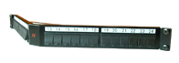
Example of product
LANsense Panel 24 Snap-In black
Aginode reference: N521.671

LANsense Panel 24 Snap-In white
Aginode reference: N521.675

Flat copper patch panel with angled connectors
Patch panels must have 19" equipment practice dimensions to permit mounting in standard cabinets, racks or bays.
The Panel with angled connectors shall be a shielded 19”/1U patch panel with a fixed tray for up to 24 regular Snap-In connectors, which are mounted in an angled position inside the panel.

Six Dual Port Packs are mounted on each side, so that 12 connectors pointing to the left side and 12 connectors pointing to the right side.
Due to the angled design of the Dual Port Packs, it is possible to patch without any cable management panel above or below the panel.
Snap-In connectors can be easily fitted into the patch panel by using blue Keystone Clips, which are delivered with the panel. The packaging of the panel does not contain connectors but is including 24 Keystone Clips for Snap-In connectors.
The panel shall be available with and without cable support tray.
The patch panels are designed for standard 19" enclosures, are 1U high, and support the following common features:
- Front colour black, similar to RAL 9005
- Designed for screened and unscreened Snap-In connectors
- Compatible with all performance categories of connector
- 24 Ports available; port numbering from left to right
- Robust steel construction
- UL94V-0

Detailed product information

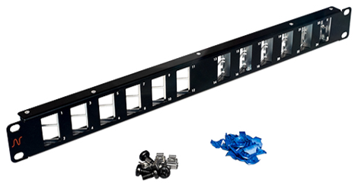

Example of product
LANmark Patch Panel 24 Angled Snap-In Black
Aginode reference: N521.680BK

Example of product
LANmark Patch Panel 24 Angled Snap-In Black Cable Support
Aginode reference: N521.681BK

High density 48-port copper patch panel

Patch panels must have 19" equipment practice dimensions to permit mounting in standard cabinets, racks or bays.

The High-Density Copper Patch Panel shall support 48 Connection Points on only 1 Rack Height Unit and allows to connect full 48 port switches. It helps to reduce the space required for cabling and to free up this space to other services.

The Panel is designed to accommodate 48 Category 6A RJ45 Connectors.
It is a robust, fully metal Patch Panel, which supports the weight load of 48 cables and offers a rear cable management with 48 T-connection points for Tie-Wraps.

Connectors are mounted Latch Up / Latch Down to enable easy patching of RJ45 Cords. Port Numbering is on the opposite side of the latch to keep it visible. Numbering is horizontal from left to right.

To install the connectors in the panel, they must be fitted with a keystone clip. Two bags of 24 clips shall be provided with the panel, for that purpose.

Connection of the panel to earth is achieved with a unique Auto-Connect feature removing the need for individual bonding conductors or earthing screws at the rear of the panel.

Detailed product information

Example of product
LANmark Patch Panel 48-port for ULTIM 1U Black
Aginode reference: N521.960BK

ZD Fibre pre-terminated assembly
The passive copper components to be used to create the MD cabling shall be the same than the ones described in the former Zone Distribution chapter.
Should the choice of component be different than the ones selected for the ZD part, delete the former sentence and use a selection of the next paragraphs according to the requirements.
If not needed just delete the following paragraphs

Fibre pre-terminated cable assembly

UHD LC fibre pre-terminated cable assembly
The Ultra High Density (UHD) assembly consists of a Bundle construction Indoor cable terminated with connectors on each side in a factory.
Cable structure
Every fibre shall be 250µm diameter secondary coated each being a different colour or suitably identified for termination identification.
The cable shall be a Bundle construction, limited filled with gel, containing 12 fibres, with a maximum of 12 -Bundles. The jacket material shall be LSZH.
The cable shall be dielectric construction, i.e. with no metallic content.

The cable shall be flame and fire retardant according to IEC 60332-1 and IEC 60332-3.
The cable shall be compliant to the IEC 60794-2-20 standard.
The Pre-Term shall have a dual stage fan-out design.
The first fan-out stage is the transition point between the cable and the legs of the fan-out. Each leg of the fan-out contains 1 Bundle with 12 fibres inside. This fan-out has been reinforced with aramid yarns.
The second fan-out stage distributes the reinforced Bundle into 12 buffered fibres. The second fan-out together with the 12 buffered fibres and connectors are optimized for installation and fixation into the UHD adaptor modules.
The connectors on the Tight Buffered fibres have coloured boots for identification in compliance with the TIA/EIA standard. In manufacturing a fibre pair flip has been implemented. When installing the connectors inside the modules of the patch panel the coloured boots need to match the colours of the integrated strip inside the module to obtain transmit-receive polarity in the channel.
The fan-out is protected with a bubble foam for protection during transport and installation. In addition every bundle of 12 connectors has an additional individual protection to avoid mixing them up with connectors from another bundle.
The Pre-Terms are optimized for both laying and pulling. A pulling eye system is positioned at one side of the Pre-Term to facilitate the installation. This pulling eye is connected to the internal strength element of the cable. The maximum pulling force on the pulling eye is 450N.
The LC/LC Pre-Terms come with a PG-13 cable gland that fits into the patch panel slots.
In order to reduce overlengths in data centres the Pre-Terms are custom made and available with 1m increments.
The typical value for the insertion loss for the low loss LC/LC connection is 0,15 dB. The limit value is 0,25 dB measured according to standard IEC61300-3-4. The minimum return loss is measured according to standard IEC 61300-3-6. For a mutimode LC connection the RL is 30 dB, for a singlemode LC connection it is 40 dB and for a LC/APC connection it is 55 dB.
All LANmark-OF Pre-term assemblies are fully terminated and tested in a quality assured factory environment. The test results are delivered in the box with the Pre-Term.
Performances
The following performances shall be warranted by the manufacturer:

CPR grade compliance requirement (Cca s1,d0,a1)
The CPR regulations came into force in July 2016 and with effect from the 1st July 2017, cable jacket
materials must be of the appropriate Construction Product Regulations Class to meet the
requirements of EN 50399 and EN 50575 2014/A:2016 standards. In particular the cables proposed for this project must conform with EN50575 for certification and labelling.
The proposed cables must meet Class Cca s1,d0,a1 and the bidder must provide a statement from the chosen manufacturer detailing their 3rd party verification of their product and its classification.

Detailed product information

Example of product
LANmark-OF ENSPACE LC/LC Pre-Term
Aginode references

UHD MTP-MTP fibre pre-terminated cable assembly

The Ultra High Density (UHD) Pre-Term cable shall be based on an advanced Micro-Bundle design. The mechanically strong Micro-Bundle cable shall feature a central strength element and aramid yarns.
Cable must feature a round small diameter of 5.9 mm for cables up to 48 fibres and of 8.4 mm for the cable with 96 fibres to facilitate use in Data Centre environment where space and airflow restrictions restrict the use of conventional design.
The cable shall have a round shape (No ribbon cable allowed) in order to avoid preferential bend radius of the cable and of the fan-outs. The minimum static bending radius of the cable shall be 65mm in any direction.

The MTP-MTP Pre-Term has standard pinned (male) connectors. This matches with the un-pinned (female) connectors in the MTP/LC modules.

In order to reduce overlengths in data centres the Pre-Terms are custom made and available with 1m increments. The "xxx" in the N-number is the length in metre between the cable glands, i.e. the Pre-Term length between the back side of the patch panels.

After the cable gland the Pre-Term has a fan-out. The fan-out splits the cable into legs. The legs are reinforced with aramid yarns. Each leg contains 12 fibres. At the end of each leg a MTP-connectors is mounted. The colour of the jacket of the legs is the same as the cable jacket. Close to the MTP-connector a label is installed to identify the number of the leg.

The Pre-Terms are optimized for both pulling and laying in data centres. On both sides the MTP connectors are protected by a bubble foam. On one side there is also a protecting net around the fan-out with MTP connectors and a pulling eye. The maximum pulling force on the pulling eye is 450N.

The MTP-MTP Pre-Terms come with a PG-13 cable gland that fits into the patch panel slots.

On the cable at a distance of 10-20 cm of the cable gland a label that provides the following information is affixed:
- Serial number
- Traceability code
- P/N-number

The Pre-Term cable shall be LSZH jacketed and shall meet the requirements for flame non propagation (IEC 60332-1) and fire non-propagation (IEC 60332-3).

Performances

Insertion loss for individual MTP connection
Fibre type | Multimode  (OM3 or OM4) | Singlemode  OS2 with G657
Typical loss | 0.15 dB | 0.30 dB
Max loss | 0.30 dB | 0.50 dB
Factory tested according to IEC 61300-3-45 standard

Factory Testing and warranty
Test report providing detailed information on each MTP cable (insertion loss and return loss) shall be included.
Every delivered item must be labelled to ensure traceability and reference to the associated test report.
The pre-terminated assemblies shall be fully terminated and tested in a quality assured factory environment, with 25-year product guarantee on the application and performance.

Method C polarity (To be selected for termination on MTP/LC modules – 10G)
The design shall incorporate in built polarity mechanisms (pair-wise fibre flip inside the MPO-MPO Pre-Term) to ensure correct link configuration with standard crossed patch cords on both sides (TIA 568-B-1-7-2006 method C - key up / key down design with a fibre pair-flip) whether installed initially or reconfigured after installation. Reconfiguration of patch cords shall not be required when moving or replacing cables.
Due to the adoption of the above mentioned method C for fibre polarity management, the same type of modules and of patch cords shall be used on both sides of the link.

Method B polarity (To be selected for direct termination on MTP adaptors – 40G/100G)
The method B Pre-Term has a straight key up / key up design in agreement with standard TIA 568-B-1-7-2006 method B.

For a duplex transmission like for 10GBase-SR (10G) polarity in the channel is maintained with this method B design and the use of a straight cassette on side A and a crossed cassette on side B. In addition the same patch cords can be used on both sides.

For parallel optics like for 40GBase-SR4 (40G) these method B Pre-Terms can be used with key up/key down adaptors on both sides of the channel. The same straight female-female patch cords can be used on both sides.

CPR grade compliance requirement (Cca s1,d0,a1)
The CPR regulations came into force in July 2016 and with effect from the 1st July 2017, cable jacket
materials must be of the appropriate Construction Product Regulations Class to meet the
requirements of EN 50399 and EN 50575 2014/A:2016 standards. In particular the cables proposed for this project must conform with EN50575 for certification and labelling.
The proposed cables must meet Class Cca s1,d0,a1 and the bidder must provide a statement from the chosen manufacturer detailing their 3rd party verification of their product and its classification.

Detailed product information

Example of product
LANmark-OF ENSPACE MTP Pre-Term
Aginode references

UHD LC patching assembly
Ultra High Density (UHD) patching assemblies allow the rapid deployment of high density patching in SAN and LAN environments in data centres. Patching assemblies allow to represent switches with patch panels. On one end the patch cord fan-out is designed to be directly connected to switches (or any active equipment) ports. On the other end the assembly is optimized for installation inside the patch panel.

On the active equipment end the fibres are grouped by 2. These couples of fibres are located inside a round 2mm patch cord and are terminated with an uniboot connector. The length from the fan-out point to the uniboot connectors is typical 1m for all uniboot connectors, but can be customized to 1,5m or 2m length.

The 900 µm side is optimised for installation inside the LANmark-OF ENSPACE patch panel. This side has a dual fan-out design.

The first fan-out stage is the transition point between the cable and the legs of the fan-out. Each leg of the fan-out contains 1 Micro-Bundle with 12 fibres inside. This fan-out has been reinforced with aramid yarns. To identify each leg a label is affixed close to the second fan-out. The jacket of the leg is the same as the jacket of the cable.
The second fan-out stage distributes the reinforced Micro-Bundle into 12 buffered fibres. The 900 µm tubes are transparent and the fibres are identified with colored boots in compliance with the TIA/EIA-standard.
The second fan-out together with the 12 buffered fibres and connectors are optimized for installation and fixing into the UHD adaptor modules.
The fan-out is protected with a bubble foam and a black net for protection during transport and installation. In addition every bundle of 12 connectors has an additional individual protection to avoid mixing them up with connectors from another bundle.
The 900 µm side of the Pre-Term is equipped with a PG13 cable gland that can be fixed on the patch panels.
On the 900µ side a pulling eye and a black protecting net are installed. The maximum pulling force on the pulling eye is 450N.
Insertion loss for the connectors is less than 0,25 dB measured according to standard IEC 61300-3-4. The minimum return loss is measured according to standard IEC 61300-3-6. For a multimode LC connection the return loss is 30 dB, for a singlemode connection it is 40 dB and for a LC/APC connection it is 55 dB.

CPR grade compliance requirement (CCA s1,d0,a1)
The CPR regulations came into force in July 2016 and with effect from the 1st July 2017, cable jacket
materials must be of the appropriate Construction Product Regulations Class to meet the
requirements of EN 50399 and EN 50575 2014/A:2016 standards. In particular the cables proposed for this project must conform with EN50575 for certification and labelling.
The proposed cables must meet Class CCA s1,d0,a1 and the bidder must provide a statement from the chosen manufacturer detailing their 3rd party verification of their product and its classification.

Detailed product information

Example of product
LANmark-OF ENSPACE patching assemblies
Aginode references

Fibre characteristics

OM4 fibre characteristics
The multi-core optical fibre cable shall consist of multimode OM4 - 50/125µ fibre with fibres colour coding for identification.

The OM4 fibres shall be compliant to the following standards:
- EC 60793-1-49: differential mode delay (DMD) to measure effective modal bandwidth (EMB)
- EC 60793-1-41: overfilled mode launch bandwidth (OFL BW)
- ISO/IEC 11801:2017 as OM4 fibre
- IEC 60793-2-10 as fibre type A1a.3b
- Compliant to annex D4 (DMD template requirements) and annex D5 (EMBc: calculated effective modal bandwidth) of IEC 60793-2-10 ed. 4

The OM4 fibres shall meet the following specifications:

Geometrical Characteristics of OM4 fibres

Optical parameters of OM4 fibres
Effective modal bandwidth shall be measured according to the templates method of IEC 60793-2-10 section D4 and the calculated effective modal bandwidth of IEC 60793-2-10 section D5.

OM5 fibre characteristics

The multi-core optical fibre cable shall consist of multimode OM5 - 50/125µ fibre with fibres colour coding for identification.

The OM5 fibres shall be compliant to the following standards:
- EC 60793-1-49: differential mode delay (DMD) to measure effective modal bandwidth (EMB)
- EC 60793-1-41: overfilled mode launch bandwidth (OFL BW)
- ISO/IEC 11801:2017 as OM5 fibre
- IEC 60793-2-10 as fibre type A1a.4b
- Compliant to annex D4 (DMD template requirements) and annex D5 and D6 (EMBc: calculated effective modal bandwidth) of IEC 60793-2-10 ed. 6

The OM5 fibres shall meet the following specifications:

Geometrical Characteristics of OM5 fibres

Optical parameters of OM5 fibres
Effective modal bandwidth shall be measured according to the templates method of IEC 60793-2-10 section D4 and the calculated effective modal bandwidth of IEC 60793-2-10 section D5.

OS2 fibre characteristics
The multi-core optical fibre cable shall consist of singlemode OS2 - 9/125µ fibre with fibres colour coding for identification.

The OS2 fibres shall be compliant to the following standards:
- ITU-T as fibre type G.652.D and G657A1
- Singlemode OS2 cable defined in ISO/IEC 11801:2017
- IEC 60793-1 Measurement Methods and Test procedures
- IEC 60793-2-50 as fibre type B1.3 and B6_a1

The OS2 fibres shall meet the following specifications:

Geometrical Characteristics of OS2 fibres

Optical parameters of OS2 fibres

Optical Fibre Patch Panel
The passive copper components to be used to create the MD cabling shall be the same than the ones described in the former Zone Distribution chapter.
Should the choice of component be different than the ones selected for the ZD part, delete the former sentence and use a selection of the next paragraphs according to the requirements.
If not needed just delete the following paragraphs

Sliding modular OF Patch Panel
The 1U Optical Fibre Patch Panel must be modular having 24 empty ports that can be loaded with SC or LC Snap-In adaptors and fits in a 19” rack or cabinet.
The modular OF panel has extended cable management with multiple entries to provide maximum flexibility. It accommodates both cable glands and tie wraps for strain relief of the cables. The cable gland sizes holes are 20 mm (8x) and 25 mm (2x).
The patch panel shall be designed with an enhanced sliding mechanism enabling front side installation and maintenance work to be carried out without having to remove the entire panel.
The front adaptor plate is fixed in a recessed position. When set in recess position the front connector plate is deeper than the front of the 19" rails of the cabinet. This will provide sufficient bend radius for the patch cords once connected to the panel. This shall also prevent damages to the patch cords when the cabinet doors are closed.
Direct Termination of the connectors (SC & LC) on to the fibres as well as splicing of pigtails (SC & LC) shall be possible.
The patch panel chassis has multiple, specially designed, slots at the rear to fix the cable glands of pre-terminated cables. There shall be ample space inside the patch panel to organise the flexible fan-out of the pre-terminated cables.
The Patch Panel shall be supplied with 3 loop rings to neatly coil the terminated fibres.
Up to four optional splice cassettes should be supported to manage up to 48 splices with heat shrink protectors and with aluminium protectors.
The splice cassettes shall feature a lifting functionality for improved ease of installation and inspection.

The front plate of the 24 port modular Patch Panel shall be compatible with the following connector types: 24 single SC, 24 duplex LC and 12 duplex DSC.
Standard LC, SC and DSC Snap-In couplers shall be available to load the modular patch panel.
The colour of the Multimode Snap-In adaptors shall be aqua.
Singlemode Snap-In adaptors shall be available in Blue and Green colour. Blue colour is going to be selected to connect PC polished SC or LC connectors while green is selected for APC polished connectors.
The fully loaded panel (One height unit or 1U) shall support up to 24 fibres when working with SC Snap-In couplers and up to 48 fibres when working with LC Snap-In couplers.

Unused positions can be populated with optional blank fillers.

Panels are fully painted for a professional look and feel. It t shall be available in both black and white colour.
In the panels, the fibres have to be wired in such a way that the dual OF channel polarity is maintained. Wiring of the fibres has to be done according to the guidelines provided by the manufacturer.

Detailed product information
Example of product
LANmark-OF Patch Panel Snap-In Sliding Black
Aginode reference: N439.4SNB

High density Plug&Play OF patch panel
The ' Plug and Play concept shall be specifically designed for installation in data centres where the high density, integrated patch cord guide and enhanced installation benefits of the patch panel meet the key requirements for implementation.

The patch panel design allows to hold up to 4 MTP/LC modules or adaptor plates in 1U of the distribution rack. Depending on the type of the module a high density of up to 96 fibre connections can be accommodated.

The patch cord guide sits in front of the modules and allows the patch cords to be managed within the same 1U saving expensive rack space. The patch cord guide also provides a labelling facility to identify connections. Additional labelling is provided by printed port numbers on the modules.

The tray shall slide and tilt for improved access to install new modules and adaptor plates.

The patch panel is optimised for installation of MTP/MTP or SC/LC Pre-Term assemblies. The cable glands of the Pre-Term allow a fast and solid fixing of the cable. There is ample space inside the patch panel to organise the flexible fan-out of the Pre-Term.

Optional Fibre Organiser shall be available to facilitate the installation of the SC/LC Pre-Term.

Up to 4 optional splice cassettes can be installed in the patch panel to accommodate up to 96 splices.
Panels are fully painted in black for a professional look and feel.
Blank fillers are available as separate accessories for unused positions to give a finished look.

The front adaptor plate can be fixed in a flush or recessed position in the rack using the adjustable side brackets. When the panel is installed recessed the distance between the rack vertical and the rear of the panel is 288 mm. The front cord management projection is 67 mm. When the panel is installed flush the distance between the rack vertical and the rear of the panel is 248 mm. The front cord management projection is 107 mm.

Detailed product information
Example of product
LANmark-OF Plug&Play Patch Panel Integrated Cord Guide Sliding Black
Aginode reference: N439.3MPP

LANmark-OF fibre organiser 10x
Aginode reference: N890.070

LANmark-OF splice cassette for heat shrink protectors
Aginode reference: N890.090
LANmark-OF splice cassette cover
Aginode reference: N890.092

LANmark-OF splice cassette for Aluminium Protectors
Aginode reference: N890.091
LANmark-OF splice cassette cover
Aginode reference: N890.092

HD OF Patch Panel
The High Density (HD) concept is designed for data centres where the high density, integrated patch cord guides and enhanced installation benefits of the HD patch panel meet the key requirements for implementation.
It shall allow quick changes with limited down time, easy migration to other applications and a transition path to parallel optics.

The Aginode’ unique ENSPACE HD 1U panel design has 2 fixed trays. Each tray can have up to 4 ENSPACE modules. The panel can accommodate up to 8 modules allowing 96 LC connections when modules with LC adaptors are used. With LANmark-OF ENSPACE MTP adaptor modules 48 MTP connections within 1U can be installed. ENSPACE modules need to be ordered separately.

The HD Patch Panels shall be available in 1U and 2U. The panels are designed for installation inside 19 inch enclosures.

The trays are staggered to facilitate patching and have easier access to the latch of the patch cord. The trays have printed letters for identification.

On the rear tray 1 cable fixing kit is provided. The slots are suitable for a PG-13 cable gland. The orientation of the fixing kit can be modified to allow for side, angled or rear entry. An optional third cable fixing kit can be installed on the tray as well.

The patch panel is optimised for installation of the LANmark-OF ENSPACE Pre-Terms: the cable gland of the Pre-Term allows a fast and solid fixing of the cable. There is ample space inside the patch panel to organise the flexible fan-out of the Pre-Terms.

A labelling hinged front cover sits in front of the modules. It can rotate almost 180° even when UHD patch panels are installed underneath. This facilitates port identification when the panel is mounted at the top of the rack.

Panels are fully painted in black for a professional look and feel.

The total depth of the panel is 493mm. The panels are delivered with the labeling front projection 129mm in front of the rack vertical. The rear of the panel is 364mm recessed compared to the rack vertical. The position of the panel inside the rack can be changed with adjustable side brackets. It can be moved backwards compared to the rack vertical by 37.5mm or forward by 37,5mm or 75mm.

Detailed product information
Example of product
LANmark-OF ENSPACE HD Patch Panel 1U 8x Modules Black
Aginode reference: NSPACE.PPHD1U

Example of product
LANmark-OF ENSPACE HD Patch Panel 2U 16x Modules Black
Aginode reference: NSPACE.PPHD2U

Optional modules and accessories

UHD OF Patch Panel
The Ultra High Density (UHD) concept is designed for data centres where the very high density, integrated patch cord guides and enhanced installation benefits of the UHD patch panel meet the key requirements for implementation.
It shall allow quick changes with limited down time, easy migration to other applications and a transition path to 40G/100G.

The UHD system consists of 3 sub-components: Pre-Terms, modules and patch panels.

The patch panel design shall have 3 sliding trays within 1U. Each tray can accommodate up to 4 modules. The panels can be loaded within 1U with up to 12 modules allowing 144 LC connections when modules with LC adaptors are used. With MTP adaptor modules 72 MTP connections within 1U can be installed. Modules have to be ordered separately.

The UHD Patch Panels shall be available in 1U, 2U and 4U. The panels are designed for installation inside 19 inch enclosures.

The tray slides shall have 3 locking positions.

The operational position (1) when the trays are completely in the rack.
The patching position (2) when the tray is moved forward by 75 mm. This allows easy access to the patch cords.
The final stop position (3) before removal of the tray.

The sliding trays shall have printed letters to identify the individual trays. Additional side handles on the left and right sides enhance the pulling forward of the tray.

The UHD Pre-Terms shall be fixed on a separate, sliding and tilting tray located at the rear of the panel. For installation of the cables the tray can be slid out of the patch panel by about 15 cm. This allows easy access to the fixing points for the cables without being in the small space formed by the panel above and underneath when working in a high density rack.
On this rear tray 2 cable fixing kits are provided. The slots are suitable for a PG-13 cable gland. The orientation of the fixing kit can be modified to allow for side, angled or rear entry. An optional third cable fixing kit can be installed on the tray as well.

The patch panel is optimised for installation of the UHD Pre-Terms: the cable gland of the Pre-Term shall allow a fast and solid fixing of the cable. Ample space is available inside the patch panel to organise the flexible fan-out of the Pre-Terms, including the additional fan-out overlength required to allow the individual trays to slide to the patching or installation position.

A labelling hinged front cover sits in front of the modules. It can rotate almost 180° even when UHD patch panels are installed underneath. This facilitates port identification when the panel is mounted at the top of the rack.

Panels are fully painted in black for a professional look and feel.

The total depth of the panel is 526mm. The panels are delivered with the labelling front projection 129mm in front of the rack vertical. The rear of the panel is 397mm recessed compared to the rack vertical. The L shaped chassis support brackets can be fitted in 5 different positions to move the position of the panel inside the rack. It can be moved backwards compared to the rack vertical by 37.5mm or forward by 37,5mm or 75mm.

Detailed product information
Example of product
LANmark-OF ENSPACE UHD Patch Panel 1U 12x Modules Black
Aginode reference: NSPACE.PP1U

Example of product
LANmark-OF ENSPACE UHD Patch Panel 2U 12x Modules Black
Aginode reference: NSPACE.PP2U

Example of product
LANmark-OF ENSPACE UHD Patch Panel 4U 12x Modules Black
Aginode reference: NSPACE.PP4U

Optional modules ad accessories

Local Distribution point (LDP)
The passive copper components to be used to create the MD cabling shall be the same than the ones described in the former Zone Distribution chapter.
Should the choice of component be different than the ones selected for the ZD part, delete the former sentence and use a selection of the next paragraphs according to the requirements.
If not needed just delete the following paragraphs
Local Distribution Points significantly improve the flexibility of connexion to server/SAN racks in the DC. It is particularly useful when reconfiguration is required between those active equipment racks.
Moreover, expensive rack space can be saved in active equipment racks by installing passive patch panels outside the racks.
The overhead position shall be preferred. This contribute to increase cabling density per square metre.
The overhead open frame shall be designed to host copper and fibre patch panels. Both 4U and 6U versions shall be available.
It can be fitted with up to 3 optional patch cords management hooks on both sides. An extra 1U cable guide can be added horizontally under the frame. These accessories hold and guide the patch cords dropping into the racks located below the frame.
The frame and brackets shall be made of galvanised steel, grey natural colour.
Overhead Patching frame shall be fitted with brackets enabling vertical installation under, along and over cable trays. The frame can be angled to 20° by using the angled side of these brackets in order to ease readability of patch panel labels.
The weight of the empty frame and its mounting brackets shall not be over 2,5kg. The total weight (frame and equipment) shall be compliant to the maximum load of the tray to which the frame will be fixed to.

Detailed product information

Example of product
LANmark Overhead Patching Frame 4U
Aginode reference: N345.400

LANmark Overhead Patching Frame 6U
Aginode reference: N345.600

Copper Patch cords
The passive copper components to be used to create the MD cabling shall be the same than the ones described in the former Zone Distribution chapter.
Should the choice of component be different than the ones selected for the ZD part, delete the former sentence and use a selection of the next paragraphs according to the requirements.
If not needed just delete the following paragraphs
To achieve a Class EA Channel performance all data Patch Cords shall be Category 6A rated.
Cat.7A and/or cat.8 patch cords will only be required in the future when full Class FA or Class II channel will be needed.
The patch cord cable shall be made from LSZH material with a metric marking indicating type of cable, brand name, production code and length.
All patch cords shall be compliant to the IEC 60332-1 standard to offer flame propagation retardant properties.

Cat.6A Data Patch cords
All Data patch cords shall be fully screened.
The standard colours offered for the LSZH flame retardant jacket shall be orange and dark grey.
Red, Blue, Green and Yellow colours shall also be available on demand.
Special length and special cable colours shall be available in 14 days “ex warehouse”.
The default lengths available from stock shall be 1, 2, 3, 5, 10 and 20 m. in order to ensure quick delivery of the cords on site.
The patch cords feature a slim over-moulded boot which is kept inside the RJ45 boundaries to enable High Density Patching with 48 cords in 1 height unit.
They also come with a ‘Replaceable’ black Latch Protector, which can be used for colour coding of different services.
The coloured retrofit latch protectors shall be available as accessory in 8 colours for colour coding of different services.
The cords shall be fitted with Category 6A RJ45 screened plugs, with a Self-latching connector. All pairs must have an impedance of 100 Ohms. The characteristic impedance of the pairs must be identical to that of the horizontal cables. The Patch Cords shall have a guaranteed performance level of greater than 750 insertions without degradation to the performance level of the solution.
The cable used for the Patch Cords shall be Category 6A LSZH U/FTP patch cable. The cable shall be a 4 twisted pair cable with individually screened stranded conductors. Traceability numbers should accompany the cables supplied from the manufacturers packaging to assist in quality validation of the installed cable.
When installed in combination with other Cat.6A components of the same manufacturer, a 25 years channel warranty can be obtained, covering full 10GBase-T support and full Cat 6A/Class EA compliance.
TheCat.6A cords fully comply and exceed the requirements of EIA/TIA-568-C.2 and ISO11801 and enable to achieve high performing Cat 6A channels. Used with other Cat.6A components of the same manufacturer, very short Cat 6A link and channel configurations with up to 3 connection points within 10 meters can be supported.

Detailed product information

Example of products

Cat.6A screened small diameter patch cords
Cat. 6A Slimflex cords are developed to support 10 Gigabit Ethernet (IEEE 802.3an) and any other Cat.6A application and require 44 % less space than regular Cat6A patch cords.
They use thin AWG30 wires inside a cable with an outer diameter of only 4.5mm. When formed into bundles, this results into significant space savings.

LANmark-6A Slimflex Cords offer a frequency range up to 500MHz and are matched with other LANmark-6A components to provide improved data throughput in complex channel configurations. They use stranded cable to provide maximum flexibility.

The patch cords feature a slim over-moulded boot which is kept inside the RJ45 boundaries to enable High Density Patching with 48 cords in 1 height unit.
They also come with a ‘Replaceable’ black Latch Protector, which can be used for colour coding of different services.
The coloured retrofit latch protectors shall be available as accessory in 8 colours for colour coding of different services.

The cords shall be fitted with Category 6A RJ45 screened plugs, with a Self-latching connector. All pairs must have an impedance of 100 Ohms. The characteristic impedance of the pairs must be identical to that of the horizontal cables. The Patch Cords shall have a guaranteed performance level of greater than 750 insertions without degradation to the performance level of the solution.
The cable used for the Patch Cords shall be Category 6A LSZH screened S/FTP patch cable. The cable shall be a 4 twisted pair cable with stranded conductors. Traceability numbers should accompany the cables supplied from the manufacturers packaging to assist in quality validation of the installed cable.
The LANmark-6A Slimflex cords fully comply and exceed the requirements of ISO11801:2017, except the maximum length requirements. The maximum length of channels is reduced to 96m. The cord derating factor is 2.6.
Used with other Cat. 6A components of the same manufacturer, very short Cat 6A link and channel configurations with up to 3 connection points within 10 meters can be supported.

Detailed product information

Example of products

Cat.7A Data Patch cords
All Cat.7A Data patch cords shall be full screened. The standard colour offered for the LSZH flame retardant jacket shall be orange.
The cords shall be fitted with Category 7A GG45 plugs, booted at each connector.
The Cat.7 plugs shall be compliant to the IEC 61076-3-110 standard.
The characteristic impedance of the pairs must be identical to that of the horizontal cables. The Patch Cords shall have a guaranteed performance level of greater than 750 insertions without degradation to the performance level of the solution.
The cable used for the Patch Cords shall be Category 7A S/FTP patch cable. The cable shall be a 4 twisted pair cable with stranded conductors. Traceability numbers should accompany the cables supplied from the manufacturers packaging to assist in quality validation of the installed cable.
All pairs must have an impedance of 100 Ohms.
When used with the LANmark-7A system, Cat 7A/Class FA channel performance complies with the channel limits of ISO/IEC 11801:2017 and it exceeds the requirements of the ISO/IEC 4-connector model.

Detailed product information

Example of products

Cat.6A Secure Lock RJ45 Patch cords
Security being of paramount importance for the current project the copper sub-system shall be equipped with a system restricting the removal of the RJ45 patch cords.
The range of Secure Lock patch cords shall be designed to meet the needs of applications such as:
- PoE connector protection (damage caused by mating/unmating under load)
- Theft prevention (Hotels/Schools/Libraries)
- Critical circuit protection
- Patch Cord availability (Meeting rooms)
- Redundant Copper links
- Connection of IP security cameras
- Use in high-density switches.
There are two variants in the LANmark-6A Secure Lock Patch Cords:
- Patch Cords with locks on both the plugs
- Patch Cords with lock on only one plug
Each cord comes preassembled with a red locking boot.
The cord can be disconnected when the matching red key is used to unlock the boot.
The standard cord colour of the LSZH jacket shall be orange.
Standard cords (cat.6A S/FTP) are stocked in lengths of 1, 2, 3 and 5m - other lengths are available on demand.

Detailed product information
Example of products

Example of products
LANmark Secure Lock Copper Patch Cord Key
Aginode reference: N1LA.KEY

Secure Lock RJ45 port blockers
Port Blockers shall secure the network infrastructure by blocking out unused or unauthorised ports.
They also protect the hardware from incoming dust and harmful foreign objects.
RJ45 Port Blockers shall fit into any standard RJ45 jack without the use of a tool.
The insertion shall be tool-free onto any standard RJ45 Jack used for outlets and Patch Panels
A dedicated black coloured key must be needed to unlock and remove Port Blockers.

Features
- Exchangeable and re-usable
- Individual packaging for Secure Lock RJ45 Port blockers should contain 100pcs
- Individual packaging for Secure Lock RJ45 Port Key should contain 5pcs
- Material: Plastic
- UL Rating: UL94V-2
- RoHS 2 compliant
- Colour of the RJ45 Port Blocker: Red, Blue and Black
- Colour of the RJ45 Port Key: Black
- Operating temperature range: -10°C~60°C
- Storage temperature range: -40°C~60°C
- Humidity: 10%~90%RH

Detailed product information
Example of products
LANmark Secure Lock RJ45 Port Blocker – Blue
Aginode reference: N110.SRJPBB
LANmark Secure Lock RJ45 Port Blocker – Red
Aginode reference: N110.SRJPBR
LANmark Secure Lock RJ45 Port Blockers – Black
Aginode reference: N110.SRJPBK
LANmark Secure Lock RJ45 Port Blocker Key
Aginode reference: N110.SRJPKK

Detailed product information
Example of products
LANmark Secure Lock RJ45 Port Blocker – Blue
Aginode reference: N110.SRJPBB
LANmark Secure Lock RJ45 Port Blocker – Red
Aginode reference: N110.SRJPBR
LANmark Secure Lock RJ45 Port Blockers – Black
Aginode reference: N110.SRJPBK
LANmark Secure Lock RJ45 Port Blocker Key
Aginode reference: N110.SRJPKK

Optical Fibre Patch Cords
The passive copper components to be used to create the MD cabling shall be the same than the ones described in the former Zone Distribution chapter.
Should the choice of component be different than the ones selected for the ZD part, delete the former sentence and use a selection of the next paragraphs according to the requirements.
If not needed just delete the following paragraphs

OM3 & OM4 BIMMF Optical Fibre Patch cords
The patch cords shall be available in lengths of 1m, 2m, 3m, 5m, 7m, 10m, 15m, 20m, 25m, 30m, 40m and 50m and have a LSHF-FR outer sheath.
The cable shall be flame and fire retardant according to IEC 60332-1.
When using OM3 or OM4 optical fibres, patch cords produced with the same OM3 or OM4 fibre have to be installed.
The patch cords have a small bend radius of 10mm.
They are produced with GIGAliteFLEX fibre. This bend insensitive multimode fibre (BIMMF) has a small bend radius of 7.5mm and is compliant to IEC 60793-2-10, fibre model A1a.3b.
Duplex LC-LC, duplex LC-SC and duplex SC-SC patch cords have a duplex cable construction with a diameter of 2 X 2.0 mm and short connector boots of 19mm.
A label shall be affixed close to the duplex connector for traceability of the factory measurement results.
Insertion Loss and Return Loss test results shall be available on request.
Patch cord cable is according to IEC 60794-2-50. The colour of Jacket and of the connectors shall be Aqua for both OM3 and OM4 patch cords.
The Fibre Snap-In adapters will be connected to the active equipment OF ports by means of “Cross-over” duplex patch cords in order to maintain the duplex OF channel polarity in accordance with the requirements of ISO/IEC 11801:2017 and EN 50174-1 Ed.3.
The "butterfly" duplex clip allows to easily change the polarity on site by simply removing the 2 connectors and put them in a reverse order back into the same clip. No tool shall be required for this polarity change.

Detailed product information
Example of products

OS2 BI Optical Fibre Patch cords

The patch cords shall be available in lengths of 1m, 2m, 3m, 5m, 7m, 10m, 15m, 20m, 25m, 30m, 40m and 50m and have a LSHF-FR outer sheath.
The cable shall be flame and fire retardant according to IEC 60332-1.
UPC polishing performance of the connectors with RL > 50 dB is required.
APC polishing style shall be available with RL > 65 dB.
The patch cords have GIGAliteFLEX fibre inside. This bend insensitive (BI) fibre has a small bend radius of 10mm and is compliant to ITU-T G.657.A1 and to IEC 60793-2-50, fibre model B6.a1.
Duplex LC-LC, duplex LC-SC and duplex SC-SC patch cords have a duplex cable construction with a diameter of 2 X 2.0 mm and short connector boots of 19mm.
A label shall be affixed close to the duplex connector for traceability of the factory measurement results.
Insertion Loss and Return Loss test results shall be available on request.
Patch cord cable is according to IEC 60794-2-50. The colour of Jacket shall be yellow for OS2 patch cords.
The Fibre Snap-In adapters will be connected to the active equipment OF ports by means of “Cross-over” duplex patch cords in order to maintain the duplex OF channel polarity in accordance with the requirements of ISO/IEC 11801:2017 and EN 50174-1 Ed.3.
The "butterfly" duplex clip allows to easily change the polarity on site by simply removing the 2 connectors and put them in a reverse order back into the same clip. No tool shall be required for this polarity change.

Detailed product information

Example of products

UHD bend insensitive LC OF Patch cords
The UHD (ultra High Density) patch cords shall be optimised for use in Data Centres environments.
These patch cords shall have a very small bend radius of 10 mm due to the use of bend insensitive fibre and very small diameter of 2 mm..
The round design of the UHD patch cord results in a small bend radius in any direction. Traditional patch cords based on a zipcord design have a bend radius that is dependent on the orientation and are therefore not accepted.
The patch cords shall be available in lengths of 1m, 2m, 3m, 5m, 7m and 10m and have a LSHF-FR outer sheath.
For the support of the advanced high speed Ethernet protocols with stringent power budgets the UHD patch cord features a low loss performance of 0.25 dB. This increases the headroom in the channel and reduces the risk of down time.
CHARACTERISTICS
- Patch cord cable is according to IEC 60794-2-50
- Maximum insertion loss according to IEC 61300-3-4: 0.25 dB
- Typical insertion loss: 0.125 dB
- Bend insensitive fibre
- A label is added close to the uniboot connector for traceability of the factory measurement results
DESIGN
The Fibre Snap-In adapters will be connected to the active equipment OF ports by means of “Cross-over” duplex patch cords in order to maintain the duplex OF channel polarity in accordance with the requirements of ISO/IEC 11801:2017 and EN 50174-1 Ed.3.
The polarity of the patch cord can be changed by opening the uniboot connector on one side and change the position of the 2 LC connectors. A black and yellow plastic square identify the fibre inside the patch cord. The patch cords are delivered with the black square on the left on side A and on the right on side B. This is required for cross-over or optical crossed patch cords. By changing the position of the black square on side A from the left to the right the patch cord becomes an optical straight patch cord.

The colour of the jacket shall be Aqua for OM4 fibres and Yellow for OS2 fibres.

Detailed product information
Example of products

UHD bend insensitive MTP PRO OF Patch cords
UHD OF MTP-MTP patch cords have been designed for indoor applications in support of parallel optics, i.e. 40GBase-SR4 and 100GBase-SR 4.
OF MTP patch cords are delivered as straight patch cords with a key up - key up design. The patch cords are delivered with female MTP* PRO connectors.
* MTP is a trade name of US Conec. MPO patch cords shall be terminated with MTP connectors to ensure superior mechanical and optical performances.
For ease of patching the MTP PRO connector has a short boot length of 17mm.
With a specific tool available from the manufacturer the gender and polarity of the patch cords can be changed. Gender can be changed to male with the pins exchangers. The polarity can be changed to a key up – key down design.
The patch cords are available with OM4 or OS2 fibres.
The typical value for the insertion loss for a multimode MTP connection is 0,125 dB. The limit value for a multimode MTP connection is 0,25 dB measured according to standard IEC 61300-3-45. The minimum return loss for a multimode MTP connection is 20 dB measured according to IEC 61300-3-6.
Mechanical characteristics of the Pre-Term are conform to the IEC 60794-20 standard for indoor cables. The small diameter of 2.5 mm and the small bend radius of 30mm the cable facilitates the patching in densely populated areas in the data centre..
The length between the 2 MTP-connectors is variable and can be increased in steps of 1m.

Detailed product information
Example of products

Secure Lock LC port blockers
Port Blockers shall secure the network infrastructure by blocking out unused or unauthorised Duplex LC Adaptors. They also protect the hardware from incoming dust and harmful foreign objects.
LC Port Blockers shall fit into any standard Duplex LC Adaptors without the use of a tool and shall not interfere or lead to the degradation of network performance.
The insertion shall be tool-free onto any standard Duplex LC Adaptors used for outlets and Patch Panels
A dedicated black coloured key must be needed to unlock and remove Port Blockers.

Features
- Exchangeable and re-usable
- Individual packaging for a LANmark-OF Secure Lock - LC Port blockers should contain 100pcs
- Individual packaging for a LANmark-OF Secure Lock LC Port Key should contain 5pcs
- Material: Plastic
- UL Rating: UL94V-2
- RoHS 2 compliant
- Colour of the LC Port Blocker: Transparent Red and Transparent Blue
- Colour of the LC Port Key: Transparent Black
- Operating temperature range: -10°C~60°C
- Storage temperature range: -40°C~68°C
- Humidity: 10%~90%RH

Detailed product information
Example of products
LANmark Secure Lock LC Port Blockers - Blue
Aginode reference: N124.SLCPBB
LANmark Secure Lock LC Port Blockers - Red
Aginode reference: N124.SLCPBR
LANmark-OF Secure Lock key for LC Port Block key (5pcs)
Aginode reference: N124.SLCPKK

Link and Channel performance
The passive copper components to be used to create the MD cabling shall be the same than the ones described in the former Zone Distribution chapter.
Should the choice of component be different than the ones selected for the ZD part, delete the former sentence and use a selection of the next paragraphs according to the requirements.
If not needed just delete the following paragraphs

Cat.6A performance
Manufacturer shall demonstrate guaranteed minimum worst-case (4-connector Link) performance to be compliant with class EA link and channel performance according to the ISO/IEC 11801:2017 standard.
The system supplier must be able to demonstrate in house design and manufacturing expertise for all components used (e.g. cables, outlets, panels and cords) in order to ensure compatibility of system elements.
Regarding short links, the standard channel performance shall be warranted for a 10 meters / 3 connectors link with 5 meters of cable length for both Patch Panel to Consolidation Point and Consolidation Point to Terminal Outlet segments.
The Cat.6A channel shall comply to the following electrical performances.
Maximum and Minimum values shall be warranted by the manufacturer.

All values are based on Worst Case 4 Connector Channel configurations according to ISO11801:2017.
Standard (Std) values are based on ISO11801:2017 Class EA.
Minimal and maximum values represent guaranteed channel performance.

Cat.7A performance
Manufacturer should demonstrate guaranteed minimum worst case (4-connector channel) performance to be compliant with class EA and class FA channel performance according to the ISO/IEC 11801:2017 standard.

Components used must be compliant with both the Category 6A and Category 7A standards mentioned above.
The performance of both the components and the link should show stable performance up to 1,000MHz in order to allow for possible future applications.
The performance of the channel should show stable performance
- Up to 500MHz when using Cat.6A patch cords
- Up to 1,250MHz when using Cat.7A patch cords
The system supplier must be able to demonstrate in house design and manufacturing expertise for all components used (e.g. cables, outlets, panels and cords) in order to ensure compatibility of system elements.
All components shall be produced by the same system manufacturer.
Electrical Performance Class FA 4 Connectors Channels:
 | Attenuation | Next PP | ACR-F | RL | Coupling Att. | PSA Next | PSA Fext
Frequency | (in dB) | (in dB) | (in dB) | (in dB) | (in dB) | (in dB) | (in dB)
(in MHz) | Std Max | Std Min | Std Min | Std Min | Std Min | Std Min | Std Min
1 | 4.0 | 65.0 | 65.0 | 19.0 | 80.0 | 67.0 | 80.0
4 | 4.1 | 65.0 | 65.0 | 19.0 | 68.0 | 67.0 | 79.8
10 | 6.4 | 65.0 | 65.0 | 19.0 | 60.0 | 67.0 | 75.9
16 | 8.0 | 65.0 | 63.3 | 18.0 | 55.9 | 67.0 | 73.9
20 | 9.0 | 65.0 | 61.4 | 17.5 | 54.0 | 67.0 | 72.9
31.25 | 11.2 | 65.0 | 57.5 | 16.5 | 50.1 | 67.0 | 71.0
62.5 | 15.9 | 65.0 | 51.5 | 14.0 | 44.1 | 67.0 | 68.0
100 | 20.3 | 65.0 | 47.4 | 12.0 | 40.0 | 67.0 | 65.9
155 | 25.4 | 63.0 | 43.6 | 10.1 | 36.2 | 67.0 | 63.9
200 | 28.9 | 60.9 | 41.4 | 9.0 | 34.0 | 67.0 | 62.8
250 | 32.5 | 59.1 | 39.4 | 8.0 | 32.0 | 67.0 | 61.8
300 | 35.7 | 57.7 | 37.8 | 8.0 | 30.5 | 67.0 | 60.9
500 | 46.7 | 53.6 | 33.4 | 8.0 | 26.0 | 64.5 | 58.6
600 | 51.4 | 52.1 | 31.8 | 8.0 | 24.4 | 63.3 | 57.8
700 | 55.8 | 50.8 | 30.5 | 7.5 | 23.1 | 62.3 | 57.1
800 | 59.9 | 49.7 | 29.3 | 7.0 | 21.9 | 61.5 | 56.4
900 | 63.8 | 48.8 | 28.3 | 6.5 | 20.9 | 60.7 | 55.9
1000 | 67.6 | 47.9 | 27.4 | 6.0 | 20.0 | 60.0 | 55.4

Network Access Cabling – ENI
The Main Distributor(s) are to be connected to the External Network Interface (ENI) to link the Data Centre to the external world (Access providers) and/or to the Campus Distributor (CD) and/or Building Distributor(s) (BDs) of the enterprise cabling system.
The necessary copper and/or OF links to be created must be defined according to the specific project requirements.
The passive fibre components to be used to create the ENI cabling shall be the same than the ones described in the former Zone Distribution and MD chapter.

Rack unit solution

Server DC racks
The proposed 19’’ rack shall be a high-performance cabling rack engineered for Data Centre environments. It shall ensure optimal airflow through an 80% perforation ratio. With the growing use of AI configurations and heavier GPU servers, the rack’s metallic frame shall be designed to support a high load capacity of up to 1500 kg.
The integrated smart cable management system shall ensure proper bending radius for all cables and patch cords, maintaining optimal performance. A double front door shall provide full access to the cabling area, facilitating technical interventions inside the rack. The doors shall be equipped with a three-point locking system to guarantee a high security level.
A smart handle with RFID card access may be offered as an option to eliminate the need for key management.
The rack shall be offered with the following dimensions
- Heights: 42U and 47U
- Depths: 800, 1000 and 1200 mm
- Width: 800 mm
The rack shall be equipped with side panels divided into upper and lower sections. For safety and ergonomic reasons, the upper section shall be opened first to allow access to the lower section. This two-part design reduces the lifting effort compared to a single large panel and facilitates easier handling during installation. The upper section shall be equipped with a lock.
The rack shall be available in both standard and extension executions. Extension executions shall be supplied without side panels for use in row configurations, as only the first and last racks in the line require side panels.
A width of 800 mm shall provide adequate lateral space for enhanced cable management through dedicated lateral cable managers. An optional internal cable tray may be added to support internal cable routing.
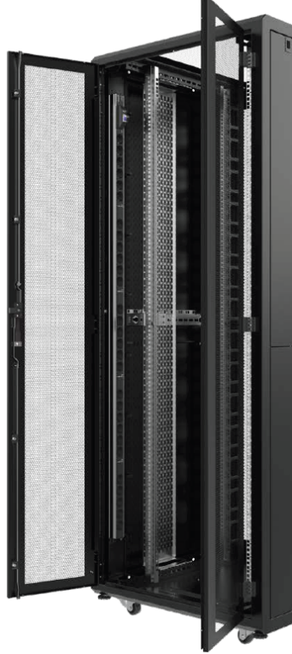
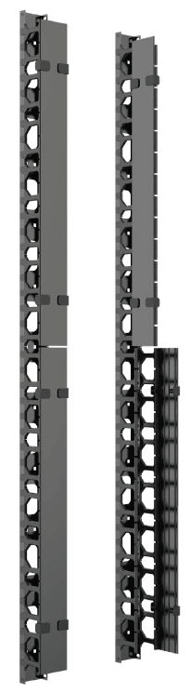
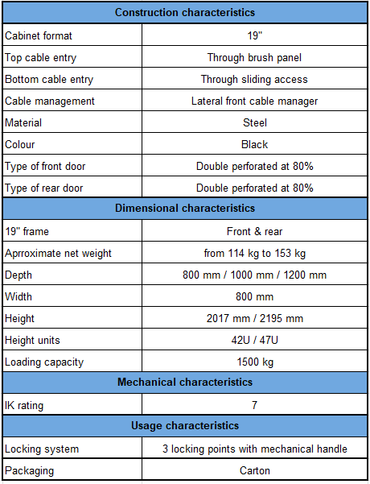

Detailed product information
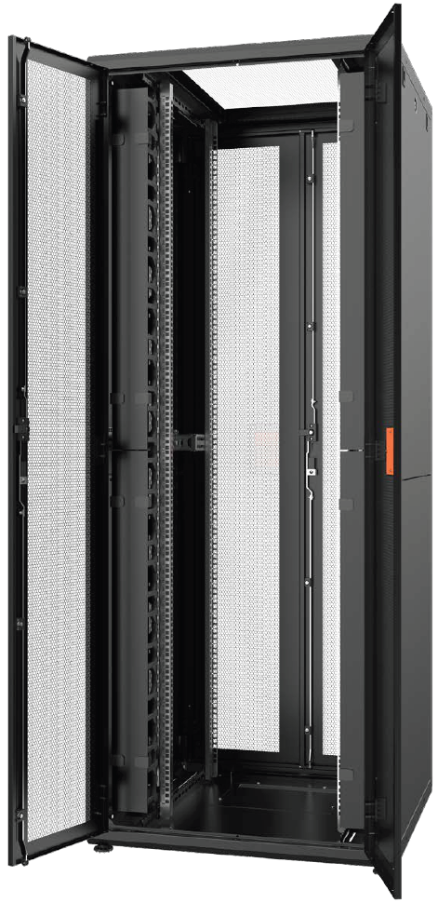
Example of products
DCMARK RACK UNIT SOLUTION SERVER DC 42U 800X800
Aginode reference: NRCK.420808.441-B

DCMARK RACK UNIT SOLUTION SERVER DC 47U 800X1000
Aginode reference: NRCK.470810.441-B

Collocation racks
The proposed 19’’ Collocation DC rack shall be designed to maximize security, flexibility, and efficient space utilization in shared data center environments. Their reinforced structure and advanced access control options shall ensure reliable isolation between tenants.
The manufacturer shall propose a range of racks equipped with
- 2 compartments of 20U
- 3 compartments of 13U
- 4 compartments of 9U
Each having a single front perforated door, lockable by key and double rear perforated door.
Moreover each key shall have a specific number printed on the barrel for the confidentiality.

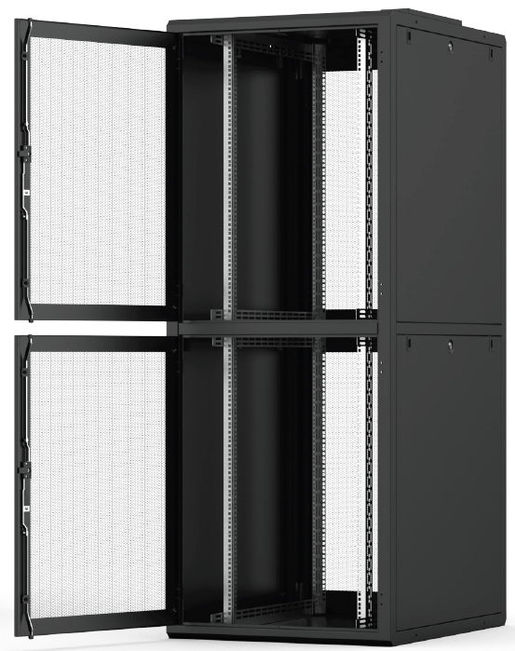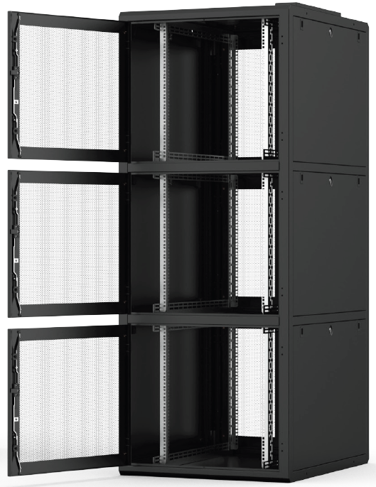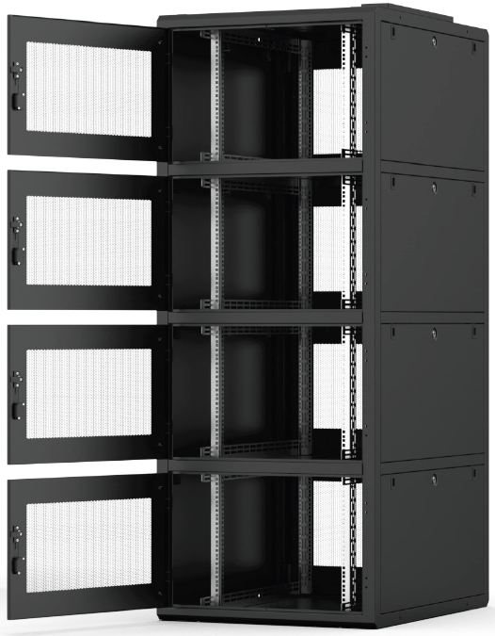

Cable entries within a brush panel shall equip the roof and serve the different compartments through closed cable ducts to offer a high level of security and avoid having access to the cable to all the tenants.
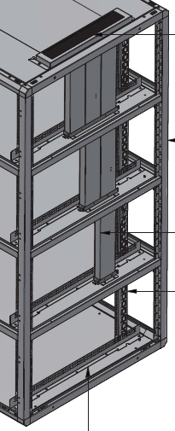
Their reinforced structure and advanced access control options shall ensure reliable isolation between tenants.
The rack shall be offered with the following dimensions with a total loading capacity of 1500 Kg
- Height: 42U
- Depth: 800 mm
- Width: 800 mm
The rack shall be available in both standard and extension executions. Extension executions shall be supplied without side panels for use in row configurations, as only the first and last racks in the line require side panels.
A width of 800 mm shall provide adequate lateral space for enhanced cable management through dedicated lateral cable managers.
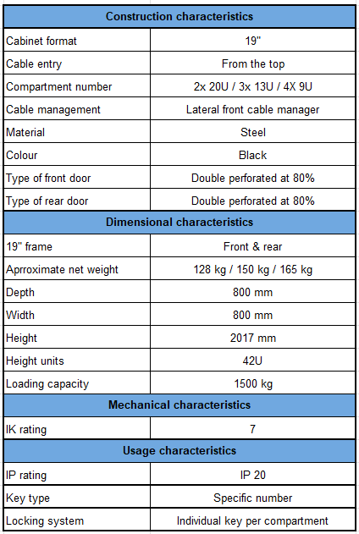

Detailed product information
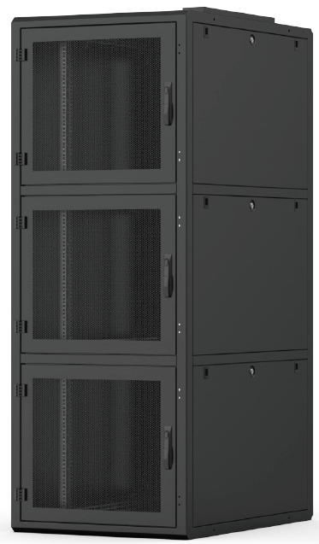

Example of products
DCMARK RACK UNIT SOLUTION COLLOCATION DC 42U 2 COMPARTMENTS
Aginode reference: NRL2.420808340-B

DCMARK RACK UNIT SOLUTION COLLOCATION DC 42U 3 COMPARTMENTS
Aginode reference: NRL3.420808340-B

DCMARK RACK UNIT SOLUTION COLLOCATION DC 42U 4 COMPARTMENTS
Aginode reference: NRL4.420808340-B

Earthing requirements
Earthing shall be implemented according to EN 50174-2:2018 & EN 50310:2016/A1:2020 standards and to local relevant regulations.
The method of achieving all earth connections at the same safe potential is to bond them together and physically connect them in the soil or ground at the same point i.e. the MET.
- This is known as equipotential bonding. The MET (Main Earthing Terminal) shall be provided by the local electricity supplier as a drilled copper bus-bar and sized in accordance with local wiring regulations, existing building requirements and future growth expectations.
This procedure applies to unshielded, shielded and fibre optic cabling systems alike. All metal parts regardless of the type of cabling must be earthed for personnel safety reasons and to avoid potential damage to equipment.
All metallic parts of the system (mainly cabinets and patch panels) shall be bonded throughout back to a local (Secondary) Bonding Busbar (SBB) usually located in the cabling distributors rooms / computer room. All those SBBs are linked back to the MET (Main Earthing Terminal) bonding point. The bonding network will normally be provided by the local Electricity supplier in accordance with country-specific wiring regulations.
The metal frame of the Patch Panel must not be bonded to the cabinet with a separate bond connection if the patch panels automatically make contact with the 19” metal frame of the Cabinets.
The bonding bar of the cabinet must be connected to the local SBB. The dimension of the bonding conductor is 6mm².
If racks are adjacent to each other they shall not be bonded together using a daisy chaining structure.
Every rack has to be directly connected to the local bonding bar (SBB) or to the main bonding backbone conductor circulating in the room.
Main bond runs back to the local SBB shall utilise larger bonding conductor.
Earth runs should be kept as short as practically possible, with the wire as straight as is practically possible.
Please refer to local bonding regulation documents in order to ensure that the bonding conductors are sized accordingly.
If no or only a poor protective bonding system is present in the building, a separate bonding conductor to the MET of the building is required. The dimensions of the conductor should then be 16mm².

Testing
The manufacturer of the cabling system shall provide copper (Data) and optical fibre testing procedures that
clearly describes the tools and settings to be used to ensure correct measurements of the system.

Data Copper Testing
100 % of the installed horizontal links have to be tested in accordance with IEC 61935-1 and with the field testing procedure of the manufacturer.

Link testing is required in accordance with the updated EN 50174 Ed.3 cabling standard.

The cabling system shall to be tested against ISO Class EA, FA, link limits. (Keep the right class only)
The measurements shall be done using Level IV testing equipment.
The testing equipment must be yearly calibrated by the manufacturer and the copy of the calibration certificate must be included in the warranty request.
The following parameters have to be tested:
- Wire-map
- Continuity
- Signal conductors
- Screen conductors (if present)
- Short circuits
- Open circuits
- Length
- Internal transmission Return loss
- Insertion loss
- Pair-to-pair NEXT
- PSNEXT
- Pair-to-pair ACR-N
- PSACR-N
- Pair-to-pair ACR-F
- PSACR-F
- Direct current (d.c.) loop resistance
- Propagation delay
- Delay skew
The PSANEXT, PSANEXTavg, PSAACR-F, and PSAACR-Favg (A-NEXT and A-ELFEXT) don’t have to be tested for screened cabling systems. The conformance to those Alien crosstalk parameters is met by design for screened systems in accordance with ISO11801:2017.
The complete test results of all the installed channels have to be collected in a certification file. It is preferred to have the test result in electronic format to facilitate the certification procedure.
Apart from all the test results mentioned above, a few more documents have to be added to the file: a list of material used for the project, a design of the network, a Cable schedule per distributor and finally all the necessary co-ordinates of the persons responsible of the project.

Fibre testing
In order to avoid contamination and potential damage of optical fibre end-faces and/or connecting hardware
due to the build-up of static charge during transport, manufacturers recommended cleaning procedures (compliant to the ISO 62627 standard – Fibre optic connector cleaning methods) shall be applied before any connection is made to any fibre connector.
Although pre-terminated assemblies (LC or MTP) are supplied with test certificates, it is a requirement under the manufacturer warranty procedure to supply test results for the installed system and applies for both Multimode and Singlemode installations.
The testing procedure shall comply with the ISO/IEC 14763-3:2006/A1 2009 and IEC 61280-4-1/Ed.3 and IEC 61280-4-2/Ed.2 standards and be in accordance with the latest issue of the ‘Field testing procedure’ document to be provided by the cabling manufacturer.
The ISO/IEC 14763 standard specifies the implementation and operation of customer premises cabling.
The part 3 of this ISO document (14763-3) details test procedures for optical fibre cabling designed in accordance with ISO/IEC 11801:2017 and installed according to the recommendations of ISO/IEC 14763-2 (Planning and installation of customer premises cabling).
For Multimode fibres, the test procedure is based on the use of the “one-jumper method” specified by Method 2 of IEC 61280-4-1. This procedure is used for testing links for which the connector loss is a significant portion of the total link attenuation. This is the case for LAN premises links.
For singlemode fibres, the test procedure to be applied is the same and is based on the use of the “one-jumper method” specified by Method 1a of IEC 61280-4-2.
Fibre-optic Tests applied to links and exclude equipment and work area cord.
All 100 % of the installed OF links have to be tested and must pass the acceptance criteria.
Test cords shall be equipped with reference connectors and ISO 14763-3:2006 limits shall be selected on the tester.
The attenuation of the link is measured using the insertion loss method. This method uses an optical source and an optical power meter to compare the difference between two optical power levels.
When testing multimode optical fibre links with a Light Source and a Power Meter, this measurement equipment has to be capable of operating at
- 850nm and 1300nm for multimode fibres (OM3, OM4 & OM5)
- 1310nm and 1550nm for singlemode fibres (OS2)
Encircled Flux compliance shall be provided through the use of a Modal Controller Device that is either integrated into the test equipment (light source), or an external device.
The test scenario with an OTDR shall be one of the following for each link:
- Dual direction @ 850nm and @ 1300nm for multimode fibres
- Dual direction @ 1310nm and @ 1550nm for singlemode fibres
The use of launch and receiving reels is required. (Refer to manufacturer testing procedure)
The use of certification tool is required. Those tools are capable of producing a report logging the time of the test the link identification under test, the link length, the attenuation at the window tested and the acceptable link attenuation. The report shall also identify in which direction the testing was implemented.
when testing with basic optical source and power meter, the operator will fill up a report logging
- the time of the test,
- the link identification under test,
- the link length and attenuation at the window tested.
- The report shall also identify in which direction the testing was implemented.
- Acceptable link attenuation (To be calculated)
The measured attenuation of the links shall have a lower value than the acceptable link attenuation calculated.
The testing equipment must be yearly calibrated by the manufacturer and the copy of the calibration certificate must be included in the warranty request.

Procedures

Installation Guide
All the components have to be installed according to the procedures prescribed by the supplier. During the whole period of installation, the installer has to put an Installation Guide at the disposal of the client, so that he can verify the compliance of the installation to the guidelines of the supplier.

Fire Protection
The installer has to closely follow the local regulations concerning fire protection.
The integrity of the fire barrier has to be maintained or restored.
Where fire-stopping compounds are used to restore integrity around data cables, they must be to an approved material so as not to damage the cable. (Cable manufacturer can advise approved compounds).

Earthing
For the earthing of all the proposed products, the installer has to closely follow the related recommendations of the supplier, in accordance with local regulations. The earthing procedure that has to be followed shall be put at the disposal by the supplier under an official document.

Management of the Project

Design of the Project and Labelling
The vendor will first make a site survey. This will allow him to propose a complete turnkey solution without any additional costs for unforeseen labour. If possible, the installer will try to use the existing infrastructure as much as possible. If cable supports or cable trays are lacking, then the vendor will have to evaluate the necessary quantities and price and take up a detailed description in his offer.
To ensure the transparency of the installation and the maintenance of the structured cabling, the vendor has to develop a numbering and labelling scheme in agreement with the owner or his representative in order to identify all the components without ambiguity. After the temporary reception of the project, all the cabinets’ layouts and the drawings of the Data Centre will be completed referring to this numbering scheme.

Project Management
For the complete duration of the project the vendor will appoint a Project Manager, who will work on his behalf. He will be the single point of contact to ensure a smooth co-ordination.
For project with an estimated duration over 2 weeks, the vendor will appoint a Site Manager, who will be permanently present on site on behalf of the vendor. The Site Manager will report to the Project Manager, in order to ensure that the correct information is communicated from the commencement of the project until the hand-over of the network to the client

Warranty
The following copper and fibre sub-system warranties apply to both standard AND AIM products.
Telecommunications contractor must register the project and submit test data for approval, per the requirements of the cabling manufacturer certification program guidelines.
Once approved, the manufacturer will extend a 25-year Warranty to the end user.
Copper and fibre patch cords are considered as replaceable items and are specifically excluded from the 25 year product guarantee due to the normal wear and tear that can occur.

Copper sub-system

Cat.6A sub-system
The manufacturer must guarantee to the End User that the products referenced within the specific Warranty Modules (Class EA System) when correctly installed in accordance with installation guidelines:
- Will be free from product defects in materials and workmanship
- Are guaranteed to exceed
- Class EA Channel and Permanent Link as specified in ISO/IEC 11801:2017
- Augmented Cat 6 Link and Channel requirements as specified in ANSI/TIA -568.2-D : 2017
- Supports the following application (not limited):
• 10baseT Ethernet
• 100baseTX Fast Ethernet
• 1000baseTX Gigabit Ethernet
• 10G base-T Ethernet IEEE 802.3an
• 155Mbit ATM
• 1200Mbit ATM
• POE type 1 to 4
- For a duration of 25 years
- Provide a guaranteed headroom
• of at least 10 dB on A-NEXT
• of at least 15 dB on A-ELFEXT
All components including the Cat6A patch cords have to be produced by the same cabling system manufacturer to ensure warranted performances and applications against the standards.

Cat.7A sub-system
The manufacturer must guarantee to the End User that the products referenced within the specific Warranty Modules (Class FA System) when correctly installed in accordance with installation guidelines:
- Will be free from product defects in materials and workmanship
- Are guaranteed to exceed the Class FA Channel and Category 7A mated component requirements as specified in ISO/IEC 11801:2017
- Supports the following application (not limited):
• 10baseT - Ethernet
• 100baseTX - Fast Ethernet
• 1000MbaseTX - Gigabit Ethernet
• 10GBaseT – 10Gigabit Ethernet over copper
• 25GBASE-T Ethernet (IEEE 802.3bq) Maximum Channel length 30 Meters
• 155Mbit ATM
• 1.2 Gbit ATM
• POE type 1 to 4
- For a duration of 25 years
Class FA Channel performance is only warranted when Cat.7A patch cords are used and these have not been subjected to any damage which can occur due to normal wear & tear.

Due to the backwards compatibility of Cat.7A/8 GG45 connector it is possible to use Cat.5e, Cat.6 and Cat.6A patch cords.
In this case the following Channel performance shall be warranted:
- Class EA using Cat.6A patch cords
- Class E using Cat.6 patch cords
- Class D using Cat.5e patch cords
All components including the patch cords have to be produced by the same cabling system manufacturer to ensure warranted performances and applications against the standards.
To ensure correct installation in accordance with the guidelines, the installer shall attend to a specific Cat.7A installation training organised by the manufacturer.
The warranty will only be issued if the installer has received the official Cat.7A installation training certificate from the cabling system manufacturer.

Fibre sub-system

OM4 sub-system
The manufacturer must guarantee to the End User that the products referenced within the specific Warranty Modules (OM4 pre-terminated fibre System) when correctly installed in accordance with installation guidelines:
- Will be free from product defects in materials and workmanship
- support any current or future application designed to be supported by fibres according to IEC 60793-2-10 A1a.3b
Fibre systems are warranted for 25 years.
Guaranteed distances vary depending on the number of connections and shall comply to the following table:
All components including the patch cords and pigtails have to be produced by the same cabling system manufacturer to ensure warranted performances and applications distances against the standards.

OM4 ULL MTP sub-system
The manufacturer must guarantee to the End User that the products referenced within the specific Warranty Modules (OM4 Ultra Low Loss MTP fibre System) when correctly installed in accordance with installation guidelines:
- Will be free from product defects in materials and workmanship
- support any current or future application designed to be supported by fibres according to IEC 60793-2-10 A1a.3b
Fibre systems are warranted for 25 years.
Guaranteed distances vary depending on the number of connections and shall comply to the following table:
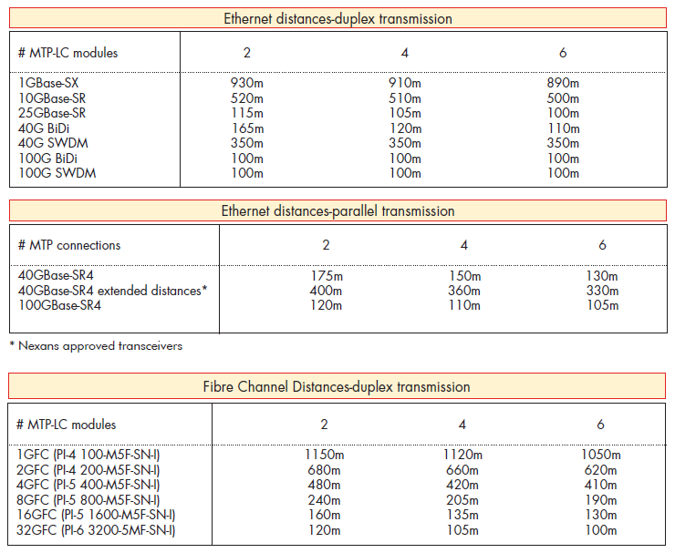
All components including the patch cords and pigtails have to be produced by the same cabling system manufacturer to ensure warranted performances and applications distances against the standards.

OM5 sub-system
The manufacturer must guarantee to the End User that the products referenced within the specific Warranty Modules (OM5 pre-terminated fibre System) when correctly installed in accordance with installation guidelines:
- Will be free from product defects in materials and workmanship
- support any current or future application designed to be supported by fibres according to IEC 60793-2-10 A1a.4b
Fibre systems are warranted for 25 years.
Guaranteed distances vary depending on the number of connections and shall comply to the following table:
All components including the patch cords and pigtails have to be produced by the same cabling system manufacturer to ensure warranted performances and applications distances against the standards.

OM5 ULL MTP sub-system
The manufacturer must guarantee to the End User that the products referenced within the specific Warranty Modules (OM5 Ultra Low Loss MTP fibre System) when correctly installed in accordance with installation guidelines:
- Will be free from product defects in materials and workmanship
- support any current or future application designed to be supported by fibres according to IEC 60793-2-10 A1a.4b
Fibre systems are warranted for 25 years.
Guaranteed distances vary depending on the number of connections and shall comply to the following table:
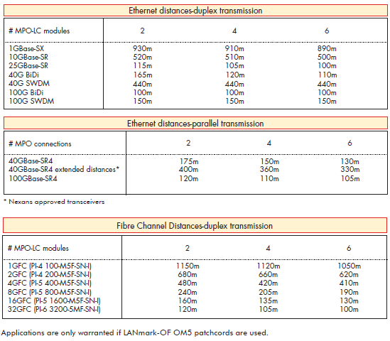
All components including the patch cords and pigtails have to be produced by the same cabling system manufacturer to ensure warranted performances and applications distances against the standards.

OS2 sub-system
The manufacturer must guarantee to the End User that the products referenced within the specific Warranty Modules (OS2 pre-terminated fibre System) when correctly installed in accordance with installation guidelines:
- Will be free from product defects in materials and workmanship
- support any current or future application designed to be supported by Singlemode G657.A1 fibres
Fibre systems are warranted for 25 years.
Guaranteed distances vary depending on the number of connections and shall comply to the following table:
All components including the patch cords and pigtails have to be produced by the same cabling system manufacturer to ensure warranted performances and applications distances against the standards.

OS2 MTP sub-system
The manufacturer must guarantee to the End User that the products referenced within the specific Warranty Modules (OS2 MPO fibre System) when correctly installed in accordance with installation guidelines:
- Will be free from product defects in materials and workmanship
- support any current or future application designed to be supported by Singlemode G657.A1 fibres
Fibre systems are warranted for 25 years.
Guaranteed distances vary depending on the number of connections and shall comply to the following table:
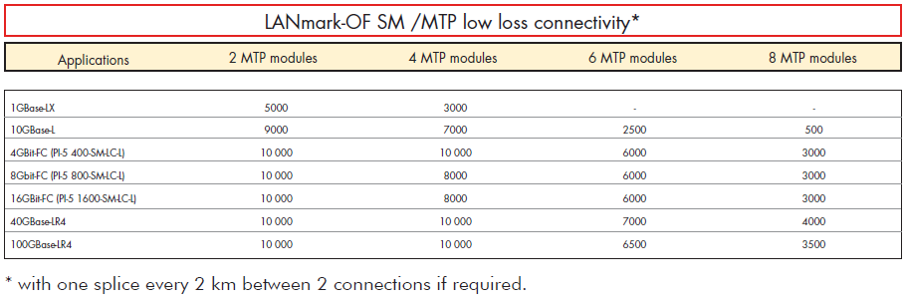
All components including the patch cords and pigtails have to be produced by the same cabling system manufacturer to ensure warranted performances and applications distances against the standards.

Documentation

Response inclusions to the bid price
- Datasheets of the proposed components
- Table with the guaranteed values for the proposed twisted pair and FO cables
- Detailed warranty conditions
- Certificate of Approved/Certified Installer granted by the supplier
- Schedule of execution with the expected start and end dates
- Summarised plan of the cabling design philosophy + cabinets layouts that have to be submitted to the customer for approval.

During the Presentation of the Offer
- Presentation of the proposed products
- Technical justification of the backbone concept

Kick-off of the Project
- Installation guide of the supplier
- Schedule of execution in agreement with the customer

On completion of the installation
- Certification file
- 25-year “Link & Channel Warranty” delivered by the supplier
- Plans “as built”

Disclaimer
This document is intended to be used as technical guidelines to develop specific requirements for LAN cabling Systems.
Aginode reserves the right to change the technical specifications at any time without notice.
The user should review the information to ensure conformity to the current applicable standards and to the project requirements.
Aginode assumes no liability due to the use of these specifications and is not responsible for any error or omission.

